All Saints Lutheran Church, ELCA
421 SW 19th St. Blue Springs, Missouri 64015 816-229-3633
Pastor Sarah Pierce Spierce.aslcpastor@gmail.com
allsaintslc64015@gmail.com https://aslcbs.org/

Sunday, December 03, 2023

First Sunday of Advent
You are absolutely invited into this sacred space. We welcome all who are seeking God’s love and grace. All Saints recognizes that we are all unique and beloved children of God. We celebrate and give thanks for the many diverse gifts that God has given us. We affirm the sacredness of people of all sexual orientations, gender identities, and gender expressions. We affirm the sacredness of all those who have experienced exclusion because of race, ability, age, or culture. We affirm the sacredness of all those who wrestle with addiction, physical or mental health, imprisonment, socio-economic circumstances, or anything that too often divides us. We believe that through our openness we all grow in our faith through Christ’s teaching to love one another as God loves us. We need each other and our sincere hope is by being in community together, we will experience God’s presence in new and real ways.

The offering plate is by the main door to the sanctuary for your convenience.

We practice open communion at All Saints Lutheran Church. What does that mean? It means that if you believe and trust that Christ offers his body and blood For You, you are welcome at the table. At All Saints, we believe that Christ invites all people to the feast. “Come to the banquet for all is now ready.”

**Stand as you are comfortable

Prelude

Announcements

Lighting of Advent Wreath

Week 1: Hope
We gather together as God’s people, a people who have hope even when it seems all hope is lost. A people who believe that God is with us, even in the midst of a doubt-filled world. To believe that God is with us, no matter what, can sometimes feel like the most audacious thing in the world. It flies in the face of every message that the world sends. And yet…

Light the first candle

We believe. We hope. We know, deeper than knowing, that God is with us. And so we look for Jesus, the one chosen by God to be God-Among-Us.

Come, Jesus. We await the radical love and justice that you bring to all people and to all of creation.

Come, Jesus. Come.

** Confession

Advent is a time of waiting, a time of anticipating the next thing - the birth of Jesus, who comes to save us from our sins. It’s also a time of examining our own behavior, seeing where we have fallen short in our efforts to walk the path that Jesus would have us walk. This is a hard thing to do, and so we practice it together, as a community, every week.

God of new beginnings,
We confess that we have not welcomed your holy reign.
We have strayed from your paths.
We have doubted your faithfulness and our own purpose.
We don’t hold our community, our world, and our creation in healthy relationships with you at the center.
Set us again on your way of love, so that we learn to turn back to you - as often as we need to learn - and welcome your coming among us.

People of God,
A new thing is growing among us - a living sign of your forgiveness! Through the waters of baptism and the gift of the Holy Spirit, you are a part of God’s reign forever. In +Christ, your sins are washed away. Rejoice in this new thing that God is creating.
Amen.

**Entrance Hymn | Blessed Be the God of Israel |  | ELW #250
**Greeting
The grace of our Lord Jesus Christ, the love of God,
and the communion of the Holy Spirit be with you all.
And also with you.

**Kyrie
God of new beginnings, we thank you for your mercy.
Come, thou long-expected Jesus.

Christ who comes to us as a child, we thank you for your forgiveness.
Come, thou long-expected Jesus.

**Glory to God
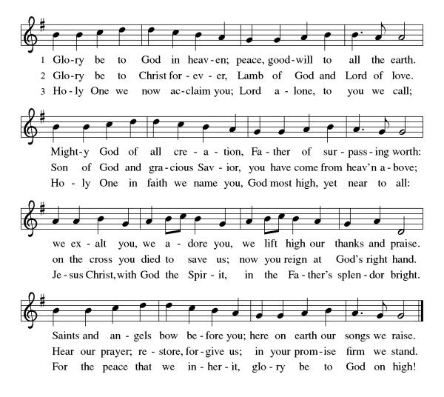
**Prayer of the Day
Loving God, we hope in the promises you give us. Help us to see the ways in which your reign is coming into fruition. Strengthen us in our faith as we wait for the final redemption you offer. We pray these things in the name of Jesus, our Savior. Amen.

Reading: Jeremiah 33:10-11, 14-18

¹⁰“Thus says YHWH: you say of this place, ‘It lies in ruins, lacking both people or animals throughout the towns of Judah and the streets of Jerusalem. All of it is a wasteland inhabited by neither people nor animals.’ ¹¹Yet in this place there will be heard once more the sounds of joy and gladness, the voices of bride and bridegroom. Here too will be heard the shouting of voices, ‘Praise YHWH Omnipotent, for our God is a good God, whose love endures forever,’ as they offer praise and thanksgiving in the Temple. For I will restore the fortunes of this land as they were before, says YHWH.
¹⁴“The days are surely coming, says YHWH, when I will bestow on Israel and Judah all the blessings I promised them. ¹⁵In those days and at that time I will raise up a righteous branch from the line of David, who will bring justice and integrity to the land. ¹⁶In those days Judah will be safe and Jerusalem will be secure. They will call the land, ‘YHWH is our Justice.’ ¹⁷“For thus says YHWH: David will never lack a successor on the judgment seat of Israel. ¹⁸Nor will there ever be lacking a levitical priest to present whole offerings, to burn grain offerings and to make other offerings every day.”

The Word of the Lord
Thanks be to God
**Gospel Acclamation
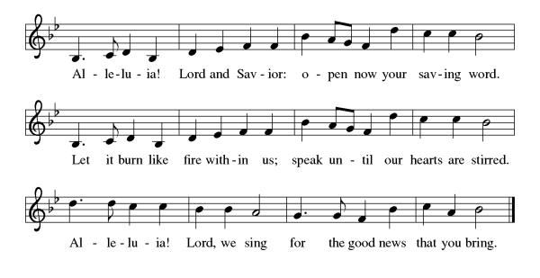
**Announcement of the Gospel
Glory to you, O Lord.

**Gospel: Mark 8:27-29

²⁷Then he and the disciples set out for the villages around Caesarea Philippi. On the way, Jesus asked the disciples this question: “Who do people say that I am?” ²⁸They replied, “Some say John the Baptizer; others, Elijah; still others, one of the prophets.” ²⁹“And you,” he went on to ask, “who do you say that I am?” Peter answered, “You are the Messiah!”

The Gospel of the Lord.
Praise to you, O Christ.

Sermon "Despair and Hope"
Hymn of the Day O Come, O Come, Emmanuel ELW#257

**Affirmation of Faith
We affirm that God created the world of which we are a part and upon which we depend. God made us and all of Creation partners in the work of sustaining and continuing to create this world.

We affirm that the love of the Creator took flesh in Jesus the Christ. Jesus calls us from fear and self-centeredness to connection with God and each other. Jesus stayed true to God’s will, though it led to death on the cross. Rising and ascending, Jesus remains present in all times and places; accepting us where we are, as we are; calling us to new life; reminding us that we are more than flesh and that death is not the end.

We affirm that God gives us the gift of the Spirit, voice of conscience and discernment, source of strength and courage, comforter in times of hardship and pain. She calls us to the joy of being our true selves together in loving community.

We affirm that we depend on God: Creator, Christ, and Spirit; joining ourselves with God’s will, seeking to become more fully ourselves in service to each other and the world, living into the Kingdom in our midst. Amen.

**Prayers of Intercession

With hope and expectation, we offer our prayers for the church, the World and all who await God’s day of restoration.

Call your church into holy fellowship as we await the restoration of all things. Reenergize your faithful people to live with hope and compassion, especially those who serve as missionaries near and far. Center us on your promise to come among us and make all things new. Merciful God,
receive our prayer.
All creation signals your presence, O God: the vastness of the cosmos, the turn of the seasons, and living things that both rest and flourish. Rekindle our commitment to care for the earth. Merciful God,
receive our prayer.
Let the nations tremble at your holy presence, that justice and liberation prevail in all corners of the earth. Restore peace to nations in conflict, teach righteousness to corrupt leaders and systems, and bring stability to areas facing uncertain futures. Merciful God,
receive our prayer.
Enrich the spirits of all who feel hopeless, fearful, or despairing. Stay close to those who await healing or relief especially Monty, David, Theresa, Paul, Linda and Bill, Dylan, Rob, Becky, Matt, Jim and Dee, and the people of Israel and Palestine. Deliver all in any need. Merciful God,
receive our prayer.
Be with those who keep awake at night: nurses working overnight shifts, caregivers of newborns and aging adults, stargazers, those who are anxious, or those who are traveling. Reveal to all that the dark can be a place of calm and comfort filled with your presence. Merciful God,
receive our prayer.
You have sent out your angels and gathered your faithful people from every time and place, calling them into one fellowship of saints. Bless the witness of those who dwell in your eternal presence. Merciful God,
receive our prayer.

Listen to these and all our prayers, gracious God, and restore us with your great and everlasting mercy.
Amen

** Sharing of the Peace

**Offering is brought forward

** Offertory Response

For the Beauty of the Earth ELW #879

**Offertory Prayer
Almighty God, we give you thanks for all that you have given us. In return, we offer up these gifts to you: our skills, our time, and our money. Help us to be good stewards of all that you have given us. In the name of Jesus, our Savior. Amen.

DIALOGUE
Jesus has prepared a sacred meal for us.
We await your coming, Jesus.

All are welcome at Jesus’ table: sinner and saint, wounded and healed, weak and strong.
We await your coming, Jesus.

Preface: We gather at God’s table…this hymn of praise:
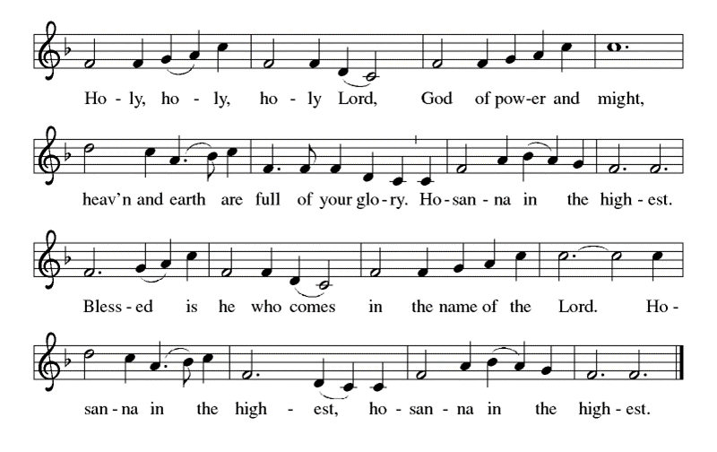
**Words of Institution

**LORD’S PRAYER
Our Loving God in heaven, hallowed be your Name,
Your kingdom come, your will be done, on earth as in heaven.
Give us today our daily bread.
Forgive us our sins as we forgive those who sin against us.
Save us from the time of trial, and deliver us from evil.
For the dominion, the power, and the glory are yours, now and forever. Amen.

Invitation to Communion

Communion Hymn If You But Trust in God to Guide You ELW #769

**Sending Song

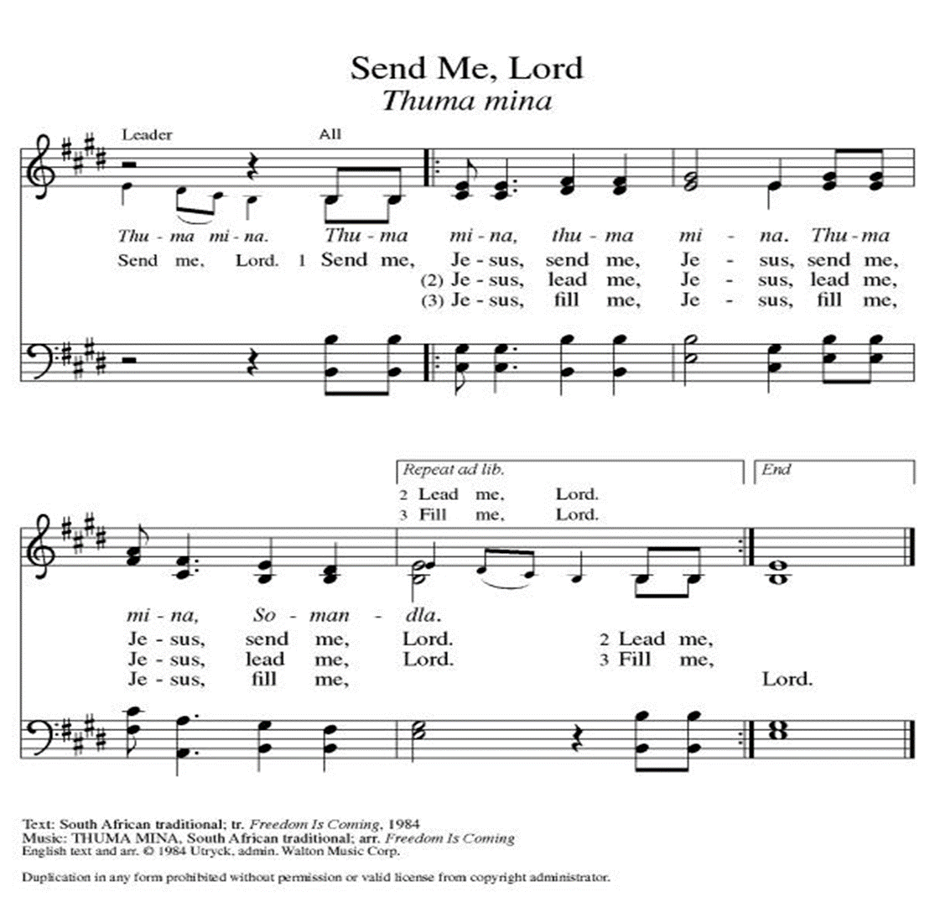

**Prayer After Communion
Loving and merciful God, you have fed us at the table and with your word. Strengthen us as we go out into the world to await the coming of your Son, Jesus, our Savior.
Amen.

**Blessing

**Closing Hymn All Earth is Hopeful ELW#266

**Dismissal
We have been fed and renewed by Christ. As we go in grace, we shout with joy:
THANKS BE TO GOD!

+ + + + + +

Hymns from the Evangelical Lutheran Worship are under copyright and used with permission under One License #733618-A. Specific copyright information as listed in bulletin. Liturgy from ELW Setting 10 is under copyright and is used with permission under Augsburg Fortress Liturgy License #SB155933. All other liturgy written by Sarah Pierce.
Weekly Attendance
Week of November 19
26
Evening of November 22
21
Week of November 26
22

******************************************************************************************
Calendar of Events
Today
- December 03-Taking Quilts MLM
December 05-Creative Frends 1:00 pm
December 06-Council Meeting 6:30 pm
December 09-Men's Breakfast IHOP 8:00 am
December 10-Bells-Carol of the Bells & The Coventry Carol
December 10-Advent Dinner after Church Services
December 11 Secret Prayer Sisters lunch at Corner Cafe 9:00 am
December 12-Creative Frends 1:00 pm
December 12 through December 17-Pastor on vacation
December 16-Project Comfort Lunch On the Border 11:30 am
December 19-Creative Frends 1:00 pm
December 20-Newsletter Deadline
December 22 through December 25-Office Closed
December 24-Christmas Eve Service 7:00 pm
December 26-Creative Frends 1:00 pm
December 31-New Year's Eve
January 01-Office Closed

Please note: Adult Bible Study will be on a break and will resume after Christmas.

Bishop Candea reminds us that as followers of Christ, we are to pray for and support the most vulnerable among us. She pointed out that right now, the most vulnerable people in the world are the women, children, and elderly people living in the Gaza Strip.

If you feel called to do something to help, Lutheran World Relief is providing aid to civilians caught in the crisis in Israel and Palestine. You can donate directly at lwr.org/israel-gaza.

All members are welcome to attend regularly scheduled council meetings. Additionally, the Council would like to remind you that the most recent Council reports and minutes are available on the bulletin board in the narthex.
*****************************************************************************************
BLUE SPRINGS COMMUNITY SERVICE LEAGUE is very appreciative of your continued support of your neighbor.
******************************************************************************************
Questions for Reflection and Discussion
- There is something of a mythic, almost supernatural, quality to this story in which the people of Judah believe that God is actively working against them due to God’s anger over their continued neglect. There are people who have actively chosen to turn away from the church because of stories like this, and belief (I think misplaced belief) in a God of vengeance, who would rain destruction down on their chosen people. How do we re-write that narrative when we are given texts like this to work with?
- One of the commentaries I read while preparing for this sermon pointed out that it’s pretty subversive to believe that the supremacy of the Babylonian empire is attributed to God, when the Babylonians had their own gods and given the worldview at the time. History is usually written by the winners; in this case, it was not. What does that say about the nature of faith?
- Jeremiah was given a hard word to prophesy. He was in Jerusalem during the last 30 years of Judah, prophesying mostly to people who did not want to hear what he had to say, who did not believe that the Babylonian juggernaut would roll over them as it had rolled over so many other small nations. In the runup to our text for this morning, he loses hope, but he never loses faith.
- As Christians, we believe that the righteous branch from David is Jesus. The verses in which God describes this righteous branch (verses 15-17) are a very specific word of hope, locating this hope in a person who will be raised up and who will engage in very specific actions. How do you feel this hope as we enter into Advent?

If you are looking for a concrete way to support the people of Ukraine, Lutheran Immigrant and Refugee Services has opportunities for directed prayer, advocacy, or financial support. https://www.lirs.org/Ukraine-crisis

Greeter
December 03 Donna Taylor

Usher
December 03 Paul Blixrud

Altar Guild
December 03 Mary Ann Gross

Reader
December 03 Sara Meyers

Communion Assistant
December 03 Flavia Via

Tech
December 03 Gary & Zach Antes

Prayer Requests
Monty Health Concerns (May 15)
David Health Concerns (April 11)
Theresa Family Concerns (May 05)
Paul Health Concerns (May 31)
Linda and Bill Health Concerns (May 16)
Dylan Military Service (September 06)
Pastor Sarah Health Concerns (October 03)
Rob Health Concerns October 11)
Becky Health Concerns (October 23)
Matt Health Concerns (November 06)
Jim and Dee Personal & Health Concerns (November 14)

Please pray for the people of Israel and Palestine.

