All Saints Lutheran Church, ELCA
421 SW 19th St. Blue Springs, Missouri 64015 816-229-3633
Pastor Sarah Pierce Spierce.aslcpastor@gmail.com
allsaintslc64015@gmail.com https://aslcbs.org/

Sunday, September 10, 2023

Time after Pentecost
The offering plate is by the main door to the sanctuary for your convenience.

We practice open communion at All Saints Lutheran Church. What does that mean? It means that if you believe and trust that Christ offers his body and blood For You, you are welcome at the table. At All Saints, we believe that Christ invites all people to the feast. “Come to the banquet for all is now ready.”

**Stand as you are comfortable

Prelude

Announcements

** Confession and Forgiveness

CONFESSION AND FORGIVENESS
Our God, Creator of the universe, Source of everything good,
appoints us to serve as God’s hands for each other, for our community, and for the world.
Jesus calls us to follow him, to care for each other, to love each other as we are loved.
The Spirit lifts and inspires us, showing us how to use our hands to God’s service.
But sometimes we fall short in answering this call.

Let us confess our sins together.

Creator God, you call us to be your hands in the world, to do your work in our community. But sometimes we forget to put you first.
Sometimes we turn away from our neighbors,
selfishly focusing on our own desires.
Sometimes we decide we know better than you do.
God, help us remember that you created us in love,
to pass on that love and care to our community.
Inspire us by your Spirit to serve as you ask us to.

Beloved children of God: in Christ +, God’s love for us is made known. Rest in that love and forgiveness, and step boldly into the life of service to which God has called us.
Amen.

**Entrance Hymn | The God of Abraham Praise |  | ELW #831
**Greeting
The grace of our Lord Jesus Christ, the love of God,
and the communion of the Holy Spirit be with you all.
And also with you.

**Kyrie
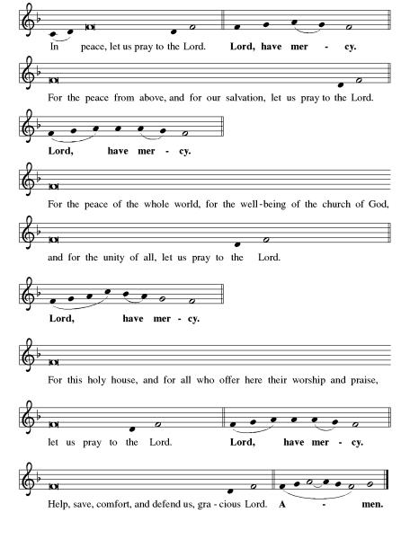

**This is the Feast

**Prayer of the Day
Creator God, who molds us and shapes us and breathes life into us, thank you for the gift of your creation. Thank you for giving us the responsibility to care for that which you have created. Help us to be your hands. In Jesus’ name, we pray. Amen.

Reading: Genesis 2:4b-25

^{4b}At the time when YHWH made the heavens and the earth, ⁵there was still no wild bush on the earth nor had any wild plant sprung up, for YHWH had not yet sent rain to the earth, and there was no human being to till the soil. ⁶Instead, a flow of water would well up from the ground and irrigate the soil. ⁷So YHWH fashioned an earth creature out of the clay of the earth, and blew into its nostrils the breath of life. And the earth creature became a living being. ⁸YHWH planted a garden to the east, in Eden — “Land of Pleasure” — and placed in it the earth creature that had been made. ⁹Then YHWH caused every kind of tree, enticing to look at and good to eat, to spring from the soil. In the center of the garden was the Tree of Life, and the Tree of the Knowledge of Good and Evil. ¹⁰A river flows through Eden to water the garden, after which it branches into four tributaries. ¹¹The first stream is named Pishon, or “Spreader.” It circles through Havilah, a land rich in gold, ¹²gold of the highest quality. There are gum resins there, and precious onyx stones. ¹³The second stream is named Gihon, or “Gusher,” and it flows through the entire land of Cush. ¹⁴The third stream is the Tigris, which borders Assyria on the east. The fourth stream the Euphrates. ¹⁵Then YHWH took the earth creature and settled it in the garden of Eden so that it might cultivate and care for the land. ¹⁶YHWH commanded the earth creature,
“You may eat as much as you like
from any of the trees of the garden—
¹⁷except the Tree of the Knowledge of Good and Evil.
You must not eat from that tree,
for on the day you eat from that tree,
that is the day you will die—yes, die.”
¹⁸Then YHWH said, “It is not good for the earth creature to be alone. I will make a fitting companion for it.” ¹⁹So from the soil YHWH formed all the various wild beasts and all the birds of the air, and brought them to the earth creature to be named. Whatever the earth creature called each one, that became its name. ²⁰The earth creature gave names to all the cattle, all the birds of the air, and all the wild animals. But none of them proved to be a fitting companion, ²¹so YHWH made the earth creature fall into a deep sleep, and while it slept, God divided the earth creature in two, then closed up the flesh from its side. ²²YHWH then fashioned the two halves into male and female, and presented them to one another. When the male realized what had happened, ²³he exclaimed, “This time, this is the one! Bone of my bone and flesh of my flesh! Now, she will be Woman, and I will be Man, because we are of one flesh!” ²⁴This is why people leave their parents and become bonded to one another, and the two become one flesh. ²⁵Now, the woman and the man were both naked, though they were not ashamed.

The Word of the Lord
Thanks be to God

**Gospel Acclamation
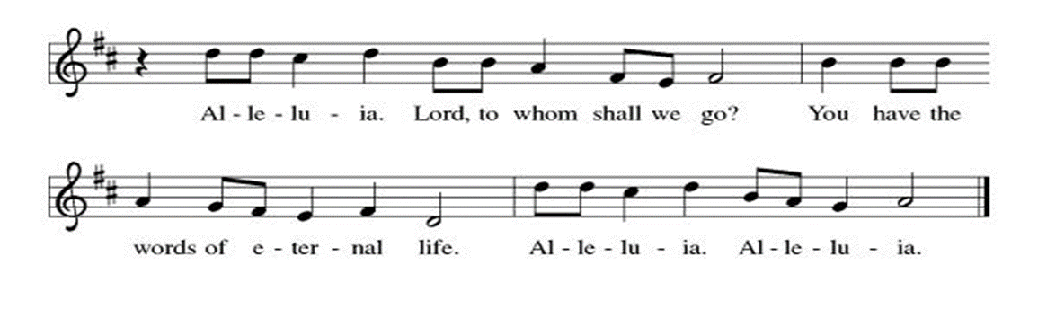
**Announcement of the Gospel
Glory to you, O Lord.

**Gospel: Mark 1:16-20

¹⁶While walking by the Sea of Galilee, Jesus saw the brothers Simon and Andrew casting their nets into the sea, since they fished by trade. ¹⁷Jesus said to them, “Follow me; I will make you fishers of humankind.” ¹⁸They immediately abandoned their nets and followed Jesus. ¹⁹Proceeding a little further along, Jesus saw the brothers James and John Bar-Zebedee. They too were in their boat, putting their nets in order. ²⁰Immediately Jesus called them, and they left their father Zebedee standing in the boat with the hired help, and went off in the company of Jesus.

The Gospel of the Lord.
Praise to you, O Christ.

Sermon | "God's Hands, Our Hands"
Hymn of the Day |  | Creating God, Your Fingers Trace |  | ELW #684

**The Apostles’ CREED
I believe in God, the Father almighty,
creator of heaven and earth.
I believe in Jesus Christ, God’s only Son, our Lord,
who was conceived by the Holy Spirit,
born of the virgin Mary,
suffered under Pontius Pilate,
was crucified, died, and was buried;
he descended to the dead.
On the third day he rose again;
he ascended into heaven,
he is seated at the right hand of the Father,
and he will come to judge the living and the dead.
I believe in the Holy Spirit,
the holy catholic church,
the communion of saints,
the forgiveness of sins,
the resurrection of the body,
and the life everlasting. Amen.

**Prayers of Intercession

So often when we pray, we pray for ourselves, which is good. We also need to remember to pray for others and so we offer our prayer for a world in need.

Hold us accountable, O God. Show your church where repentance is needed and lead us in paths of intentional compassion and listening. Help us extend hands of reconciliation and care, especially in relationships with other Christians and people of other faiths. Merciful God,
receive our prayer.
Reveal your miracles to us, O God. Move us to cherish you as we behold the wonders of creation. Renew the seas and the soil, the forests and the creatures that live in them. Turn us to ways of living that seek Earth’s thriving. Merciful God,
receive our prayer.
Inspire us to lead with honor, O God. Guide judges and legislators, police, and government officials to create and uphold just laws. Move us to treat all people with dignity and guide our conversations with one another. Merciful God,
receive our prayer.
Help us comfort those who suffer, O God. Reassure any who are harmed by the wicked acts of others. Bring peace to all who are vulnerable, frightened, despairing, or sick especially Monty, David, Theresa, Paul, Jane, Dylan, Linda and Bill, family of Lori and the families of Maui. Guard their waking and their sleeping. Merciful God,
receive our prayer.
Awaken us, O God. Challenge and encourage your people to value the vocation to which each is called. We pray for all discerning new possibilities or changing employment. In all our diverse callings, teach us to love our neighbor above all else. Merciful God,
receive our prayer.
Be our hope, O God. We remember with thanksgiving your disciples who died in faith. May their trust in your promise be our protection and our hope. Merciful God,
receive our prayer.

Gracious God, you are big enough and good enough to hear all prayers and so we know you hear and will answer our prayers today.
Amen

** Sharing of the Peace

**Offering is brought forward

** Offertory Response

For the Beauty of the Earth ELW#879

**Offertory Prayer
Good and loving God, everything we have comes from you. Receive these gifts that we offer back to you in thanksgiving for all that you have done for us. Bless these offerings of time, talents, and money to your work in this place. Amen.

The Great Thanksgiving
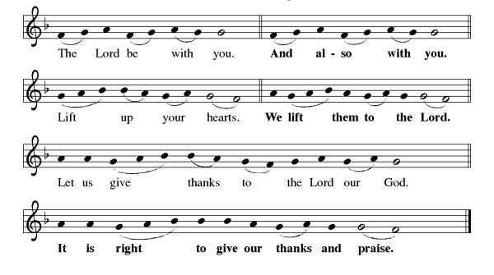
Preface: We praise you, Holy One…this hymn of praise:
**Words of Institution

**LORD’S PRAYER
Invitation to Communion

Communion Hymn Morning Has Broken ELW#556

**Sending Song

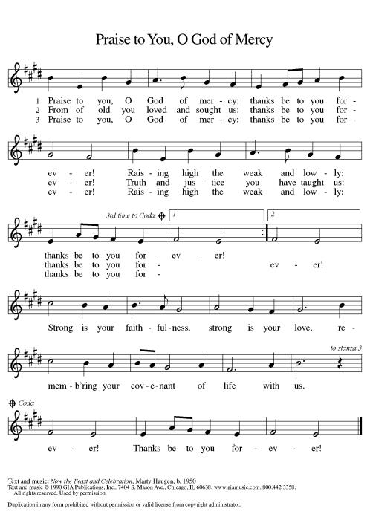

**Prayer After Communion
Jesus, thank you for the gift of your presence with us in the waters of baptism and in the Word that we read and hear, and in the bread and the wine. Fill us now with your Spirit as we go out into the world to be your hands. Amen.

**Blessing

**Closing Hymn Go, My Children, With My Blessing ELW#543

**Dismissal
Go in Peace. Love your neighbor.
Thanks be to God.

+ + + + + +

Hymns from the Evangelical Lutheran Worship are under copyright and used with permission under One License #733618-A. Specific copyright information as listed in bulletin. Liturgy from ELW Setting 3 is under copyright and is used with permission under Augsburg Fortress Liturgy License #SB155933. All other liturgy written by Sarah Pierce.
Weekly Attendance
September 03 19

******************************************************************************************
Calendar of Events
Today
- Adult Bible Study
- God's Work our Hands
September 11-BSCT Rehearsals 6:30 pm-9:00 pm
September 12-Creative Friends 1:00 pm
September 12-BSCT Rehearsals 6:30 pm-9:00 pm
September 13-Bell Choir Cleaning 6:30 pm
September 13 through 17-Pastor Sarah’s on Vacation
September 13-BSCT Rehearsals 6:30 pm-9:00 pm
September 19-Creative Friends 1:00 pm
September 20-Newsletter Deadline
September 24-Coffee with Council
September 26-Creative Friends 1:00 pm
October 01-Workday, wear work clothes (October 08-Rain Date)

Pastor Sarah will be on vacation Wednesday, September 13 through Sunday, September 17.

" As a thank you for your support to ASLC members, Blue Springs City Theatre is offering a 10% discount on tickets to its production of "Marian or the True Tale of Robin Hood". The play will be a Theater in the Park production at Rotary Park, 600 NW Vesper Street, Blue Springs, and will run from 9/21-24, 7:30pm each evening. For more information about the play, please go to bluespringscitytheatre.com. "

To receive the discount, please contact Pam Meek at 816-863-3884."

BELL CHOIR

The Abiding Saints bell choir will be back in action this fall! After having our rehearsals stopped in March 2020 because of Covid, we are ready to get back to praising God through music. We will use our 2-octave set which means we ideally would have 7-8 members. Especially needed are people that can play the lower/larger bells, but we welcome any new members. Reading music is a plus but not a requirement. Weekly rehearsals are tentatively scheduled for Wednesday nights at 6:30 pm but this is always open to change to accommodate member schedules (marching band, church council meetings, etc.). We try to play once a month during a Sunday service. Our first priority is cleaning and polishing the bells to get them ready after over 4 years of sitting idle. More information will be shared once a date is scheduled for this task. We have a lot of fun and would like to have you join us. Please contact any of these people if you have questions about joining our bell choir: Sara Meyers, Heather Antes, Anne Lee, Mary Ann Gross, Flavia Via and Joyce Cutbirth.

Angel Fund Procedures

We want to ensure our limited resources are available to help as many people as possible, so we have created the following guidelines:
- Housing assistance/motel room assistance is capped at $200 per request.
- Utility assistance is capped at $75 per request.
- Housing assistance/motel room assistance or utility assistance is paid directly to the motel or to the utility.
  - For housing/motel room, this involves a phone call to the motel to verify that the person is staying there and does have the outstanding bill.
  - For utility assistance, the person requesting assistance provides us with their account number. We will call the utility’s automated line directly to make a payment.
- We also have gas cards and sometimes grocery store gift cards available, and can purchase phone cards for people. Maximum $40 per request.
- Jean will track the people that we provide assistance to; because we want to be able to assist as many people as possible, we don’t provide financial assistance to people more than one time per year.

We are happy to provide referrals to Community Service League.

All members are welcome to attend regularly scheduled council meetings. Additionally, the Council would like to remind you that the most recent Council reports and minutes are available on the bulletin board in the narthex.
*****************************************************************************************
BLUE SPRINGS COMMUNITY SERVICE LEAGUE is very appreciative of your continued support of your neighbor.
******************************************************************************************
Questions for Reflection and Discussion
- Do you prefer one story of creation over the other? Why or why not?
- What were things that you took into consideration when naming someone (whether a pet or a child)? Were there hopes you had that went into that decision, or characteristics you hoped would develop? Have those things come to pass?
- There’s a tradition of interpretation that says that Eve was created from Adam’s rib, but Old Testament biblical scholars say that actually, Adam was divided in half and Eve was created from half of Adam, not just from a rib. There is also an interpretation, one that I prefer, that Adam contained both genders until God divided Adam in half to create Eve. That’s why I choose to use the pronoun “they” for Adam until after Adam is divided and male and female are created.
- There is also a tradition of interpretation that Eve was created to be Adam’s helpmeet, or assistant, or hierarchical inferior. The word that’s used in Hebrew, ezer, which is translated in the Inclusive Bible as “companion” in verse 20, actually means helper. But this word is used 21 times in the Old Testament. Two of those times are in Exodus chapter 2; the other 19 times are found in Exodus, Deuteronomy, the Psalms, and the Prophets; all 19 of them are used to refer to God. (See Psalm 121:1-2 for two examples.)

If you are looking for a concrete way to support the people of Ukraine, Lutheran Immigrant and Refugee Services has opportunities for directed prayer, advocacy, or financial support. https://www.lirs.org/Ukraine-crisis

Greeter
September 10 Donna Taylor

Usher
September 10 Paul Blixrud

Altar Guild
September 10 Sara Meyers

Reader
September 10 Jim McDonald
Tech
September 10 Gary & Zach Antes

Prayer Requests
Monty Health Concerns (May 15)
David Health Concerns (April 11)
Theresa Family Concerns (May 05)
Jane Health Concerns (May 01)
Paul Health Concerns (May 31)
Linda and Bill Health Concerns (May 16)
Dylan Military Service (September 06)

Please pray for the family of Lori
Please pray for the families in Maui

