Monarch Watch. Monarch butterflies are known for their migration from their overwintering sites in Mexico to northern states and Canada. These migrants then produce several generations of offspring that will migrate back to Mexico in the fall. However, in the last few years a drastic decrease in the eastern monarch population has been noted. There are several reasons for this decline in monarch populations. First is the lack of milkweed, the plant needed as a food source for monarch caterpillars. Milkweed has been decimated by the use of the herbicide Round-UpTM. Additionally, habitat loss and fragmentation has decreased the areas monarchs need. As a part of our emphasis this year on creation care and to increase awareness of this decline of monarch butterflies, we have been watching monarch caterpillars in the sanctuary as they have grown from caterpillars to the chrysalis stage and as they hopefully emerge as adult butterflies. In this process, we’ve seen the caterpillars grow from about 5 mm to almost 2 inches long, an increase of about 2000X in about 2 weeks.
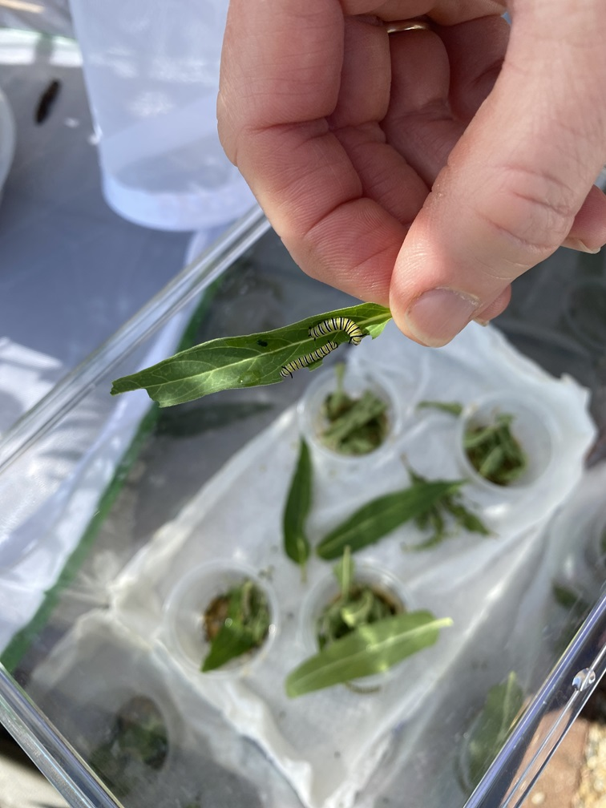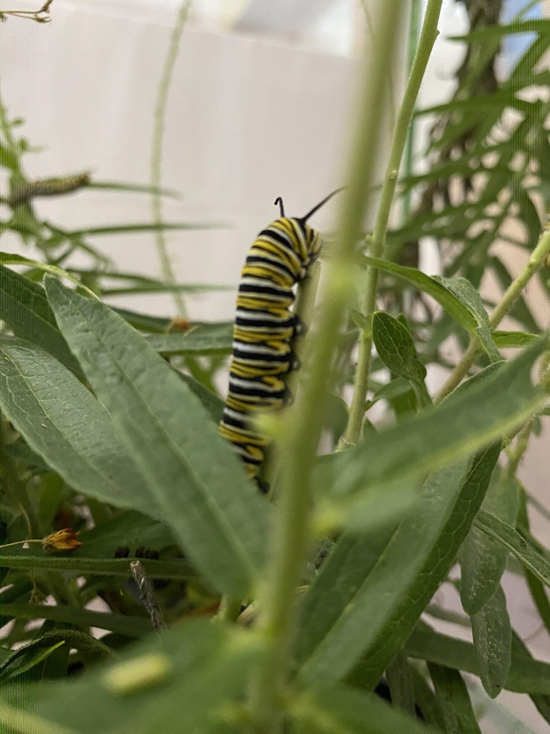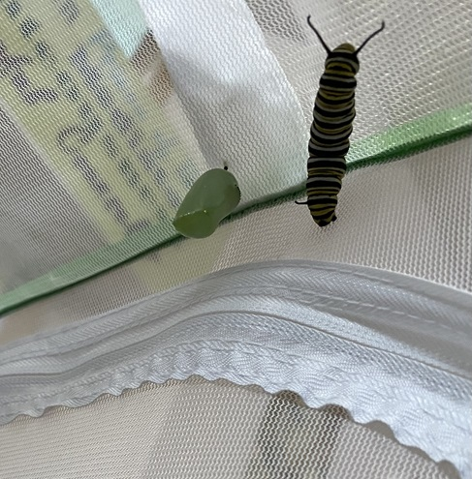
Additionally, we have planted a Monarch Waystation outside the church to provide a habitat for monarch butterflies. This waystation has been certified by the Monarch Watch group in Lawrence, KS as Monarch Waystation #48296. Keep your eye on this area for monarchs or butterflies in general. While we (David Fast, Lisa Melton and Janet Cooper) were planting the bed, we saw a few butterflies stop by and take a sip of nectar.
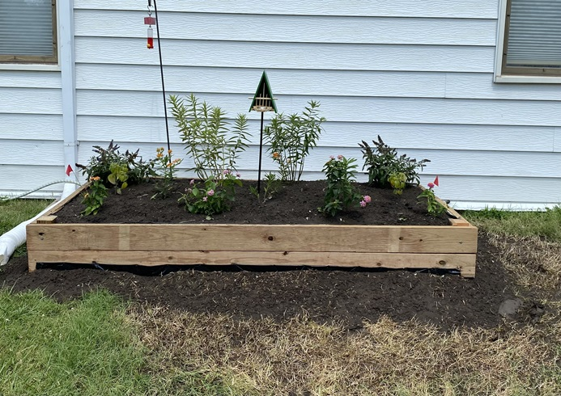
Our Monarch Waystation consists of 2 swamp milkweed plants, 4 butterfly weeds, 4 lantanas, 2 salvia and 2 butterfly bushes. When our monarchs emerge in the sanctuary we will release them to our waystation.
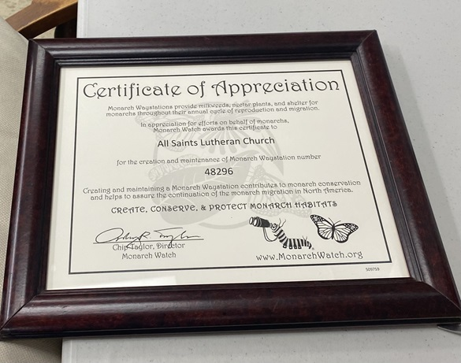
If you would like to help the monarchs and provide a habitat in your yard, there are 4 things needed. First is food. Monarch caterpillars need milkweed. Native milkweed species include Butterfly Weed and Swamp milkweed. Adult monarchs need nectar so blooming plants will provide monarchs with an energy source. The second requirement is water. If you soak the soil of your garden to create puddles, these can be a source of water and minerals. Third is a sunny place such as a rock to spread their wings and warm up. Finally, monarchs need a sheltered area to hide from predators. Your area does not have to be large and your milkweed plants can be in flower pots so if you don’t have a lot of space, you can still have a milkweed plant or two in pots on your balcony or patio.

