All Saints Lutheran Church, ELCA
421 SW 19th St. Blue Springs, Missouri 64015 816-229-3633
Pastor Sarah Pierce Spierce.aslcpastor@gmail.com
allsaintslc64015@gmail.com https://aslcbs.org/

Sunday, October 26, 2025

Reformation Sunday

You are absolutely invited into this sacred space. We welcome all who are seeking God’s love and grace. All Saints recognizes that we are all unique and beloved children of God. We celebrate and give thanks for the many diverse gifts that God has given us. We affirm the sacredness of people of all sexual orientations, gender identities, and gender expressions. We affirm the sacredness of all those who have experienced exclusion because of race, ability, age, or culture. We are committed to working towards anti-racism in ourselves and our community. We affirm the sacredness of all those who wrestle with addiction, physical or mental health, imprisonment, socio-economic circumstances, or anything that too often divides us. We believe that through our openness we all grow in our faith through Christ’s teaching to love one another as God loves us. We need each other and our sincere hope is by being in community together, we will experience God’s presence in new and real ways.

The offering plate is by the main door to the sanctuary for your convenience.

We practice open communion at All Saints Lutheran Church. What does that mean? It means that if you believe and trust that Christ offers his body and blood For You, you are welcome at the table. At All Saints, we believe that Christ invites all people to the feast. “Come to the banquet for all is now ready.”

**Stand as you are comfortable

Prelude

Announcements

** Affirmation of Baptism

In the name of God, the Source of all that is good; Christ +, the Word who dwells among us; and the Spirit, who empowers and sends us. Amen.

Water is a powerful symbol for us as followers of Christ. It reminds us of God’s grace and presence with us: it reminds us of God’s spirit moving on the first day of creation. It reminds us of God’s saving work for Noah and his family and the animals during the flood, and the calling and sending of Jonah. It reminds us of the saving of the people of Israel through the parting of the Red Sea.

John baptized Jesus with water, and the Holy Spirit anointed him. In much the same way, through the water and the Word, we are claimed as God’s children, heirs to the promise of God’s salvation and stewards of all that God has created.

Holy God,
We give you thanks for this life-sustaining water. We give you thanks for the gift of new life in Jesus, our Savior. Shower us with your Spirit, and renew in us the knowledge of your forgiveness, your love, and your grace.

We believe in God’s grace, which is the gift of God’s unending love and forgiveness. In our baptisms we are given that gift and become members of God’s family. Let us take a moment to give thanks.

Holy God,
We can turn our backs on you, but you will never turn your back on us because we are members of your family. No matter how far we stray from you, you will always welcome us home. You will always love us. Remembering our baptism reassures us our sins are washed away so we can live the free and full lives you created us to live. Amen.

**Entrance Hymn Built On A Rock ELW #652

**Greeting
The grace of our Lord Jesus Christ, the love of God,
and the communion of the Holy Spirit be with you all.
And also with you.

**Kyrie
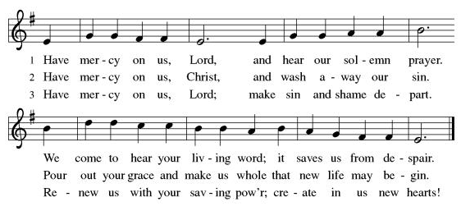

**Glory Be to God
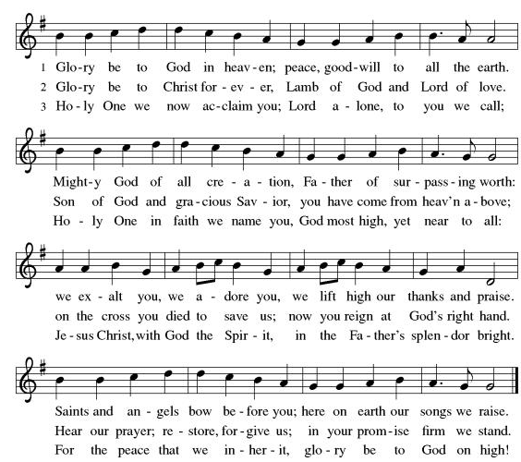
**Prayer of the Day

Loving and eternal God, we know you are with us always, and we know that, in Jesus, you promise to meet us in the bread and the cup and in the waters of our baptism. Help us to experience you at the font, in the meal, and through your Word, to be fed and sent out to be your presence for others who hunger for you. We pray this in the name of Jesus, our Savior. Amen.

Reading: 1 Kings 5:1-5; 8:1-13

¹ Solomon ruled over the entire realm from the Euphrates River to Philistia and as far as the frontier of Egypt. These countries paid tribute and were Solomon’s subjects as long as the ruler lived.

²The daily provisions for Solomon were 180 bushels of fine flour and 365 bushels of meal, ³ ten fattened oxen, twenty pastured oxen, and one hundred sheep; as well as stags, gazelles, roebucks; and fattened poultry.

⁴Solomon ruled over all the realms west of the Jordan River, from Tiphsah to Gaza. And peace reigned. ⁵Throughout Solomon’s life, peace reigned in Judah and Israel, from Dan to Beersheba, and everyone prospered under their own vines and fig trees.

¹Then Solomon summoned the elders of Israel, all the tribal leaders, and the heads of the families of the people of Israel to bring up the Ark of the Covenant of God from the City of David, that is, Zion. ²All the people of Israel assembled in Solomon’s presence at the time of the festival in the month of Ethanim, the seventh month. ³Once all the elders of Israel had arrived the priests lifted the Ark of God ⁴and brought it to the Temple; the Tent of Meeting, together with all the sacred furnishings of the Tent, were also carried by the priests and the Levites. ⁵In the presence of the Ark, Solomon and all Israel sacrificed sheep and oxen in numbers beyond reckoning.

⁶The priests then brought the Ark of the Covenant of God to its place in the inner sanctuary of the Temple, the Most Holy Place, under the wings of the cherubim. ⁷The cherubim spread their wings over the place of the Ark and formed a canopy above the Ark and its carrying poles. ⁸The poles were so long that their ends could be seen from the sanctuary immediately in front of the inner sanctuary, but not from anywhere else outside. They are there to this day.

⁹There was nothing inside the Ark but the two stone tablets which Moses deposited there at Horeb, when God made the Covenant with the people of Israel after they left Egypt.

¹⁰When the priests came out of the sanctuary, a cloud filled the Temple of God, ¹¹and they could not continue to minister because of it, for the Glory of God filled the Temple. ¹²Then Solomon said: “God, you chose to dwell among us in a thick cloud. ¹³But now I have built you a magnificent House, a settled place where you may dwell forever.”

Word of God, Word of Life.
Thanks be to God!

**Gospel Acclamation
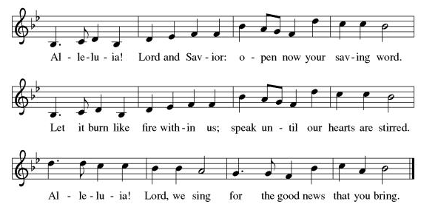
Announcement of the Gospel
Glory to you, O Lord.

Gospel: John 2:19-21

¹⁹Jesus [said], “Destroy this temple, and in three days I will raise it up.” ²⁰They retorted, “It has taken forty-six years to build this Temple, and you’re going to raise it up in three days?” ²¹But the temple he was speaking of was his body.

The Gospel of the Lord.
Praise to you, O Christ!

Sermon “Where Do We Find Jesus?”

Hymn of the Day All Are Welcome ELW#641

**Affirmation of Faith – Immigrant’s Creed by Jose Luis Casal

I believe in Almighty God, who guided the people in exile and in exodus, the God of Joseph in Egypt and Daniel in Babylon, the God of foreigners and immigrants.

I believe in Jesus Christ, a displaced Galilean, who was born away from his people and his home, who fled his country with his parents when his life was in danger. When he returned to his own country he suffered under the oppression of Pontius Pilate, the servant of a foreign power. Jesus was persecuted, beaten, tortured, and unjustly condemned to death. But on the third day Jesus rose from the dead, not as a scorned foreigner but to offer us citizenship in God’s kingdom.

I believe in the Holy Spirit, the eternal immigrant from God’s kingdom among us, who speaks all languages, lives in all countries, and reunites all races.

I believe that the Church is the secure home for foreigners and for all believers. I believe that the communion of saints begins when we embrace all God’s people in all their diversity. I believe in forgiveness, which makes us all equal before God, and in reconciliation, which heals our brokenness. I believe that in the Resurrection God will unite us as one people in which all are distinct and all are alike at the same time. I believe in life eternal, in which no one will be foreigner but all will be citizens of the kingdom where God reigns forever and ever. Amen.

**Prayers of Intercession

God of Love, hear the prayers that we lift before you. Hold close to you all those for whom we pray.

Uniting God, you draw your church together as the one body of Christ. Bring congregations into conversation and dialogue so the church is transformed and reformed in your abundant grace. God of grace,
receive our prayer.
Sustaining God, you create all the beauty around us. We give you thanks for the harvest of your creation. Restore creation as the seasons change. God of grace,
receive our prayer.
Governing God, you bring peace and justice through mercy. Guide judges, lawmakers, attorneys, and those in any position of authority to act with compassion and understanding. God of grace,
receive our prayer.
Healing God, you comfort those who suffer. Console people whose lives are disrupted by cancer, disease, and illness. Bring your healing mercy to any in need especially Monty, Paul, Linda, Betty F., Kay, Becky H., Jim & Jan, Becky W., David, William and family, Helen, Larry, Otto, families in our community who endure hunger, Kevin, Kent and Carla, and our beloved for whom death is near. God of grace,
receive our prayer.
Proclaiming God, you bring the gift of proclamation through music. We thank you for all music ministers of this congregation. Transform your church through the musical arts. God of grace,
receive our prayer.
Calm the fears of migrants and refugees who set out, not knowing where they go. Provide shelter, sustenance, protection from harm, and welcome. Bless the work of Global Refuge and other support and advocacy programs. God of grace,
receive our prayer.
We pray for the nations. Pave a way to justice, drown the forces of oppression, bring peace on earth. Give leaders the will to turn from war and violence. Especially we pray for the people of Gaza, Israel, and Ukraine, and for Jim’s grandson Dylan, who is deployed in Oman. When people must flee their homes, guide them to safety. Comfort those living with deep trauma, anxiety, or fear; all those who serve people in need, and accompany all those who care for people in harm’s way. God of grace,
receive our prayer.
We pray for people who rise up against injustice. Bring courage and resilience to those who resist tyranny with their words and their bodies. Strengthen those who fight for justice in your name across the country, and around the world. Protect and sustain immigrants and refugees and all who work with them, that your kingdom, without borders and without walls, may truly come on earth as it is in heaven. We pray for all victims of gun violence or kidnapping, especially those who are targeted out of hate or fear. Embolden us to holy outrage and empower us to speak our truth of love and justice. God of grace,
receive our prayer.
God of learning, we lift up all who teach and all who learn. Thank you for teachers who share their knowledge and wisdom. Bless the students in our midst. Especially we remember Evie, in kindergarten; Addison, in high school; and Tyler, Zach, Katie and Katy, in college. Bless Janet and Lisa as they teach. God of grace,
receive our prayer.

Good and loving God, we give everyone we have prayed for into your care. Amen.

** Sharing of the Peace

**Offering is brought forward

** Offertory Response Create in Me ELW#186

**Offertory Prayer
Good and loving God, everything that we have and everything that we are comes from you. We respond in gratitude, offering up to you our gifts of our money, our time, and our talents. We dedicate these gifts to your service. In Jesus’ name we pray, amen.

**Dialogue
God has prepared a sacred meal for us.
We praise you, O God.

God invites us to this sacred meal; we lift our voices in gratitude.
We praise you, O God.

**Preface: Since the earliest days of the covenant… this hymn of praise:

**Holy, Holy, Holy
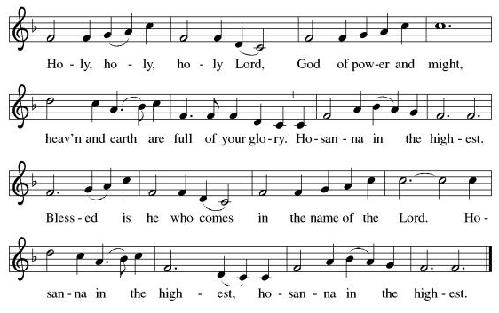
**Words of Institution

**LORD’S PRAYER

Our Father, who art in heaven,
hallowed be thy name,
thy kingdom come,
thy will be done,
on earth as it is in heaven.
Give us this day our daily bread;
and forgive us our trespasses,
as we forgive those
who trespass against us;
and lead us not into temptation,
but deliver us from evil.
For thine is the kingdom,
and the power, and the glory,
forever and ever. Amen.

Invitation to Communion

Communion Hymn The King of Love My Shepherd Is ELW#502

**Sending Song Now Thank We All Our God (verse 1) ELW#840

**Prayer After Communion

Gracious God, when we participate in this holy meal, we are connected to all who believe throughout the world. We are connected through faith, through your presence and through your mission to share your grace with all we meet. Amen.

**Affirmation of Christian Vocation
Siblings in Christ, everything you do - your work and your rest - is in God. Will you strive to model your life on Jesus Christ, in gratitude to God and in service to others, throughout your waking hours, at work and at play, all the days of your life?

I will, and I ask God to help me.

And will you support and encourage each other in these efforts, reminding each other that you are created in God’s image, and called by Christ, and empowered by the Spirit to serve?

We will, and we ask God to help us.

Let us pray.

Eternal and loving God, by the power of the Spirit you have collected your children into the body of Christ. Encourage them in their desire to serve in Jesus’ name. Empower them and give them vision and patience; and strengthen us all in our Christian vocation of service to others and witness to the world through our daily lives and through all that we say and do. We pray all these things in the name of your Son, Jesus Christ our Savior. Amen.

**Blessing

**Closing Hymn A Mighty Fortress Is Our God ELW#503

**Dismissal

Go in peace to serve Christ and the world!

THANKS BE TO GOD!

+ + + + + +
Setting 10 liturgy is under copyright and used with permission under One License #733618-A. The Prayers of Intercession are under copyright and are used with permission under Augsburg Fortress Liturgy License #SB155933. Affirmation of Christian Vocation based on “Affirmation of Christian Vocation, ELW p84. All other liturgy written by Sarah Pierce.

***********************************************************************************************************
Weekly Attendance

Week of October 19

23

******************************************************************************************

Calendar of Events
Today

- Reformation Sunday; Pledge Sunday Film/Potluck after Worship

This Week

Upcoming Events
November 02 | Daylight Savings Time Clocks back 1 Hour/All Saints Sunday: Celebrating gifts/Follow up film after Worship
November 05 | Council Meeting 6:30 pm
November 16 | Congregational Meeting
November 26 | Thanksgiving Eve Worship 7:00 pm Pie Night
December 07 | Advent Dinner after Worship
December 10 | Council Meeting 6:30 pm
January 14, 2026 | Council Meeting 6:30 pm
February 18 | Ash Wednesday
March 29 | Palm Sunday
April 05 | Easter Sunday

*****************************************************************************************
BLUE SPRINGS COMMUNITY SERVICE LEAGUE is very appreciative of your continued support of your neighbor.
******************************************************************************************
Questions for Reflection and Discussion from Pastor Sarah
- Those of you who have been members of All Saints since we have been in this building, what do you remember about the first Sunday here? Was there a dedication? What was involved? Those of you who have been members of All Saints since the beginning, what do you remember about the first Sunday?
- What differences do you see between the way we express, or experience, our faith today and the way the ancient Israelites did? Do you think there was a “nearness” to God as part of the community that we don’t experience now? Do we try to keep God at arm’s length? Do we try to keep ourselves from having intimate encounters from God, or at least try to keep those encounters to a minimum, so they will be “special” or rare? Why? Would we gain something, or lose something, by having everyday encounters with God?
- How do we make our faith more central to our lives?
- God appears in this reading as a great cloud that fills the temple, so thick they can’t continue to minister in the temple. This is reminiscent of the pillar of cloud that was present during the day during their ancestors’ wanderings during the exodus, but it also points to our limited vocabulary to describe God’s nearness. How can we, or how do we, describe encounters with God?
- God has promised to be present with us during the sacraments. We receive communion weekly, but the other sacrament (baptism) we only experience once. But we have opportunities to remind ourselves of often: every time we do an affirmation of baptism as part of worship, as we do this morning; every time we dip our fingers in the waters of the font and make the sign of the cross. The imposition of ashes on Ash Wednesday is another. Confirmation is another. How do you remember your baptism? Do you have a practice that helps you remember your baptism regularly?
**************************************************************************************
Birthdays
October 27-Katie Thompson

Greeter – October 26-Donna Taylor
Usher – October 26-Paul Blixrud
Altar Guild- October 26-Sara Meyers
Reader- October 26-Kent Deubner
Communion Assistant- October 26-Tracy Nelson
Tech- October 26-Gary Antes

Prayer Requests
Monty Health Concerns (May 15)
Paul Health Concerns (May 31)
Mary Health Concerns (May 15)
James & Family Health Concerns (September 11)
Betty F (Sara’s friend) Health Concerns (July 15)
William and Family Health Concerns (September 25)
Becky H Health Concerns (October 28)
David Health Concerns (November 18)
Becky W Health Concerns (November 18)
Larry Health Issues (December 16)
Helen Health Issues (January 14)
Otto Health Concerns (July 15)
Kay (Sara’s cousin) Health Concerns (July 15)
Kevin Health Concerns (October 01)
Kent Health Concerns (October 01)
Carla Health Concerns (October 01)

Merciful God, your justice and mercy are without limits. Bring courage and resilience to those who resist tyranny with their words and their bodies. Strengthen those who fight for justice in your name in Los Angeles, across the country, and around the world.

Please pray for the victims of the shooting at Annunciation Catholic School in Minneapolis.

Please pray for the people of Gaza, Ukraine, Israel, Iran and Palestine.
Please pray for the people of the Sudan.
Please pray for the Homeless.
Please pray for legal & illegal immigrants & those seeking asylum or citizenship.

