All Saints Lutheran Church, ELCA
421 SW 19th St. Blue Springs, Missouri 64015 816-229-3633
Pastor Sarah Pierce Spierce.aslcpastor@gmail.com
allsaintslc64015@gmail.com https://aslcbs.org/

Sunday, January 18, 2026

Second Sunday of Epiphany

You are absolutely invited into this sacred space. We welcome all who are seeking God’s love and grace. All Saints recognizes that we are all unique and beloved children of God. We celebrate and give thanks for the many diverse gifts that God has given us. We affirm the sacredness of people of all sexual orientations, gender identities, and gender expressions. We affirm the sacredness of all those who have experienced exclusion because of race, ability, age, or culture. We are committed to working towards anti-racism in ourselves and our community. We affirm the sacredness of all those who wrestle with addiction, physical or mental health, imprisonment, socio-economic circumstances, or anything that too often divides us. We believe that through our openness we all grow in our faith through Christ’s teaching to love one another as God loves us. We need each other and our sincere hope is by being in community together, we will experience God’s presence in new and real ways.

The offering plate is by the main door to the sanctuary for your convenience.

We practice open communion at All Saints Lutheran Church. What does that mean? It means that if you believe and trust that Christ offers his body and blood For You, you are welcome at the table. At All Saints, we believe that Christ invites all people to the feast. “Come to the banquet for all is now ready.”

**Stand as you are comfortable

Prelude

Announcements

** Affirmation of Baptism

God prepares a way for us, a path through the desert. In our baptisms, Jesus calls us to follow that path, and we receive the gift of the Holy Spirit, empowering us to answer Jesus’ call. But sometimes, we forget the gift of forgiveness and unending love that we have been given, and we need to be reminded.

Jesus, sometimes we forget to listen to your call. We forget about the power of our baptisms. Sometimes, we get distracted with other things and forget to place you first. We ask that you help us to turn back to you when we turn away. We ask you to help us recenter our lives on you, so that we remember the power of our baptisms. We pray that we can feel your presence in our lives.

We ask you to receive our prayers and to be with us, today and forever. We pray that your presence shines through us to those who most need to see it.

Holy and loving God, we thank you for the gift of forgiveness. We thank you for the gift of your unconditional love.

Holy and loving Jesus, we thank you for the gift of the baptism which frees us from the power of sin and death, for all time. We thank you for showing us how to live in that freedom.

Holy and loving Spirit, we thank you for infusing us with your presence. Empower us to live out our baptismal call to proclaim Christ through word and deed, to care for others and for the world, and to work for justice and peace. Amen.

**Entrance Hymn Wash, O God, Our Sons and Daughters ELW#445

**Greeting
The grace of our Lord Jesus Christ, the love of God,
and the communion of the Holy Spirit be with you all.
And also with you.

**Kyrie
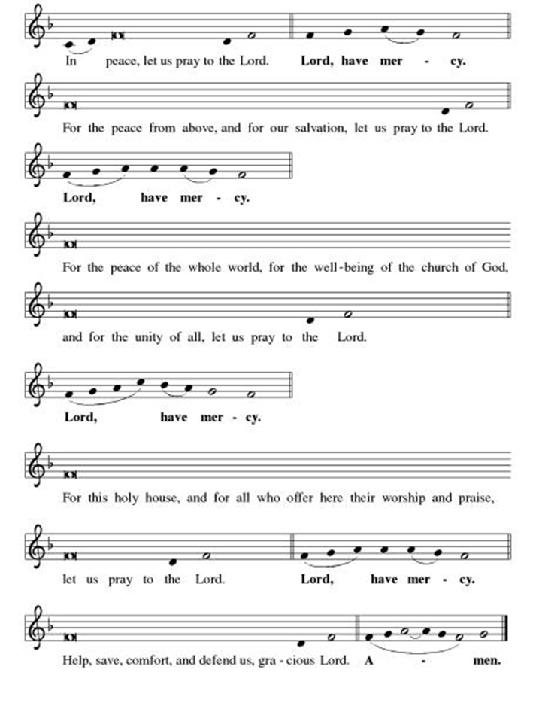

**This is the Feast
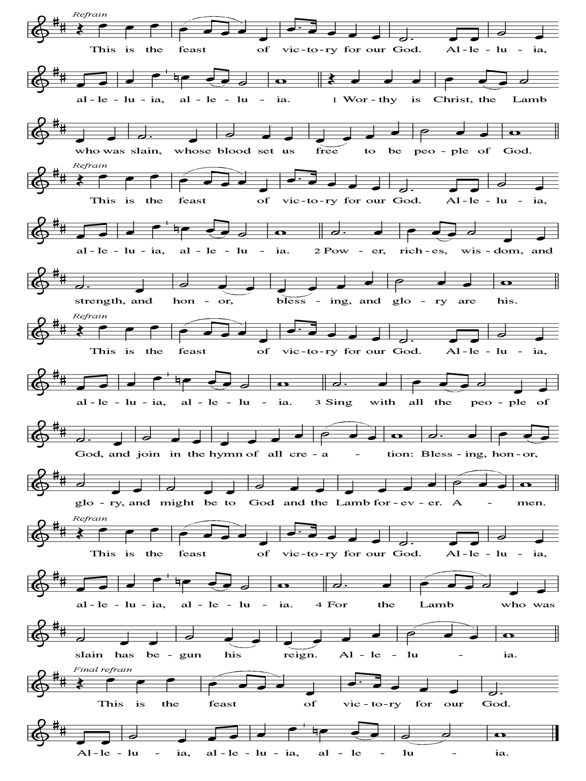
**Prayer of the Day
Holy God, your liberating word frees us to find you wherever we are. We know that you long for justice; help us hear the cries of our siblings who are oppressed, and empower us to work for their liberation, so that all your people are free to live as you created them to be. We pray this in Jesus’ name. Amen.

Reading: Psalm 127:1-2

¹If God doesn’t build the house,
the builders work in vain;
if God doesn’t guard the city,
the sentries watch in vain.
²In vain you get up early and stay up late,
sweating to make a living,
because God loves us and provides for us
even while we sleep.

The Word of the Lord
Thanks be to God

**Gospel Acclamation

**Alleluia
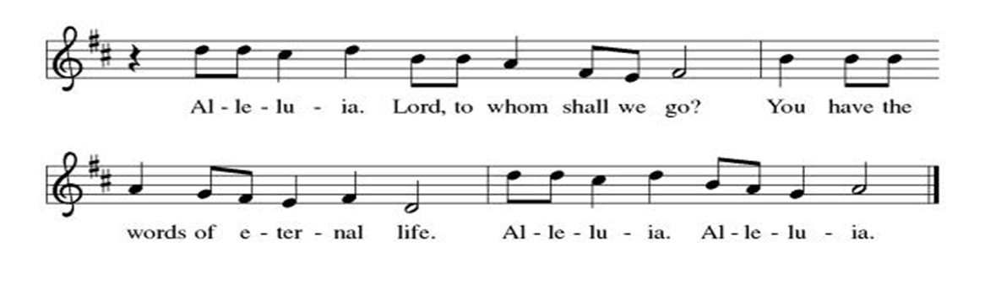
Announcement of the Gospel
Glory to you, O Lord.

Gospel: John 2:13-25

¹³Since it was almost the Jewish Passover, Jesus went up to Jerusalem.

¹⁴In the Temple, he found people selling cattle, sheep and pigeons, while moneychangers sat at their counters. ¹⁵Making a whip out of cords, Jesus drove them all out of the Temple—even the cattle and sheep—and overturned the tables of the money changers, scattering their coins. ¹⁶Then he faced the pigeon sellers: “Take all this out of here! Stop turning God’s house into a market!” ¹⁷The disciples remembered the words of scripture: “Zeal for your house consumes me.”

¹⁸The Temple authorities intervened and said, “What sign can you show us to justify what you’ve done?”

¹⁹Jesus answered, “Destroy this temple, and in three days I will raise it up.”

²⁰They retorted, “It has taken forty-six years to build this Temple, and you’re going to raise it up in three days?” ²¹But the temple he was speaking of was his body. ²²It was only after Jesus had been raised from the dead that the disciples remembered this statement and believed the scripture—and the words that Jesus had spoken.

²³While Jesus was in Jerusalem for the Passover festival, many people believed in him, for they could see the signs he was performing. ²⁴But Jesus knew all people, and didn’t entrust himself to them. ²⁵Jesus never needed evidence about people’s motives; he was well aware of what was in everyone’s heart.

The Gospel of the Lord.
Praise to you, O Christ.

Sermon "A Story of Liberation"

Hymn of the Day God is Here! ELW#526

**Affirmation of Faith – Immigrant’s Creed by Jose Luis Casal

I believe in Almighty God, who guided the people in exile and in exodus, the God of Joseph in Egypt and Daniel in Babylon, the God of foreigners and immigrants.

I believe in Jesus Christ, a displaced Galilean, who was born away from his people and his home, who fled his country with his parents when his life was in danger. When he returned to his own country he suffered under the oppression of Pontius Pilate, the servant of a foreign power. Jesus was persecuted, beaten, tortured, and unjustly condemned to death. But on the third day Jesus rose from the dead, not as a scorned foreigner but to offer us citizenship in God’s kingdom.

I believe in the Holy Spirit, the eternal immigrant from God’s kingdom among us, who speaks all languages, lives in all countries, and reunites all races.

I believe that the Church is the secure home for foreigners and for all believers. I believe that the communion of saints begins when we embrace all God’s people in all their diversity. I believe in forgiveness, which makes us all equal before God, and in reconciliation, which heals our brokenness. I believe that in the Resurrection God will unite us as one people in which all are distinct and all are alike at the same time. I believe in life eternal, in which no one will be foreigner but all will be citizens of the kingdom where God reigns forever and ever. Amen.

**Prayers of Intercession

Jesus, you came to live with us on earth so that we would know you love us no matter what. Listen to the prayers we lift to you.

Gracious God, gather the church into one great fellowship. Equip your people to work together for justice and peace, following the example of Martin Luther King Jr., re-newer of society, whose birth we remember this week. Merciful God,
receive our prayer.
Creating God, sustain the web of life on this planet. Protect wild places, endangered species, and vulnerable habitats. Come to the aid of those affected by natural disasters. Merciful God,
receive our prayer.
Just God, you desire respect and equality for everyone. Raise up prophets who speak truth to the nations. Embolden leaders and those in authority to advocate for people in need. Merciful God,
receive our prayer.
Healing God, you lift up those who are bowed down by trouble, oppression, or illness especially Monty, Paul, Linda, Betty F., Kay, Becky H., Jim & Jan, Melian, Becky W., David, William & family, Helen, Larry & Judy, Otto, Kevin, Peter & Carrie, Barbara & Donna, families in our community who endure hunger, and our beloved for whom death is near. Bring an end to social injustice and inequities of every kind, so that all people may have abundant life. Merciful God,
receive our prayer.
Abiding God, you are present with this congregation. Keep us mindful of our mission and guide our ministries in this community. Kindle in us a desire to help one another. Merciful God,
receive our prayer.
Pave a way to justice, drown the forces of oppression, bring peace on earth. Give leaders the will to turn from war and violence. Especially we pray for the people of Venezuela, Sudan, Gaza, Israel, and Ukraine, and for Jim’s grandson Dylan, who is deployed. When people must flee their homes, guide them to safety. Comfort those living with deep trauma, anxiety, or fear; all those who serve people in need, and accompany all those who care for people in harm’s way. Merciful God,
receive our prayer.
We pray for people who rise up against injustice. Bring courage and resilience to those who resist tyranny with their words and their bodies. Strengthen those who fight for justice in your name across the country, and around the world. Protect and sustain immigrants and refugees and all who work with them, that your kingdom, without borders and without walls, may truly come on earth as it is in heaven. We pray for all victims of gun violence or kidnapping, especially those who are targeted out of hate or fear. Embolden us to holy outrage and empower us to speak our truth of love and justice. Merciful God,
receive our prayer.
We lift up all who teach and all who learn. Thank you for teachers who share their knowledge and wisdom. Bless the students in our midst. Especially we remember Evie, in kindergarten; Addison, in high school; and Tyler, Zach, Katie and Katy, in college. Bless Janet and Lisa as they teach. Merciful God,
receive our prayer.
Faithful God, you promise to be with us always. We remember with gratitude the faithful departed who now rest in you. Strengthen us to the end, that we may see you face to face. Merciful God,
receive our prayer.

Loving God, because you lived among us, we know that you hear our prayers and hold close all for whom we pray. Amen

** Sharing of the Peace

**Offering is brought forward

** Offertory Response Let Us Talents and Tongues Employ (V. 1) ELW#674

**Offertory Prayer

God of abundance, with thanks, we return to you the gifts you have given us so freely. Bless these offerings of our time, our talents, and our treasure. Shape us to be your hands and feet. Use our gifts to shower each other, our communities, and the world with your loving kindness. All this we ask in Jesus’ name. Amen.

**Dialogue
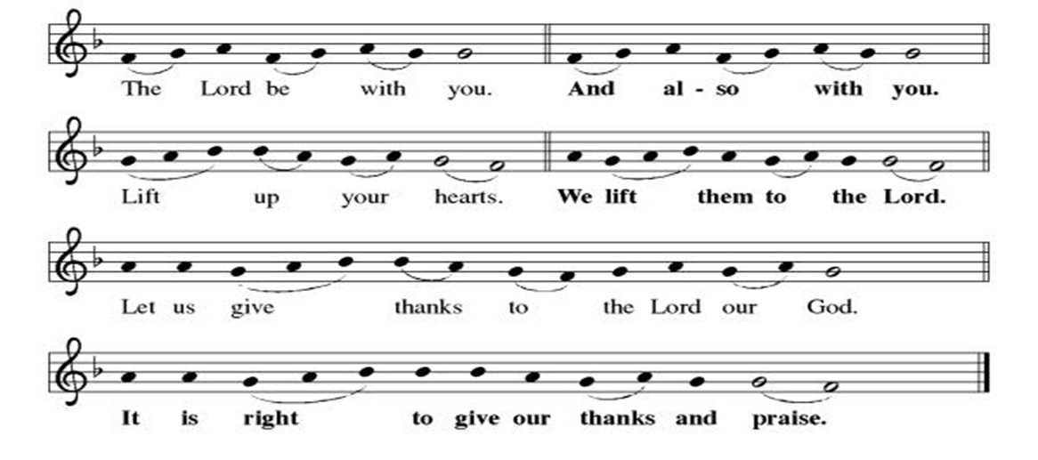

**Preface: From the beginning of time…this hymn of praise:

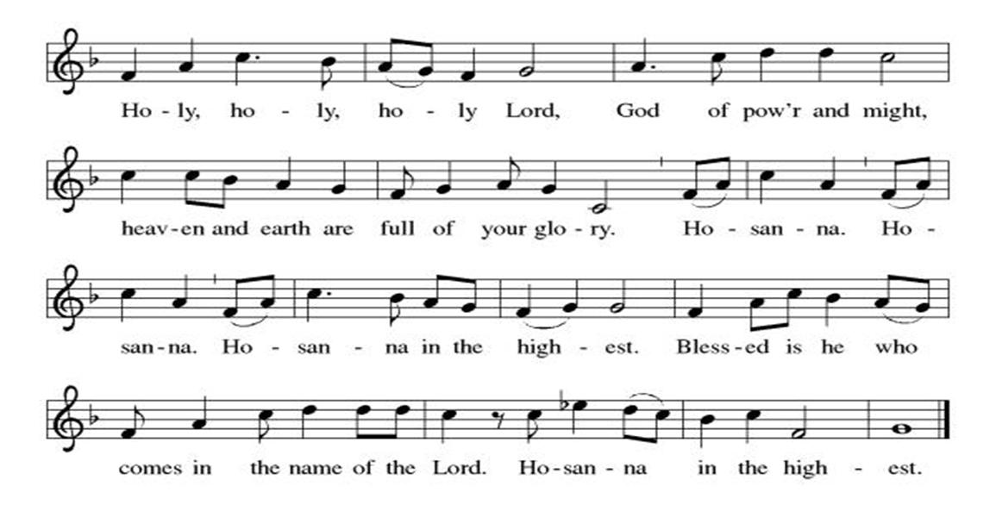

** Thanksgiving at the Table

**LORD’S PRAYER
Our Father in heaven,
hallowed be your name,
your kingdom come,
your will be done,
on earth as in heaven.
Give us today our daily bread.
Forgive us our sins
as we forgive those
who sin against us.
Save us from the time of trial
and deliver us from evil.
For the kingdom, the power,
and the glory are yours,
now and forever. Amen.

Invitation to Communion

Communion Hymn Beautiful Savior ELW #838

**Post-communion prayer

Holy One, Human and Divine, we give you thanks for the life-giving invitation to gather at your table and be fed. Strengthen us now for your service, and send us out from this place renewed in our commitment to love you and serve each other and all of creation. Send your Spirit upon us, so that we can proclaim your blessings to a world that hungers to receive them. All this we ask in your name, the one who is, who was, and who is to come. Amen.

**Sending Song

Listen, God Is Calling (refrain, V. 1, refrain) ELW#513

**Benediction

**Closing Hymn Built on a Rock ELW#652

**Dismissal

Go in peace. Share the good news!
THANKS BE TO GOD!

+ + + + + +

Hymns from the Evangelical Lutheran Worship are under copyright and used with permission under One License #733618-A. ELW setting #3 the Prayers of Intercession are under copyright and are used with permission under Augsburg Fortress Liturgy License #SB155933. All other liturgy written by Sarah Pierce.

Weekly Attendance

Week of January 11
22

Next Week:
Third Sunday after Epiphany

The Color of the day is Green
Psalm 139:13-18
John 3:1-21

Calendar of Events
Today

- Adult Bible Study

Upcoming Week
- January 22 Zoom Presentation: Putting Faith into Action

January 25 | Dave Mareske Preaches  Coffee with Council
February 04 | Paint Party Fundraiser
February 05 | Zoom Presentation: ELCA Social Statement
February 08 | Souper Bowl for CSL  Special Offering for Hollis
February 11 | Church Council Meeting 6:30 pm
February 15 | Pre-Lent Ice Cream Social after Church
February 18 | Ash Wednesday  God’s Global Barn yard begins February 18-April 05
February 22 | Coffee with Council
March 04 | Paint Party Fundraiser
March 15 | Church Council Meeting 6:30 pm
March 22 | Coffee with Council
March 29 | Palm Sunday
April 01 | Paint Party Fundraiser
April 02 | Maundy Thursday
April 05 | Easter Sunday
April 06 | Church Council Meeting 6:30 pm
April 26 | Coffee with Council
May 06 | Paint Party Fundraiser
May 10 | Mother’s Day
May 13 | Church Council Meeting 6:30 pm
May 17 | Congregational Meeting
May 24 | Pentecost
May 25 | Memorial Day
June 03 | Paint Party Fundraiser
June 19 | Juneteenth Office Closed
July 01 | Paint Party Fundraiser
July 04 | Independence Day
July 26 | Coffee with Council  Celebrate Niel’s Birthday (July 28)
Note: 2006 paint party fundraisers: Feb. 4, March 4, April 1, May 6, June 3, July 1, Aug. 5, Sept. 2, Oct. 7, Nov. 4, Dec. 2
Note: Theater group church use: auditions Feb. 6&7, 6:30-9:30; callbacks Feb. 8, 1-5; rehearsals MWF & Saturday, Feb.16-April 18, MWF 6:30-9:30 and Saturdays 12-4.

**All Saints no longer has a source to reuse old greeting cards.
*****************************************************************************************
BLUE SPRINGS COMMUNITY SERVICE LEAGUE is very appreciative of your continued support of your neighbor.
*****************************************************************************************
Questions for Reflection and Discussion from Pastor Sarah

- When Jesus says, “Stop turning God’s house into a market” in verse 16, he paraphrases Zechariah, one of the minor prophets, prophesied during the Babylonian captivity. The book is full of apocalyptic imagery. Parts of it read very similarly to Daniel and Ezekiel. At the very end of the book, the prophet foretells a time when finally, all war has ended, and the survivors of all the nations are brought within the covenant and make the pilgrimage to Jerusalem for the Festival of Tabernacles, marking the end of the 40 years’ wandering in the desert. The prophet writes that there will be so many people in Jerusalem that they won’t all be able to make their sacrifices in the Temple, but it won’t matter, because the entire city will be sacred. The entire city will become the holy place of God. And the book ends with the prophecy, “and there will no longer be merchants in the Temple of God the Sovereign on that day.”
- One of the things that I read was that when we get a part of a verse that someone remembers, like the disciples do in verse 17, that’s really a shorthand, because the original hearers/readers of the text would have been familiar enough with the psalms (in this case; this is Psalm 69:9) or the Hebrew Testament to be able to supply the rest of the verse or the passage from memory. In this case, the entire verse supplies a little more context: “Because I am consumed with zeal for your House, the insults of those who ridicule you fall upon me.” Does that change how you see the disciples’ interpretation of Jesus’ actions? What if you were to go back and read more of the psalm (which I encourage you to do)? Does having even more context change how you read this?
- Tomorrow is Martin Luther King Jr. Day. I quote from his sermon, “The Birth of a New Nation,” delivered at Dexter Avenue Baptist Church in Montgomery, AL on April 7, 1957. I would encourage you to read something of his today or tomorrow, whether it’s this, or whether it’s another speech or sermon; many of them are publicly available online. (Some are excerpts, while others will be the whole text.) Look for references to biblical texts or hymns in whatever you read, whether it’s a sermon or a speech outside a church setting, or something else. (Standford has a Martin Luther King Jr Research and Education Institute, which is where I found this speech; kinginstitute.stanford.edu will take you there. It was footnoted, which makes finding and tracing back biblical references particularly easy.)
- What does Martin Luther King have to say about what’s happening today in the US, as the Dept of Homeland Security uses an ACTUAL Nazi slogan on their podium (“One of ours, all of yours”) and quotes the KKK on X (Twitter) (“We’ll have our home back”), as Fourth Amendment rights are violated as ICE goes door to door without judicial warrants, as legal observers are beaten and pepper sprayed, and as Renee Good, who appears to have been an innocent bystander, is shot three times and killed for being “disrespectful?” What does Jesus have to say about it? And how are we called to respond?

“***********************************************************************************

The Central States Synod and Kansas Interfaith Action present “We the People: a virtual series on faith & public life”

- Thursday, January 22 6:30pm: “Putting Faith Into Action” with Rev. Dr. Mandy Todd
- Thursday, February 05 6:30pm: “Diving Into the ELCA Social Statement on Faith and Civic Life” with Dr. Jim Brandt

We will join all of these sessions from the sanctuary via Zoom.

January 18
Altar Guild-Anne Lee & Paul Blixrud
Lector – Tonya Hamilton
Communion Assistant-Flavia Via
Greeter – Donna Taylor
Tech – Gary Antes

Prayer Requests
Monty Health Concerns (May 15)
Paul Health Concerns (May 31)
Mary Health Concerns (May 15)
James & Family Health Concerns (September 11)
Betty F (Sara’s friend) Health Concerns (July 15)
William and Family Health Concerns (September 25)
Becky H Health Concerns (October 28)
David Health Concerns (November 18)
Becky W Health Concerns (November 18)
Larr & Judy Health Issues (December 16)
Helen Health Issues (January 14)
Otto Health Concerns (July 15)
Kay (Sara’s cousin) Health Concerns (July 15)
Kevin Health Concerns (October 01)
Fred Health Concerns (October 22)
Sharon Health Concerns (October 22)
Michael Health Concerns (October 22)
Peter and Carrie Health Concerns (November 26)
Melian Health Concerns (November 16)
RJ Health Concerns (November 17)
Barbara Health Concerns (December 30)

Merciful God, your justice and mercy are without limits. Bring courage and resilience to those who resist tyranny with their words and their bodies. Strengthen those who fight for justice in your name across the country, and around the world.

Please pray for the people of Venezuela, Sudan, Gaza, Ukraine, Israel, Iran and Palestine.
Please pray for the Homeless.
Please pray for legal & illegal immigrants & those seeking asylum or citizenship

