**All Saints Lutheran Church, ELCA**

**421 SW 19th St. Blue Springs, Missouri 64015 816-229-3633**

**Pastor Sarah Pierce** Spierce.aslcpastor@gmail.com

[allsaintslc64015@gmail.com](mailto:allsaintslc64015@gmail.com) <https://aslcbs.org/>

## Sunday, July 06, 2025

## Fourth Sunday after Pentecost

## *You are absolutely invited into this sacred space.  We welcome all who are seeking God’s love and grace.  All Saints recognizes that we are all unique and beloved children of God.  We celebrate and give thanks for the many diverse gifts that God has given us.  We affirm the sacredness of people of all sexual orientations, gender identities, and gender expressions.  We affirm the sacredness of all those who have experienced exclusion because of race, ability, age, or culture. We are committed to working towards anti-racism in ourselves and our community. We affirm the sacredness of all those who wrestle with addiction, physical or mental health, imprisonment, socio-economic circumstances, or anything that too often divides us.  We believe that through our openness we all grow in our faith through Christ’s teaching to love one another as God loves us.  We need each other and our sincere hope is by being in community together, we will experience God’s presence in new and real ways.*

*The offering plate is by the main door to the sanctuary for your convenience.*

*We practice open communion at All Saints Lutheran Church. What does that mean? It means that if you believe and trust that Christ offers his body and blood For You, you are welcome at the table. At All Saints, we believe that Christ invites all people to the feast. “Come to the banquet for all is now ready.”*

***\*\*Stand as you are comfortable***

***Prelude***

***Announcements***

**\*\* Confession and Forgiveness**

Siblings in Christ, as we gather in this place, let us confess our sins together in the ancient words of the people:

**O God, have mercy on me!**

**Because of your love and your great compassion, wipe away my faults;**

**wash me clean of my guilt;**

**purify me of my sin.**

**For I am aware of my faults,**

**and have my sin constantly in mind.**

**I sinned against you alone,**

**and did what is evil in your sight.**

**You are just when you pass sentence on me,**

**blameless when you give judgment.**

**I was born in sin, conceived in sin -**

**yet you want truth to live in my innermost being.**

**Teach me your wisdom!**

**Bless God, my soul!**

**All that is in me, bless God’s holy name!**

**Bless God, my soul,**

**and remember all God’s kindness!**

The One who forgives all your sins is the One who heals all your disease;

the One + who ransoms your life from the Pit is the One who crowns you with love and tenderness.

God’s love lasts from age to age for those who revere them,

as does God’s goodness to our children’s children,

and to those who cling to the faith of Christ.

**Amen.**

***\*\*Entrance Hymn This Is My Song ELW #887***

***\*\*Greeting***

The grace of our Lord Jesus Christ, the love of God,

and the communion of the Holy Spirit be with you all.

**And also with you.**

**\*\*Kyrie**

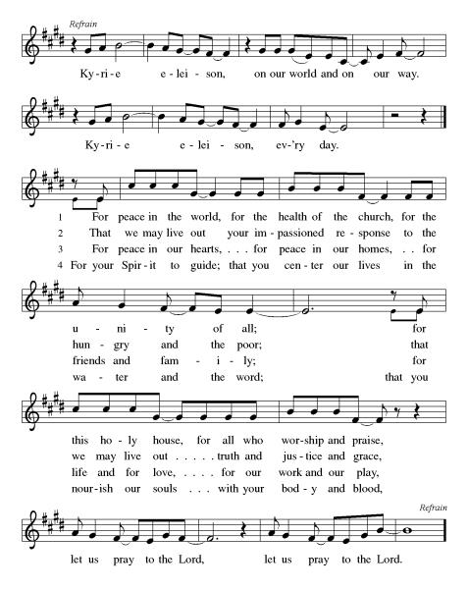

***\*\*Prayer of the Day***

**God of Love, you do not want us to be separated from you or our community. Strengthen us for your service so that separation does not happen. But if it occurs, help us to see the way back to you. In Jesus’ name we pray. Amen.**

***Reading:*** **Leviticus 13:1-3, 45-46; 14:2-11, 20b**

13:1God told Moses and Aaron these things: 2When one of you has a swelling, an inflammation, or a shiny spot on your skin that could develop into an infectious skin disease, you must go to a priest, either Aaron or one of Aaron’s heirs. 3The priest will examine the afflicted area, and if the hair in or around the infected spot is white and appears to be more than skin deep, you have an infectious skin disease; the priest, after examination, will pronounce you ceremonially unclean.

45When you have an infectious skin disease, you must wear torn clothes, let your hair become unkempt, and cover the lower half of your face and cry out, “Unclean! Unclean!” 46As long as you have the infection you remain ceremonially unclean. You must live alone. You must live outside the camp.

14:2This is the instruction for the ritual of ceremonial cleansing from infectious skin diseases. 3You must come to the priest, who will come outside of the camp to examine you. If you have been healed of your infectious skin disease, 4the priest will order that two live unblemished birds, some cedar wood, scarlet yarn, and hyssop be brought out for you who are to be purified. 5The priest will have one of the birds slaughtered over an earthen bowl filled with water from a running stream, 6and then will take the live bird, the cedar wood, the scarlet yarn and the hyssop, and dip them in the blood of the bird slaughtered over the water from the running stream, 7and then sprinkle it seven times on you who are to be cleansed of the disease. The priest will then pronounce you clean and release the bird to fly into open country.

8You must wash your clothes, shave off all your hair, and bathe in water; then you will be ceremonially clean. After this you will be allowed to return to the camp, but you must stay outside of your tent for seven days. 9On the seventh day you must shave off the hair on your head, including your eyebrows and all the hair on your body. Then you must wash your clothes and bathe your body in water; and you will be ceremonially clean.

10On the eighth day you must bring two male lambs without blemish and one female yearling lamb without blemish, a grain offering of six quarts of fine flour mixed with oil, plus one and a half measures of oil. 11The priest will present you and your offerings before God at the entrance to the Tent of Meeting. 20bIn this way the priest will atone for you and you will be ceremonially clean.

Word of God, Word of Life

**Thanks be to God**

***\*\*Gospel Acclamation***

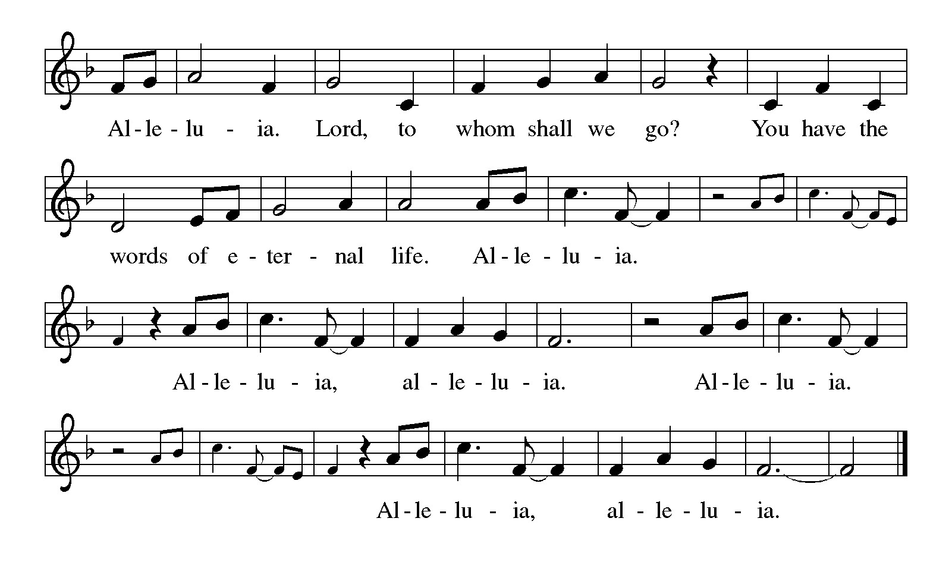

*Announcement of the Gospel*

**Glory to you, O Lord.**

***Gospel:* Luke 17:11-19**

11On the journey to Jerusalem, Jesus passed along the borders of Samaria and Galilee. 12As Jesus was entering a village, ten people with leprosy met him. Keeping their distance, 13they raised their voices and said, “Jesus, Rabbi, have pity on us!”

14When Jesus saw them, he responded, “Go and show yourselves to the priests.”

As they were going, they were healed. 15One of them, realizing what had happened, came back praising God in a loud voice, 16then fell down at the feet of Jesus and spoke his praises. The individual was a Samaritan.

17Jesus replied, “Weren’t all ten made whole? Where are the other nine? 18Was there no one to return and give thanks except this foreigner?” 19then Jesus said to the Samaritan, “Stand up and go your way; your faith has saved you.”

The Gospel of the Lord.

**Praise to you, O Christ.**

**Sermon Appearance/Cleanliness**

***Hymn of the Day* Lift Every Voice and Sing ELW#841**

\*\***Affirmation of Faith – Immigrant’s Creed by Jose Luis Casal**

**I believe in Almighty God, who guided the people in exile and in exodus, the God of Joseph in Egypt and Daniel in Babylon, the God of foreigners and immigrants.**

**I believe in Jesus Christ, a displaced Galilean, who was born away from his people and his home, who fled his country with his parents when his life was in danger. When he returned to his own country he suffered under the oppression of Pontius Pilate, the servant of a foreign power. Jesus was persecuted, beaten, tortured, and unjustly condemned to death. But on the third day Jesus rose from the dead, not as a scorned foreigner but to offer us citizenship in God’s kingdom.**

**I believe in the Holy Spirit, the eternal immigrant from God’s kingdom among us, who speaks all languages, lives in all countries, and reunites all races.**

**I believe that the Church is the secure home for foreigners and for all believers. I believe that the communion of saints begins when we embrace all God’s people in all their diversity. I believe in forgiveness, which makes us all equal before God, and in reconciliation, which heals our brokenness. I believe that in the Resurrection God will unite us as one people in which all are distinct and all are alike at the same time. I believe in life eternal, in which no one will be foreigner but all will be citizens of the kingdom where God reigns forever and ever. Amen.**

***\*\*Prayers of Intercession***

**God of Love, hear the prayers that we lift before you. Hold close to you all those for whom we pray.**

You send your church into the world with a message of peace. Center the whole church in this peace, and strengthen our faith by the example of all those who creatively and faithfully proclaim your good news. God of grace,

**hear our prayer.**

All the earth sings out your name. Inspire your people to drink deeply from the beauty of the life cycle of the monarch butterfly and all your creation. When ecosystems are wounded, bring your healing. When our actions endanger the survival of other species, curb our greed and waste. God of grace,

**hear our prayer.**

You call us to work for the good of all. Give resolve to those who lead, that they do not grow weary in doing what is right. Guide them to seek peace between nations and freedom for all people. God of grace,

**hear our prayer.**

As a mother comforts her child, so you comfort us. Bring this comfort to those in any pain, especially Monty, Paul, Linda, Betty F, Carla, Becky H., Becky W., David, William and family, Helen, Larry, Stephen, Jennifer, Otto, families in our community who endure hunger, and our beloved for whom death is near. Carry your people when grief is heavy, and lift burdens of shame and self-doubt. God of grace,

**hear our prayer.**

Your harvest is plentiful, O God. Make us laborers and companions with one another in this assembly. Send your peace to rest upon us, heal divisions among us, and open our hearts to receive one another as gifts from you. God of grace,

**hear our prayer.**

We pray for the nations. Pave a way to justice, drown the forces of oppression, bring peace on earth. Give leaders the will to turn from war and violence. Especially we pray for the people of Gaza, Israel, Iran, and Ukraine. When people must flee their homes, guide them to safety. Comfort those living with deep trauma, anxiety, or fear; all those who serve people in need, and accompany all those who care in harm’s way.

God of grace,

**hear our prayer.**

We pray for people who rise up against injustice. Bring courage and resilience to those who resist tyranny with their words and their bodies. Strengthen those who fight for justice in your name across the country, and around the world. Protect and sustain immigrants and refugees and all who work with them, that your kingdom, without borders and without walls, may truly come on earth as it is in heaven. We pray for all victims of gun violence or kidnapping, especially those who are targeted out of hate or fear. Embolden us to holy outrage and empower us to speak our truth of love and justice, God of grace,

**hear our prayer.**

You have written our names in heaven, O God, and we rejoice. We thank you for those who have lived and died in your love. Accompany us on our life’s journey and draw us at last to life forever in you. God of grace,

**hear our prayer.**

**Good and loving God, we give everyone we have prayed for into your care. Amen.**

*\*\** ***Sharing of the Peace***

### *\*\*Offering is brought forward*

### *\*\** *Offertory Response*

**Create in Me ELW#186**

### *\*\*Blessing of CSL Offering*

### *\*\*Offertory Prayer*

**Holy God, we return to you with thanks the first fruits of what you have given us: our time, our talents and interests, and our money. Use these gifts to your service and for your ministry in this place. We pray this in Jesus’ name. Amen.**

**Dialogue**

Thank you God, for you are good!

**Your love is everlasting!**

You alone perform such great marvels.

**Your love is everlasting!**

Your wisdom made the heavens.

**Your love is everlasting!**

You spread the land out over the waters.

**Your love is everlasting!**

You made the great lights:

**Your love is everlasting!**

The sun to govern the day, moon and stars to govern the night.

**Your love is everlasting!**

**\*\*Preface:** Since the earliest days of the covenant…this hymn of praise:

**\*\*Holy, Holy, Holy**

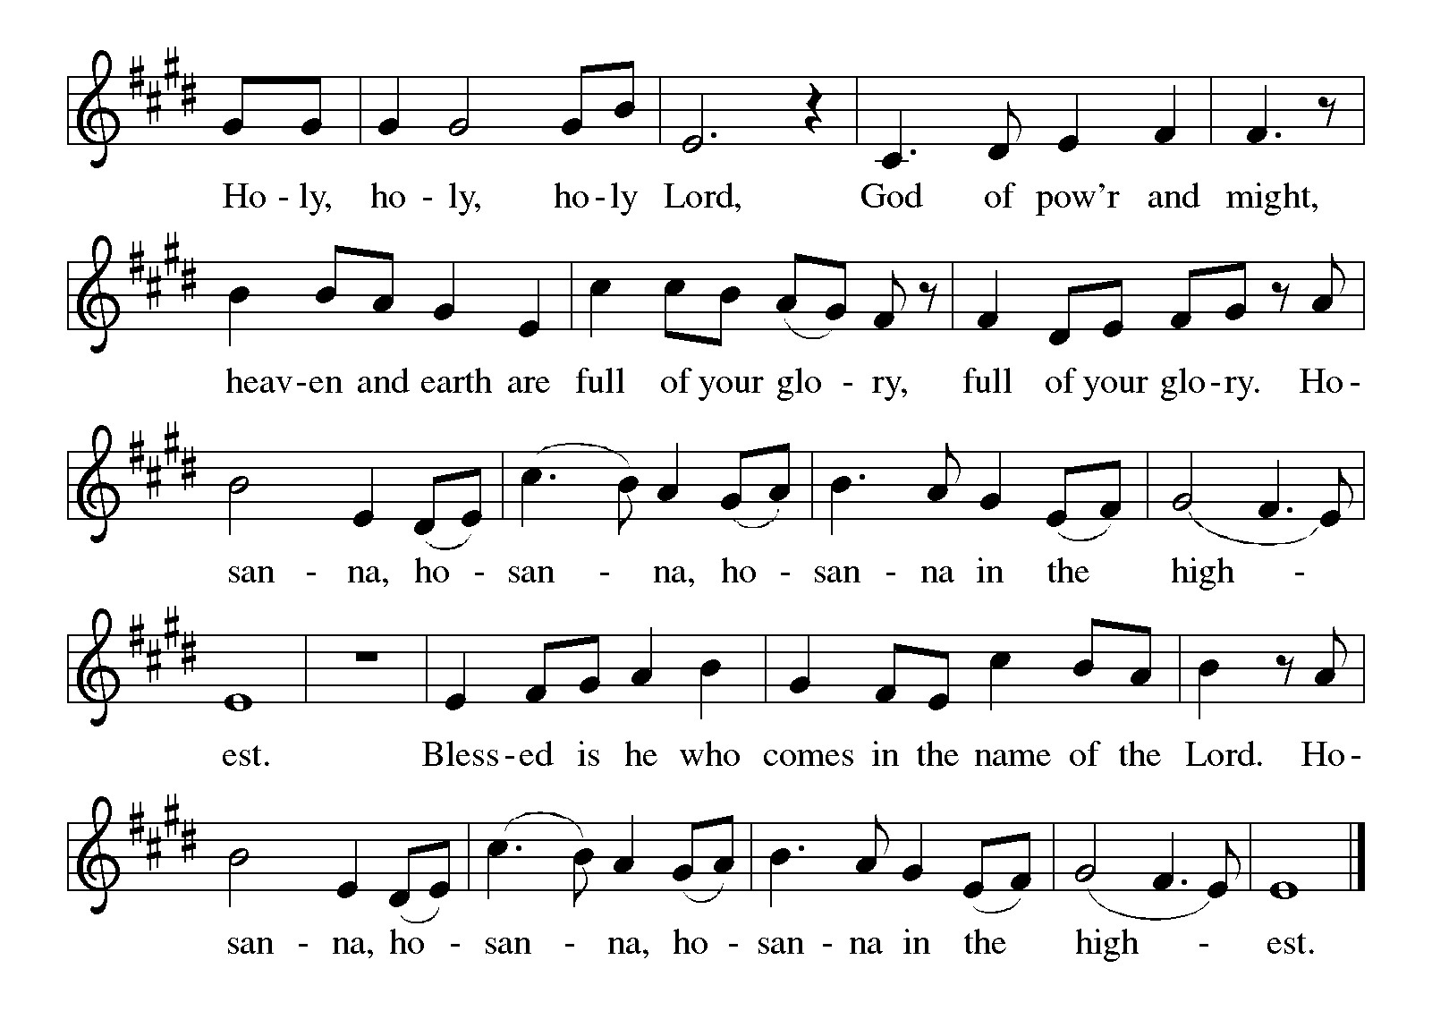

***\*\*Words of Institution***

**\*\*LORD’S PRAYER**

**Our Father, who art in heaven,**

**hallowed be thy name,**

**thy kingdom come,**

**thy will be done,**

**on earth as it is in heaven.**

**Give us this day our daily bread;**

**and forgive us our trespasses,**

**as we forgive those**

**who trespass against us;**

**and lead us not into temptation,**

**but deliver us from evil.**

**For thine is the kingdom,**

**and the power, and the glory,**

**forever and ever. Amen.**

***Invitation to Communion***

# ***Communion Hymn We Come to the Hungry Feast ELW#479***

### *\*\*Sending Song*

### *Praise to you, O God of Mercy ELW#208*

### *\*\*Prayer After Communion*

**Grafted onto the tree of faith and grounded in our baptisms, we have been fed by the Word and at the Table. Now send us out to share the joy of Christ with all whom we encounter. Amen.**

### *\*\*Blessing*

### *\*\*Closing Hymn Praise the One Who Breaks the Darkness ELW#*843

### 

### *\*\*Dismissal*

Go in peace to serve Christ and the world!

**THANKS BE TO GOD!**

### + + + + + +

*Setting 8 liturgy are under copyright and used with permission under One License #733618-A. Specific copyright information as listed in bulletin, the Prayers of Intercession are under copyright and are used with permission under Augsburg Fortress Liturgy License #SB155933. All other liturgy written by Sarah Pierce.*

*Confession and Forgiveness based on Psalm 51:1-6 and Psalm 103:104, 17-18 (adapted). Dialog based on Psalm 136:1, 4-8. Thanksgiving based on Psalm 100 (adapted). Benediction based on 1 Thessalonians 5:16-24 (adapted).*

**Weekly Attendance**

***Week of June 29***

***22***

*\*\*\*\*\*\*\*\*\*\*\*\*\*\*\*\*\*\*\*\*\*\*\*\*\*\*\*\*\*\*\*\*\*\*\*\*\*\*\*\*\*\*\*\*\*\*\*\*\*\*\*\*\*\*\*\*\*\*\*\*\*\*\*\*\*\*\*\*\*\*\*\*\*\*\*\*\*\*\*\*\*\*\*\*\*\*\*\*\*\**

**Calendar of Events**

***Today***

* ***Adult Bible Study***
* ***Blessing of CSL Contributions***

***This Week***

|  |  |
| --- | --- |
| ***July 08*** | ***Creative Friends 1:00 pm*** |

***Upcoming Events***

|  |  |
| --- | --- |
| ***July 13*** | ***Baptismal Birthdays*** |
| ***July 13*** | ***Installation of Church Council/Ice Cream Social after Worship/Photo OP*** |
| ***July 15*** | ***Creative Friends 1:00 pm*** |
| ***July 16*** | ***Council Meeting 6:30 pm*** |
| ***July 20*** | ***David’s last Sunday*** |
| ***July 27*** | ***Coffee with Council*** |
| ***August 09*** | ***BS Back to School Bingo 1:00 p -3:00 pm*** |
| ***August 13*** | ***Council Meeting 6:30 pm*** |
| ***September 07*** | ***God’s Work. Our Hands*** |
| ***September 14*** | ***Council Meeting 6:30 pm after Worship*** |
| ***October 04*** | ***Blessing of Animals TBA*** |
|  |  |

****************************************************************************************

The book of Leviticus has kind of a bad reputation. We often think of it as being excessively rules-based, really strict, with regulations that don’t really apply to us any longer in our modern world. So much so that it seems like Leviticus has two purposes in modern Christianity – either to be ignored and set aside, or to have verses pulled out of context to be used to condemn others. But neither of those are a fair treatment of Leviticus. When we dive into it, we discover a text that we can wrestle with and learn from. A text that has much to teach us about faithfulness to God and to each other.

We will be exploring this book in a **7-part sermon series** this summer, starting on **Holy Trinity Sunday.**

* **July 13: Holiness Code part 1**
* **July 20: Holiness Code part 2**
* **July 27: Sabbath/Conclusion**

**\*\*\*\*\*\*\*\*\*\*\*\*\*\*\*\*\*\*\*\*\*\*\*\*\*\*\*\*\*\*\*\*\*\*\*\*\*\*\*\*\*\*\*\*\*\*\*\*\*\*\*\*\*\*\*\*\*\*\*\*\*\*\*\*\*\*\*\*\*\*\*\*\*\*\***

***David Fast’s last Sunday with us will be July 20. Join us after worship as we celebrate him and wish him well in Hutchinson!***

***\*\*\*\*\*\*\*\*\*\*\*\*\*\*\*\*\*\*\*\*\*\*\*\*\*\*\*\*\*\*\*\*\*\*\*\*\*\*\*\*\*\*\*\*\*\*\*\*\*\*\*\*\*\*\*\*\*\*\*\*\*\*\*\*\*\*\*\*\*\*\*\*\*\*\****

**“The New Colossus” by Emma Lazarus (1849-1887)**

Not like the brazen giant of Greek fame,  
With conquering limbs astride from land to land;  
Here at our sea-washed, sunset gates shall stand  
A mighty woman with a torch, whose flame  
Is the imprisoned lightning, and her name  
Mother of Exiles. From her beacon-hand  
Glows world-wide welcome; her mild eyes command  
The air-bridged harbor that twin cities frame.  
“Keep, ancient lands, your storied pomp!” cries she  
With silent lips. “Give me your tired, your poor,  
Your huddled masses yearning to breathe free,  
The wretched refuse of your teeming shore.  
Send these, the homeless, tempest-tost to me,  
I lift my lamp beside the golden door!”

*(poets.org)*

This poem was written by Lazarus in 1883 as part of the fund-raising efforts for a base for the Statue of Liberty. It is cast on a plaque that is mounted on the inside of the base of the statue. Lazarus was an activist and advocate for Jewish refugees fleeing from Russian pogroms in the 1800s, and wrote the poem as a way to express empathy for Russian Jewish refugees to the US.

The statue was intended to be a symbol of republican (anti-imperialist) values; however, Lazarus’ poem gave it a new purpose, turning it into a symbol of welcome for immigrants and refugees at the front door of the country. *(Wikipedia article on “The New Colossus”)*

*\*\*\*\*\*\*\*\*\*\*\*\*\*\*\*\*\*\*\*\*\*\*\*\*\*\*\*\*\*\*\*\*\*\*\*\*\*\*\*\*\*\*\*\*\*\*\*\*\*\*\*\*\*\*\*\*\*\*\*\*\*\*\*\*\*\*\*\*\*\*\*\*\*\*\*\*\*\*\*\*\*\*\*\*\*\*\*\*\**

*You may recall that there has been an announcement in the bulletin over the past year directing you to Lutheran Immigration and Refugee Services (LIRS) if you wish to support the people of Ukraine. LIRS has changed its name to Global Refuge and can be found at* ***globalrefuge.org****. Although their name has changed, their mission remains the same: to assist and support refugees in the United States and around the world. Visit their website to see all the ways you can support this important work.*

**\*\*\*\*\*\*\*\*\*\*\*\*\*\*\*\*\*\*\*\*\*\*\*\*\*\*\*\*\*\*\*\*\*\*\*\*\*\*\*\*\*\*\*\*\*\*\*\*\*\*\*\*\*\*\*\*\*\*\*\*\*\*\*\*\*\*\*\*\*\*\*\*\*\*\*\*\*\*\*\*\*\*\*\*\*\*\*\*\***

**BLUE SPRINGS COMMUNITY SERVICE LEAGUE** *is very appreciative of your continued support of your neighbor.*

*\*\*\*\*\*\*\*\*\*\*\*\*\*\*\*\*\*\*\*\*\*\*\*\*\*\*\*\*\*\*\*\*\*\*\*\*\*\*\*\*\*\*\*\*\*\*\*\*\*\*\*\*\*\*\*\*\*\*\*\*\*\*\*\*\*\*\*\*\*\*\*\*\*\*\*\*\*\*\*\*\*\*\*\*\*\*\*\*\*\**

**Questions for Reflection and Discussion**

1. In verses we don’t read, Leviticus suggests 7 skin diseases, all classified under one word that is usually translated “leprosy” (but isn’t). Seven is usually seen as a representative survey of all probable diseases. Jacob Milgrom, a theologian who wrote what is usually seen as the definitive commentary on Leviticus, wrote that he asked a dermatologist to weigh in on chapter 13. The doctor said that this clearly doesn’t represent chronic diseases like psoriasis, because the 7- to13-day quarantine wouldn’t be effective. It’s also not representative of most infectious diseases, since the text makes clear they’re more concerned ith appearance than actual disease. Milgrom calls this collection of diseases “scale disease,” because the dermatologist was ultimately unable to recognize the description as any modern-day condition.
2. If you want to see examples of where the skin ailment is treated as a punishment for sin, Miriam’s story can be found in Numbers 12:1-15; Gehazi’s can be found in 2 Kings 5:25-27, although I would start much earlier in the chapter to get Naaman’s whole story; and Uzziah’s can be found in 2 Chronicles 26:16-21. The entire book of Job presents the opposing point of view, as does reading through the entirety of chapters 13 and 14 in Leviticus.
3. I allude to an 8-day process for becoming ceremonially clean. It starts with coming to the priest, who verifies that your disease is gone. Then there’s the sacrifice in 14:2-7, followed by washing your clothes, bathing, and shaving, and the first declaration that you’re ceremonially clean. That’s day one. Then the rest of the first week is spent living at the camp, but outside the walls – no longer banished, but not yet retuned. On day 7, you wash your clothes, bathe, and shave again – including your eyebrows! And you’re declared ceremonially clean for the second time. And on day 8, you provide a sacrifice of reparation, one of purification, and one of burnt cereal. Then you are ceremonially clean for the third and last time.
4. This 8-day process mirrors in some ways the priests’ process of ordination – that was a 7-dayprocess, with worship on the 8th day as well. In both processes, you move closer and closer to the community and to God throughout the three stages of the journey. Why would this be significant?
5. What do you think it would be like to be banished, away from the community, for that time of being “unclean?”
6. The analogy I use in my sermon breaks down at the end, as I acknowledge. But it’s very much an analogy of our time, as it speaks to the question of who belongs, and who decides who belongs. What is our role in that? What should our role be? Is there a disconnect? If so, why?

***\*\*\*\*\*\*\*\*\*\*\*\*\*\*\*\*\*\*\*\*\*\*\*\*\*\*\*\*\*\*\*\*\*\*\*\*\*\*\*\*\*\*\*\*\*\*\*\*\*\*\*\*\*\*\*\*\*\*\*\*\*\*\*\*\*\*\*\*\*\*\*\*\*\*\*\*\*\*\*\*\*\*\*\*\*\****

***Greeter –*** **July 06*-******Donna Taylor***

***Usher –* July 06*-Paul Blixrud***

***Altar Guild-* July 06-*Mary Ann Gross & Donna Taylor***

***Reader-* July 06-*Sara Meyers***

***Tech-* July 06*-Gary Antes***

**Prayer Requests**

***Monty Health Concerns (May 15)***

*Paul Health Concerns (May 31)*

*Mary Health Concerns (May 15)*

*Carla (Pr. George’s wife) Health Concerns (June 26)*

*James & Family Health Concerns (September 11)*

*Betty F (Sara’s friend) Health Concerns (September 23)*

*William and Family Health Concerns (September 25)*

*Becky H Health Concerns (October 28)*

*David Health Concerns (November 18)*

*Becky W Health Concerns (November 18)*

*Larry Health Issues (December 16)*

*Helen Health Issues (January 14)*

*Stephen Health Concerns (February 27)*

*Jennifer Health Concerns (February 27)*

*Otto Health Concerns (April 23)*

***Merciful God, your justice and mercy are without limits. Bring courage and resilience to those who resist tyranny with their words and their bodies. Strengthen those who fight for justice in your name in Los Angeles, across the country, and around the world.***

***Please pray for the people of Gaza, Ukraine, Israel, Iran and Palestine.***

***Please pray for the people of the Sudan.***

***Please pray for the Homeless.***

***Please pray for legal & illegal immigrants & those seeking asylum or citizenship.***