All Saints Lutheran Church, ELCA
421 SW 19th St. Blue Springs, Missouri 64015 816-229-3633
Pastor Sarah Pierce Spierce.aslcpastor@gmail.com
allsaintslc64015@gmail.com https://aslcbs.org/

Sunday, October 19, 2025

Nineteenth Sunday after Pentecost

You are absolutely invited into this sacred space. We welcome all who are seeking God’s love and grace. All Saints recognizes that we are all unique and beloved children of God. We celebrate and give thanks for the many diverse gifts that God has given us. We affirm the sacredness of people of all sexual orientations, gender identities, and gender expressions. We affirm the sacredness of all those who have experienced exclusion because of race, ability, age, or culture. We are committed to working towards anti-racism in ourselves and our community. We affirm the sacredness of all those who wrestle with addiction, physical or mental health, imprisonment, socio-economic circumstances, or anything that too often divides us. We believe that through our openness we all grow in our faith through Christ’s teaching to love one another as God loves us. We need each other and our sincere hope is by being in community together, we will experience God’s presence in new and real ways.

The offering plate is by the main door to the sanctuary for your convenience.

We practice open communion at All Saints Lutheran Church. What does that mean? It means that if you believe and trust that Christ offers his body and blood For You, you are welcome at the table. At All Saints, we believe that Christ invites all people to the feast. “Come to the banquet for all is now ready.”

**Stand as you are comfortable

Prelude

Announcements

** Confession and Forgiveness

God who created the heavens, the earth, and all that exists, sometimes we feel small when we stand before you. But we trust that you see and hear us when we come to you.

Let us take a moment to draw near to God.

Holy God,
You always listen to us when we pray.
Forgive us when we forget to center our lives around you.
Forgive us when we turn away, distracted by other things that delight or distress us.
Forgive us when we sin against you, scorning the promises you have made to us.
Help us remember that you are always the solid foundation on which we stand.
Remind us, your children, to turn back to you.

Beloved children of God, the Spirit moves among us, bringing comfort and renewal. Our Creator, the Source of all that is good and holy, is making all things new. And in Jesus, our Savior +, we find the promise of forgiveness and mercy.

Amen.

**Entrance Hymn Hail To The Lord’s Annointed ELW #311

**Greeting
The grace of our Lord Jesus Christ, the love of God,
and the communion of the Holy Spirit be with you all.
And also with you.

**Kyrie
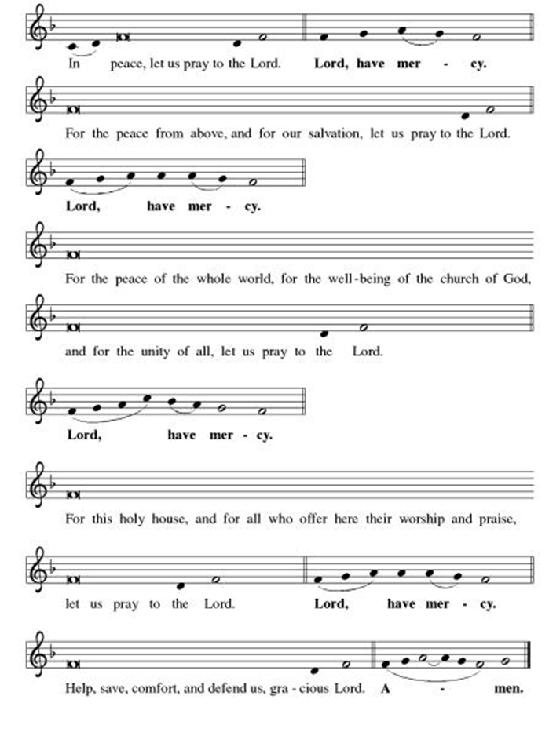

**This is the Feast
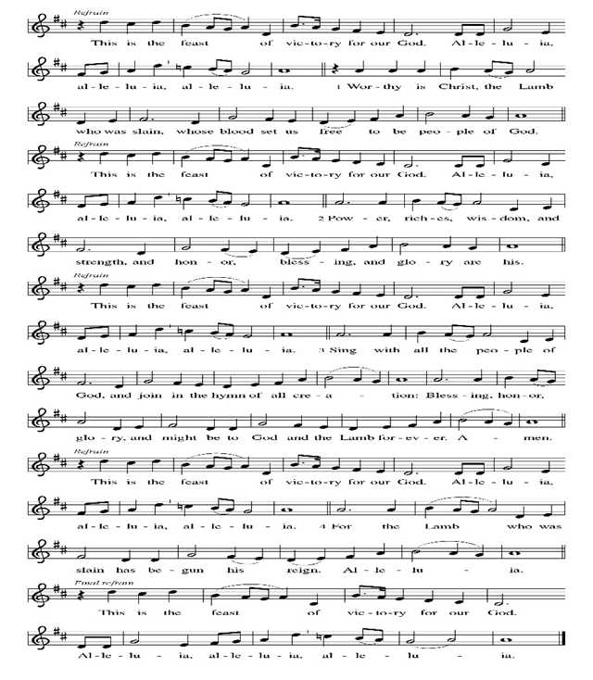
**Prayer of the Day

Loving and steadfast God, sometimes we struggle to hear you. We get distracted by the messages the world throws at us, which clog our minds and our memories, and our ability to listen clearly to you. Create clean hearts in us, God; declutter our minds and our souls, so that we can feel your Spirit. And make us bold to follow you. All this we pray in Jesus’ name. Amen.

Reading: 1 Samuel 16:1-13; Psalm 51:10-14

¹God said to Samuel, “How long will you grieve for Saul since I rejected him as ruler of Israel? Fill your horn with oil, and be on your way. For I am sending you to Jesse in Bethlehem, for I have chosen my ruler from among his children.”

²But Samuel replied, “How can I go? For if Saul learns about it, I will be murdered.”

God replied, “Take a heifer with you: I am sending you to Jesse. Tell him that you came to offer a sacrifice to God, ³and invite Jesse to the sacrifice. Then I will show you what to do. You are to anoint for me my selection.”

⁴Samuel did what God said. When he arrived at Bethlehem, the elders of the town trembled when they met Samuel. They asked, “Do you come in peace?”

⁵Samuel said, “Yes, in peace; I have come to sacrifice to God. Consecrate yourselves and come to the sacrifice with me.” Then he consecrated Jesse and his children and invited them to the sacrifice.

⁶When they arrived, and Samuel saw Eliab, and said to himself, “Surely, God’s anointed stands here before God.”

⁷But God said to Samuel, “Pay no attention to appearance and height; I have rejected him. God does not see as mortals see; mortals see only appearances but God sees into the heart.”

⁸Then Jesse called Abinadab to pass before Samuel, who said, “No. God has not chosen this one.”

⁹Next came Shammah, but Samuel said, “Not this one either.”

¹⁰Seven sons were presented to Samuel by Jesse, who said, “God has not chosen any of these.”

¹¹Samuel asked, “Are these all the sons you have?”

“There is still the youngest,” Jesse said, “but he is tending the sheep.”

Samuel said, “Send for him; we will not begin the sacrificial banquet until the lad arrives.”

¹²So they sent for the boy, a ruddy youth with bright eyes, and handsome to behold. God said, “Rise and anoint this one.”

¹³Then Samuel took the horn of oil and anointed the boy in the presence of his brothers, and from that day forward the Spirit of God came upon David and was with him. Then Samuel set out on his way to Ramah.

Psalm 51:10-14

¹⁰O God, create a clean heart in me,
put into me a new and steadfast spirit;
¹¹do not banish me from your presence,
do not deprive me of your holy Spirit!
¹²Be my savior again, renew my joy,
keep my spirit steady and willing;
¹³and I will teach transgressors your ways,
and sinners will return to you.
¹⁴Save me from bloodshed, O God, God of my salvation—
and my tongue will acclaim your justice.

Word of God, Word of Life
Thanks be to God

**Gospel Acclamation
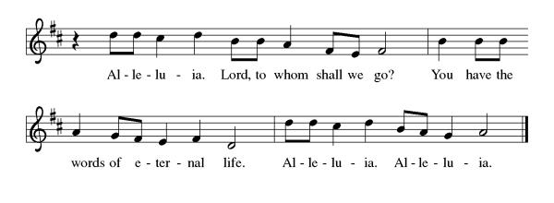
Announcement of the Gospel
Glory to you, O Lord.

Gospel: John 7:24

²⁴[Jesus said,] “Stop judging for the sake of appearances! Start judging justly!”

The Gospel of the Lord.
Praise to you, O Christ.

Sermon "Clean-Hearted Listening"

Hymn of the Day Change My Heart, O God ELW#801

**Affirmation of Faith – Immigrant’s Creed by Jose Luis Casal

I believe in Almighty God, who guided the people in exile and in exodus, the God of Joseph in Egypt and Daniel in Babylon, the God of foreigners and immigrants.

I believe in Jesus Christ, a displaced Galilean, who was born away from his people and his home, who fled his country with his parents when his life was in danger. When he returned to his own country he suffered under the oppression of Pontius Pilate, the servant of a foreign power. Jesus was persecuted, beaten, tortured, and unjustly condemned to death. But on the third day Jesus rose from the dead, not as a scorned foreigner but to offer us citizenship in God’s kingdom.

I believe in the Holy Spirit, the eternal immigrant from God’s kingdom among us, who speaks all languages, lives in all countries, and reunites all races.
I believe that the Church is the secure home for foreigners and for all believers. I believe that the communion of saints begins when we embrace all God’s people in all their diversity. I believe in forgiveness, which makes us all equal before God, and in reconciliation, which heals our brokenness. I believe that in the Resurrection God will unite us as one people in which all are distinct and all are alike at the same time. I believe in life eternal, in which no one will be foreigner but all will be citizens of the kingdom where God reigns forever and ever. Amen.

**Prayers of Intercession

God of Love, hear the prayers that we lift before you. Hold close to you all those for whom we pray.

We pray for the church universal. O God, who unites the church across the globe, bring unity and peace to a world divided by hatred and opposition. Turn our hearts toward the gospel of Jesus Christ. God of grace,
receive our prayer.
We pray for creation. O God, who made heaven and earth, draw us to the beauty of the whole creation. Turn us toward a right relationship with the entire cosmos. God of grace,
receive our prayer.
We pray for all nations, states, cities, and towns. O God, you rule over all the earth. Grant our elected officials humility in their decision-making for the sake of the entire world. God of grace,
receive our prayer.
We pray for those who suffer in body, mind, or spirit. O God, who heals and strengthens, our help comes from you in times of need. Support, comfort, and heal those who suffer especially Monty, Paul, Linda, Betty F., Kay, Becky H., Jim & Jan, Becky W., David, William and family, Helen, Larry, family of Jennifer, Otto, families in our community who endure hunger, Kevin, Kent and Carla and our beloved for whom death is near. God of grace,
receive our prayer.
We pray for All Saints Lutheran Church. O God, who guides this congregation, encourage us to share the good news of Jesus Christ. Nurture our relationships with the community, that we serve and advocate for those who come to us in need. God of grace,
receive our prayer.
Calm the fears of migrants and refugees who set out, not knowing where they go. Provide shelter, sustenance, protection from harm, and welcome. Bless the work of Global Refuge and other support and advocacy programs. God of grace,
receive our prayer.
We pray for the nations. Pave a way to justice, drown the forces of oppression, bring peace on earth. Give leaders the will to turn from war and violence. Especially we pray for the people of Gaza, Israel, and Ukraine, and for Jim’s grandson Dylan, who is deployed in Oman. When people must flee their homes, guide them to safety. Comfort those living with deep trauma, anxiety, or fear; all those who serve people in need, and accompany all those who care for people in harm’s way. God of grace,
receive our prayer.
We pray for people who rise up against injustice. Bring courage and resilience to those who resist tyranny with their words and their bodies. Strengthen those who fight for justice in your name across the country, and around the world. Protect and sustain immigrants and refugees and all who work with them, that your kingdom, without borders and without walls, may truly come on earth as it is in heaven. We pray for all victims of gun violence or kidnapping, especially those who are targeted out of hate or fear. Embolden us to holy outrage and empower us to speak our truth of love and justice. God of grace,
receive our prayer.
God of learning, we lift up all who teach and all who learn. Thank you for teachers who share their knowledge and wisdom. Bless the students in our midst. Especially we remember Evie, in kindergarten; Addison, in high school; and Tyler, Zach, Katie and Katy, in college. Bless Janet and Lisa as they teach. God of grace,
receive our prayer.
We offer thanksgiving for the faithful departed. O God, whose promises never end, we thank you for all the saints who have shown us the way of your Son, Jesus Christ. God of grace,
receive our prayer.
We remember in thanksgiving the faithful departed. Inspire us by their example to love and serve our neighbors, and bring us to eternal life. God of grace,
receive our prayer.

Good and loving God, we give everyone we have prayed for into your care. Amen.

** Sharing of the Peace

**Offering is brought forward

** Offertory Response

Create in Me ELW#186

**Offertory Prayer
Good and loving God, everything that we have and everything that we are comes from you. We respond in gratitude, offering up to you our gifts of our money, our time, and our talents. We dedicate these gifts to your service. In Jesus’ name we pray, amen.

**Dialogue
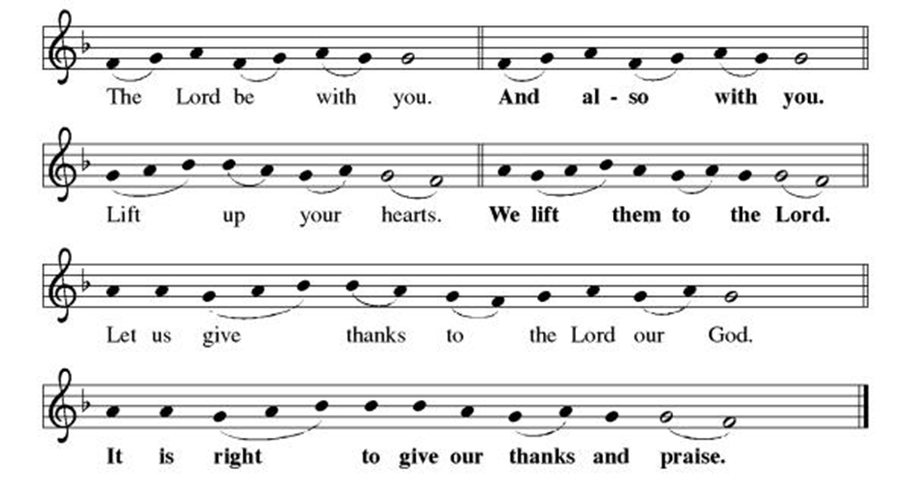

**Preface: Since the earliest days of the covenant… this hymn of praise:

**Holy, Holy, Holy
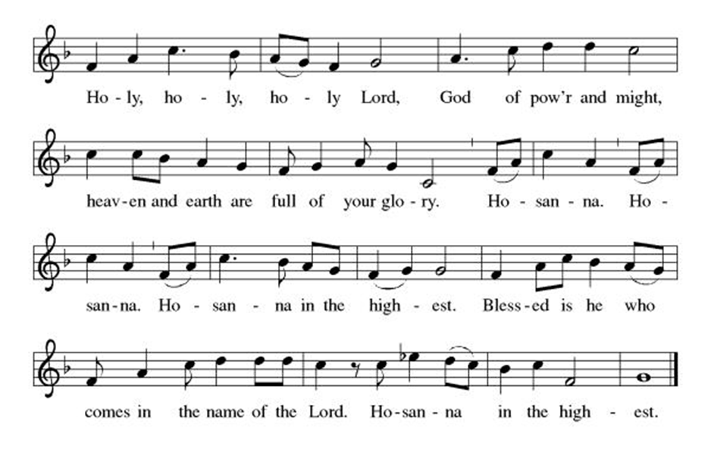
**Words of Institution

**LORD’S PRAYER

Our Father, who art in heaven,
hallowed be thy name,
thy kingdom come,
thy will be done,
on earth as it is in heaven.
Give us this day our daily bread;
and forgive us our trespasses,
as we forgive those
who trespass against us;
and lead us not into temptation,
but deliver us from evil.
For thine is the kingdom,
and the power, and the glory,
forever and ever. Amen.

Invitation to Communion

Communion Hymn Lord Jesus, Think On Me ELW#599

**Sending Song

Praise to you, O God of Mercy ELW#208

**Prayer After Communion

Abiding God, you call us then feed and nurture us. Now you send us out in the world you created with a purpose: to love our neighbors and care for those who need us. Strengthen us to do your work. In Jesus’ name we pray, Amen.

**Blessing
**Closing Hymn Just As I Am, Without One Plea ELW#592

**Dismissal

Go in peace to serve Christ and the world!

THANKS BE TO GOD!

+ + + + + +
Setting 3 liturgy are under copyright and used with permission under One License #733618-A. Specific copyright information as listed in bulletin, the Prayers of Intercession are under copyright and are used with permission under Augsburg Fortress Liturgy License #SB155933. All other liturgy written by Sarah Pierce.

***********************************************************************************************************
Weekly Attendance

Week of October 12
23
******************************************************************************************
Calendar of Events
Today

- Stewardship: Treasure
- Coffee with Council

This Week
October 21 | Creative Friends 1:00 pm
October 21 | Jean’s Surgery Scheduled
October 25 | Project Comfort 9:00 am-Noon

Upcoming Events
October 26 | Reformation Sunday; Wear Red/Pledge Sunday Film/Potluck after Worship
October 28 | Creative Friends 1:00 pm
November 01 | Project Comfort Special Quilting Day
November 05 | Council Meeting 6:30 pm
November 16 | Congregational Meeting
November 26 | Thanksgiving Eve Worship 7:00 pm Pie Night
December 07 | Advent Dinner after Worship
December 10 | Council Meeting 6:30 pm
January 14, 2026 | Council Meeting 6:30 pm
February 18 | Ash Wednesday
March 29 | Palm Sunday
April 05 | Easter Sunday

*****************************************************************************************
BLUE SPRINGS COMMUNITY SERVICE LEAGUE is very appreciative of your continued support of your neighbor.
Donate 10 pairs of shoes and Trident will donate $250. This will run to the end of November 30th.
******************************************************************************************
Questions for Reflection and Discussion from Pastor Sarah

- Do you recognize the words from the verses of this psalm? (Hint: there’s a reason we’ve been this offertory response this fall. It wasn’t a random choice!) A claim has been made that this psalm, in full or in part, is used in worship or devotion more than any other psalm.
- This is our second week in a row with texts about Samuel listening to God. And even though he’s been doing it for most of his life, he still doesn’t get it right all the time! And this is just about the only thing he does! So even though we are called to listen to God, it takes work. How can we eliminate some of the distractions in life to help us hear God’s voice more clearly? (Those of you who were here last Sunday: remember what I said last week about the internal and external call? God’s voice comes to us in a multitude of ways.)
- Samuel is inclined to pay attention to appearance when trying to determine which of Jesse’s sons God has chosen to be the next king. This isn’t totally out of left field; when Saul was chosen by God, we are told in 1 Samuel 9 that he was tall and handsome. But he ends up not being very faithful in the promises that he made to God when he was anointed, and God is determined not to make the same mistake again, looking at the qualities of leadership and discipleship, rather than the outward appearance.
- But, despite God’s focus on seeing into the heart, and despite the fact that David is off tending the sheep – a common metaphor for kings and other leaders, as well as for deities, in the Ancient Near East, the description of David is interesting: “a ruddy youth with bright eyes, and handsome to behold.” Why do you think that matters? Do you think it matters?
- David is important for a lot of reasons. He was a skilled military and political leader, and he and his son Solomon did a lot to unite the kingdom of Israel. For Christians, perhaps most importantly, the prophets foretold that the messiah (which means “anointed one”) would be David’s descendant; and Joseph, who married Mary, was David’s descendant. So although Jesus isn’t BIOLOGICALLY David’s descendant, he has certainly been adopted into that lineage.
- But one of the most famous stories about David is the story about Bathsheba and Uriah. David fell in love with Bathsheba, and sent her husband Uriah, one of his generals, off to the front line to be killed, so that he could marry her. That story gets told in a lot of ways, and Bathsheba gets painted in a lot of different lights – some more fair and some less fair. But in none of the ways of telling that story does David come out smelling like a rose. At the very least, he’s guilty of Uriah’s death. But, as one of the commentators said in a podcast I listened to, he’s very good at repenting. Psalm 51 is reputed to have been written by him after the Bathsheba incident.
- How do you interpret the plea for God to create a clean heart?

**************************************************************************************
Birthdays
October 24-Monty Benz
October 25-Jordan Via

Greeter – October 19-Donna Taylor
Usher – October 19-Paul Blixrud
Altar Guild- October 19-Anne Lee & Paul Blixrud
Reader- October 19-Sara Meyers
Tech- October 19-Gary Antes

Prayer Requests
Monty Health Concerns (May 15)
Paul Health Concerns (May 31)
Mary Health Concerns (May 15)
James & Family Health Concerns (September 11)
Betty F (Sara’s friend) Health Concerns (July 15)
William and Family Health Concerns (September 25)
Becky H Health Concerns (October 28)
David Health Concerns (November 18)
Becky W Health Concerns (November 18)
Larry Health Issues (December 16)
Helen Health Issues (January 14)
Jennifer Health Concerns (February 27)
Otto Health Concerns (July 15)
Kay (Sara’s cousin) Health Concerns (July 15)
Kevin Health Concerns (October 01)
Kent Health Concerns (October 01)
Carla Health Concerns (October 01)

Family of Jennifer (October 05)

Merciful God, your justice and mercy are without limits. Bring courage and resilience to those who resist tyranny with their words and their bodies. Strengthen those who fight for justice in your name in Los Angeles, across the country, and around the world.

Please pray for the people of Gaza, Ukraine, Israel, Iran and Palestine.
Please pray for the people of the Sudan.
Please pray for the Homeless.
Please pray for legal & illegal immigrants & those seeking asylum or citizenship.

