All Saints Lutheran Church, ELCA
421 SW 19th St. Blue Springs, Missouri 64015 816-229-3633
Pastor Sarah Pierce Spierce.aslcpastor@gmail.com
allsaintslc64015@gmail.com https://aslcbs.org/

Sunday, January 11, 2026

Baptism of Our Lord

You are absolutely invited into this sacred space. We welcome all who are seeking God’s love and grace. All Saints recognizes that we are all unique and beloved children of God. We celebrate and give thanks for the many diverse gifts that God has given us. We affirm the sacredness of people of all sexual orientations, gender identities, and gender expressions. We affirm the sacredness of all those who have experienced exclusion because of race, ability, age, or culture. We are committed to working towards anti-racism in ourselves and our community. We affirm the sacredness of all those who wrestle with addiction, physical or mental health, imprisonment, socio-economic circumstances, or anything that too often divides us. We believe that through our openness we all grow in our faith through Christ’s teaching to love one another as God loves us. We need each other and our sincere hope is by being in community together, we will experience God’s presence in new and real ways.

The offering plate is by the main door to the sanctuary for your convenience.

We practice open communion at All Saints Lutheran Church. What does that mean? It means that if you believe and trust that Christ offers his body and blood For You, you are welcome at the table. At All Saints, we believe that Christ invites all people to the feast. “Come to the banquet for all is now ready.”

**Stand as you are comfortable

Prelude

Announcements

Remembrance of Baptism

** Affirmation of Baptism

God prepares a way for us, a path through the desert. In our baptisms, Jesus calls us to follow that path, and we receive the gift of the Holy Spirit, empowering us to answer Jesus’ call. But sometimes, we forget the gift of forgiveness and unending love that we have been given, and we need to be reminded.

As you came in, you were given a piece of paper and a pen. I invite you to write a prayer on that paper. It could be a prayer of thanks for your baptism, or a prayer asking God to help you remember your baptism, or anything at all. Whatever is on your heart that you want to give to God.

Jesus, sometimes we forget to listen to your call. We forget about the power of our baptisms. Sometimes, we get distracted with other things and forget to place you first. We ask that you help us to turn back to you when we turn away. We ask you to help us recenter our lives on you, so that we remember the power of our baptisms. We pray that we can feel your presence in our lives.

We ask you to receive our prayers and to be with us, today and forever. We pray that your presence shines through us to those who most need to see it.

I invite you now to come forward and place your prayers in the font. Watch as your prayer dissolves into the waters of baptism, mingling with all of the other prayers that are being lifted to God. Then, I invite you to take a candle and light it, in remembrance of your baptism.
Let your light so shine before others that they may see your good works and glorify God in heaven.

Holy and loving God, we thank you for the gift of forgiveness. We thank you for the gift of your unconditional love.

Holy and loving Jesus, we thank you for the gift of the baptism which frees us from the power of sin and death, for all time. We thank you for showing us how to live in that freedom.

Holy and loving Spirit, we thank you for infusing us with your presence. Empower us to live out our baptismal call to proclaim Christ through word and deed, to care for others and for the world, and to work for justice and peace. Amen.

**Entrance Hymn Oh, Worship the King ELW#842

**Greeting
The grace of our Lord Jesus Christ, the love of God,
and the communion of the Holy Spirit be with you all.
And also with you.

**Kyrie
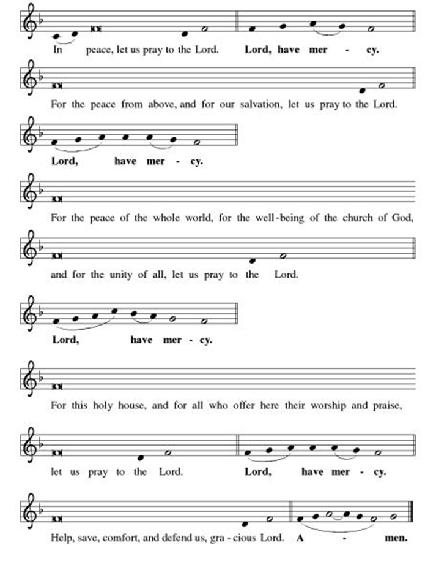
**This is the Feast
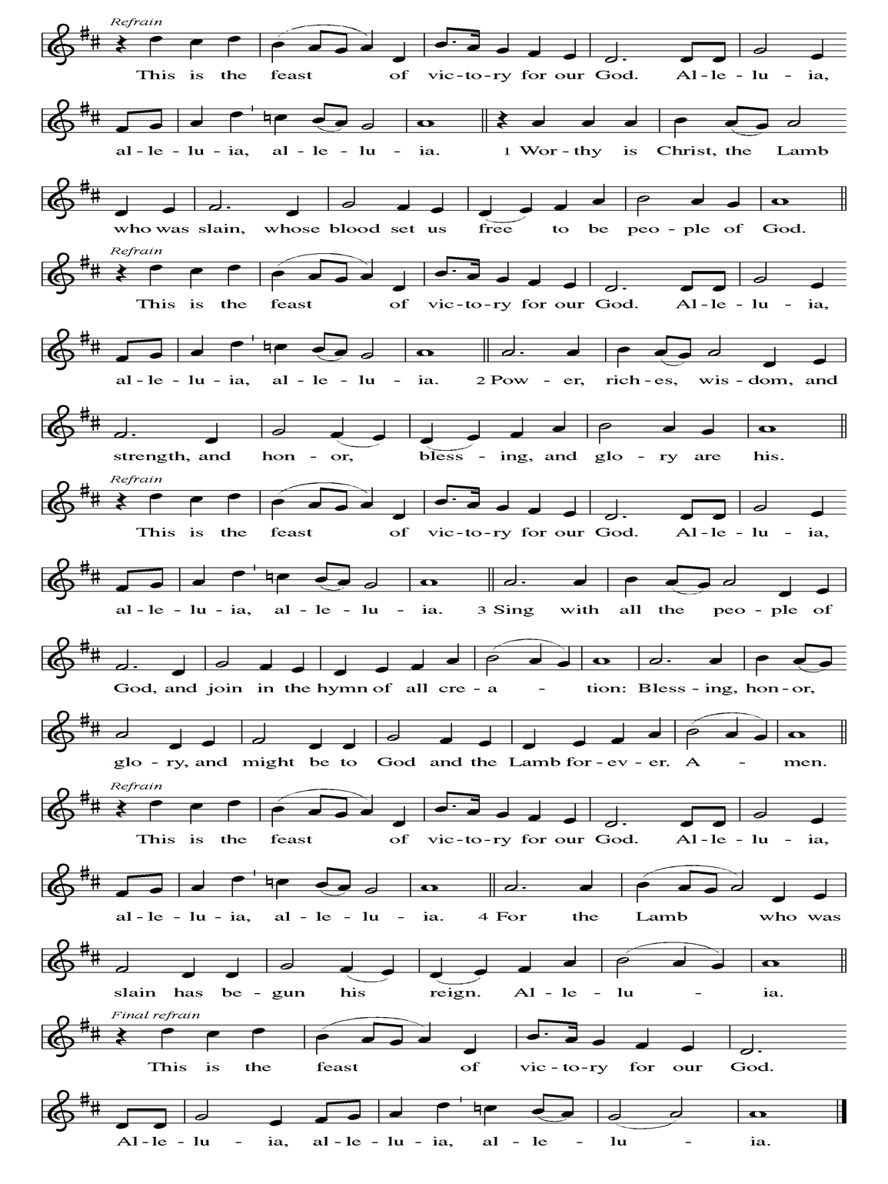
**Prayer of the Day
Jesus, you pour out your grace abundantly in our lives. Help us to see and taste the fullness of your generosity. Help us to show others what it means to explore your grace with our minds, our hearts, and our lives, to live our epiphanies in you. Amen.

Reading: Psalm 104:14-16

¹⁴You make fresh grass grow for cattle
and plants for us to cultivate
to get food from the soil—
¹⁵wine to cheer our hearts,
oil to make our faces shine,
and bread to sustain our life.
¹⁶The trees of God drink their fill—
those cedars of Lebanon,

The Word of the Lord
Thanks be to God

**Gospel Acclamation

**Alleluia
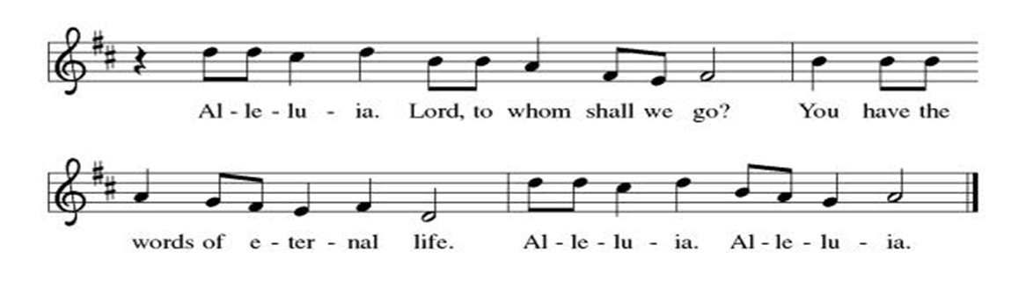
Announcement of the Gospel
Glory to you, O Lord.

Gospel: John 2:1-11

¹Three days later, there was a wedding at Cana in Galilee, and Mary, the mother of Jesus, was there. ²Jesus and his disciples had likewise been invited to the celebration.

³At a certain point, the wine ran out, and Jesus’ mother told him, “They have no wine.”

⁴Jesus replied, “Mother, what does that have to do with me? My hour has not yet come.”

⁵She instructed those waiting on tables, “Do whatever he tells you.”

⁶As prescribed for Jewish ceremonial washings, there were six stone water jars on hand, each one holding between fifteen and twenty-five gallons. ⁷“Fill those jars with water,” Jesus said, and the servers filled them to the brim.

⁸“Now,” said Jesus, “draw some out and take it to the caterer.” They did as they were instructed.
⁹The caterer tasted the water—which had been turned into wine—without knowing where it had come from; the only ones who knew were those who were waiting on tables, since they had drawn the water. The caterer called the bride and groom over ¹⁰and remarked, “People usually serve the best wine first; then, when the guests have been drinking a while, a lesser vintage is served. What you’ve done is to keep the best wine until now!”

¹¹Jesus performed this first of his signs at Cana in Galilee; in this way he revealed his glory, and the disciples believed in him.

The Gospel of the Lord.
Praise to you, O Christ.

Sermon "Abundant Grace"

Hymn of the Day Jesus Shall Reign ELW#434

**Affirmation of Faith – Immigrant’s Creed by Jose Luis Casal

I believe in Almighty God, who guided the people in exile and in exodus, the God of Joseph in Egypt and Daniel in Babylon, the God of foreigners and immigrants.

I believe in Jesus Christ, a displaced Galilean, who was born away from his people and his home, who fled his country with his parents when his life was in danger. When he returned to his own country he suffered under the oppression of Pontius Pilate, the servant of a foreign power. Jesus was persecuted, beaten, tortured, and unjustly condemned to death. But on the third day Jesus rose from the dead, not as a scorned foreigner but to offer us citizenship in God’s kingdom.

I believe in the Holy Spirit, the eternal immigrant from God’s kingdom among us, who speaks all languages, lives in all countries, and reunites all races.

I believe that the Church is the secure home for foreigners and for all believers. I believe that the communion of saints begins when we embrace all God’s people in all their diversity. I believe in forgiveness, which makes us all equal before God, and in reconciliation, which heals our brokenness. I believe that in the Resurrection God will unite us as one people in which all are distinct and all are alike at the same time. I believe in life eternal, in which no one will be foreigner but all will be citizens of the kingdom where God reigns forever and ever. Amen.

**Prayers of Intercession

Jesus, you came to live with us on earth so that we would know you love us no matter what. Listen to the prayers we lift to you.

Steadfast God, give courage to your servant church. Heal our divisions and unite us in mission. Uphold our lay leaders, missionaries, pastors, and bishops, and all who proclaim hope in a broken world. Merciful God,
receive our prayer.
Restoring God, cleanse the life-giving waters of rivers, seas, and springs. Create in us an urgent desire to preserve the beauty and bounty of your good creation. Merciful God,
receive our prayer.
Righteous God, you guide the nations. Reconcile warring enemies and end cycles of violent retribution. Defend the rights of prisoners, detainees, and all who flee from persecution. Sustain international aid workers and peacemakers. Merciful God,
receive our prayer.
Compassionate God, you care for all in distress. Provide safety and support for those seeking asylum or in need of shelter. Be near to the dying, and comfort all who are grieving or ill especially Monty, Paul, Linda, Betty F., Kay, Becky H., Jim & Jan, Becky W., David, William and family, Helen, Larry, Otto, Kevin, Peter and Carrie, Barbara & Donna, families in our community who endure hunger, and our beloved for whom death is near. Merciful God,
receive our prayer.
Loving God, awaken the gifts of the Spirit in this congregation, that we may serve Christ by loving one another, our neighbors, and our enemies. We pray for travelers and those who are homebound. Merciful God,
receive our prayer.
Pave a way to justice, drown the forces of oppression, bring peace on earth. Give leaders the will to turn from war and violence. Especially we pray for the people of Venezuela, Sudan, Gaza, Israel, and Ukraine, and for Jim’s grandson Dylan, who is deployed. When people must flee their homes, guide them to safety. Comfort those living with deep trauma, anxiety, or fear; all those who serve people in need, and accompany all those who care for people in harm’s way. Merciful God,
receive our prayer.
We pray for people who rise up against injustice. Bring courage and resilience to those who resist tyranny with their words and their bodies. Strengthen those who fight for justice in your name across the country, and around the world. Protect and sustain immigrants and refugees and all who work with them, that your kingdom, without borders and without walls, may truly come on earth as it is in heaven. We pray for all victims of gun violence or kidnapping, especially those who are targeted out of hate or fear. Embolden us to holy outrage and empower us to speak our truth of love and justice. Merciful God,
receive our prayer.
We lift up all who teach and all who learn. Thank you for teachers who share their knowledge and wisdom. Bless the students in our midst. Especially we remember Evie, in kindergarten; Addison, in high school; and Tyler, Zach, Katie and Katy, in college. Bless Janet and Lisa as they teach. Merciful God,
receive our prayer.
Promising God, in baptism we die and rise with Christ. We give thanks for those who have gone before us, and we trust that we will join them in your everlasting peace. Merciful God,
receive our prayer.

Loving God, because you lived among us, we know that you hear our prayers and hold close all for whom we pray. Amen

** Sharing of the Peace

**Offering is brought forward

** Offertory Response Let Us Talents and Tongues Employ (V. 1) ELW#674

**Offertory Prayer

God of abundance, with thanks, we return to you the gifts you have given us so freely. Bless these offerings of our time, our talents, and our treasure. Shape us to be your hands and feet. Use our gifts to shower each other, our communities, and the world with your loving kindness. All this we ask in Jesus’ name. Amen.

**Dialogue
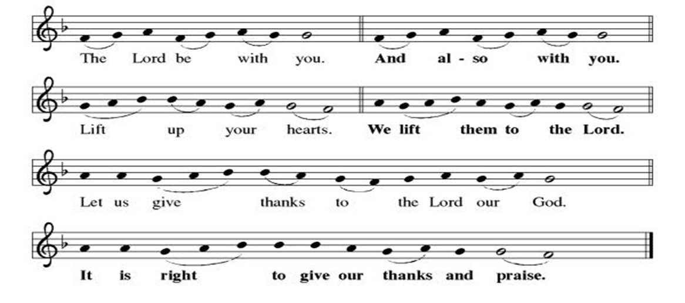

**Preface: From the beginning of time…this hymn of praise:

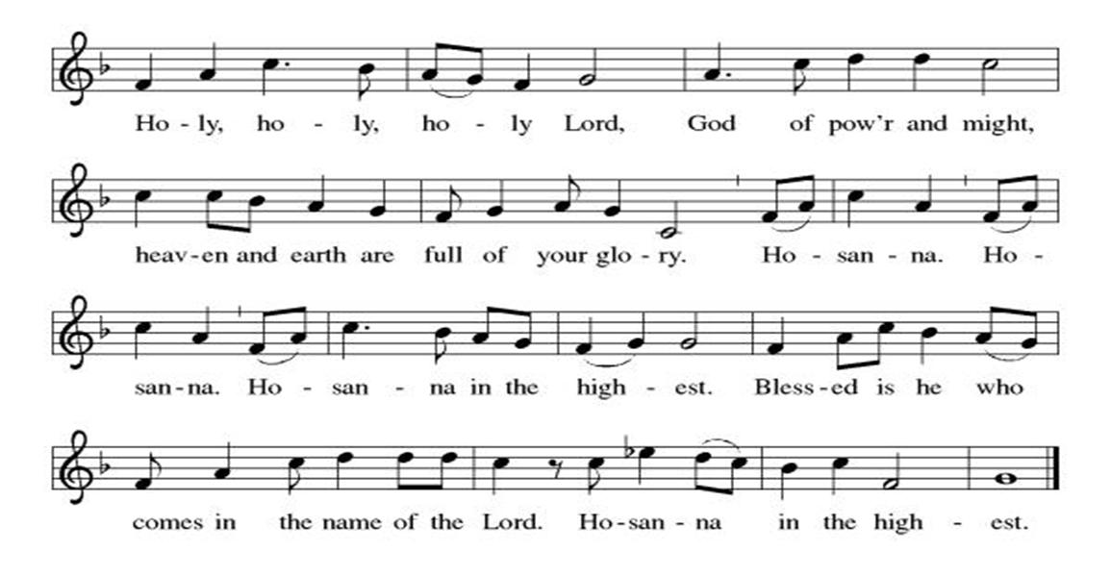

** Thanksgiving at the Table

**LORD’S PRAYER
Our Father in heaven,
hallowed be your name,
your kingdom come,
your will be done,
on earth as in heaven.
Give us today our daily bread.
Forgive us our sins
as we forgive those
who sin against us.
Save us from the time of trial
and deliver us from evil.
For the kingdom, the power,
and the glory are yours,
now and forever. Amen.

Invitation to Communion

Communion Hymn Blest Be the Tie That Binds ELW #656

**Post-communion prayer

Holy One, Human and Divine, we give you thanks for the life-giving invitation to gather at your table and be fed. Strengthen us now for your service, and send us out from this place renewed in our commitment to love you and serve each other and all of creation. Send your Spirit upon us, so that we can proclaim your blessings to a world that hungers to receive them. All this we ask in your name, the one who is, who was, and who is to come. Amen.

**Sending Song

Listen, God Is Calling (refrain, V. 1, refrain) ELW#513

**Benediction

**Closing Hymn Earth and All Stars ELW#731

**Dismissal

Go in peace. Share the good news!
THANKS BE TO GOD!

+ + + + + +

Hymns from the Evangelical Lutheran Worship are under copyright and used with permission under One License #733618-A. ELW setting #3 the Prayers of Intercession are under copyright and are used with permission under Augsburg Fortress Liturgy License #SB155933. All other liturgy written by Sarah Pierce.

Weekly Attendance

Week of January 04
19

Next Week:
Second Sunday after Epiphany

The Color of the day is Green
Psalm 127:1-2
John 2:13-25

Calendar of Events
Today

- Remembrance of Baptism

Upcoming Week
- January 14 Council Meeting 6:30 pm

January 22 | Zoom Presentation: Putting Faith into Action
January 25 | Dave Mareske Preaches  Coffee with Council
February 04 | Paint Party Fundraiser
February 05 | Zoom Presentation: ELCA Social Statement
February 08 | Souper Bowl for CSL  Special Offering for Hollis
February 11 | Church Council Meeting 6:30 pm
February 15 | Pre-Lent Ice Cream Social after Church
February 18 | Ash Wednesday  God’s Global Barn yard begins February 18-April 05
February 22 | Coffee with Council
March 04 | Paint Party Fundraiser
March 15 | Church Council Meeting 6:30 pm
March 22 | Coffee with Council
March 29 | Palm Sunday
April 01 | Paint Party Fundraiser
April 02 | Maundy Thursday
April 05 | Easter Sunday
April 06 | Church Council Meeting 6:30 pm
April 26 | Coffee with Council
May 06 | Paint Party Fundraiser
May 10 | Mother’s Day
May 13 | Church Council Meeting 6:30 pm
May 17 | Congregational Meeting
May 24 | Pentecost
May 25 | Memorial Day
June 03 | Paint Party Fundraiser
June 19 | Juneteenth Office Closed
July 01 | Paint Party Fundraiser
July 04 | Independence Day
July 26 | Coffee with Council  Celebrate Niel’s Birthday (July 28)

*****************************************************************************************
BLUE SPRINGS COMMUNITY SERVICE LEAGUE is very appreciative of your continued support of your neighbor.
*****************************************************************************************
Questions for Reflection and Discussion from Pastor Sarah
- “I don’t know how to define it, but I know it when I see it.” I use this quote in my sermon to describe grace, but it’s actually from US Supreme Court Justice Potter Stewart. He used it during the 1964 case Jacobellis vs. Ohio (in case you’re wondering where it came from – and when he said it, it didn’t have anything to do with grace!!!).
- We don’t have Jesus’ baptismal experience in John. Mark and Luke have Jesus’ baptism, which are Epiphany texts for those gospels. In Matthew, the Epiphany text is the visit of the magi, and in John, the Epiphany text is the wedding at Cana, because it’s the first sign Jesus performs. It’s the first time people outside his inner circle have the opportunity to see and believe who he is and what he can do.
- There are a couple of things in this text that call forward to his passion (arrest, trial, and crucifixion) and resurrection: the reference to the “three days later” (or “on the third day,” as some translations say) at the beginning; this is how long the time is from the passion through the resurrection. Mary, who is not actually named in John’s gospel, but whose name some translators add, appears twice: once here, and once at the foot of the cross. And when he says to her, “My hour has not yet come,” he’s generally thought to be referring to his passion, resurrection, and ascension.
- This is a story about abundance. Each household would have had one of these stone water jars, but for some reason, there are six on hand – probably borrowed from the neighbors for some reason for the wedding. Why do you think the servers were willing to follow Jesus’ instructions? How long do you think it would have taken to fill the jars with water, going back and forth with buckets from the well?
- One of the comments made in one of the podcasts I listened to this week drew a connection between the new wine being the “good stuff” and Abraham and Sarah receiving extraordinary blessings in their old age. Speaking metaphorically, what do you think the good wine is? Does it simply mean it’s never too late to follow Jesus? Or is there more (or less) to it than that?

**************************************************************************************
The Central States Synod and Kansas Interfaith Action present “We the People: a virtual series on faith & public life”

- Thursday, January 22 6:30pm: “Putting Faith Into Action” with Rev. Dr. Mandy Todd
- Thursday, February 05 6:30pm: “Diving Into the ELCA Social Statement on Faith and Civic Life” with Dr. Jim Brandt

We will join all of these sessions from the sanctuary via Zoom.

Birthdays
Judy Taylor-January 15
Mary Ann Gross-January 16
Lisa Melton-January 17
Sharon Levasseur-January 17

January 11
Altar Guild-Sara Meyers
Lector – Tonya Hamilton
Communion Assistant-Suelyn Olson
Greeter – Donna Taylor
Tech – Gary Antes

Prayer Requests
Monty Health Concerns (May 15)
Paul Health Concerns (May 31)
Mary Health Concerns (May 15)
James & Family Health Concerns (September 11)
Betty F (Sara’s friend) Health Concerns (July 15)
William and Family Health Concerns (September 25)
Becky H Health Concerns (October 28)
David Health Concerns (November 18)
Becky W Health Concerns (November 18)
Larry Health Issues (December 16)
Helen Health Issues (January 14)
Otto Health Concerns (July 15)
Kay (Sara’s cousin) Health Concerns (July 15)
Kevin Health Concerns (October 01)
Fred Health Concerns (October 22)
Sharon Health Concerns (October 22)
Michael Health Concerns (October 22)
Peter and Carrie Health Concerns (November 26)
Melian Health Concerns (November 16)
RJ Health Concerns (November 17)
Barbara Health Concerns (December 30)

Merciful God, your justice and mercy are without limits. Bring courage and resilience to those who resist tyranny with their words and their bodies. Strengthen those who fight for justice in your name across the country, and around the world.

Please pray for the people of Venezuela, Sudan, Gaza, Ukraine, Israel, Iran and Palestine.
Please pray for the Homeless.
Please pray for legal & illegal immigrants & those seeking asylum or citizenship

