All Saints Lutheran Church, ELCA
421 SW 19th St. Blue Springs, Missouri 64015 816-229-3633
Pastor Sarah Pierce Spierce.aslcpastor@gmail.com
allsaintslc64015@gmail.com https://aslcbs.org/

Sunday, April 26, 2026

Fourth Sunday after Easter

You are absolutely invited into this sacred space. We welcome all who are seeking God’s love and grace. All Saints recognizes that we are all unique and beloved children of God. We celebrate and give thanks for the many diverse gifts that God has given us. We affirm the sacredness of people of all sexual orientations, gender identities, and gender expressions. We affirm the sacredness of all those who have experienced exclusion because of race, ability, age, or culture. We are committed to working towards anti-racism in ourselves and our community. We affirm the sacredness of all those who wrestle with addiction, physical or mental health, imprisonment, socio-economic circumstances, or anything that too often divides us. We believe that through our openness we all grow in our faith through Christ’s teaching to love one another as God loves us. We need each other and our sincere hope is by being in community together, we will experience God’s presence in new and real ways.

The offering plate is by the main door to the sanctuary for your convenience.

We practice open communion at All Saints Lutheran Church. What does that mean? It means that if you believe and trust that Christ offers his body and blood For You, you are welcome at the table. At All Saints, we believe that Christ invites all people to the feast. “Come to the banquet for all is now ready.”

**Stand as you are comfortable

Prelude

Announcements

**Thanksgiving for Baptism
Blessed be the Holy Trinity: the God who creates us and all that exists, the Risen One + in whom we are set free from sin, and the Spirit who strengthens and enlightens us with her gifts.
Amen.

Alleluia! Christ is risen!

Christ is risen indeed! Alleluia!

We are joined to Christ in the waters of our baptism, made part of God’s holy family that extends to every time and every place. Through our baptisms, we are given new birth each day, and through the Word and the Meal we receive new life in abundance.

Let us give thanks for the saving gift of our baptism.

Holy God, in our baptism you reached out your saving hand to give to us the gift of new life in you. You are the river of life, the source of all renewal and all joy.

We are blessed by your gift of holy water: oceans and lakes, rivers and streams.
We are blessed by your gift of the holy water which cleans and sustains our bodies.
We are blessed by your gift of holy water: rain and clouds, puddles and pools.
We are blessed by your gift of the holy water which nourishes flowerbeds and fields, and sustains all of creation.

We thank you for the gift of our holy baptism into Christ’s death and resurrection.
Wash away all our sin in your holy water.
Empower and encourage us to share the good news of the empty tomb.
Help us find the courage to speak and act toward justice for all your children.

Refresh us and the world through this holy and living water.
Where there is drought, bring rain and renewal.
Where there is doubt and despair, bring hope.
Where war and chaos thrive, bring the promise of peace.
We ask all these things through Christ, the Risen One,
who reigns with you and the Spirit forever.
Amen.

**Entrance Hymn Be Thou My Vision ELW#793

**Greeting
The grace of our Lord Jesus Christ, the love of God,
and the communion of the Holy Spirit be with you all.
And also with you.

**Kyrie
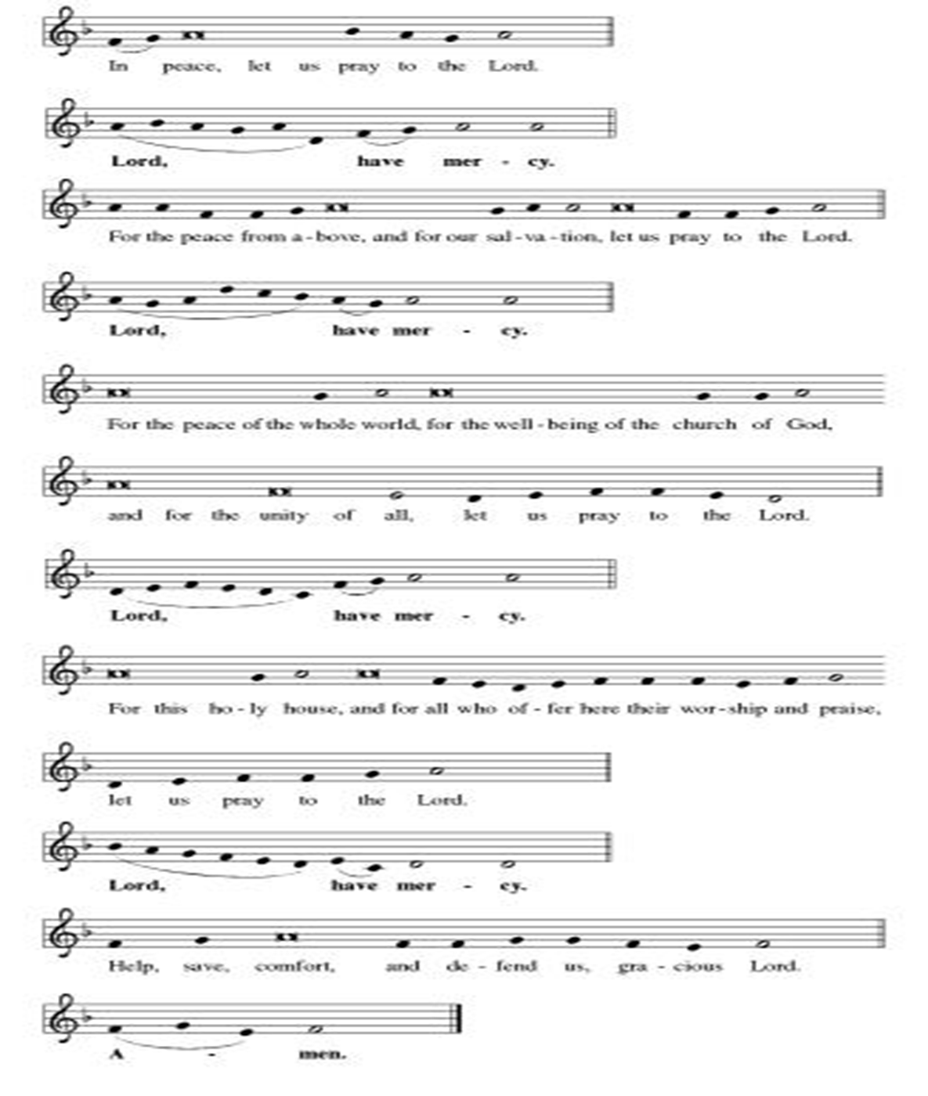
**Hymn of Praise
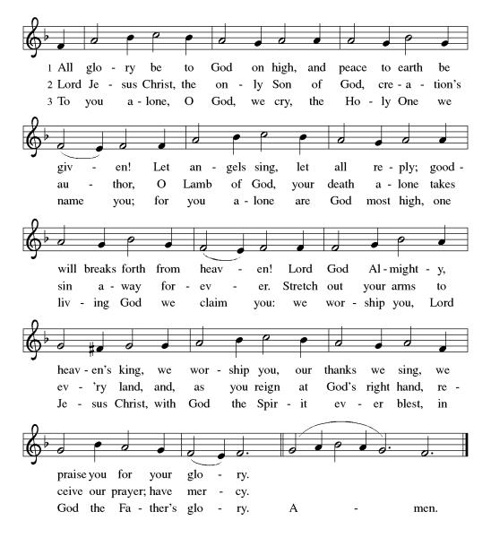
**Prayer of the Day
Loving God, you are with us when we suffer, bringing comfort and strength for the journey. Empower us to comfort those who need us, and to strengthen them for their own journeys. Embolden us to speak out when it is easier to stay silent. We pray this in Jesus’ name. Amen.

Reading: Acts 16:13-40

¹³On the Sabbath we went along the river outside the gates, thinking we might find a place of prayer. We sat down and preached to the women who had come to the gathering. ¹⁴One of them was named Lydia, a devout woman from the town of Thyatira who was in the purple-dye trade. As she listened to us, Christ opened her heart to accept what Paul was saying. ¹⁵After she and her household were baptized, she extended us an invitation: “If you are convinced that I am a believer in Christ, please come and stay with us.” We accepted.

¹⁶Once when we were going to prayer, we met a household worker who was possessed by a spirit of divination, and who made a great deal of money for her employers through its fortune telling. ¹⁷She began to follow Paul and the rest of us, shouting, “These are faithful followers of the Most High God, who proclaim to you the way of salvation!” ¹⁸She did this for many days.

Finally one day Paul lost his temper, and turned around and said to the spirit, “In the name of Jesus Christ I command you to leave this woman!” It left her that moment.

¹⁹When her employers saw that their profitable operation was now hopelessly dead, they seized Paul and Silas and dragged them before the authorities in the public square. ²⁰They brought them to the chief magistrates and said, “These people are Jews and are disturbing the peace ²¹by advocating practices which are unlawful for us Romans to accept or practice.”

²²The crowd joined in the attack on them, and the magistrates stripped them and ordered them to be flogged. ²³They were whipped many times and thrown into prison, and the jailer was told to keep a close watch on them. ²⁴So, following these instructions, the warden threw them into the innermost cell of the prison and chained their feet to a stake.

²⁵About midnight, Paul and Silas were praying and singing hymns to God as the other prisoners listened. ²⁶Suddenly a severe earthquake shook the place, rocking the prison to its foundation. Immediately all the doors flew open, and everyone’s chains were pulled loose. ²⁷When the jailer woke up and found the doors wide open, he drew a sword and was about to commit suicide, presuming that the prisoners had escaped.

²⁸But Paul shouted, “Don’t harm yourself! We’re all still here.”

²⁹The jailer called for a light, then rushed in and fell trembling at the feet of Paul and Silas, and, ³⁰after a brief interval, led them out and asked them, “What must I do to be saved?” ³¹They answered, “Believe in Jesus the Savior, and you will be saved—you and everyone in your household.”

³²They proceeded to preach the word of God to the jailer and his whole household. ³³At that late hour of the night he took them in and bathed their wounds; then he and the whole household were baptized. ³⁴He led them up into his house, spread a table before them, and the whole family joyfully celebrated their newfound faith in God.

³⁵In the morning the magistrates sent officers with the order, “Release them both.”
³⁶The jailer reported to Paul, “The magistrates have ordered your release. Go in peace.”

³⁷ “What’s this?” replied Paul. “They beat us publicly and throw us, Roman citizens, into prison without a trial. And now they want to release us quietly? No! They’ll have to come and escort us out themselves!”

³⁸The officers brought this news to the magistrates, who were horrified to learn that Paul and Silas were Roman citizens. ³⁹So the magistrates came to assuage them, led them out of prison and begged the to leave the city.

⁴⁰From prison Paul and Silas returned to Lydia’s house, where they met with the sisters and brothers to give them encouragement. Then they left.

Word of God, Word of Life
Thanks be to God

**Gospel Acclamation
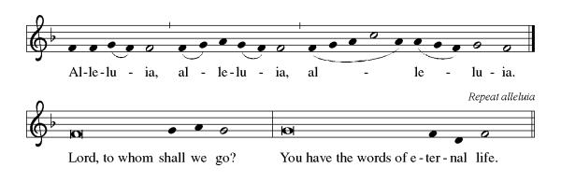
Announcement of the Gospel
Glory to you, O Lord.

Gospel: John 1:16-18

¹⁶Of this One’s fullness
we’ve all had a share—
gift on top of gift.
¹⁷For while the Law was given through Moses,
the Gift—and the Truth—came through Jesus Christ.
¹⁸No one has ever seen God;
it is the Only Begotten,
ever at Abba’s side,
who has revealed God to us.

The Gospel of the Lord.
Praise to you, O Christ.

Sermon “Small Ways”

Hymn of the Day Rock of Ages, Cleft for Me ELW#623

**Affirmation of Faith – Immigrant’s Creed by Jose Luis Casal

I believe in Almighty God, who guided the people in exile and in exodus, the God of Joseph in Egypt and Daniel in Babylon, the God of foreigners and immigrants.

I believe in Jesus Christ, a displaced Galilean, who was born away from his people and his home, who fled his country with his parents when his life was in danger. When he returned to his own country he suffered under the oppression of Pontius Pilate, the servant of a foreign power. Jesus was persecuted, beaten, tortured, and unjustly condemned to death. But on the third day Jesus rose from the dead, not as a scorned foreigner but to offer us citizenship in God’s kingdom.

I believe in the Holy Spirit, the eternal immigrant from God’s kingdom among us, who speaks all languages, lives in all countries, and reunites all races.

I believe that the Church is the secure home for foreigners and for all believers. I believe that the communion of saints begins when we embrace all God’s people in all their diversity. I believe in forgiveness, which makes us all equal before God, and in reconciliation, which heals our brokenness. I believe that in the Resurrection God will unite us as one people in which all are distinct and all are alike at the same time. I believe in life eternal, in which no one will be foreigner but all will be citizens of the kingdom where God reigns forever and ever. Amen.

**Prayers of Intercession

God of Love, hear the prayers that we lift before you. Hold close to you all those for whom we pray.

Almighty God, you provide for the needs of all creation. Bless the fields that are being prepared for planting, and send favorable weather so that the soil may yield an abundant harvest. Merciful God,
receive our prayer.
God of justice, where leaders abuse power, confront them and call them to repentance. Where there is corruption, bring integrity; where there is violence, sow peace. Merciful God,
receive our prayer.
Healing Savior, your resurrection brings hope to a hurting world. Heal those who are sick especially Monty & Marie, Paul, Helen, Linda, Betty F., Kay, Becky H., Jim & Jan, Melian, Becky W., David, Val, William & family, Judy, Peter & Carrie, Barbara & Donna, Lorey, families in our community who endure hunger, and our beloved for whom death is near. Strengthen the weary, give courage to the despairing, and comfort the dying. Merciful God,
receive our prayer.
Gracious One, you have made us your own through the gift of baptism. Unite us in genuine love for one another and uphold this community in your name. Merciful God,
receive our prayer.
Pave a way to justice, drown the forces of oppression, bring peace on earth. Give leaders the will to turn from war and violence. Especially we pray for the people of Cuba & Venezuela, Iran, Sudan, Gaza, Israel, and Ukraine. When people must flee their homes, guide them to safety. Comfort those living with deep trauma, anxiety, or fear; all those who serve people in need, and accompany all those who care for people in harm’s way. We also lift up Jim’s grandson Dylan, who is deployed, and Sharon’s great nephew, Taylor, who is deployed in the Middle East. Merciful God,
receive our prayer.
We pray for people who rise up against injustice. Bring courage and resilience to those who resist tyranny with their words and their bodies. Strengthen those who fight for justice in your name across the country, and around the world. Protect and sustain immigrants and refugees and all who work with them, that your kingdom, without borders and without walls, may truly come on earth as it is in heaven. We pray for all victims of gun violence or kidnapping, especially those who are targeted out of hate or fear. Embolden us to holy outrage and empower us to speak our truth of love and justice. Merciful God,
receive our prayer.
We lift up all who teach and all who learn. Thank you for teachers who share their knowledge and wisdom. Bless the students in our midst. Especially we remember Evie, in kindergarten; Addison, in high school; and Tyler, Zach, Katie and Katy, in college. Bless Janet, Carla, and Lisa as they teach. Merciful God,
receive our prayer.
Eternal Light, we give thanks for all who have nurtured your church’s life in ages past. Bring us at last with them to the brightness of your glorious presence. Merciful God,
receive our prayer.

Good and loving God, we give everyone we have prayed for into your care. Amen.

** Sharing of the Peace

**Offering is brought forward

** Offertory Response

Let Us Talents and Tongues Employ (Refrain Only) ELW#674

**Offertory Prayer

Good and loving God, all you have created is good. Help us to be generous with that which you have first given us, so that we can respond to those who hunger in any way. As we gather now at your Table, prepare us to go out and proclaim Christ’s resurrection through what we say and do. Amen.

Dialogue
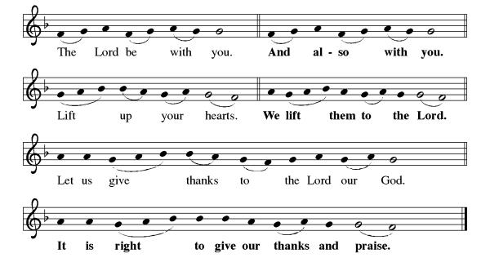
**Preface: As we celebrate Christ’s resurrection from the dead… this hymn of praise:
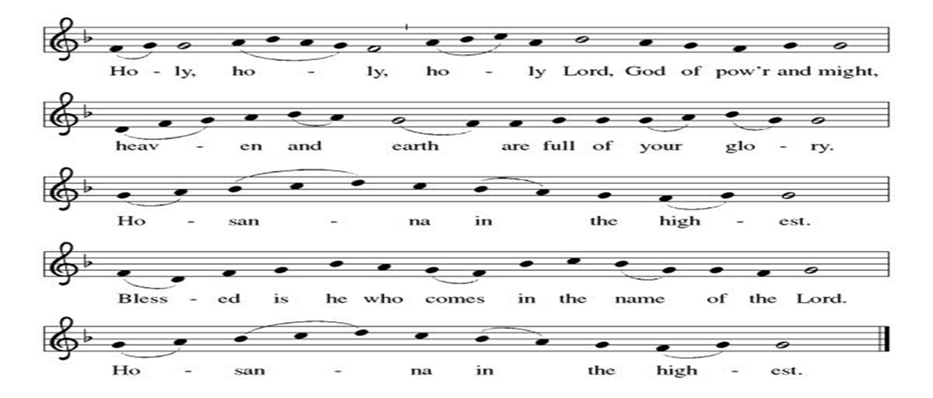
**Words of Institution

**LORD’S PRAYER
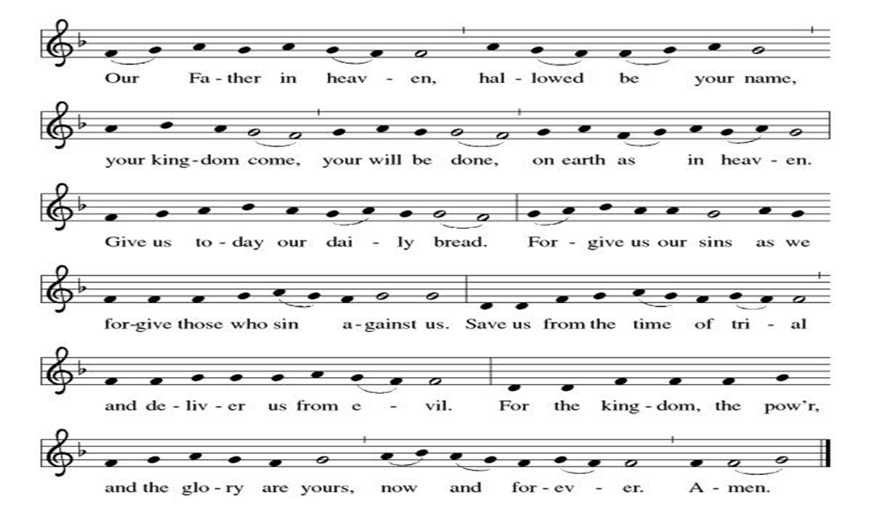

Invitation to Communion

Communion Hymn It Is Well with My Soul EL#785

**Sending Song

Now Lord ELW#201

**Prayer After Communion
Alleluia! We give you thanks, risen Lord, for your life-giving presence among us. You have fed and refreshed us with the healing gift of life. Now send us out to share the good news of the empty tomb, through all that we say and do. Amen! Alleluia!

**Blessing

**Closing Hymn Great Is Thy, Faithfulness ELW#733

**Dismissal

Go in peace to serve our Risen Christ. Alleluia!
THANKS BE TO GOD!

+ + + + + +

Hymns from Setting 05 and the Evangelical Lutheran Worship are under copyright and used with permission under One License #733618-A. Specific copyright information as listed in bulletin, the Prayers of Intercession are under copyright and are used with permission under Augsburg Fortress Liturgy License #SB155933. All other liturgy written by Sarah Pierce.

Weekly Attendance

Week of April 19

26
******************************************************************************************

Calendar of Events

Today
- Coffee with Council

This Week
April 28 | Creative Friends
April 29 | Bells practice
May 03 | Blessing of CSL  View Christian Nationalism part 2

Upcoming Events

May 05 | Creative Friends
May 06 | Paint Party Fundraiser
May 09 | Men’s Breakfast IHOP
May 10 | Baptismal Sunday  Mother’s Day
May 12 | Creative Friends
May 13 | Church Council Meeting 6:30 pm
May 17 | Congregational Meeting after worship
May 19 | Creative Friends
May 20 | Newsletter Deadline
May 23 | Project Comfort 9:00 am-Noon
May 24 | Pentecost  Vigil 7:00 pm
May 25 | Memorial Day
May 26 | Creative Friends
May 31 | Fifth Sunday Conversation
June 03 | Paint Party Fundraiser
June 07 | View Christian Nationalism part 3  Ice Cream Social
June 19 | Juneteenth Office Closed
June 21 | Father’s Day
June 28 | Coffee with Council
July 01 | Paint Party Fundraiser
July 04 | Independence Day
July 26 | Coffee with Council  Celebrate Niel’s Birthday (July 28)
September 13 | God’s Work. Our Hands.

Note: 2026 paint party fundraisers: May 6, June 3, July 1, Aug. 5, Sept. 2, Oct. 7, Nov. 4, Dec. 2
*****************************************************************************
Pastor Sarah Questions:

- There’s a story that I came across for the first time this week, although some of you may be familiar with it if you’ve studied Greek mythology. As so often happens, there are a couple of versions of this story in which the details differ. In brief, here’s the story. There was an oracle at Delphi, at which lived a demon named Python, a child of Gaia. Either Apollo was looking for a place to establish his temple and liked Delphi, and wanted to rid the place of the dangerous Python, or Python was pursuing Apollo’s mother and she encouraged him to kill Python to save her. Either way, Apollo did battle with Python and was victorious, slaying the demon. Apollo established his temple at Delphi and became the patron god of clairvoyance, and the priestesses at the oracle began to prophesy in his name, rather than in Python’s name. The word that is used for the spirit that possesses the girl is the Greek form of Python. And, on top of that, Caesar Augustus credited Apollo with his military success, so Philippi was a city loyal to Apollo. So this story is really a battle that God is waging to show the people of Philippi that God is stronger than Apollo.
- I chose to lift up a connection with the girl (household worker) who was possessed by the spirit of divination/clairvoyance, but there are other ways to go in this story too. The second half of the story, where Paul and Silas are in jail, is important in the American Civil Rights movement, because of Paul and Silas’ nonviolent response to the violence and imprisonment perpetrated against them. What other directions could this text go?
- It’s likely that none of the people in the innermost cell with Paul and Silas were followers of Christ, since they were looking on, rather than participating in the singing and praying that Paul and Silas were doing. But none of them left when the earthquake happened. I know it’s pure speculation, but what do you think convinced them to stay? Paul and Silas’ oratorical skills on behalf of the guard? Sympathy for the guard, who would have faced public execution if they had run away? Paul and Silas’ faith? Or had they received their own faith? (Or none of the above?)
- Why do you think Paul and Silas chose to hide their Roman citizenship until after they were released?

******************************************************************************************
BLUE SPRINGS COMMUNITY SERVICE LEAGUE is very appreciative of your continued support of your neighbor.
April 26
Altar Guild – Sara Meyers
Lector – Kent Deubner
Greeter – Donna Taylor
Usher-Paul Blixrud
Tech – Gary Antes

Prayer Requests
Monty & Marie Health Concerns (Maech 04)
Paul Health Concerns (May 31)
Mary Health Concerns (May 15)
James & Family Health Concerns (September 11)
Betty F (Sara’s friend) Health Concerns (July 15)
William and Family Health Concerns (September 25)
Becky H Health Concerns (October 28)
David Health Concerns (November 18)
Becky W Health Concerns (November 18)
Judy Health Issues (December 16)
Kay (Sara’s cousin) Health Concerns (July 15)
Sharon Health Concerns (October 22)
Michael Health Concerns (October 22)
Peter and Carrie Health Concerns (November 26)
Melian Health Concerns (November 16)
RJ Health Concerns (November 17)
Barbara Health Concerns (December 30)
Helen Health Concerns (February 25)
Val (Tonya’s sister) Health Concerns (February 18)
Lorey Health Concerns (April 14)

Merciful God, your justice and mercy are without limits. Bring courage and resilience to those who resist tyranny with their words and their bodies. Strengthen those who fight for justice in your name across the country, and around the world.

Please pray for the people of Venezuela & Iran, Sudan, Gaza, Ukraine, Israel, Cuba, Iran and Palestine.
Please pray for the Homeless.
Please pray for legal & illegal immigrants & those seeking asylum or citizenship

