**All Saints Lutheran Church, ELCA**

**421 SW 19th St. Blue Springs, Missouri 64015 816-229-3633**

**Pastor Sarah Pierce** Spierce.aslcpastor@gmail.com

[allsaintslc64015@gmail.com](mailto:allsaintslc64015@gmail.com) <https://aslcbs.org/>

## Sunday, June 15, 2025

## The Holy Trinity

## *You are absolutely invited into this sacred space.  We welcome all who are seeking God’s love and grace.  All Saints recognizes that we are all unique and beloved children of God.  We celebrate and give thanks for the many diverse gifts that God has given us.  We affirm the sacredness of people of all sexual orientations, gender identities, and gender expressions.  We affirm the sacredness of all those who have experienced exclusion because of race, ability, age, or culture. We are committed to working towards anti-racism in ourselves and our community. We affirm the sacredness of all those who wrestle with addiction, physical or mental health, imprisonment, socio-economic circumstances, or anything that too often divides us.  We believe that through our openness we all grow in our faith through Christ’s teaching to love one another as God loves us.  We need each other and our sincere hope is by being in community together, we will experience God’s presence in new and real ways.*

*The offering plate is by the main door to the sanctuary for your convenience.*

*We practice open communion at All Saints Lutheran Church. What does that mean? It means that if you believe and trust that Christ offers his body and blood For You, you are welcome at the table. At All Saints, we believe that Christ invites all people to the feast. “Come to the banquet for all is now ready.”*

***\*\*Stand as you are comfortable***

***Prelude***

***Announcements***

**\*\* Confession and Forgiveness**

Siblings in Christ, as we gather in this place, let us confess our sins together in the ancient words of the people:

**O God, have mercy on me!**

**Because of your love and your great compassion, wipe away my faults;**

**wash me clean of my guilt;**

**purify me of my sin.**

**For I am aware of my faults,**

**and have my sin constantly in mind.**

**I sinned against you alone,**

**and did what is evil in your sight.**

**You are just when you pass sentence on me,**

**blameless when you give judgment.**

**I was born in sin, conceived in sin -**

**yet you want truth to live in my innermost being.**

**Teach me your wisdom!**

**Bless God, my soul!**

**All that is in me, bless God’s holy name!**

**Bless God, my soul,**

**and remember all God’s kindness!**

The One who forgives all your sins is the One who heals all your disease;

the One + who ransoms your life from the Pit is the One who crowns you with love and tenderness.

God’s love lasts from age to age for those who revere them,

as does God’s goodness to our children’s children,

and to those who cling to the faith of Christ.

**Amen.**

***\*\*Entrance Hymn Holy, Holy, Holy, Lord God Almighty! ELW#413***

***\*\*Greeting***

The grace of our Lord Jesus Christ, the love of God,

and the communion of the Holy Spirit be with you all.

**And also with you.**

**\*\*Kyrie**

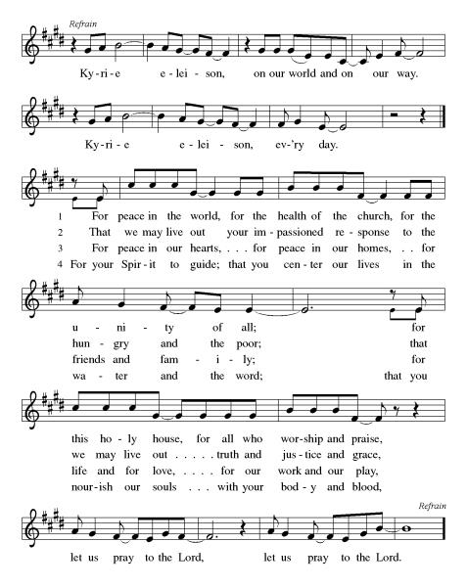

***\*\*Prayer of the Day***

**God of Cloud and Fire, you call us to holiness. You call us to relationship with you, with each other, and with all of creation. With the Spirit’s help, strengthen and sustain us for the work you have set before us to do. We pray this in Jesus’ name. Amen.**

***Reading:*** **Exodus 40: 34-38; Leviticus 1:1-2a, 19:2b**

34Then the cloud covered the Tent of Meeting, and the glory of God filled the Tabernacle. 35Moses could not enter the Tent of Meeting, because the cloud so densely covered it and because the glory of God so completely filled the Tabernacle.

36Throughout all their journeys, whenever the cloud would rise from the Tabernacle, the Israelites would set out. 37If the cloud did not rise, they waited and would not move until it did. 38The cloud rested on the Tabernacle in the daytime, and at night there was fire in the cloud so that the whole house of Israel could see. And so it remained for every stage of their journey.

1:1 God called to Moses from the Tent of Meeting, and told him 2to tell these things to the people of Israel: 19:2b“Be holy, for I, your God, am holy.”

Word of God, Word of Life

**Thanks be to God**

***\*\*Gospel Acclamation***

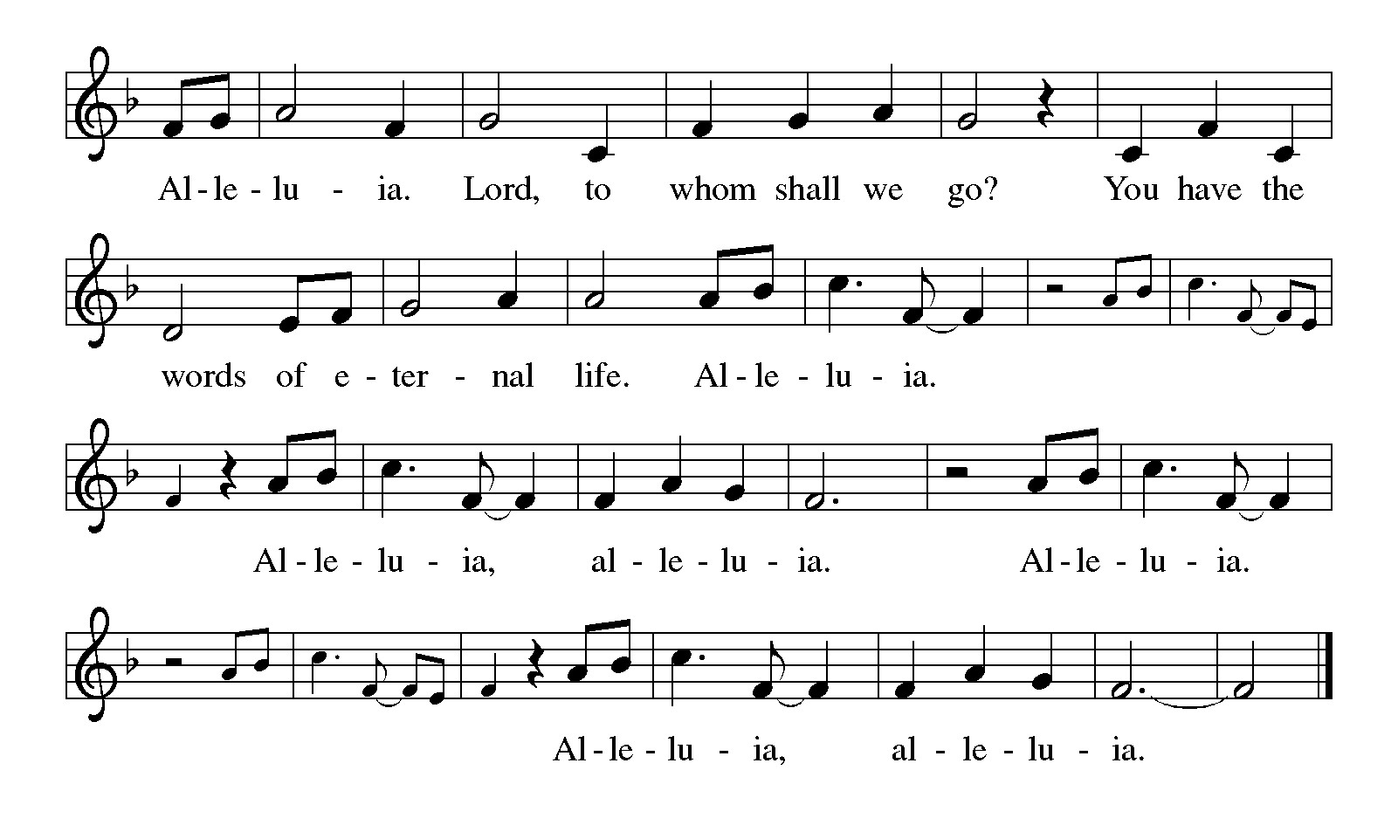

*Announcement of the Gospel*

**Glory to you, O Lord.**

***Gospel:* Luke 10: 1-11**

1After this, Jesus appointed seventy-two others, and sent them on ahead in pairs to every town and place he intended to visit. 2He said to them, “The harvest is rich, but the workers are few; therefore ask the overseer to send workers to the harvest.

3 “Be on your way, and remember: I am sending you as lambs in the midst of wolves. 4Don’t carry a walking stick or knapsack; wear no sandals and greet no one along the way. 5And whatever house you enter, first say, ‘Peace be upon this house!’ 6If the people live peacably there, your peace will rest on them; if not, it will come back to you. 7Stay in that house, eating and drinking what they give you, for the laborer is worth a wage. Don’t keep moving from house to house.

8 “And whatever city you enter, after they welcome you, eat what they set before you 9and heal those who are sick in town. Say to them, ‘The reign of God has drawn near to you.’ 10If the people of any town you enter don’t welcome you, go into its streets and say, 11 ‘We shake the dust of this town from our feet as testimony against you. But know that the reign of God has drawn near.’”

The Gospel of the Lord.

**Praise to you, O Christ.**

**Sermon "Introduction/Holiness"**

***Hymn of the Day* Glorious Things of You Are Spoken ELW#647**

\*\***Affirmation of Faith – Immigrant’s Creed by Jose Luis Casal**

**I believe in Almighty God, who guided the people in exile and in exodus, the God of Joseph in Egypt and Daniel in Babylon, the God of foreigners and immigrants.**

**I believe in Jesus Christ, a displaced Galilean, who was born away from his people and his home, who fled his country with his parents when his life was in danger. When he returned to his own country he suffered under the oppression of Pontius Pilate, the servant of a foreign power. Jesus was persecuted, beaten, tortured, and unjustly condemned to death. But on the third day Jesus rose from the dead, not as a scorned foreigner but to offer us citizenship in God’s kingdom.**

**I believe in the Holy Spirit, the eternal immigrant from God’s kingdom among us, who speaks all languages, lives in all countries, and reunites all races.**

**I believe that the Church is the secure home for foreigners and for all believers. I believe that the communion of saints begins when we embrace all God’s people in all their diversity. I believe in forgiveness, which makes us all equal before God, and in reconciliation, which heals our brokenness. I believe that in the Resurrection God will unite us as one people in which all are distinct and all are alike at the same time. I believe in life eternal, in which no one will be foreigner but all will be citizens of the kingdom where God reigns forever and ever. Amen.**

***\*\*Prayers of Intercession***

**God of Love, hear the prayers that we lift before you. Hold close to you all those for whom we pray.**

Abiding God, your love pours into your whole church, creating faith and bestowing hope. Fill all the baptized with these good gifts in our various callings. Gather your church in every place and expression into the unity of your Spirit. God of grace,

**hear our prayer.**

Creating God, your name is majestic in all the earth, and we are filled with awe at your creation. Renew this planet and all its wonders: springs abounding with water, earth and soil, beasts of the field, birds of the air, and fish of the sea. God of grace,

**hear our prayer.**

Sovereign God, you delight in the whole human race. On this week of Juneteenth, bring an end to racial oppression and heal the wounds of racial trauma. Grant us your wisdom, so that all people, especially those in authority, work for the life and freedom of others. God of grace,

**hear our prayer.**

Compassionate God, your mindful care for us is everlasting. Give peace to all who are troubled, endurance to all who suffer, deliverance to all who are afflicted, and healing to all who are sick especially Monty, Paul, Linda, Betty F, Carla, Becky H., Becky W., David, William and family, Helen, Larry, Stephen, Jennifer, Otto, Fran, families in our community who endure hunger, and our beloved for whom death is near. Embrace all who are far from home or estranged from loved ones, and all who live with regret. Embolden your people to offer and to seek forgiveness. May all who weep now sing songs of joy again. Wipe away every tear. Lift up all who have been bowed low by circumstances or internal strife. Bring to wholeness those who cry out to you in need. God of grace,

**hear our prayer.**

Living God, your glory appears in our shared life. On this Father’s Day, give to all fathers and father figures gentle hearts and strong spirits, heal the wounds in our families, and comfort those for whom this day brings pain. God of grace,

**hear our prayer.**

Merciful God, your justice and mercy are without limits. Bring courage and resilience to those who resist tyranny with their words and their bodies. Strengthen those who fight for justice in your name in Los Angeles, across the country, and around the world. Protect and sustain immigrants and refugees and all who work with them. That your Kingdom, without borders and without walls, may truly come on earth as it is in heaven. God of grace,

**Your mercy is great.**

Eternal God, your hope does not disappoint. We give you thanks for all who have died in the hope of the resurrection. Hold us in our grief, and bring us at last to fullness of life in you. God of grace,

**hear our prayer.**

**Good and loving God, we give everyone we have prayed for into your care. Amen.**

*\*\** ***Sharing of the Peace***

### *\*\*Offering is brought forward*

### *\*\** *Offertory Response*

### *As the Grains of Wheat (Refrain Only) ELW#465*

### *\*\*Offertory Prayer*

**Holy God, we return to you with thanks the first fruits of what you have given us: our time, our talents and interests, and our money. Use these gifts to your service and for your ministry in this place. We pray this in Jesus’ name. Amen.**

**Dialogue**

Thank you God, for you are good!

**Your love is everlasting!**

You alone perform such great marvels.

**Your love is everlasting!**

Your wisdom made the heavens.

**Your love is everlasting!**

You spread the land out over the waters.

**Your love is everlasting!**

You made the great lights:

**Your love is everlasting!**

The sun to govern the day, moon and stars to govern the night.

**Your love is everlasting!**

**\*\*Preface:** Since the earliest days of the covenant…this hymn of praise:

**Create in Me ELW#186**

***\*\*Words of Institution***

**\*\*LORD’S PRAYER**

**Our Father, who art in heaven,**

**hallowed be thy name,**

**thy kingdom come,**

**thy will be done,**

**on earth as it is in heaven.**

**Give us this day our daily bread;**

**and forgive us our trespasses,**

**as we forgive those**

**who trespass against us;**

**and lead us not into temptation,**

**but deliver us from evil.**

**For thine is the kingdom,**

**and the power, and the glory,**

**forever and ever. Amen.**

***Invitation to Communion***

# ***Communion Hymn Now We Join in Celebration ELW#462***

### *\*\*Sending Song*

### *Praise to you, O God of Mercy ELW#208*

### *\*\*Prayer After Communion*

**Grafted onto the tree of faith and grounded in our baptisms, we have been fed by the Word and at the Table. Now send us out to share the joy of Christ with all whom we encounter. Amen.**

### *\*\*Blessing*

### *\*\*Closing Hymn Jesu, Jesu, Fill Us With Your Love ELW#*708

### *\*\*Dismissal*

Go in peace, serve, Christ and the world

**THANKS BE TO GOD!**

### + + + + + +

*Hymns from the Evangelical Lutheran Worship are under copyright and used with permission under One License #733618-A. Specific copyright information as listed in bulletin, the Prayers of Intercession are under copyright and are used with permission under Augsburg Fortress Liturgy License #SB155933. All other liturgy written by Sarah Pierce.*

*Confession and Forgiveness based on Psalm 51:1-6 and Psalm 103:104, 17-18 (adapted). Dialog based on Psalm 136:1, 4-8. Thanksgiving based on Psalm 100 (adapted). Benediction based on 1 Thessalonians 5:16-24 (adapted).*

**Weekly Attendance**

***Week of June 08***

***26***

*\*\*\*\*\*\*\*\*\*\*\*\*\*\*\*\*\*\*\*\*\*\*\*\*\*\*\*\*\*\*\*\*\*\*\*\*\*\*\*\*\*\*\*\*\*\*\*\*\*\*\*\*\*\*\*\*\*\*\*\*\*\*\*\*\*\*\*\*\*\*\*\*\*\*\*\*\*\*\*\*\*\*\*\*\*\*\*\*\*\**

**Calendar of Events**

***Today***

* ***Father’s Day***
* ***Adult Bible Study***

***This Week***

|  |  |
| --- | --- |
| ***June 17*** | ***Creative Friends 1:00 pm*** |
| ***June 18*** | ***Council Meeting 6:30 pm*** |
| ***June 19*** | ***Juneteenth-Office Closed*** |
| ***June 21*** | ***PMA Worship Class 10:00am-2:00pm*** |

***Upcoming Events***

|  |  |
| --- | --- |
| ***June 22*** | ***Coffee with Council*** |
| ***June 24*** | ***Creative Friends 1:00 pm*** |
| ***June 28*** | ***Project Comfort 9:00 am-Noon*** |
| ***June 29*** | ***Fifth Sunday of Conversation*** |
| ***July 01*** | ***Creative Friends 1:00 pm*** |
| ***July 04*** | ***Independence Day-Office Closed*** |
| ***July 06*** | ***Blessing of CSL Contributions*** |
| ***July 08*** | ***Creative Friends 1:00 pm*** |
| ***July 13*** | ***Baptismal Birthdays*** |
| ***July 13*** | ***Installation of Church Council/Ice Cream Social after Worship/Photo OP*** |
| ***July 15*** | ***Creative Friends 1:00 pm*** |

****************************************************************************************

The book of Leviticus has kind of a bad reputation. We often think of it as being excessively rules-based, really strict, with regulations that don’t really apply to us any longer in our modern world. So much so that it seems like Leviticus has two purposes in modern Christianity – either to be ignored and set aside, or to have verses pulled out of context to be used to condemn others. But neither of those are a fair treatment of Leviticus. When we dive into it, we discover a text that we can wrestle with and learn from. A text that has much to teach us about faithfulness to God and to each other.

We will be exploring this book in a **7-part sermon series** this summer, starting on **Holy Trinity Sunday.**

* **June 22: Sacrifices**
* **June 29: Worship (5th Sunday Conversation)**
* **July 06: Purification**
* **July 13: Holiness Code part 1**
* **July 20: Holiness Code part 2**
* **July 27: Sabbath/Conclusion**

**\*\*\*\*\*\*\*\*\*\*\*\*\*\*\*\*\*\*\*\*\*\*\*\*\*\*\*\*\*\*\*\*\*\*\*\*\*\*\*\*\*\*\*\*\*\*\*\*\*\*\*\*\*\*\*\*\*\*\*\*\*\*\*\*\*\*\*\*\*\*\*\*\*\*\***

**“The New Colossus” by Emma Lazarus (1849-1887)**

Not like the brazen giant of Greek fame,  
With conquering limbs astride from land to land;  
Here at our sea-washed, sunset gates shall stand  
A mighty woman with a torch, whose flame  
Is the imprisoned lightning, and her name  
Mother of Exiles. From her beacon-hand  
Glows world-wide welcome; her mild eyes command  
The air-bridged harbor that twin cities frame.  
“Keep, ancient lands, your storied pomp!” cries she  
With silent lips. “Give me your tired, your poor,  
Your huddled masses yearning to breathe free,  
The wretched refuse of your teeming shore.  
Send these, the homeless, tempest-tost to me,  
I lift my lamp beside the golden door!”

*(poets.org)*

This poem was written by Lazarus in 1883 as part of the fund-raising efforts for a base for the Statue of Liberty. It is cast on a plaque that is mounted on the inside of the base of the statue. Lazarus was an activist and advocate for Jewish refugees fleeing from Russian pogroms in the 1800s, and wrote the poem as a way to express empathy for Russian Jewish refugees to the US.

The statue was intended to be a symbol of republican (anti-imperialist) values; however, Lazarus’ poem gave it a new purpose, turning it into a symbol of welcome for immigrants and refugees at the front door of the country. *(Wikipedia article on “The New Colossus”)*

*\*\*\*\*\*\*\*\*\*\*\*\*\*\*\*\*\*\*\*\*\*\*\*\*\*\*\*\*\*\*\*\*\*\*\*\*\*\*\*\*\*\*\*\*\*\*\*\*\*\*\*\*\*\*\*\*\*\*\*\*\*\*\*\*\*\*\*\*\*\*\*\*\*\*\*\*\*\*\*\*\*\*\*\*\*\*\*\*\**

*You may recall that there has been an announcement in the bulletin over the past year directing you to Lutheran Immigration and Refugee Services (LIRS) if you wish to support the people of Ukraine. LIRS has changed its name to Global Refuge and can be found at* ***globalrefuge.org****. Although their name has changed, their mission remains the same: to assist and support refugees in the United States and around the world. Visit their website to see all the ways you can support this important work.*

**\*\*\*\*\*\*\*\*\*\*\*\*\*\*\*\*\*\*\*\*\*\*\*\*\*\*\*\*\*\*\*\*\*\*\*\*\*\*\*\*\*\*\*\*\*\*\*\*\*\*\*\*\*\*\*\*\*\*\*\*\*\*\*\*\*\*\*\*\*\*\*\*\*\*\*\*\*\*\*\*\*\*\*\*\*\*\*\*\***

**BLUE SPRINGS COMMUNITY SERVICE LEAGUE** *is very appreciative of your continued support of your neighbor.*

*\*\*\*\*\*\*\*\*\*\*\*\*\*\*\*\*\*\*\*\*\*\*\*\*\*\*\*\*\*\*\*\*\*\*\*\*\*\*\*\*\*\*\*\*\*\*\*\*\*\*\*\*\*\*\*\*\*\*\*\*\*\*\*\*\*\*\*\*\*\*\*\*\*\*\*\*\*\*\*\*\*\*\*\*\*\*\*\*\*\**

**Questions for Reflection and Discussion**

1. The people of God come to a stop at the foot of Mt. Sinai in Exodus 19:2 and remain there until Numbers 10:11. The last 22 books of Exodus, all of Leviticus, and the first 9 books of Numbers all take place while the Israelites are camped at the foot of Mt. Sinai. In terms of the narrative, scholars assume that Leviticus picks up almost exactly where Exodus leaves off.
2. The name Leviticus comes from the Greek word Levite, which is roughly translated “priestly class.” That’s not a great name for the book. A better name would be “Vayikra,” which is Hebrew for “And [God] called,” which is the first word in the book and the traditional naming convention in Hebrew. While part of Leviticus is directed toward the Levites, much of it is directed toward all of the people.
3. The Tabernacle is basically a portable house for the Ark of the Covenant, so that God can travel with the people on their wanderings. When they stop in Exodus 19:2, they are exactly 3 months into their journey; by the time they start again in Numbers, they’ll still have 39 years left, give or take. Why is it important that God has a house among them?
4. What does it mean to you to be holy, because God is holy?
5. How are you being sent out by Jesus on the three-fold mission (to become part of the community, heal the sick, and proclaim the reign of God)?

***\*\*\*\*\*\*\*\*\*\*\*\*\*\*\*\*\*\*\*\*\*\*\*\*\*\*\*\*\*\*\*\*\*\*\*\*\*\*\*\*\*\*\*\*\*\*\*\*\*\*\*\*\*\*\*\*\*\*\*\*\*\*\*\*\*\*\*\*\*\*\*\*\*\*\*\*\*\*\*\*\*\*\*\*\*\****

***Birthdays***

***June 20 Katy Melton***

***June 21 Chuck Dustin***

***Anniversaries***

***June 18 Larry & Judy Taylor***

***June 20 Aaron & Jackie Soetmelk***

***Acolyte-June 15-Youth***

***Greeter –*** **June 15*-******Donna Taylor***

***Usher –* June 15*-Paul Blixrud***

***Altar Guild-* June 15-Sara Myers**

***Reader-* June 15-Jim McDonald**

***Communion Assistant-* June 15-Youth**

**Fellowship-June 15-Youth**

***Tech-* June 15*-Gary Antes***

**Prayer Requests**

***Monty Health Concerns (May 15)***

*Paul Health Concerns (May 31)*

*Mary Health Concerns (May 15)*

*Carla (Pr. George’s wife) Health Concerns (June 26)*

*James & Family Health Concerns (September 11)*

*Betty F (Sara’s friend) Health Concerns (September 23)*

*William and Family Health Concerns (September 25)*

*Becky H Health Concerns (October 28)*

*David Health Concerns (November 18)*

*Becky W Health Concerns (November 18)*

*Larry Health Issues (December 16)*

*Helen Health Issues (January 14)*

*Stephen Health Concerns (February 27)*

*Jennifer Health Concerns (February 27)*

*Otto Health Concerns (April 23)*

*Fran Health Concerns (April 23)*

***Merciful God, your justice and mercy are without limits. Bring courage and resilience to those who resist tyranny with their words and their bodies. Strengthen those who fight for justice in your name in Los Angeles, across the country, and around the world.***

***Please pray for the people of Haiti, Ukraine, Israel and Palestine.***

***Please pray for the people of the Sudan.***

***Please pray for the Homeless.***

***Please pray for legal & illegal immigrants & those seeking asylum or citizenship.***