All Saints Lutheran Church, ELCA
421 SW 19th St. Blue Springs, Missouri 64015 816-229-3633
Pastor Sarah Pierce Spierce.aslcpastor@gmail.com
allsaintslc64015@gmail.com https://aslcbs.org/

Sunday, February 15, 2026

Transfiguration of our Lord

You are absolutely invited into this sacred space. We welcome all who are seeking God’s love and grace. All Saints recognizes that we are all unique and beloved children of God. We celebrate and give thanks for the many diverse gifts that God has given us. We affirm the sacredness of people of all sexual orientations, gender identities, and gender expressions. We affirm the sacredness of all those who have experienced exclusion because of race, ability, age, or culture. We are committed to working towards anti-racism in ourselves and our community. We affirm the sacredness of all those who wrestle with addiction, physical or mental health, imprisonment, socio-economic circumstances, or anything that too often divides us. We believe that through our openness we all grow in our faith through Christ’s teaching to love one another as God loves us. We need each other and our sincere hope is by being in community together, we will experience God’s presence in new and real ways.

The offering plate is by the main door to the sanctuary for your convenience.

We practice open communion at All Saints Lutheran Church. What does that mean? It means that if you believe and trust that Christ offers his body and blood For You, you are welcome at the table. At All Saints, we believe that Christ invites all people to the feast. “Come to the banquet for all is now ready.”

**Stand as you are comfortable

Prelude

Announcements

** Affirmation of Baptism

God prepares a way for us, a path through the desert. In our baptisms, Jesus calls us to follow that path, and we receive the gift of the Holy Spirit, empowering us to answer Jesus’ call. But sometimes, we forget the gift of forgiveness and unending love that we have been given, and we need to be reminded.

Jesus, sometimes we forget to listen to your call. We forget about the power of our baptisms. Sometimes, we get distracted with other things and forget to place you first. We ask that you help us to turn back to you when we turn away. We ask you to help us recenter our lives on you, so that we remember the power of our baptisms. We pray that we can feel your presence in our lives.

We ask you to receive our prayers and to be with us, today and forever. We pray that your presence shines through us to those who most need to see it.
Let your light so shine before others that they may see your good work and glorify God in heaven.

Holy and loving God, we thank you for the gift of forgiveness. We thank you for the gift of your unconditional love.

Holy and loving Jesus, we thank you for the gift of the baptism which frees us from the power of sin and death, for all time. We thank you for showing us how to live in that freedom.

Holy and loving Spirit, we thank you for infusing us with your presence. Empower us to live out our baptismal call to proclaim Christ through word and deed, to care for others and for the world, and to work for justice and peace. Amen.

**Entrance Hymn Christ, Be Our Light ELW#715

**Greeting
The grace of our Lord Jesus Christ, the love of God,
and the communion of the Holy Spirit be with you all.
And also with you.

**Kyrie
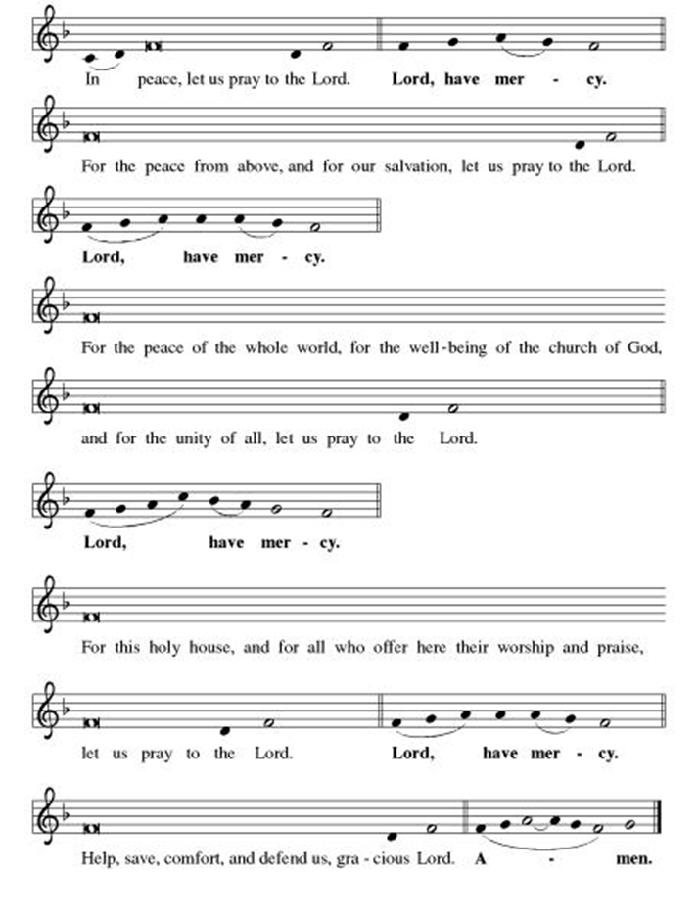

**This is the Feast
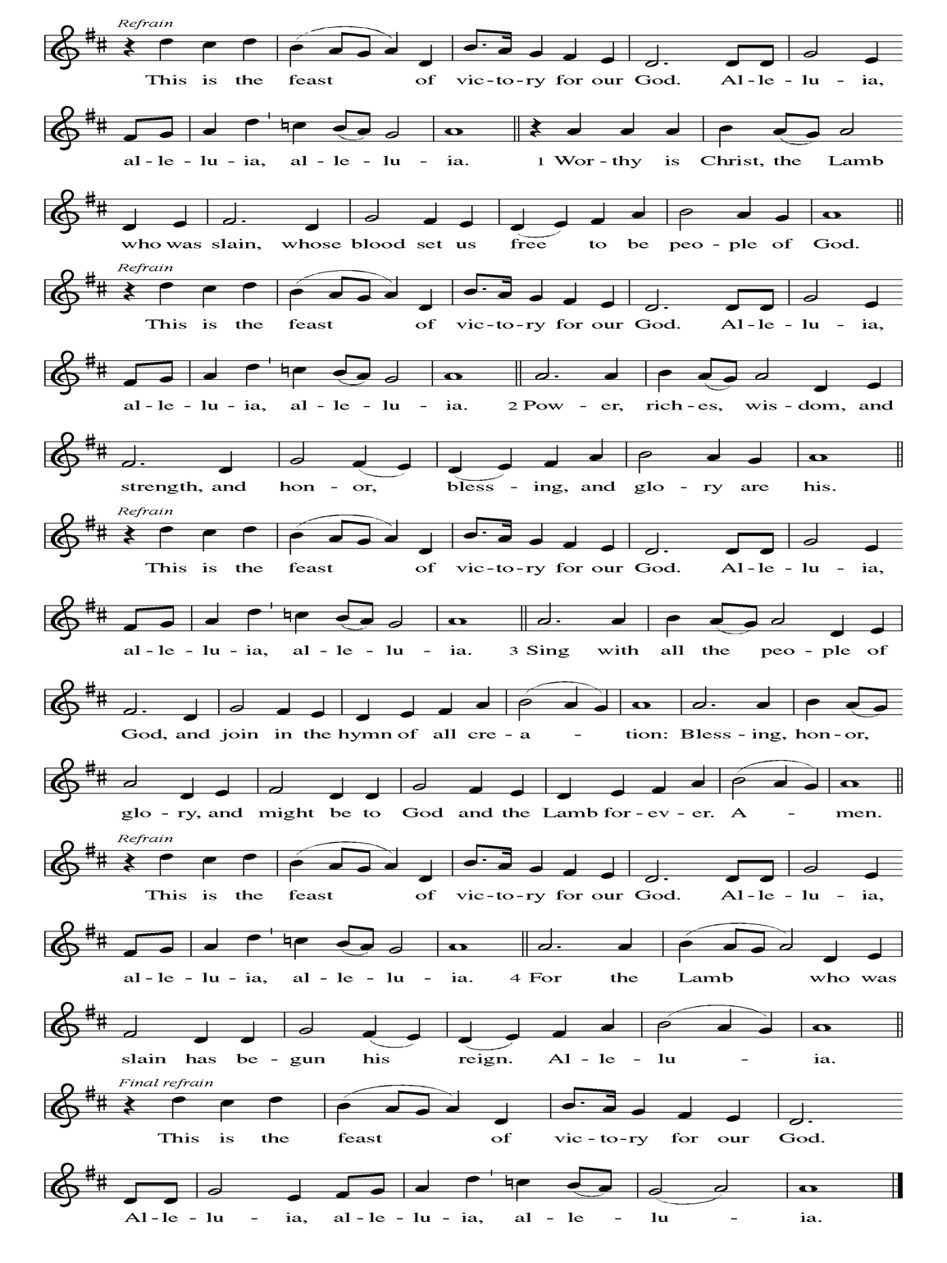
**Prayer of the Day
Jesus, we don’t always understand the signs you send us. Help us to see that it is as simple as caring for those who need us and being cared for in return. Empower us to feed those who hunger for you. We pray this in your name. Amen.

Reading: Psalm 104:27-31

²⁷All creatures depend on you to feed them at the proper time.
²⁸Give it to them – they gather it up.
Open your hand – they are well satisfied.
²⁹Hide your face – they are terrified.
Take away their breath – they die and return to dust.
³⁰Send back your breath – fresh life begins
and you renew the face of the earth.
³¹Glory forever to God!
May you find joy in your creation!

Word of God, Word of Life
Thanks be to God

**Gospel Acclamation

**Alleluia
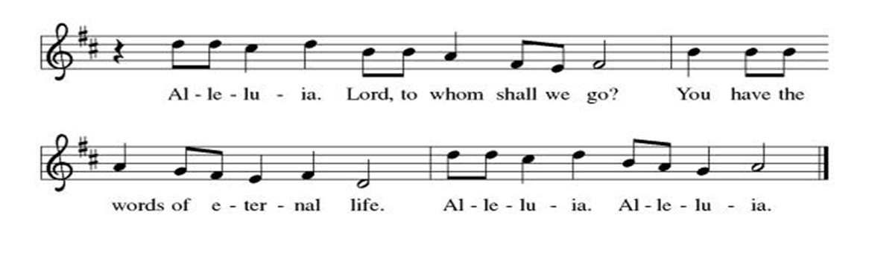
Announcement of the Gospel
Glory to you, O Lord.

Gospel: John 6:1-15

¹Some time later, Jesus crossed over to the other side of the Sea of Galilee – that is, Lake Tiberius – ²and a huge crowd followed him, impressed by the signs he gave by healing sick people. ³Jesus climbed the hillside and sat down there with the disciples. ⁴It was shortly before the Jewish feast of Passover.

⁵Looking up, Jesus saw the crowd approaching and said to Philip, “Where can we buy some bread for these people to eat?” ⁶Jesus knew very well what he was going to do, but asked this to test Philip’s response.

⁷Philip answered, “Not even with two hundred days’ wages could we buy loaves enough to give each of them a mouthful!”

⁸One of the disciples, Simon Peter’s brother Andrew, said, ⁹“There’s a small boy here with five barley loaves and two dried fish. But what good is that for so many people?”
¹⁰Jesus said to them, “Make the people sit down.” There was plenty of grass there, and as many as five thousand families sat down. ¹¹Then Jesus took the loaves, gave thanks, and gave them out to all who were sitting there; he did the same with the fish, giving out as much as they could eat.

¹²When the people had eaten their fill, Jesus said to the disciples, “Gather up the leftover pieces so that nothing gets wasted.” ¹³So they picked them up and filled twelve baskets with the scraps left over from the five barley loaves.

¹⁴The people, seeing this sign that Jesus had performed, said, “Surely this is the Prophet who was to come into the world.” ¹⁵Seeing that they were about to come and carry him off to crown him as a ruler, Jesus escaped into the hills alone.

The Gospel of the Lord.
Praise to you, O Christ.

Sermon "Alimentary Theology"

Hymn of the Day Beautiful Savior ELW#838

**Affirmation of Faith – Immigrant’s Creed by Jose Luis Casal

I believe in Almighty God, who guided the people in exile and in exodus, the God of Joseph in Egypt and Daniel in Babylon, the God of foreigners and immigrants.

I believe in Jesus Christ, a displaced Galilean, who was born away from his people and his home, who fled his country with his parents when his life was in danger. When he returned to his own country he suffered under the oppression of Pontius Pilate, the servant of a foreign power. Jesus was persecuted, beaten, tortured, and unjustly condemned to death. But on the third day Jesus rose from the dead, not as a scorned foreigner but to offer us citizenship in God’s kingdom.

I believe in the Holy Spirit, the eternal immigrant from God’s kingdom among us, who speaks all languages, lives in all countries, and reunites all races.

I believe that the Church is the secure home for foreigners and for all believers. I believe that the communion of saints begins when we embrace all God’s people in all their diversity. I believe in forgiveness, which makes us all equal before God, and in reconciliation, which heals our brokenness. I believe that in the Resurrection God will unite us as one people in which all are distinct and all are alike at the same time. I believe in life eternal, in which no one will be foreigner but all will be citizens of the kingdom where God reigns forever and ever. Amen.

**Prayers of Intercession

Jesus, you came to live with us on earth so that we would know you love us no matter what. Listen to the prayers we lift to you.

Revealing God, your Spirit sustains the church. Christ is revealed to us in many ways. Help us to recognize him, that we may joyfully follow him in the way of the cross. Merciful God,
receive our prayer.
Life-giving God, creation is full of your majesty. Nurture in us a deep respect for the interdependence of all life, and make us wise and vigilant stewards of your good earth. Merciful God,
receive our prayer.
Peacemaking God, the nations are in turmoil. We pray for an end to violent conflict. Give wisdom to negotiators and sanctuary to refugees. Defend any who are in danger. Merciful God,
receive our prayer.
Healing God, you desire wholeness for all people. Bring healing to any who are experiencing illness, chronic pain, or mental anguish. Comfort the dying and those who grieve especially Monty, Paul, Linda, Betty F., Kay, Becky H., Jim & Jan, Melian, Becky W., David, William & family, Helen, Larry & Judy, Kevin, Peter & Carrie, Barbara & Donna, Irene, families in our community who endure hunger, and our beloved for whom death is near. Merciful God,
receive our prayer.
Holy God, in our worship we glimpse your glory, hear your voice, and receive assurance of your love. Inspire all who prepare, lead, and participate in worship to serve you with reverence and joy. Merciful God,
receive our prayer.
Pave a way to justice, drown the forces of oppression, bring peace on earth. Give leaders the will to turn from war and violence. Especially we pray for the people of Venezuela, Sudan, Gaza, Israel, and Ukraine, and for Jim’s grandson Dylan, who is deployed. When people must flee their homes, guide them to safety. Comfort those living with deep trauma, anxiety, or fear; all those who serve people in need, and accompany all those who care for people in harm’s way. Merciful God,
receive our prayer.
We pray for people who rise up against injustice. Bring courage and resilience to those who resist tyranny with their words and their bodies. Strengthen those who fight for justice in your name across the country, and around the world. Protect and sustain immigrants and refugees and all who work with them, that your kingdom, without borders and without walls, may truly come on earth as it is in heaven. We pray for all victims of gun violence or kidnapping, especially those who are targeted out of hate or fear. Embolden us to holy outrage and empower us to speak our truth of love and justice. Merciful God,
receive our prayer.
We lift up all who teach and all who learn. Thank you for teachers who share their knowledge and wisdom. Bless the students in our midst. Especially we remember Evie, in kindergarten; Addison, in high school; and Tyler, Zach, Katie and Katy, in college. Bless Janet, Lisa and Carla as they teach. Merciful God,
receive our prayer.
Transforming God, you bring life from death. We give thanks for the witness of those who have died in faith, and we praise you for the hope we have in Christ, our Morning Star. Merciful God,
receive our prayer.

Loving God, because you lived among us, we know that you hear our prayers and hold close all for whom we pray. Amen

** Sharing of the Peace

**Offering is brought forward

** Offertory Response Let Us Talents and Tongues Employ (V. 1) ELW#674

**Offertory Prayer
God of abundance, with thanks, we return to you the gifts you have given us so freely. Bless these offerings of our time, our talents, and our treasure. Shape us to be your hands and feet. Use our gifts to shower each other, our communities, and the world with your loving kindness. All this we ask in Jesus’ name. Amen.

**Dialogue
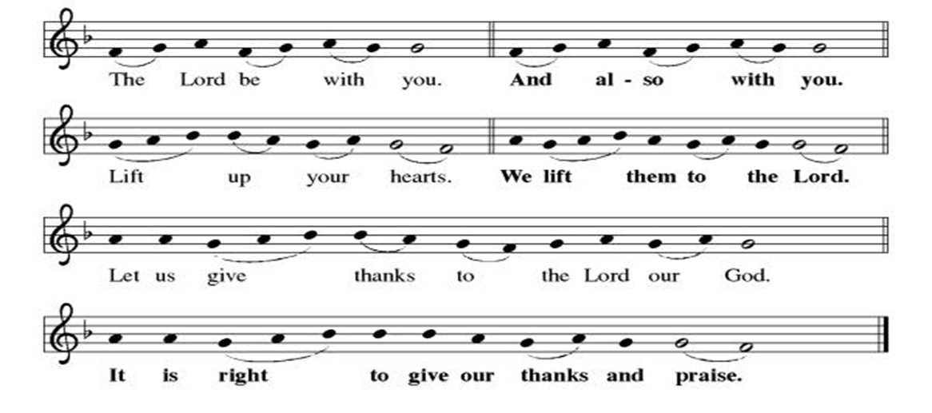
**Preface: From the beginning of time…this hymn of praise:

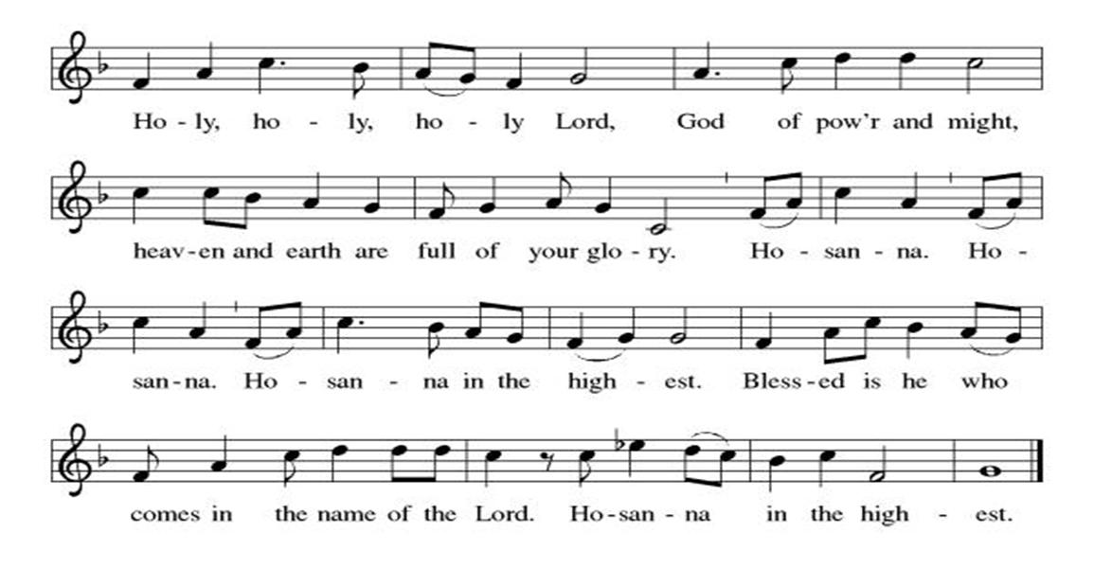
** Thanksgiving at the Table

**LORD’S PRAYER
Our Father in heaven,
hallowed be your name,
your kingdom come,
your will be done,
on earth as in heaven.
Give us today our daily bread.
Forgive us our sins
as we forgive those
who sin against us.
Save us from the time of trial
and deliver us from evil.
For the kingdom, the power,
and the glory are yours,
now and forever. Amen.

Invitation to Communion

Communion Hymn We Place Upon Your Tab;e, Lord ELW#467

**Post-communion prayer
Holy One, Human and Divine, we give you thanks for the life-giving invitation to gather at your table and be fed. Strengthen us now for your service, and send us out from this place renewed in our commitment to love you and serve each other and all of creation. Send your Spirit upon us, so that we can proclaim your blessings to a world that hungers to receive them. All this we ask in your name, the one who is, who was, and who is to come. Amen.

**Sending Song

Listen, God Is Calling (refrain, V. 1, refrain) ELW#513

**Benediction

**Closing Hymn All Creatures, Worship God Most High ELW#635

**Dismissal
Go in peace. Share the good news!
THANKS BE TO GOD!

+ + + + + +

Hymns from the Evangelical Lutheran Worship are under copyright and used with permission under One License #733618-A. ELW setting #3 the Prayers of Intercession are under copyright and are used with permission under Augsburg Fortress Liturgy License #SB155933. All other liturgy written by Sarah Pierce.

Weekly Attendance

Week of February 08
21
Next Week:
Ash Wednesday

The Color of the day is Purple
Psalm 78:23-29
John 6:16-40

Calendar of Events
Today
- Ice Cream Social
Upcoming Week
- Ash Wednesday
- God’s Global Barn yard begins February 18-April 05
February 18 | Ash Wednesday  :00Dinner 5:00 pm  Worship 7:00 pm  God’s Global Barn yard begins February 18-April 05
February 18 | Bells will play: Let All Mortal Flesh Keep Silence/Graduation Cake
February 24 | Bells
March 01 | Deacon Dave Mareske will Preach
March 01 | Information on Hollis
March 01 | Coffee with Council
March 03 | Bells
March 04 | Paint Party Fundraiser
March 10 | Bells
March 15 | Hollis Special Offering
March 15 | Church Council Meeting 11:30 am
March 17 | Bells
March 22 | Bells will play: Jesus the Very Thought Of You & O Master Let Me Walk With You
March 22 | Coffee with Council
March 24 | Bells
March 29 | Palm Sunday/Work Day wear your work clothes
March 31 | Bells
April 01 | Paint Party Fundraiser
April 05 | Easter Sunday
April 05 | Bells will play: My Lord What A Morning & We Will Glorify
April 08 | Church Council Meeting 6:30 pm
April 15 | Bells
April 20 | Good Friday Office Closed
April 22 | Bells
April 26 | Coffee with Council
April 29 | Bells
May 06 | Paint Party Fundraiser
May 10 | Mother’s Day
May 13 | Church Council Meeting 6:30 pm
May 17 | Congregational Meeting
May 24 | Pentecost
May 25 | Memorial Day
June 03 | Paint Party Fundraiser
June 19 | Juneteenth Office Closed
July 01 | Paint Party Fundraiser
July 04 | Independence Day
July 26 | Coffee with Council  Celebrate Niel’s Birthday (July 28)
Note: 2026 paint party fundraisers: Feb. 4, March 4, April 1, May 6, June 3, July 1, Aug. 5, Sept. 2, Oct. 7, Nov. 4, Dec. 2
Note: Theater group church use: auditions Feb. 6&7, 6:30-9:30; callbacks Feb. 8, 1-5; rehearsals MWF & Saturday, Feb.16-April 18, MWF 6:30-9:30 and Saturdays 12-4.

As we have done for many years now, we will join together with our ecumenical siblings in Christ to worship together during Lent. We will gather for a meal at 5:30, with worship beginning at about 6:40. As in years past, the offerings will go to Community Services League. Here is the schedule:

- February 25: Worship at Chapel Hill Presbyterian; Rev. Jonathan Galles preaching
- March 04: Worship at Episcopal Church of the Resurrection; Rev. Louie Lowe preaching
- March 11: Worship at First Christian; Rev. Steve Crandall preaching
- March 18: Worship at Good Shepherd Christian; Rev. Sarah Pierce preaching
- March 25: Worship at All Saints Lutheran; Rev. Dr. Andrew Florio preaching

February 22 | Coffee with Council
Our theme this year is Reconciliation.

******************************************************************************************

Pastor Sarah Questions

- This story is the only miracle story that appears in all four gospels. Why do you think that might be?
- The difference between this one and the ones in Matthew, Mark, and Luke is that in this one, Jesus feeds the crowd, while in the other three, he commands the disciples, “You feed them.” That’s a significant theological difference, and there’s definitely value to both. But in John, where Jesus performs signs that point to abundance, and in this story, where he is giving abundant life (which in some ways mirrors the living water he gave to the woman at the well), it is important that he be the one to feed them.
- Another small difference is that in John’s story, there is “plenty of grass” (in our translation) which likely foreshadows the Good Shepherd narrative, which is in chapter 10. The abundance of grass will provide plenty of grazing for the sheep of the Shepherd!
- This isn’t a typical Transfiguration Sunday text, in which Peter and two others go up on the mountain with Jesus, where they see him, along with Moses and Elijah arrayed in dazzling white and offer to build tabernacles for them. John doesn’t have that story. Instead, in this story, the 5000 people who are gathered finally begin to identify Jesus as the prophet (a teacher, sent by God, to teach in God’s name). But even then, much like Peter and the others don’t understand the assignment in the Transfiguration stories in the Synoptics, the 5000 gathered who eat the food that Jesus offers don’t understand the assignment here. They think he’s come for an entirely different reason – to overthrow Rome. And so they try to put him on the throne. But that’s not what he’s here for. And so he escapes.

*****************************************************************************************
BLUE SPRINGS COMMUNITY SERVICE LEAGUE is very appreciative of your continued support of your neighbor.
*****************************************************************************************
February 15
Altar Guild – Ane Lee/Paul Blixrud
Lector – Tonya Hamilton
Greeter – Donna Taylor
Tech – Gary Antes

Prayer Requests
Monty Health Concerns (May 15)
Paul Health Concerns (May 31)
Mary Health Concerns (May 15)
James & Family Health Concerns (September 11)
Betty F (Sara’s friend) Health Concerns (July 15)
William and Family Health Concerns (September 25)
Becky H Health Concerns (October 28)
David Health Concerns (November 18)
Becky W Health Concerns (November 18)
Larry & Judy Health Issues (December 16)
Helen Health Issues (January 14)
Kay (Sara’s cousin) Health Concerns (July 15)
Kevin Health Concerns (October 01)
Fred Health Concerns (October 22)
Sharon Health Concerns (October 22)
Michael Health Concerns (October 22)
Peter and Carrie Health Concerns (November 26)
Melian Health Concerns (November 16)
RJ Health Concerns (November 17)
Barbara Health Concerns (December 30)
Irene Health Concerns (February 01)

Merciful God, your justice and mercy are without limits. Bring courage and resilience to those who resist tyranny with their words and their bodies. Strengthen those who fight for justice in your name across the country, and around the world.

Please pray for the people of Venezuela, Sudan, Gaza, Ukraine, Israel, Iran and Palestine.
Please pray for the Homeless.
Please pray for legal & illegal immigrants & those seeking asylum or citizenship

