All Saints Lutheran Church, ELCA
421 SW 19th St. Blue Springs, Missouri 64015 816-229-3633
Pastor Sarah Pierce Spierce.aslcpastor@gmail.com
allsaintslc64015@gmail.com https://aslcbs.org/

Sunday, July 12, 2026

Seventh Sunday after Pentecost

You are absolutely invited into this sacred space. We welcome all who are seeking God’s love and grace. All Saints recognizes that we are all unique and beloved children of God. We celebrate and give thanks for the many diverse gifts that God has given us. We affirm the sacredness of people of all sexual orientations, gender identities, and gender expressions. We affirm the sacredness of all those who have experienced exclusion because of race, ability, age, or culture. We are committed to working towards anti-racism in ourselves and our community. We affirm the sacredness of all those who wrestle with addiction, physical or mental health, imprisonment, socio-economic circumstances, or anything that too often divides us. We believe that through our openness we all grow in our faith through Christ’s teaching to love one another as God loves us. We need each other and our sincere hope is by being in community together, we will experience God’s presence in new and real ways.

The offering plate is by the main door to the sanctuary for your convenience.

We practice open communion at All Saints Lutheran Church. What does that mean? It means that if you believe and trust that Christ offers his body and blood For You, you are welcome at the table. At All Saints, we believe that Christ invites all people to the feast. “Come to the banquet for all is now ready.”

**Stand as you are comfortable

Prelude

Announcements

Baptismal Sunday

** Confession and Forgiveness

The God that we worship is complex, multi-faceted, a single God made up of three Persons. When we try to understand the fullness of God, we fail. But God knows us and loves us and wants to be in relationship with us, so God is constantly finding new ways to be present with us. But sometimes, we fall short in our awareness. When that happens, we find that we have turned away from God to the idols of our own making.

Let us confess our sins together, as a community.

God of All the Cosmos,
Sometimes we try to make you small.
We try to put you in a box,
confine you to our way of understanding.
God, sometimes we misunderstand what you tell us.
Inspire us, Holy Spirit, to remember that you are beyond definition.
Help us to remember that you cannot be made small.
Help us to think deeply about who you are
and to respect and honor other people’s experiences of you.

Beloved in Christ, the God who walks beside you
is the same God who brings peace passing all understanding.
The Spirit who inspires your knowledge of the presence of God
is the same Spirit who moves over the waters of creation.
The Christ who hears your prayers
is the same Christ + who defeated death for the forgiveness of all sin, for all time.
Be at peace, for your sins are forgiven.

Amen.

**Entrance Hymn A Mighty Fortress ELW#504

**Greeting
The grace of our Lord Jesus Christ, the love of God,
and the communion of the Holy Spirit be with you all.
And also with you.

**Kyrie ELW 513
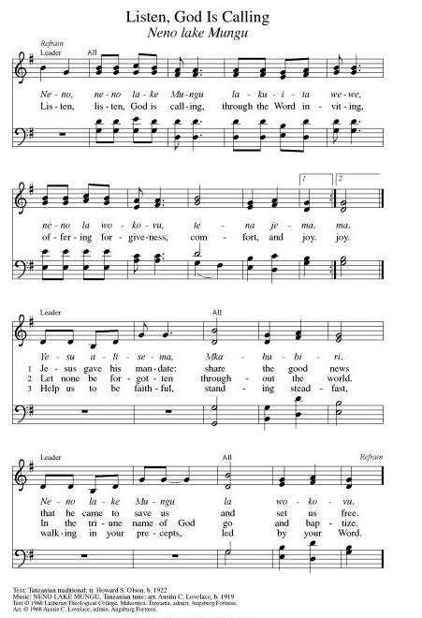
**Hymn of Praise ELW 866
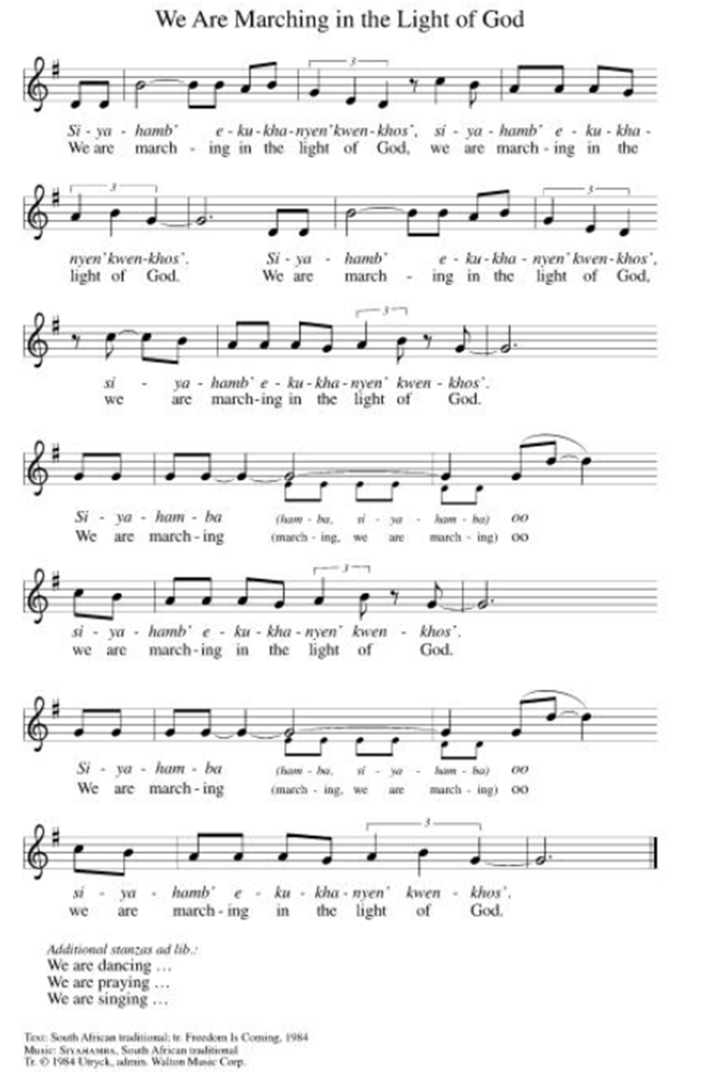

**Prayer of the Day
Holy God, you are our refuge and our strength. In our baptisms, you have brought us into your family; help us to live into our baptismal promise of renewal day after day. Encourage us to follow Jesus’ teachings, to care for our neighbor, and to share with each other the ways we sense you moving in our lives. Amen.

Reading: Psalm 46

¹God is our refuge and our strength,
who from of old has helped us in our distress.
²Therefore we fear nothing –
even if the earth should open up in front of us
and mountains plunge into the depths of the sea,
³even if the earth’s waters rage and foam
and the mountains tumble with its heaving.
⁴There’s a river whose streams
gladden the city of God,
the holy dwelling of the Most High.
⁵God is in its midst, it will never fall –
God will help it at daybreak.
⁶Though nations are in turmoil and empires crumble,
God’s voice resounds, and it melts the earth.
⁷Our God, the God of Hosts, is with us –
our stronghold is the God of Israel!
⁸Come, see what God has done –
God makes the earth bounteous!
⁹God has put an end to war,
from one end of the earth to the other,
breaking bows, splintering spears,
and setting chariots on fire.
¹⁰“Be still, and know that I am God!
I will be exalted among the nations;
I will be exalted upon the earth.”
¹¹Our God, the God of Hosts, is with us –
our stronghold is the God of Israel!

Word of God, Word of Life
Thanks be to God

Reading: Acts 2:37-42

³⁷When [the gathered crowds] heard this, they were deeply shaken. They asked Peter and the other disciples, “What are we to do?”

³⁸Peter replied, “You must repent and be baptized, each one of you, in the name of Jesus the Messiah, that your sins may be forgiven; then you will receive the gift of the Holy Spirit. ³⁹It was to you and your children that the promise was made, and to all those still far off whom our God calls.”

⁴⁰In support of his testimony, Peter used many other arguments and kept saying, “Save yourselves from this corrupt generation!” ⁴¹They were convinced by his arguments, and they accepted what he said and were baptized. That very day about three thousand were added to the number of those converted. ⁴²They devoted themselves to the apostles’ instructions and the communal life, to the breaking of bread and the prayers.

Word of God, Word of Life
Thanks be to God

**Gospel Acclamation ELW 519
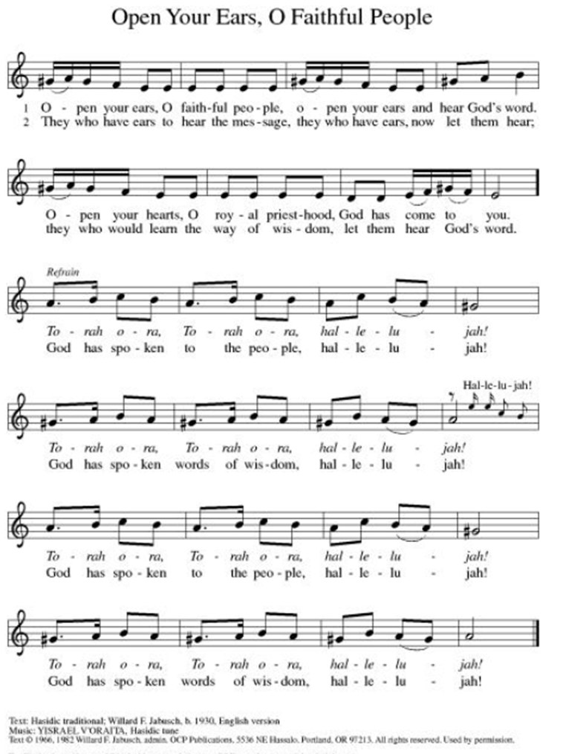
Announcement of the Gospel
Glory to you, O Lord.

Gospel: Luke 9:1-6

¹Jesus called the Twelve together and gave them power and authority to overcome all demons and to cure diseases. ²He sent them forth to proclaim the kingdom of God and to heal the afflicted.

³Jesus told them, “Take nothing for the journey, neither walking staff, nor travelling bag, nor bread, nor money. Don’t even take a change of clothes. ⁴Stay at whatever house you enter, and proceed from there. ⁵As for those who don’t receive you, leave that town and shake its dust from your feet as a testimony against them.”

⁶So they set out and went from village to village, spreading the Good News everywhere and healing people.

The Gospel of the Lord.
Praise to you, O Christ.

Sermon "Storytelling"

Hymn of the Day Baptized in Water ELW#456

**Affirmation of Faith – Immigrant’s Creed by Jose Luis Casal

I believe in Almighty God, who guided the people in exile and in exodus, the God of Joseph in Egypt and Daniel in Babylon, the God of foreigners and immigrants.

I believe in Jesus Christ, a displaced Galilean, who was born away from his people and his home, who fled his country with his parents when his life was in danger. When he returned to his own country he suffered under the oppression of Pontius Pilate, the servant of a foreign power. Jesus was persecuted, beaten, tortured, and unjustly condemned to death. But on the third day Jesus rose from the dead, not as a scorned foreigner but to offer us citizenship in God’s kingdom.

I believe in the Holy Spirit, the eternal immigrant from God’s kingdom among us, who speaks all languages, lives in all countries, and reunites all races.

I believe that the Church is the secure home for foreigners and for all believers. I believe that the communion of saints begins when we embrace all God’s people in all their diversity. I believe in forgiveness, which makes us all equal before God, and in reconciliation, which heals our brokenness. I believe that in the Resurrection God will unite us as one people in which all are distinct and all are alike at the same time. I believe in life eternal, in which no one will be foreigner but all will be citizens of the kingdom where God reigns forever and ever. Amen.

Affirmation of Baptism

People of God, you have made a public profession of your faith. Do you intend to continue in the covenant God made with you in your baptism:
To live together as God’s faithful people with all the body of Christ;
To listen to the Word preached and taught, and to answer Jesus’ invitation to the Table;
To proclaim the good news: that in Christ, we are set free to love and serve our neighbor, through our words and our actions;
To serve our neighbors in our community and around the world, striving always to follow Jesus’ example to the best of our abilities;
And to work for God’s justice and the peace that is beyond our understanding, throughout creation?

I do, and I ask God to help and guide me.

People of God, do you promise to support and pray for one another in your life in Christ?

We do, and we ask God to help and guide us.

Let us pray. Loving God, through water and the Holy Spirit you give us new birth, cleanse us from sin, and raise us to eternal life. Stir up in all your people the gift of your Holy Spirit: the spirit of wisdom and understanding, the spirit of counsel and strength, the spirit of knowledge and the reverence for our God, that we may delight in your presence now and forever.
Amen.

**Prayers of Intercession

Holy God, our prayers rise to you like the wings of a dove. We call upon your name, and we ask that you hear us.

God our joy, your bountiful creation reflects your commitment to life despite our actions disregarding its wonder. We look toward Isaiah’s vision, when all creation rejoices, and the trees will clap for joy at your salvation. God of grace,
hear our prayer.
God our joy, your bountiful creation reflects your commitment to life despite our actions disregarding its wonder. We look toward the day when all creation celebrates the grace you shower so abundantly on us, and we rejoice at your saving Spirit throughout the world. God of grace,
hear our prayer.
God our source, tend this assembly with your grace throughout this summer season. May those who travel for work or recreation do so safely, and may visitors find refreshment among us. God of grace,
hear our prayer.
Pave a way to justice, drown the forces of oppression, bring peace on earth. Give leaders the will to turn from war and violence. Especially we pray for the people of Cuba & Venezuela, Iran, Sudan, Gaza, Israel, and Ukraine. When people must flee their homes, guide them to safety. Comfort those living with deep trauma, anxiety, or fear; all those who serve people in need, and accompany all those who care for people in harm’s way. We also lift up Jim’s grandson, Dylan, who is deployed, and Sharon’s great nephew, Taylor, who is serving in the military. God of grace,
hear our prayer.
We pray for people who rise up against injustice. Bring courage and resilience to those who resist tyranny with their words and their bodies. Strengthen those who fight for justice in your name across the country, and around the world. Protect and sustain immigrants and refugees and all who work with them, that your kingdom, without borders and without walls, may truly come on earth as it is in heaven. We pray for all victims of gun violence or kidnapping, especially those who are targeted out of hate or fear. Embolden us to holy outrage and empower us to speak our truth of love and justice. God of grace,
hear our prayer.
We give you thanks that the roots of your goodness run deep throughout history. We remember those saints who have gone before us in faith. God of grace,
hear our prayer.

Good and loving God, we give everyone we have prayed for into your care. Amen.

** Sharing of the Peace

**Offering is brought forward

** Offertory Response ELW486

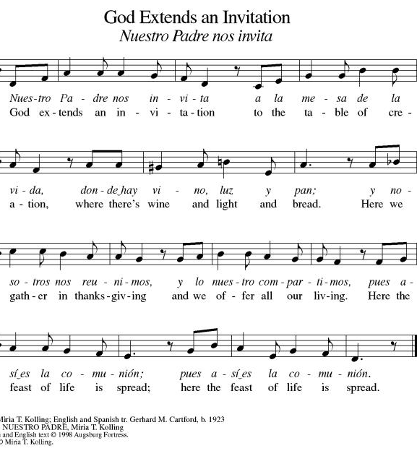
**Offertory Prayer
Jesus, all that we have and all that we are comes from you. Thank you for the gifts you have given us. Receive these gifts – our money, our service, our time – which we give in gratitude for all that we have received from you. Amen.

Dialogue
Christ is with you!
And also with you!
Lift up your hearts in joyful praise!
We lift them up to God in joy!

**Preface: We give thanks and praise to God...this hymn of praise:
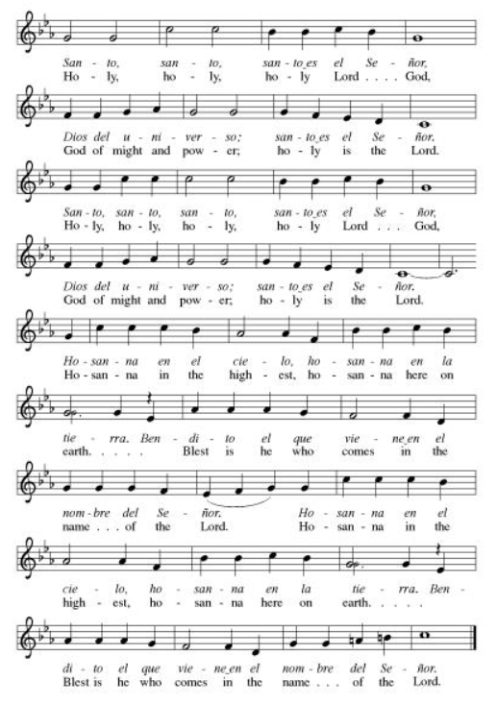
**Words of Institution

**LORD’S PRAYER
You are invited during this Pentecost season to pray whichever version feels most comfortable on your lips and in your soul. A separate sheet is available with alternate versions, should you be interested. Or, you are invited to use one of these:
Our Father in heaven, Our Father, who art in heaven,
hallowed be your name, hallowed be thy name,
your kingdom come, thy kingdom come,
your will be done, thy will be done,
on earth as in heaven. on earth as it is in heaven.
Give us today our daily bread. Give us this day our daily bread;
Forgive us our sins and forgive us our trespasses
as we forgive those as we forgive those
who sin against us. who trespass against us;
Save us from the time of trial and lead us not into temptation,
and deliver us from evil. but deliver us from evil.
For the kingdom, the power, For thine is the kingdom,
and the glory are yours, and the power, and the glory,
now and forever. Amen. forever and ever. Amen.

Invitation to Communion

Communion Hymn Jesus Loves Me ELW#595

**Sending Song ELW 535

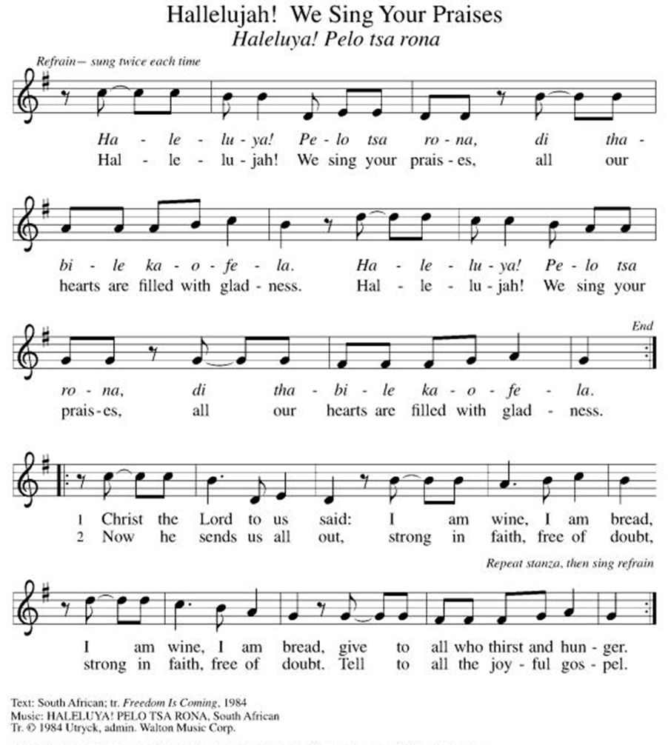

**Prayer After Communion
Holy God, you love us so much that you transformed an act of destruction into an act that gives new life. Thank you for the renewal we receive at your Table, as you send us out from this place into the world. Strengthen us for your service. In Jesus’ name we pray. Amen.

**Blessing

**Closing Hymn Will You Come and Follow Me ELW#798

**Dismissal

Empowered by the Spirit, may you go in peace to share the gospel!
THANKS BE TO GOD!

+ + + + + +

Setting 07 and hymns from the Evangelical Lutheran Worship are under copyright and used with permission under One License #733618-A. Specific copyright information as listed in bulletin, the Prayers of Intercession are under copyright and are used with permission under Augsburg Fortress Liturgy License #SB155933. All other liturgy written by Sarah Pierce.

Weekly Attendance

Week of July 05:
24
******************************************************************************************

Next Week:
8th Sunday after Pentecost:
Psalm 84
Romans 6:1-11
Luke 24:45-53

John 4:1-14
The color of the day is Green

Calendar of Events

Today
- Baptismal Sunday

This Week
July 13 | BSCT Rehearsals
July 14 | Creative Friends
July 15 | Council Meeting 6:30 pm

Upcoming Events

July 20 | Newsletter Deadline
July 21 | Creative Friends
July 25 | Project Comfort
July 26 | Coffee with Council  Celebrate Niel’s Birthday (July 28)
July 28 | Creative Friends
August 19 | Council Meeting 6:30
September 13 | God’s Work. Our Hands.
September 23 | Council Meeting 6:30 pm
September 27 | Celebration 5th year Anniversary of Pastor’s Ordination

Note: 2026 paint party fundraisers: Aug. 5, Sept. 2, Oct. 7, Nov. 4, Dec. 2

SYNOD CONFIRMATION

As announced during the recent conference gatherings and synod assembly, the Central States Synod is putting together synod-wide confirmation. Details are in the works, but here are the basics. . .

  - Classes will run from September 3 through April 15. We will meet via Zoom from 6:30 – 7:45 pm on the 1st & 3rd Thursdays.
  - We will be on a two-year cycle. One year will be a Catechism year, and one will be a Bible year. We will be starting this fall with the Catechism year.
  - Anyone of any age can participate. (It's not just for students)
  - Each student will receive a Confirmation Kit containing items that will be used throughout the year.
  - There will be a weekly homework assignment.
  - Participants will be connected via GroupMe. Parents will need to give permission for this.
  - There will be some in-person retreats and/or camps offered along the way to connect in person with the other students.
  

As we prepare, we are hosting orientation meetings for parents, pastoral leaders, and students. We will talk about expectations, logistics, and answer your questions. If you are thinking of participating in the synod confirmation, please join us for one of two sessions, to be held on August 13 and August 20 at 6:30. Ask Pastor Sarah for the link or go to
https://www.css-elca.org/workshops#confirmation to register.

******************************************************************************************

Pastor Sarah Questions:

Questions for Reflection and Discussion

- For those of you who don’t remember, who weren’t alive, or who weren’t living here in 1993, that was the summer of the Great Flood in the Missouri and Mississippi River valleys and their tributaries. The flood started in May and lasted until October. In St. Joe, where I was living as a high schooler, the levee broke on July 25, flooding much of downtown, including the waterworks plant, which has since been moved to higher ground to protect St. Joe’s water supply in the event of future floods. In Kansas City, businesses on Southwest Boulevard were flooded - Ponak’s Restaurant has a high watermark sign on the wall dated July 10. The river crested in Kansas City on July 25. (I do not, however, think that any of this has anything to do with me. God certainly didn't cause it to happen just for my elucidation - or at all. God didn’t cause it. I put it here because it’s all background detail for the second story in my sermon.)
- As I say in my sermon, and as I kind of hint at above with my first point, we use water - are encouraged to use an abundance of water - in baptism. But it’s important to remember the water doesn’t do the work, and it doesn’t matter in the end where the water comes from. It’s the Word of God connected with the water. Why do you think we use water? Is it simply because John baptized Jesus with water in the Jordan? Or is there more to it than that?
- Psalm 46 is the biblical basis for the hymn “A Mighty Fortress,” with the opening verse and the refrain in verses 7 and 11 about God, our refuge and our stronghold, the self-defeating nature of war (the ones who practice it are destroyed by it), and the overwhelming joy we find in belonging to God through the waters of our baptism, no matter what suffering we face along the way.
- Verse 42 of our reading from Acts lists 4 qualities of the church: following the teaching of the apostles/Jesus, engaging in fellowship, sharing communion, and praying for the coming of God’s kingdom. How well do we embody these precepts?
- As I mention in my sermon, although the rite of baptism is a one-time event, baptism itself stretches throughout our lifetimes. As the “Use of the Means of Grace,” the ELCA’s 2014 statement on the practice of Word and Sacrament tells us, “Baptism includes instruction and nurture in the faith for a lifetime of discipleship.” One of Bishop Donna’s initiatives, starting this fall, is a synod-wide confirmation course. It will be open, of course, to any confirmation-age youth, particularly from congregations such as ours that don’t have many youth to participate; but she has shared that she is also hoping that it will be intergenerational. So, if any of you are interested in participating in confirmation (or in helping to lead part of a synod-wide confirmation), let me know.
- I encourage you to think about what stories you share about God’s witness in your life. How do you share these stories? Do you share them in ways that are easy for people to understand? Who do you share them with? If you don’t routinely share these stories, think about who you can start sharing with and what stories you feel comfortable sharing. Start small. Vulnerability takes courage.

******************************************************************************************
BLUE SPRINGS COMMUNITY SERVICE LEAGUE is very appreciative of your continued support of your neighbor.
Birthdays
July 13-Kimberly Bradshaw
July 13-Pastor Sarah Pierce
July 18-Becky Wilson

July 12
Greeter – Donna Taylor
Usher-Paul Blixrud
Tech – Gary Antes

Prayer Requests
Monty & Marie Health Concerns (March 04)
Paul Health Concerns (May 31)
Mary Health Concerns (May 15)
James & Family Health Concerns (September 11)
Betty F (Sara’s friend) Health Concerns (July 15)
William and Family Health Concerns (September 25)
Becky H Health Concerns (October 28)
David Health Concerns (November 18)
Becky W Health Concerns (November 18)
Judy Health Issues (December 16)
Kay (Sara’s cousin) Health Concerns (July 15)
Sharon Health Concerns (October 22)
Michael Health Concerns (October 22)
Peter and Carrie Health Concerns (November 26)
Melian Health Concerns (November 16)
RJ Health Concerns (November 17)
Barbara Health Concerns (December 30)
Helen Health Concerns (February 25)
Val (Tonya’s sister) Health Concerns (February 18)
Chris Health Concerns (June 09)

Merciful God, your justice and mercy are without limits. Bring courage and resilience to those who resist tyranny with their words and their bodies. Strengthen those who fight for justice in your name across the country, and around the world.

Please pray for the people of Venezuela & Iran, Sudan, Gaza, Ukraine, Israel, Cuba, Iran and Palestine.
Please pray for the Homeless.
Please pray for legal & illegal immigrants & those seeking asylum or citizenship

