All Saints Lutheran Church, ELCA
421 SW 19th St. Blue Springs, Missouri 64015 816-229-3633
Pastor Sarah Pierce Spierce.aslcpastor@gmail.com
allsaintslc64015@gmail.com https://aslcbs.org/

Sunday, October 18 2026

Twenty-first Sunday after Pentecost

You are absolutely invited into this sacred space. We welcome all who are seeking God’s love and grace. All Saints recognizes that we are all unique and beloved children of God. We celebrate and give thanks for the many diverse gifts that God has given us. We affirm the sacredness of people of all sexual orientations, gender identities, and gender expressions. We affirm the sacredness of all those who have experienced exclusion because of race, ability, age, or culture. We are committed to working towards anti-racism in ourselves and our community. We affirm the sacredness of all those who wrestle with addiction, physical or mental health, imprisonment, socio-economic circumstances, or anything that too often divides us. We believe that through our openness we all grow in our faith through Christ’s teaching to love one another as God loves us. We need each other and our sincere hope is by being in community together, we will experience God’s presence in new and real ways.
The offering plate is by the main door to the sanctuary for your convenience.
We practice open communion at All Saints Lutheran Church. What does that mean? It means that if you believe and trust that Christ offers his body and blood For You, you are welcome at the table. At All Saints, we believe that Christ invites all people to the feast. “Come to the banquet for all is now ready.”
**Stand as you are comfortable
Note: Bold Print - Congregational Statements

Prelude
Announcements

** Confession and Forgiveness
God who created the heavens, the earth, and all that exists, sometimes we feel small when we
stand before you. But we trust that you see and hear us when we come before you.
Let us take a moment to draw near to God.
Holy God,
You always listen to us when we pray.
Forgive us when we forget to center our lives around you.
Forgive us when we turn away, distracted by other things that delight or distress us.
Forgive us when we sin against you, scorning the promises you have made to us.
Help us remember that you are always the solid foundation on which we stand.
Remind us, your children, to turn back to you.

Beloved children of God, the Spirit moves among us, bringing comfort and renewal. Our
Creator, the Source of all that is good and holy, is making all things new. And in Jesus, our
Savior +, we find the promise of forgiveness and mercy.
Amen.

**Entrance Hymn All Are Welcome ELW # 641

**Greeting
The grace of our Lord Jesus Christ, the love of God,
and the communion of the Holy Spirit be with you all.
And also with you.
**Kyrie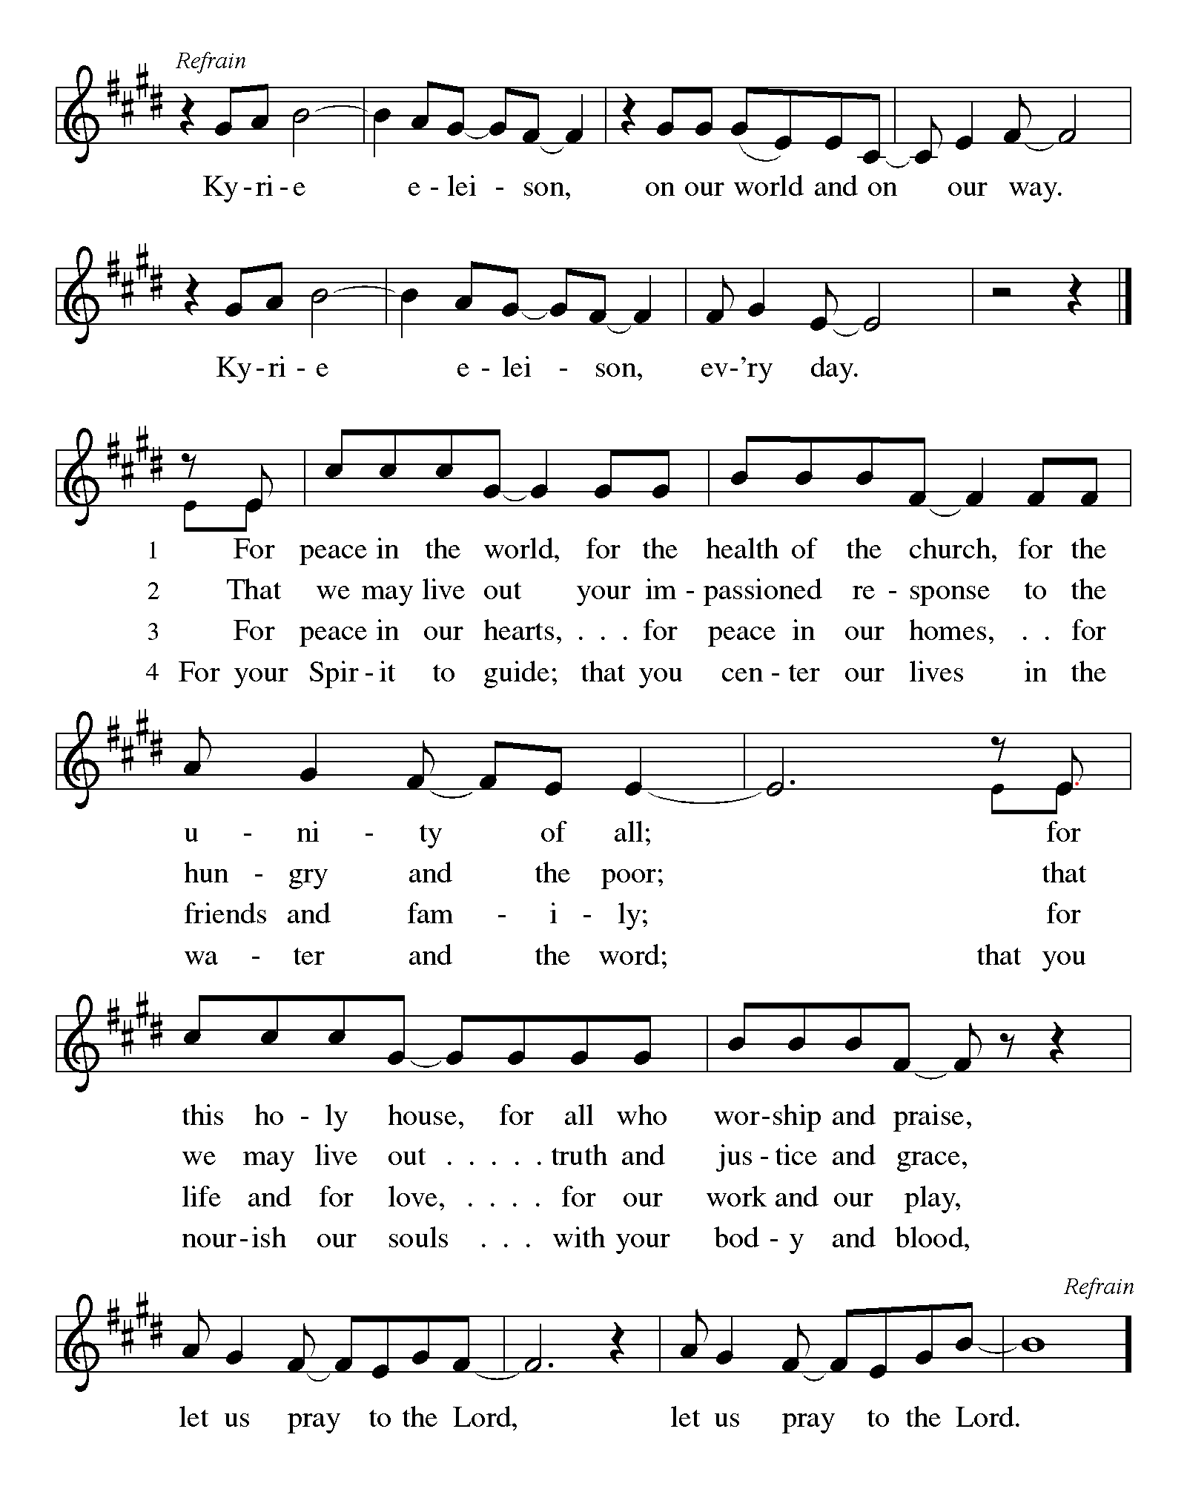
**Hymn of Praise:
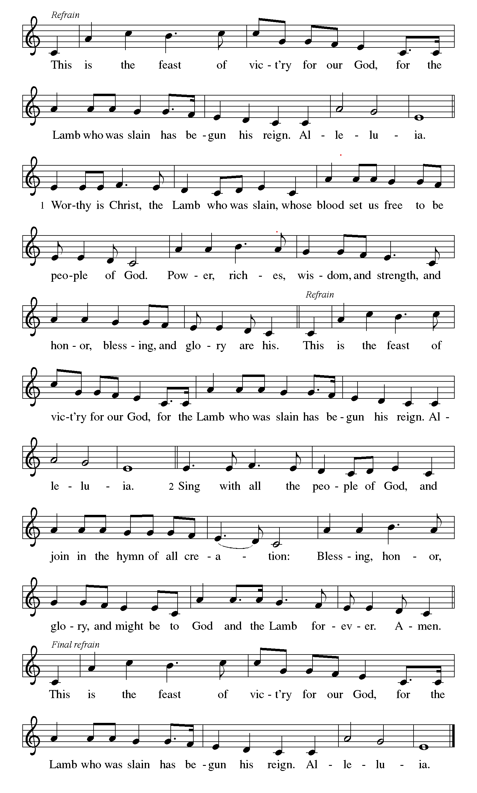
**Prayer of the Day

Holy God, in Rahab you chose an outsider to become the first voice of faith in a story that was not
her own. Open our eyes to the courage, wisdom, and welcome that come from the margins, and help
us to remember we belong to you and that your mercy reaches wider than our walls. In the name of
the One born into Rahab’s s own family line, we pray. Amen.

Reading: Joshua 2:1-21

¹Joshua ben-Nun secretly sent out two spies from Shittim, ordering them, “Go – scout out the territory – especially Jericho.”

The two spies set off and went to Jericho. There they went to the house of an innkeeper named Rahab, where they spent the night. ²When the word reached the ruler of Jericho that two Israelites had arrived that evening to scout the territory, ³the ruler sent this message to Rahab: “Bring me the two who are lodging in your house, for they are here to spy on my land.”

⁴But Rahab took the two spies and hid them, then told the ruler, “Yes, they did come here, but I didn’t know where they were from. ⁵And after dark, knowing that the gate would be closed soon, they left. I don’t know where they went. But you might catch up to them if you hurry.” ⁶As a matter of fact, Rahab had taken them up to the roof and hidden them under stalks of flax stored there. ⁷The ruler’s posse set off in pursuit, down the road that crosses the Jordan at a ford. But as soon as the posse had left, they shut the gate.

⁸The spies had not yet bedded down when Rahab came to them on the roof. ⁹She said to them, “I know that God has given you this land. Dread of you has fallen on us, and the inhabitants of this land are terror-stricken. ¹⁰We have heard how God dried up the waters of the Sea of Reeds ahead of you when you came out of Egypt, and what you did to Sihon and Og, the Amorite rulers east of the Jordan whom you utterly destroyed. We heard all this, and we lost heart. Because of you, no one has any courage left. For your God is truly God, in heaven above and the earth below. ¹²Please swear to me by God that you will show mercy to my family, as I have shown mercy to you. Give me a sign of good faith: ¹³promise me that you will spare the lives of my parents, siblings, and all who belong to them. Deliver us from death.”

¹⁴The spies replied, “We pledge our lives for yours, as long as you do not disclose our mission. When God gives us this land, we will show true loyalty to you.”

¹⁵Then Rahab let them down through the window with a rope – she lived in a house built against the city’s outer wall. ¹⁶Then she said to them, “Go up into the hills and hide out there from your pursuers. Stay there for three days until the posse returns. Then you can go on your way.”

¹⁷The two then warned her, “When we invade the country, we will keep this oath you made us swear, ¹⁸provided you tie this scarlet cord to the window through which you have let us down. You must also gather your parents, your siblings – your entire family – into this house. ¹⁹Should any of them pass through the doors of the house and go into the street, their blood will be on their own heads, and we will be released from our oath; but if they stay in the house with you, and anyone lays a hand on them, their blood will be on our heads. ²⁰If, however, you betray us and tell anyone of our plans, we will be free of the oath you made us take.”

²¹“Let it be as you say,” Rahab replied, and sent the spies on their way. And she tied the scarlet cord to the window.
Word of God, Word of Life

Thanks be to God

**Gospel Acclamation
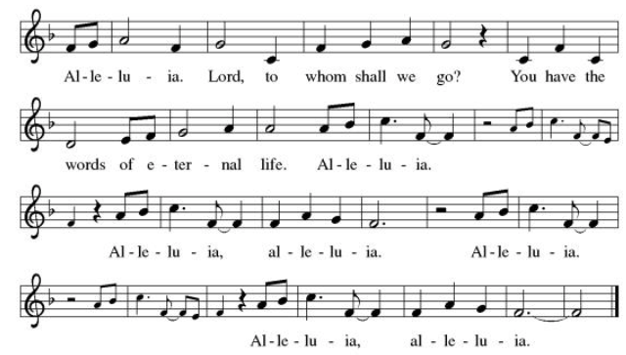
Announcement of the Gospel
Glory to you, O Lord.

Gospel: Matthew 1:1-6

¹This is the family record of Jesus the Christ, descendant of David, descendant of Abraham: ²Abraham begot Isaac; Isaac begot Jacob; Jacob begot Judah and his siblings; ³Tamar and Judah begot Perez and Zerah; Perez begot Hezron; Hezron begot Ram; ⁴Ram begot Amminadab; Amminadab begot Nahshon; Nahshon begot Salmon; ⁵Rahab and Salmon begot Boaz; Ruth and Boaz begot Obed; Obed begot Jesse; ⁶and Jesse begot David, the ruler.

The Gospel of the Lord.
Praise to you, O Christ.

Sermon “Immigrant Ancestor”

Hymn of the Day God Whose Almighty Word ELW # 673

**Affirmation of Faith – Immigrant’s Creed by Jose Luis Casal
I believe in Almighty God, who guided the people in exile and in exodus, the God of Joseph in Egypt and Daniel in Babylon, the God of foreigners and immigrants.

I believe in Jesus Christ, a displaced Galilean, who was born away from his people and his home, who fled his country with his parents when his life was in danger. When he returned to his own country he suffered under the oppression of Pontius Pilate, the servant of a foreign power. Jesus was persecuted, beaten, tortured, and unjustly condemned to death. But on the third day Jesus rose from the dead, not as a scorned foreigner but to offer us citizenship in God’s kingdom.

I believe in the Holy Spirit, the eternal immigrant from God’s kingdom among us, who speaks all languages, lives in all countries, and reunites all races.
I believe that the Church is the secure home for foreigners and for all believers. I believe that the communion of saints begins when we embrace all God’s people in all their diversity. I believe in forgiveness, which makes us all equal before God, and in reconciliation, which heals our brokenness. I believe that in the Resurrection God will unite us as one people in which all are distinct and all are alike at the same time. I believe in life eternal, in which no one will be foreigner but all will be citizens of the kingdom where God reigns forever and ever. Amen.

**Prayers of Intercession

Holy God, our prayers rise to you like the wings of a dove. We call upon your name, and we ask that you hear us.

Living and true God, you inspire us to share the message of the gospel. Give your spirit of love to seminarians and those beginning their lives in ordained ministry. Hear us, O God.
Your mercy is great.
We give you thanks for the majesty of our oceans. Protect the abundant life within them and sustain all those who work to preserve them. Hear us, O God.
Your mercy is great.
We seek your wisdom in all things. Direct all who hold positions of authority around the world, that they act with compassion, seeking the good of all. Hear us, O God.
Your mercy is great.
We pray for all people who work in dangerous or degrading environments. Grant them safety and courage, and heal all those who are injured, sick, or suffering especially Monty & Marie, Paul, Helen, Linda, Kay, Becky H., Jim & Jan, Melian, Becky W., David, William & family, Judy, Peter & Carrie, Barbara & Donna, Brad & Chris, Drake, Bill & Sandy, Betsy, Jean, Howard & Sara and the people of Hawaii, Nepal, and Tibet. Hear us, O God.
Your mercy is great.
We ask your blessing on those who do the quiet, unseen work of the church. Encourage them in their work of faith and labor of love. Hear us, O God.
Your mercy is great.
Pave a way to justice, drown the forces of oppression, bring peace on earth. Give leaders the will to turn from war and violence. Especially we pray for the people of Cuba, Venezuela, Iran, Sudan, Gaza, Israel, and Ukraine. When people must flee their homes, guide them to safety. Comfort those living with deep trauma, anxiety, or fear; all those who serve people in need, and accompany all those who care for people in harm’s way. We also lift up Jim’s grandson, Dylan, who is deployed, and Sharon’s great nephew, Taylor, who is serving in the military. Hear us, O God.
Your mercy is great.
We lift up all who teach and all who learn. Thank you for teachers who share their knowledge and wisdom. Bless the students in our midst. Especially we remember Evie, in Elementary school; Addison, in high school; and Tyler and Zack, in college. Bless Lisa and Carla as they teach. Hear us, O God.
Your mercy is great.
We thank you for our ancestors who have been called home to you. Hear us, O God.
Your mercy is great.

Good and loving God, we give everyone we have prayed for into your care. Amen.

** Sharing of the Peace

**Offering is brought forward

** Offertory Response Take Oh, Take Me As I Am ELW # 814

** Offertory Prayer
Good and loving God, everything that we have and everything that we are comes from you.
We respond in gratitude, offering up to you our gifts of our money, our time, and our
talents. We dedicate these gifts to your service. In Jesus’ name we pray, amen.

Dialogue
Christ is with you!
And also with you!
Lift up your hearts in joyful praise!
We lift them up to God in joy!

**Preface: Since the earliest days of the covenant…this hymn of praise: 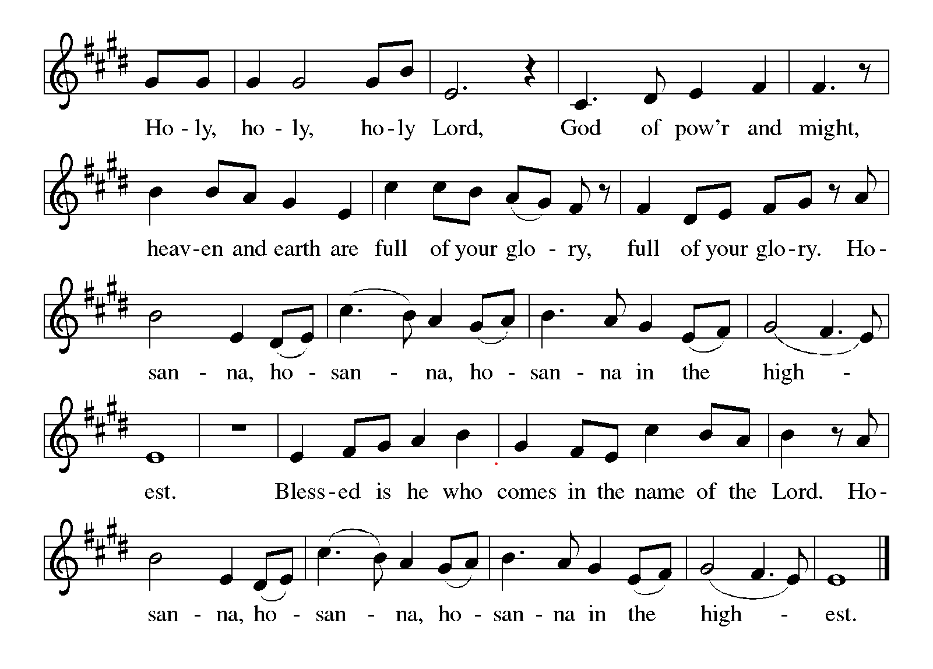
**words of institution

**LORD’S PRAYER

Our Father in heaven,
hallowed be your name,
your kingdom come,
your will be done,
on earth as in heaven.
Give us today our daily bread.
Forgive us our sins
as we forgive those
who sin against us.
Save us from the time of trial
and deliver us from evil.
For the kingdom, the power,
and the glory are yours,
now and forever. Amen.

Invitation to Communion

Communion Hymn O Bread of Life From Heaven ELW # 480

** Sending Song Lord Jesus, You Shall Be My Song (verse 1) ELW # 808

**Prayer After Communion

Abiding God, you call us then feed and nurture us. Now you send us out in the world you created with a purpose: to love our neighbors and care for those who need us. Strengthen us to do your work. In Jesus’ name we pray, amen.

** Blessing

** Closing Hymn If You But Trust in God to Guide You ELW #769

**Dismissal

Go In Peace! Serve Your Neighbor!
THANKS BE TO GOD!

+ + + + + +

Setting 08 from the Evangelical Lutheran Worship are under copyright and used with permission under One License #733618-A. Specific copyright information as listed in bulletin, the Prayers of Intercession are under copyright and are used with permission under Augsburg Fortress Liturgy License #SB155933. All other liturgy written by Sarah Pierce.
******************************************************************************************

Weekly Attendance
Week of October 11: 25
Next Week:
22nd Sunday after Pentecost:
2 Samuel 11:1-5, 26-17; 12:1-9
Psalm 51:1-9
Matthew 21:33-41

Calendar of Events

This Week
October 18 | Stewardship Talent

Upcoming Events

October 25 | Reformation Sunday | Stewardship Time | Coffee with Council
November 01 | All Saints Sunday | Stewardship Treasure | Celebration of Gifts  Service for the Healing of the World
November 8 | Pledge Sunday
November 11 | Council Meeting 6:30 pm
November 15 | Congregational Meeting after worship
November 25 | Thanksgiving Eve Service 7:00 pm | Pie Night
November 26 - 27 | Thanksgiving - Office Closed
November 29 | Last day to bring shoes to MLM – Thrivent will match us if we donate 10 pairs
December 4 | Council Meeting 6:30pm
December 6 | Advent Dinner after worship | Shoes will be delivered to MLM
December 13 | Coffee with Council

******************************************************************************************

Pastor Sarah Questions:

Questions for Reflection and Discussion
1. Rahab lives on the edge of Jericho—literally in a house built into the city wall—and she is also
someone her society likely pushed to the margins. Where have you felt “on the edge” of
community, church, or belonging? What might it mean that God’s story moves through someone
in Rahab’s position?
2. The spies come to Jericho seeking information, but Rahab becomes the one who speaks the
clearest word of faith: “I know that God has given you this land.” Who has surprised you by
showing courage, faith, or wisdom from a place you did not expect?
3. Rahab risks her safety and her standing in order to protect the spies and ask for mercy for her
family. When have you had to make a costly choice for the sake of love, loyalty, or faithfulness?
What helped you act with courage?
4. The scarlet cord in Rahab’s window becomes a visible sign of promise, protection, and trust.
What visible signs, practices, or reminders help you hold on to God’s mercy when the future feels
uncertain?
5. Rahab begins this story as a Canaanite outsider, yet later tradition remembers her as part of
Israel’s story—and Matthew names Rahab in the family line of Jesus. How does her story
challenge the boundaries we draw around who belongs, who can be faithful, and who God can
work through?

******************************************************************************************
BLUE SPRINGS COMMUNITY SERVICE LEAGUE is very appreciative of your continued support of your neighbor.

Birthdays
October 24 - Monty Benz

October 18
Altar Guild – Anne Lee & Paul Blixrud
Reader – Tonya Hamilton
Greeter – Donna Taylor
Usher - Paul Blixrud
Tech – Gary Antes

Prayer Requests
Monty & Marie Health Concerns (March 04)
Paul Health Concerns (May 31)
Mary Health Concerns (May 15)
James & Family Health Concerns (September 11)
William and Family Health Concerns (September 25)
Becky H Health Concerns (October 28)
David Health Concerns (November 18)
Becky W Health Concerns (November 18)
Judy Health Issues (December 16)
Kay (Sara’s cousin) Health Concerns (July 15)
Sharon Health Concerns (October 22)
Michael Health Concerns (October 22)
Peter and Carrie Health Concerns (November 26)
Melian Health Concerns (November 16)
RJ Health Concerns (November 17)
Barbara Health Concerns (December 30)
Helen Health Concerns (February 25)
Chris Health Concerns (June 09)
Drake Issues (August 11)
Bill & Sandy Health Issues (August 12)
Betsy Surgery Sept. 17th (September 2)
Jim Health Concerns (September 29)
Howard & Sarah Health Concerns (September 29)
Jean Health Concerns (September 29)
Dennis & Mary Health Concerns (October 01)

Merciful God, your justice and mercy are without limits. Bring courage and resilience to those who resist tyranny with their words and their bodies. Strengthen those who fight for justice in your name across the country, and around the world.

Please pray for the people of Venezuela & Iran, Sudan, Gaza, Ukraine, Israel, Cuba, Iran and Palestine.
Please pray for the Homeless.
Please pray for legal & illegal immigrants & those seeking asylum or citizenship

