All Saints Lutheran Church, ELCA
421 SW 19th St. Blue Springs, Missouri 64015 816-229-3633
Pastor Sarah Pierce Spierce.aslcpastor@gmail.com
allsaintslc64015@gmail.com https://aslcbs.org/

Sunday, May 10, 2026

Sixth Sunday after Easter

You are absolutely invited into this sacred space. We welcome all who are seeking God’s love and grace. All Saints recognizes that we are all unique and beloved children of God. We celebrate and give thanks for the many diverse gifts that God has given us. We affirm the sacredness of people of all sexual orientations, gender identities, and gender expressions. We affirm the sacredness of all those who have experienced exclusion because of race, ability, age, or culture. We are committed to working towards anti-racism in ourselves and our community. We affirm the sacredness of all those who wrestle with addiction, physical or mental health, imprisonment, socio-economic circumstances, or anything that too often divides us. We believe that through our openness we all grow in our faith through Christ’s teaching to love one another as God loves us. We need each other and our sincere hope is by being in community together, we will experience God’s presence in new and real ways.

The offering plate is by the main door to the sanctuary for your convenience.

We practice open communion at All Saints Lutheran Church. What does that mean? It means that if you believe and trust that Christ offers his body and blood For You, you are welcome at the table. At All Saints, we believe that Christ invites all people to the feast. “Come to the banquet for all is now ready.”

**Stand as you are comfortable

Prelude

Announcements

Baptismal Birthdays
May 03-Jackie Soetmelk
May 14-Jerrian Renfro
May 30-Heather Antes

Call to Worship – Mother’s Day

We gather this morning in the presence of Abba God, from whom every family in heaven and on earth takes its name.

We ask that God, in their divine mercy, will strengthen us through the Spirit, so that Christ dwells in our hearts through faith.

When we are rooted and grounded in God’s love, we are rooted and grounded in Christ. With the whole body of Christ, we experience the peace that passes all understanding.

We lift our voices in praise to God, the Source of all we do.

To God be glory in the church, and in Jesus Christ through all generations, world without end! Amen.

**Thanksgiving for Baptism
Blessed be the Holy Trinity: the God who creates us and all that exists, the Risen One + in whom we are set free from sin, and the Spirit who strengthens and enlightens us with her gifts.
Amen.

Alleluia! Christ is risen!

Christ is risen indeed! Alleluia!

We are joined to Christ in the waters of our baptism, made part of God’s holy family that extends to every time and every place. Through our baptisms, we are given new birth each day, and through the Word and the Meal we receive new life in abundance.

Let us give thanks for the saving gift of our baptism.

Holy God, in our baptism you reached out your saving hand to give to us the gift of new life in you. You are the river of life, the source of all renewal and all joy.

We are blessed by your gift of holy water: oceans and lakes, rivers and streams.
We are blessed by your gift of the holy water which cleans and sustains our bodies.
We are blessed by your gift of holy water: rain and clouds, puddles and pools.
We are blessed by your gift of the holy water which nourishes flowerbeds and fields, and sustains all of creation.

We thank you for the gift of our holy baptism into Christ’s death and resurrection.
Wash away all our sin in your holy water.
Empower and encourage us to share the good news of the empty tomb.
Help us find the courage to speak and act toward justice for all your children.

Refresh us and the world through this holy and living water.
Where there is drought, bring rain and renewal.
Where there is doubt and despair, bring hope.
Where war and chaos thrive, bring the promise of peace.
We ask all these things through Christ, the Risen One,
who reigns with you and the Spirit forever.
Amen.

**Entrance Hymn Mothering God, You Gave Me Birth ELW#735

**Greeting
The grace of our Lord Jesus Christ, the love of God,
and the communion of the Holy Spirit be with you all.
And also with you.

**Kyrie
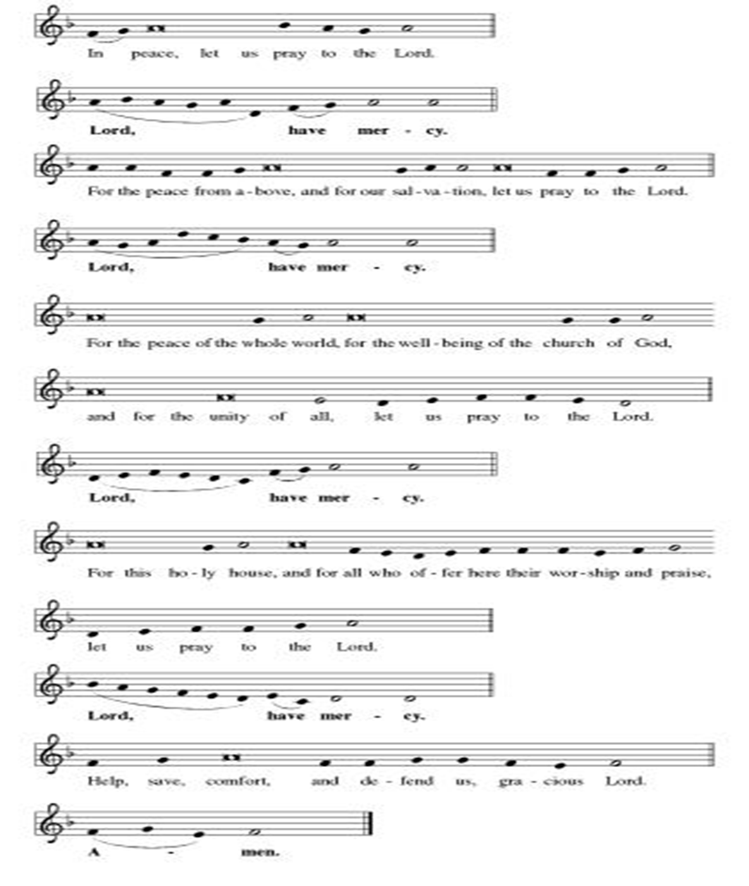
**Hymn of Praise
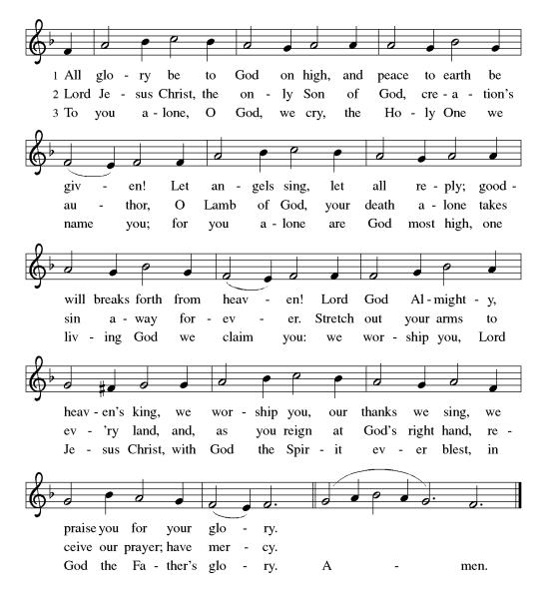
**Prayer of the Day
Mothering God, you nurture and support us, calling us to be our best selves and to boldly proclaim the good news. Empower us to support and nurture each other as we seek to find joy in the proclamation of your Word in a world that so desperately needs to hear your love and acceptance. We pray this in Jesus’ name. Amen.

Reading: Philippians 1:1-18

¹From Paul and Timothy, who serve Christ Jesus,

To all the holy ones in Christ Jesus at Philippi, together with their bishops and deacons:

²Grace and peace be yours from our Abba God and from Jesus Christ, our Savior.

³I thank my God every time I think of you. ⁴In every prayer I utter, as I plead on your behalf, I rejoice ⁵at the way you have all continually helped promote the Good News from the very first day. ⁶And I am sure of this much: that God, who has begun the good work in you, will carry it through to completion, right up to the day of Christ Jesus. ⁷It’s only right that I should entertain such expectations about you, since I hold all of you dear—you who are all partakers of grace with me, even when I lie in prison or am summoned to defend the solid ground on which the Good News rests.

⁸God knows how much I long for each of you with all the affection of Christ Jesus! ⁹My prayer is that your love may abound more and more, both in understanding and in wealth of experience, ¹⁰so that with a clear conscience and blameless conduct you may learn to value the things that really matter, up to the very day of Christ. ¹¹It’s my wish that you be found rich in the harvest of justice which Jesus Christ has ripened in you, to the glory and praise of God.

¹²I’m glad to announce to you, sisters and brothers, that what has happened to me has actually served to advance the Good News. ¹³Consequently it has become clear throughout the Praetorium and everywhere else that I am in chains for Christ. ¹⁴Because of my chains, most of our sisters and brothers in Christ have been encouraged to speak the word of God more fearlessly.

¹⁵It’s true that some preach Christ out of envy and rivalry, but others do so with the right intention. ¹⁶These latter act out of love, aware that I am here in the defense of the Good News. ¹⁷The others, who proclaim Christ for selfish or jealous motives, don’t care if they make my chains heavier to bear.

¹⁸All that matters is that in any and every way, whether from specious or genuine motives, Christ is being proclaimed! That is what brings me joy.

Word of God, Word of Life
Thanks be to God

**Gospel Acclamation
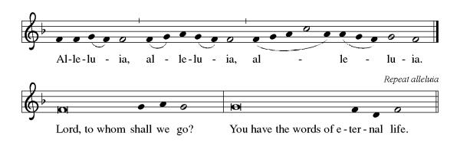
Announcement of the Gospel
Glory to you, O Lord.

Gospel: Luke 9:46-48

⁴⁶A dispute arose among the disciples as to which of them was the greatest. ⁴⁷Jesus, who knew their thoughts, took a little child and had it stand next to him. ⁴⁸Then he said to them, “Whoever welcomes this child in my name welcomes me. And anyone who welcomes me, welcomes the One who sent me. For the lowliest among you is the greatest.”

The Gospel of the Lord.
Praise to you, O Christ.

Sermon "Mothering"

Hymn of the Day My Hope Is Built on Nothing Less ELW#597

**Affirmation of Faith – Immigrant’s Creed by Jose Luis Casal

I believe in Almighty God, who guided the people in exile and in exodus, the God of Joseph in Egypt and Daniel in Babylon, the God of foreigners and immigrants.

I believe in Jesus Christ, a displaced Galilean, who was born away from his people and his home, who fled his country with his parents when his life was in danger. When he returned to his own country he suffered under the oppression of Pontius Pilate, the servant of a foreign power. Jesus was persecuted, beaten, tortured, and unjustly condemned to death. But on the third day Jesus rose from the dead, not as a scorned foreigner but to offer us citizenship in God’s kingdom.

I believe in the Holy Spirit, the eternal immigrant from God’s kingdom among us, who speaks all languages, lives in all countries, and reunites all races.

I believe that the Church is the secure home for foreigners and for all believers. I believe that the communion of saints begins when we embrace all God’s people in all their diversity. I believe in forgiveness, which makes us all equal before God, and in reconciliation, which heals our brokenness. I believe that in the Resurrection God will unite us as one people in which all are distinct and all are alike at the same time. I believe in life eternal, in which no one will be foreigner but all will be citizens of the kingdom where God reigns forever and ever. Amen.

**Prayers of Intercession

God of Love, hear the prayers that we lift before you. Hold close to you all those for whom we pray.

God of new life, you call us through the waters of baptism to be in relationship with you and one another. Guide the church and its leaders to proclaim Christ’s righteousness throughout the world. Merciful God,
receive our prayer.
You create the world and all that is in it. Shelter budding plants and young animals, provide unpolluted habitats and clean water, and raise up stewards for the environment. Merciful God,
receive our prayer.
You set civil servants in the places where we live. Instill truth and equity among judges and lawyers, gentleness and courage among first responders, and peace among leaders of towns and nations. Merciful God,
receive our prayer.
You provide comfort in times of trouble. Heal those who are sick, shelter any who are unhoused, feed those undernourished, and accompany and console all who are lonely, bereaved, anxious, or ill especially Monty & Marie, Paul, Helen, Linda, Betty F., Kay, Becky H., Jim & Jan, Melian, Becky W., David, Val, William & family, Judy, Peter & Carrie, Barbara & Donna, Lorey, families in our community who endure hunger, and our beloved for whom death is near. Strengthen the weary, give courage to the despairing, and comfort the dying. Merciful God,
receive our prayer.
You are love and you desire that we love one another. As a mother hen cares for her chicks, bless all who provide motherly care in our lives, and inspire us to care for one another. Merciful God,
receive our prayer.
Pave a way to justice, drown the forces of oppression, bring peace on earth. Give leaders the will to turn from war and violence. Especially we pray for the people of Cuba & Venezuela, Iran, Sudan, Gaza, Israel, and Ukraine. When people must flee their homes, guide them to safety. Comfort those living with deep trauma, anxiety, or fear; all those who serve people in need, and accompany all those who care for people in harm’s way. We also lift up Jim’s grandson Dylan, who is deployed, and Sharon’s great nephew, Taylor, who is deployed in the Middle East. Merciful God,
receive our prayer.
We pray for people who rise up against injustice. Bring courage and resilience to those who resist tyranny with their words and their bodies. Strengthen those who fight for justice in your name across the country, and around the world. Protect and sustain immigrants and refugees and all who work with them, that your kingdom, without borders and without walls, may truly come on earth as it is in heaven. We pray for all victims of gun violence or kidnapping, especially those who are targeted out of hate or fear. Embolden us to holy outrage and empower us to speak our truth of love and justice. Merciful God,
receive our prayer.
We lift up all who teach and all who learn. Thank you for teachers who share their knowledge and wisdom. Bless the students in our midst. Especially we remember Evie, in kindergarten; Addison, in high school; and Tyler, Zach, Katie and Katy, in college. Bless Janet, Carla, and Lisa as they teach. Merciful God,
receive our prayer.
God of new life, your steadfast love endures forever. Inspire us by the example of the faithful departed, who clung to your promises of life, forgiveness of sins, and salvation. Merciful God,
receive our prayer.

Good and loving God, we give everyone we have prayed for into your care. Amen.

** Sharing of the Peace

**Offering is brought forward

** Offertory Response

Let Us Talents and Tongues Employ (Refrain Only) ELW#674

**Offertory Prayer

Good and loving God, all you have created is good. Help us to be generous with that which you have first given us, so that we can respond to those who hunger in any way. As we gather now at your Table, prepare us to go out and proclaim Christ’s resurrection through what we say and do. Amen.

Dialogue
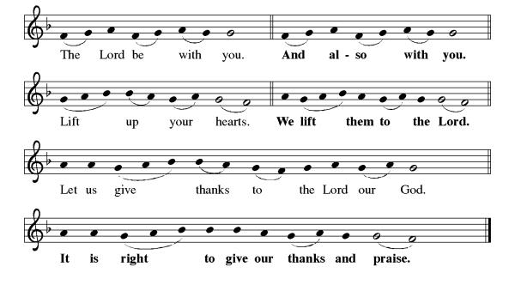
**Preface: As we celebrate Christ’s resurrection from the dead… this hymn of praise:
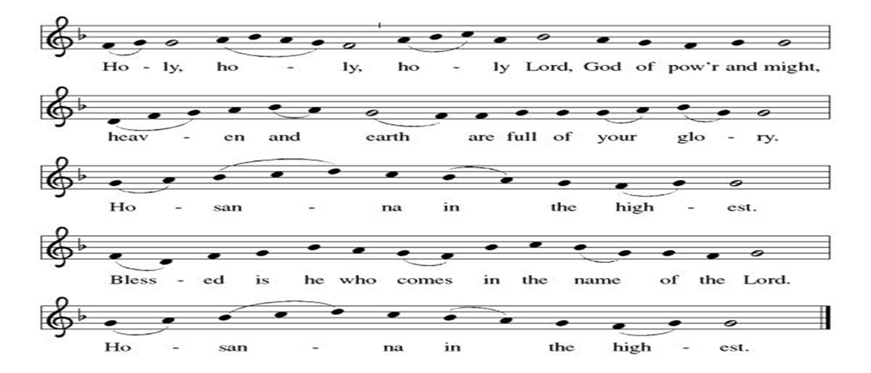
**Words of Institution

**LORD’S PRAYER
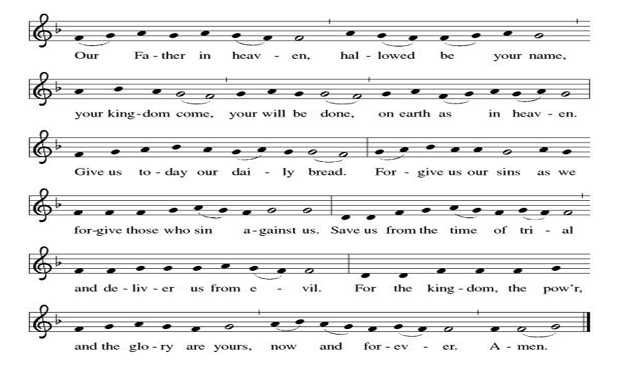

Invitation to Communion

Communion Hymn Around You, O Lord Jesus ELW#468

**Sending Song

Now Lord ELW#201

**Prayer After Communion
Alleluia! We give you thanks, risen Lord, for your life-giving presence among us. You have fed and refreshed us with the healing gift of life. Now send us out to share the good news of the empty tomb, through all that we say and do. Amen! Alleluia!

**Blessing

**Closing Hymn Love Devine, All Loves Excelling ELW#631

Mothering Sunday Conversations

+ + + + + +

Hymns from Setting 05 and the Evangelical Lutheran Worship are under copyright and used with permission under One License #733618-A. Specific copyright information as listed in bulletin, the Prayers of Intercession are under copyright and are used with permission under Augsburg Fortress Liturgy License #SB155933. All other liturgy written by Sarah Pierce.

Weekly Attendance

Week of May 03

26
******************************************************************************************

Calendar of Events

Today
- Baptismal Sunday
- Mother’s Day

This Week
May 12 | Creative Friends
May 13 | Church Council Meeting 6:30 pm

Upcoming Events

May 17 | Congregational Meeting after worship
May 19 | Creative Friends
May 20 | Newsletter Deadline
May 23 | Project Comfort 9:00 am-Noon
May 24 | Pentecost  Vigil 7:00 pm
May 25 | Memorial Day
May 26 | Creative Friends
May 31 | Fifth Sunday Conversation
June 03 | Paint Party Fundraiser
June 07 | View Christian Nationalism part 3  Ice Cream Social
June 19 | Juneteenth Office Closed
June 21 | Father’s Day
June 28 | Coffee with Council
July 01 | Paint Party Fundraiser
July 04 | Independence Day
July 26 | Coffee with Council  Celebrate Niel’s Birthday (July 28)
September 13 | God’s Work. Our Hands.

Note: 2026 paint party fundraisers: May 6, June 3, July 1, Aug. 5, Sept. 2, Oct. 7, Nov. 4, Dec. 2

Thank you all again for the generous Christmas gift! It always takes some time for us to decide what we'll do with the gift, and this year we have a once-in-a-lifetime opportunity. My sister called a couple of weeks ago to say that her colleague has 4 tickets to the Netherlands - Tunisia World Cup game at Arrowhead that he's not going to be able to use, and he wondered if she would be interested. So, she invited Rebecca and I to go along with her and her husband. We love live sporting events, so we were eager to say yes! Pastor Sarah
*****************************************************************************
Pastor Sarah Questions:

- We don’t know where Paul is imprisoned: we just know it’s an imperial city, from the mention of the Praetorian Guard and other mentions throughout the letter. So it could be Rome, Caesarea, or Ephesus. Rome imprisoned people for 3 reasons: because they were guilty and getting ready to face a trial and sentencing (innocence was not a potential outcome of a trial); for extortion purposes, to get their family to pay money, or for peacekeeping – because the military expected the person’s words or actions to cause a riot. Because Paul indicates later in the letter that he expects to be released soon, and a known sequela of Paul’s preaching was rioting, we can assume that he’s in jail for peacekeeping purposes.
- Paul’s salutation was common for the day: signature (From Paul and Timothy, who serve Christ Jesus), address (to all the holy ones in Christ Jesus at Philippi; together with their bishops and deacons), and greeting (Grace and peace be yours from our Abba God and from Christ Jesus, our Savior). Commentators note that “bishop” just meant supervisor and “deacon” just meant in service to the supervisor, so these aren’t strictly “churchy” words yet, at the time the letter was written.
- This is a stewardship letter. Paul’s reminding them of all of the support they’ve given him over the years and drawing on their long and close relationship, even though he’s in prison, to ask them to keep supporting his ministry and travels. He’s asking them to put their faith into practice. He’s drawing on the memory of what God has already done, and asking them to do the same, because that provides the strength to continue the work when the future is uncertain. When there are conflicts within the body of Christ in Philippi and threats from outside, and when Paul is in prison and they don’t know what’s next for him.
- Paul is suffering. And he says, “I’m glad to announce to you…that what has happened to me has actually served to advance the Good News.” It’s important to point out that Paul has the right to say this about his own suffering; anyone who is suffering or has suffered and understands their suffering this way can make this claim on their own behalf, but no one else has the right to say this about someone else’s suffering.
- We know something about this in our own day, when the threats inside the body of Christ take the shape of worrying about the building and the threats outside take the much scarier form of Christian Nationalism, when we don’t know what’s next for us as the body of Christ.
- But this text prompts a question, one that I hope all of us consider over the next days, months, and years: what does faithfulness look like when the outcome is uncertain or intangible?
******************************************************************************************
BLUE SPRINGS COMMUNITY SERVICE LEAGUE is very appreciative of your continued support of your neighbor.

May 10
Altar Guild – Anne Lee & Paul Blixrud
Lector – Sara Meyers
Communion Assistant – Suelyn Olson
Greeter – Donna Taylor
Usher-Paul Blixrud
Tech – Gary Antes

Prayer Requests
Monty & Marie Health Concerns (Maech 04)
Paul Health Concerns (May 31)
Mary Health Concerns (May 15)
James & Family Health Concerns (September 11)
Betty F (Sara’s friend) Health Concerns (July 15)
William and Family Health Concerns (September 25)
Becky H Health Concerns (October 28)
David Health Concerns (November 18)
Becky W Health Concerns (November 18)
Judy Health Issues (December 16)
Kay (Sara’s cousin) Health Concerns (July 15)
Sharon Health Concerns (October 22)
Michael Health Concerns (October 22)
Peter and Carrie Health Concerns (November 26)
Melian Health Concerns (November 16)
RJ Health Concerns (November 17)
Barbara Health Concerns (December 30)
Helen Health Concerns (February 25)
Val (Tonya’s sister) Health Concerns (February 18)
Lorey Health Concerns (April 14)

Merciful God, your justice and mercy are without limits. Bring courage and resilience to those who resist tyranny with their words and their bodies. Strengthen those who fight for justice in your name across the country, and around the world.

Please pray for the people of Venezuela & Iran, Sudan, Gaza, Ukraine, Israel, Cuba, Iran and Palestine.
Please pray for the Homeless.
Please pray for legal & illegal immigrants & those seeking asylum or citizenship

