All Saints Lutheran Church, ELCA
421 SW 19th St. Blue Springs, Missouri 64015 816-229-3633
Pastor Sarah Pierce Spierce.aslcpastor@gmail.com
allsaintslc64015@gmail.com https://aslcbs.org/

Sunday, May 17, 2026

Seventh Sunday after Easter

You are absolutely invited into this sacred space. We welcome all who are seeking God’s love and grace. All Saints recognizes that we are all unique and beloved children of God. We celebrate and give thanks for the many diverse gifts that God has given us. We affirm the sacredness of people of all sexual orientations, gender identities, and gender expressions. We affirm the sacredness of all those who have experienced exclusion because of race, ability, age, or culture. We are committed to working towards anti-racism in ourselves and our community. We affirm the sacredness of all those who wrestle with addiction, physical or mental health, imprisonment, socio-economic circumstances, or anything that too often divides us. We believe that through our openness we all grow in our faith through Christ’s teaching to love one another as God loves us. We need each other and our sincere hope is by being in community together, we will experience God’s presence in new and real ways.

The offering plate is by the main door to the sanctuary for your convenience.

We practice open communion at All Saints Lutheran Church. What does that mean? It means that if you believe and trust that Christ offers his body and blood For You, you are welcome at the table. At All Saints, we believe that Christ invites all people to the feast. “Come to the banquet for all is now ready.”

**Stand as you are comfortable

Prelude

Announcements

**Thanksgiving for Baptism
Blessed be the Holy Trinity: the God who creates us and all that exists, the Risen One + in whom we are set free from sin, and the Spirit who strengthens and enlightens us with her gifts.
Amen.

Alleluia! Christ is risen!

Christ is risen indeed! Alleluia!

We are joined to Christ in the waters of our baptism, made part of God’s holy family that extends to every time and every place. Through our baptisms, we are given new birth each day, and through the Word and the Meal we receive new life in abundance.

Let us give thanks for the saving gift of our baptism.

Holy God, in our baptism you reached out your saving hand to give to us the gift of new life in you. You are the river of life, the source of all renewal and all joy.

We are blessed by your gift of holy water: oceans and lakes, rivers and streams.
We are blessed by your gift of the holy water which cleans and sustains our bodies.
We are blessed by your gift of holy water: rain and clouds, puddles and pools.
We are blessed by your gift of the holy water which nourishes flowerbeds and fields, and sustains all of creation.

We thank you for the gift of our holy baptism into Christ’s death and resurrection.
Wash away all our sin in your holy water.
Empower and encourage us to share the good news of the empty tomb.
Help us find the courage to speak and act toward justice for all your children.

Refresh us and the world through this holy and living water.
Where there is drought, bring rain and renewal.
Where there is doubt and despair, bring hope.
Where war and chaos thrive, bring the promise of peace.
We ask all these things through Christ, the Risen One,
who reigns with you and the Spirit forever.
Amen.

**Entrance Hymn Praise and Thanksgiving ELW#689

**Greeting
The grace of our Lord Jesus Christ, the love of God,
and the communion of the Holy Spirit be with you all.
And also with you.

**Kyrie
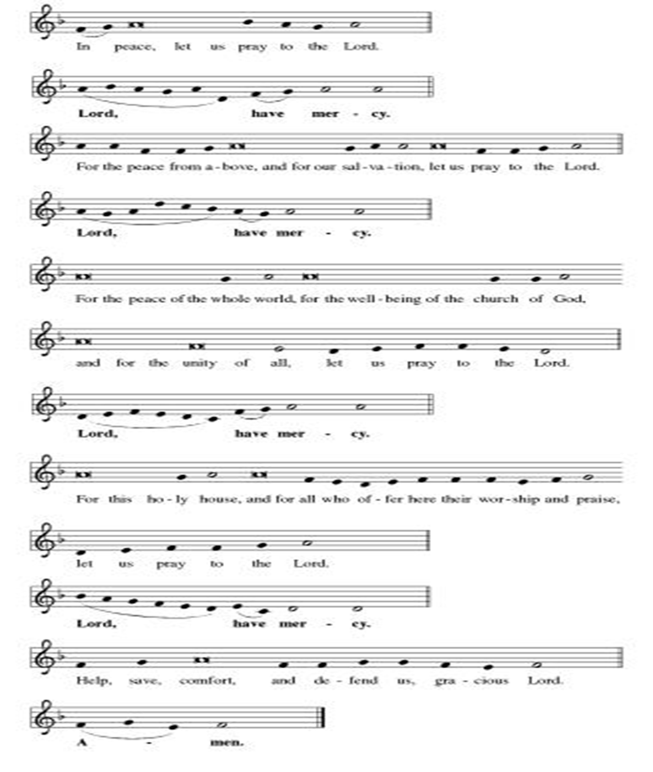
**Hymn of Praise
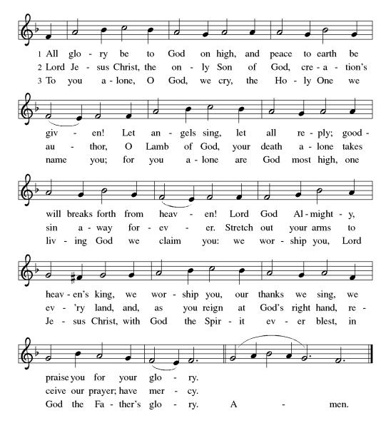
**Prayer of the Day
God of all times and places, Jesus came to earth as the poorest of the poor and lived among us, showing us the importance of humility and the concern for others’ welfare. In thanksgiving for our salvation, help us to hold to this purpose and this mind. We pray this in Jesus’ name. Amen.

Reading: Philippians 1:27—2:13

²⁷Conduct yourselves, then, in a way worthy of the Gospel of Christ. If you do, whether I come and see you myself or hear about your behavior from a distance, it will be clear that you’re standing firm in unity of spirit, and exerting yourselves with one accord for the faith of the Gospel, ²⁸without being intimidated by your enemies. Standing together without fear is an indication that they will be destroyed and you will be saved. It’s a divine signal that God –²⁹on behalf of our Savior – has given you the privilege of believing in and suffering for Christ. ³⁰You’re now experiencing the same struggle that you saw in me – and now hear that I still have.

^{2:1}If our life in Christ means anything to you—if love, or the Spirit that we have in common, or any tenderness or sympathy can persuade you at all—²then be united in your convictions and united in your love, with a common purpose and a common mind. That is the one thing that would make me completely happy. ³There must be no competition among you, no conceit, but everybody is to be humble: value others over yourselves, ⁴each of you thinking of the interests of others before your own. ⁵Your attitude must be the same as that of Christ Jesus:
⁶Christ, though in the image of God,
didn’t deem equality with God
something to be clung to—
⁷but instead became completely empty
and took on the image of oppressed humankind:
born into the human condition,
found in the likeness of a human being.
⁸Jesus was thus humbled—
obediently accepting death, even death on a cross!
⁹Because of this, God highly exalted Christ
and gave to Jesus the name above every other name,
¹⁰so that at the name of Jesus every knee must bend
in the heavens, on the earth and under the earth,
¹¹and every tongue proclaim to the glory of God:
Jesus Christ reigns supreme!

¹²Therefore, my dear friends, you who are always obedient to my urging, work out your salvation with fear and trembling, not only when I happen to be with you, but all the more now that I’m absent. ¹³It is God at work in you that creates the desire to do God’s will.

Word of God, Word of Life
Thanks be to God

**Gospel Acclamation
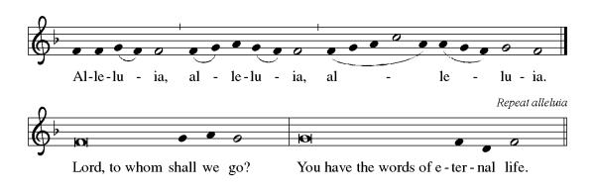
Announcement of the Gospel
Glory to you, O Lord.

Gospel: Luke 6:43-45

⁴³[Jesus said,] “A good tree doesn’t produce bad fruit any more than a bad tree produces good fruit. ⁴⁴Each tree is known by its yield. Figs are not taken from thorn bushes, or grapes picked from briars. ⁴⁵Good people produce goodness from the good they’ve stored up in their hearts; evil people produce evil from the evil stored up in their hearts. People speak from the fullness of their hearts.”

The Gospel of the Lord.
Praise to you, O Christ.

Sermon “A Common Purpose & a Common Mind"

Hymn of the Day Take My Life, That I May Be ELW#685

**Affirmation of Faith – Immigrant’s Creed by Jose Luis Casal

I believe in Almighty God, who guided the people in exile and in exodus, the God of Joseph in Egypt and Daniel in Babylon, the God of foreigners and immigrants.
I believe in Jesus Christ, a displaced Galilean, who was born away from his people and his home, who fled his country with his parents when his life was in danger. When he returned to his own country he suffered under the oppression of Pontius Pilate, the servant of a foreign power. Jesus was persecuted, beaten, tortured, and unjustly condemned to death. But on the third day Jesus rose from the dead, not as a scorned foreigner but to offer us citizenship in God’s kingdom.

I believe in the Holy Spirit, the eternal immigrant from God’s kingdom among us, who speaks all languages, lives in all countries, and reunites all races.

I believe that the Church is the secure home for foreigners and for all believers. I believe that the communion of saints begins when we embrace all God’s people in all their diversity. I believe in forgiveness, which makes us all equal before God, and in reconciliation, which heals our brokenness. I believe that in the Resurrection God will unite us as one people in which all are distinct and all are alike at the same time. I believe in life eternal, in which no one will be foreigner but all will be citizens of the kingdom where God reigns forever and ever. Amen.

**Prayers of Intercession

God of Love, hear the prayers that we lift before you. Hold close to you all those for whom we pray.

O God, your people sing praises throughout the church. By your Holy Spirit, inspire musicians, deacons, pastors, and bishops to proclaim the gospel of Jesus. Merciful God,
receive our prayer.
Your creative power fills the universe. Bring favorable weather, nurture plants and animals, protect us from natural disasters, and guide us to care for all you have made. Merciful God,
receive our prayer.
Your justice is exercised in society by those in authority. Instill in political leaders, business leaders, school administrators, and all who care for others a desire for peace and equity. Merciful God,
receive our prayer.
Your compassion and care come through the gifts of medicine and relationships. Soothe the anxious, protect widows and orphans, comfort those living with memory loss and their families, and heal the sick especially Monty & Marie, Paul, Helen, Linda, Betty F., Kay, Becky H., Jim & Jan, Melian, Becky W., David, Val, William & family, Judy, Peter & Carrie, Barbara & Donna, Lorey, families in our community who endure hunger, and our beloved for whom death is near. Merciful God,
receive our prayer.
Your love radiates from communities gathered in your name. Bless those experiencing significant transitions in life such as graduation, retirement, new employment, and accompany us in our prayers during these times. Merciful God,
receive our prayer.
Pave a way to justice, drown the forces of oppression, bring peace on earth. Give leaders the will to turn from war and violence. Especially we pray for the people of Cuba & Venezuela, Iran, Sudan, Gaza, Israel, and Ukraine. When people must flee their homes, guide them to safety. Comfort those living with deep trauma, anxiety, or fear; all those who serve people in need, and accompany all those who care for people in harm’s way. We also lift up Jim’s grandson Dylan, who is deployed, and Sharon’s great nephew, Taylor, who is deployed in the Middle East. Merciful God,
receive our prayer.
We pray for people who rise up against injustice. Bring courage and resilience to those who resist tyranny with their words and their bodies. Strengthen those who fight for justice in your name across the country, and around the world. Protect and sustain immigrants and refugees and all who work with them, that your kingdom, without borders and without walls, may truly come on earth as it is in heaven. We pray for all victims of gun violence or kidnapping, especially those who are targeted out of hate or fear. Embolden us to holy outrage and empower us to speak our truth of love and justice. Merciful God,
receive our prayer.
We lift up all who teach and all who learn. Thank you for teachers who share their knowledge and wisdom. Bless the students in our midst. Especially we remember Evie, in kindergarten; Addison, in high school; and Tyler, Zach, Katie and Katy, in college. Bless Janet, Carla, and Lisa as they teach. Merciful God,
receive our prayer.
O God, your promise of eternal life is certain and sure. Inspire us by the steadfast faith of those who have gone before us, so that we may be confident in the assurances you give. Merciful God,
receive our prayer.

Good and loving God, we give everyone we have prayed for into your care. Amen.

** Sharing of the Peace

**Offering is brought forward

** Offertory Response

Let Us Talents and Tongues Employ (Refrain Only) ELW#674

**Offertory Prayer

Good and loving God, all you have created is good. Help us to be generous with that which you have first given us, so that we can respond to those who hunger in any way. As we gather now at your Table, prepare us to go out and proclaim Christ’s resurrection through what we say and do. Amen.

Dialogue
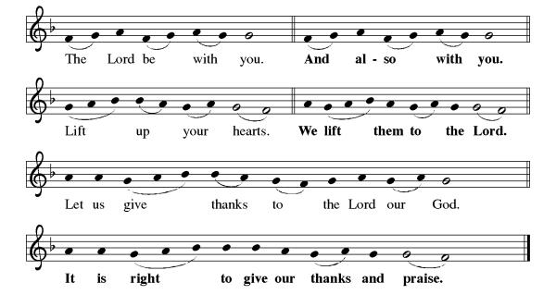
**Preface: As we celebrate Christ’s resurrection from the dead… this hymn of praise:
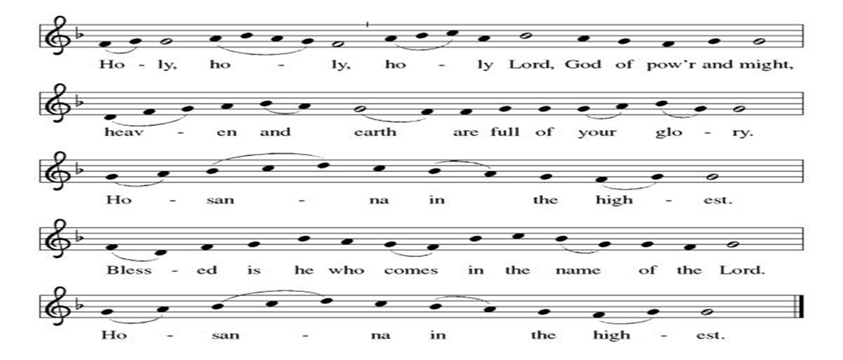
**Words of Institution

**LORD’S PRAYER
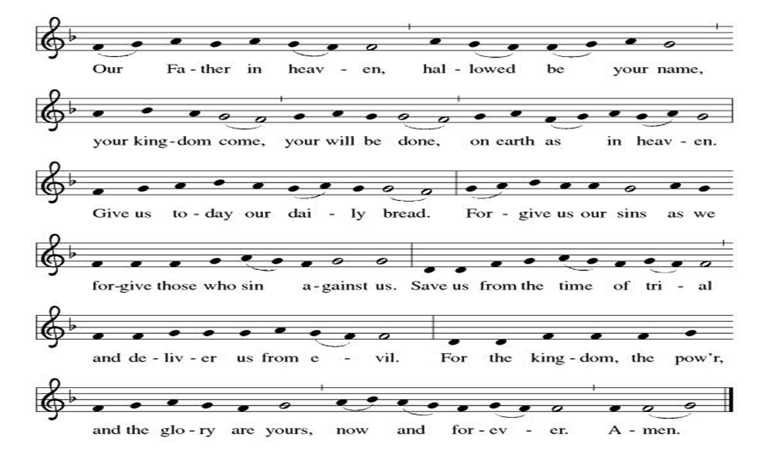

Invitation to Communion

Communion Hymn One Bread, One Body ELW#496

**Sending Song

Now Lord ELW#201

**Prayer After Communion
Alleluia! We give you thanks, risen Lord, for your life-giving presence among us. You have fed and refreshed us with the healing gift of life. Now send us out to share the good news of the empty tomb, through all that we say and do. Amen! Alleluia!

Recognition of Retirement

**Blessing

**Closing Hymn All Hail the Power of Jesus’ Name! ELW#634

**Dismissal

Go in peace to serve our Risen Christ. Alleluia!
THANKS BE TO GOD!

+ + + + + +

Hymns from Setting 05 and the Evangelical Lutheran Worship are under copyright and used with permission under One License #733618-A. Specific copyright information as listed in bulletin, the Prayers of Intercession are under copyright and are used with permission under Augsburg Fortress Liturgy License #SB155933. All other liturgy written by Sarah Pierce.

Weekly Attendance

Week of May 10

21
******************************************************************************************

Calendar of Events

Today
- Congregational Meeting after worship

This Week
May 19 | Creative Friends
May 20 | Newsletter Deadline
May 23 | Project Comfort 9:00 am-Noon

Upcoming Events

May 24 | Pentecost  Vigil 7:00 pm
May 25 | Memorial Day
May 26 | Creative Friends
May 31 | Fifth Sunday Conversation
June 03 | Paint Party Fundraiser
June 07 | View Christian Nationalism part 3  Ice Cream Social
June 17  June 21 | Pastor Sarah Vacation
June 19 | Juneteenth Office Closed
June 21 | Father’s Day
June 28 | Coffee with Council
July 01 | Paint Party Fundraiser
July 04 | Independence Day
July 26 | Coffee with Council  Celebrate Niel’s Birthday (July 28)
September 13 | God’s Work. Our Hands.

Note: 2026 paint party fundraisers: May 6, June 3, July 1, Aug. 5, Sept. 2, Oct. 7, Nov. 4, Dec. 2

Pastor Sarah Questions:

- Verse 27 instructs us to conduct ourselves in a way “worthy” of the gospel. This word “worthy” would have been a loaded word for the people in Philippians. It’s not about whether they deserve the gospel, not about their character. Instead, this word was used to describe people’s conduct as citizens: was their behavior “worthy” of Rome, of what a Roman citizen would do? That’s the comparison Paul is making. He’s asking them to live up to the standard of “citizenship,” so to speak that Jesus sets in the gospel.
- There’s also a call to be humble in chapter 2 verse 3. What do you think humility is? One commentator I read this week defined it this way: when we are humble, we know we’re not self-sufficient; we recognize our smallness next to God’s greatness, and we exhibit care and concern for others.
- The so-called Christ Hymn, verses 6-11, may or may not have been written by Paul; scholars are divided on that. But they are fairly certain that it was actually a hymn sung in the early church (although that word is still anachronistic to use), and one way or another Paul felt like it was the perfect example of the point he was trying to make to the Philippians – which is to ground them again in the story of Jesus’ incarnation, crucifixion, and resurrection and ascension. And we still sing hymns like this! We’re singing “All Hail the Power of Jesus’ Name!” this morning!
- In verse 7, the word “empty” is synonymous with “poor,” pointing out that Jesus was incarnated as a servant, or someone in that class of people, not as an emperor or ruler, which he certainly had the power to do, but which would have been uncharacteristic for God.
- One of the commentators I read pointed out that for Paul, EVERYTHING is theological, even a section of a letter in which he was helping to settle a dispute about a menu. He identifies so totally with Christ and with the church that he can’t separate any issues from how we treat each other, or what example Jesus would have set. Sometimes it might feel a bit much but honestly, there are worse ways to live.

******************************************************************************************
BLUE SPRINGS COMMUNITY SERVICE LEAGUE is very appreciative of your continued support of your neighbor.

Birthdays
May 23-Sue Limburg

May 17
Altar Guild – Mary Ann Gross & Donna Taylor
Communion Assistant – Kent Deubner
Greeter – Donna Taylor
Usher-Paul Blixrud
Tech – Gary Antes

Prayer Requests
Monty & Marie Health Concerns (Maech 04)
Paul Health Concerns (May 31)
Mary Health Concerns (May 15)
James & Family Health Concerns (September 11)
Betty F (Sara’s friend) Health Concerns (July 15)
William and Family Health Concerns (September 25)
Becky H Health Concerns (October 28)
David Health Concerns (November 18)
Becky W Health Concerns (November 18)
Judy Health Issues (December 16)
Kay (Sara’s cousin) Health Concerns (July 15)
Sharon Health Concerns (October 22)
Michael Health Concerns (October 22)
Peter and Carrie Health Concerns (November 26)
Melian Health Concerns (November 16)
RJ Health Concerns (November 17)
Barbara Health Concerns (December 30)
Helen Health Concerns (February 25)
Val (Tonya’s sister) Health Concerns (February 18)
Lorey Health Concerns (April 14)

Merciful God, your justice and mercy are without limits. Bring courage and resilience to those who resist tyranny with their words and their bodies. Strengthen those who fight for justice in your name across the country, and around the world.

Please pray for the people of Venezuela & Iran, Sudan, Gaza, Ukraine, Israel, Cuba, Iran and Palestine.
Please pray for the Homeless.
Please pray for legal & illegal immigrants & those seeking asylum or citizenship

