All Saints Lutheran Church, ELCA
421 SW 19th St. Blue Springs, Missouri 64015 816-229-3633
Pastor Sarah Pierce Spierce.aslcpastor@gmail.com
allsaintslc64015@gmail.com https://aslcbs.org/

Sunday, July 05, 2026

Sixth Sunday after Pentecost

You are absolutely invited into this sacred space. We welcome all who are seeking God’s love and grace. All Saints recognizes that we are all unique and beloved children of God. We celebrate and give thanks for the many diverse gifts that God has given us. We affirm the sacredness of people of all sexual orientations, gender identities, and gender expressions. We affirm the sacredness of all those who have experienced exclusion because of race, ability, age, or culture. We are committed to working towards anti-racism in ourselves and our community. We affirm the sacredness of all those who wrestle with addiction, physical or mental health, imprisonment, socio-economic circumstances, or anything that too often divides us. We believe that through our openness we all grow in our faith through Christ’s teaching to love one another as God loves us. We need each other and our sincere hope is by being in community together, we will experience God’s presence in new and real ways.

The offering plate is by the main door to the sanctuary for your convenience.

We practice open communion at All Saints Lutheran Church. What does that mean? It means that if you believe and trust that Christ offers his body and blood For You, you are welcome at the table. At All Saints, we believe that Christ invites all people to the feast. “Come to the banquet for all is now ready.”

**Stand as you are comfortable

Prelude

Announcements

** Confession and Forgiveness

The God that we worship is complex, multi-faceted, a single God made up of three Persons. When we try to understand the fullness of God, we fail. But God knows us and loves us and wants to be in relationship with us, so God is constantly finding new ways to be present with us. But sometimes, we fall short in our awareness. When that happens, we find that we have turned away from God to the idols of our own making.

Let us confess our sins together, as a community.

God of All the Cosmos,
Sometimes we try to make you small.
We try to put you in a box,
confine you to our way of understanding.
God, sometimes we misunderstand what you tell us.
Inspire us, Holy Spirit, to remember that you are beyond definition.
Help us to remember that you cannot be made small.
Help us to think deeply about who you are
and to respect and honor other people’s experiences of you.

Beloved in Christ, the God who walks beside you
is the same God who brings peace passing all understanding.
The Spirit who inspires your knowledge of the presence of God
is the same Spirit who moves over the waters of creation.
The Christ who hears your prayers
is the same Christ + who defeated death for the forgiveness of all sin, for all time.
Be at peace, for your sins are forgiven.

Amen.

**Entrance Hymn This is My Song ELW#887

**Greeting
The grace of our Lord Jesus Christ, the love of God,
and the communion of the Holy Spirit be with you all.
And also with you.

**Kyrie ELW 513
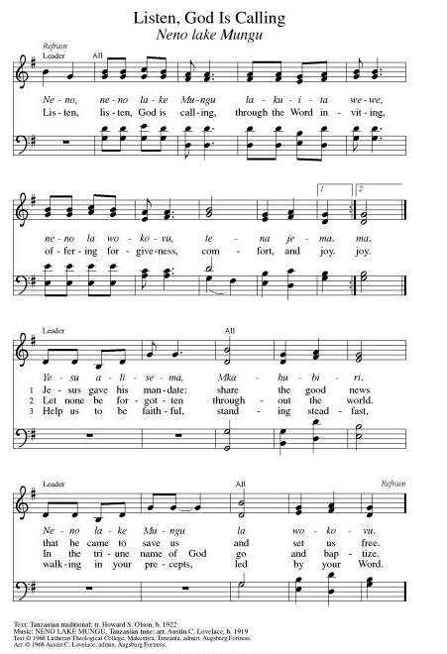
**Hymn of Praise ELW 866
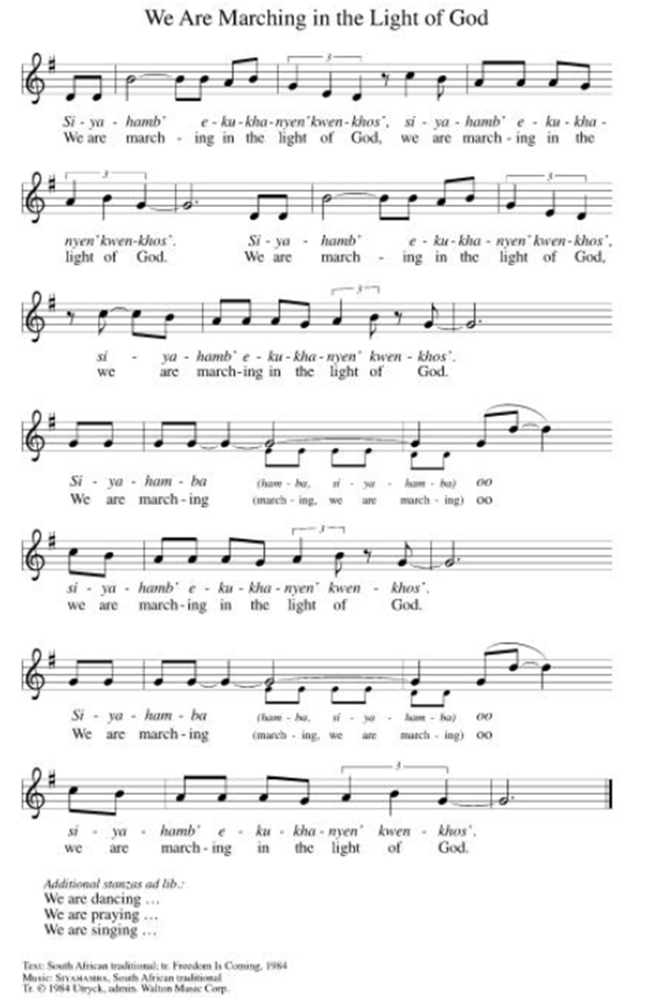

**Prayer of the Day
Loving and eternal God, we look forward to the day when death and pain will be no more. While we wait, empower us to love and care for our neighbors, especially those who are vulnerable. We pray this in the name of Jesus, our savior. Amen.

Reading: Revelation 21:1-6, 22-22:5

^{21:1}Then I saw new heavens and a new earth. The former heavens and the former earth had passed away, and the sea existed no longer. ²I also saw a new Jerusalem, the holy city, coming down out of heaven from God, beautiful as brides and grooms on their wedding day.

³And I heard a loud voice calling from the throne, “Look! God’s Tabernacle is among humankind! God will live with them; they will be God’s people, and God will be fully present among them. ⁴The Most High will wipe away every tear from their eyes. And death, mourning, crying, and pain will be no more, for the old order has fallen.”

⁵The One who sat on the throne said, “Look! I’m making everything new!” and added, “Write this, for what I am saying is trustworthy and true.”

⁶And that One continued, “It is finished. I am the Alpha and the Omega, the Beginning and the End. To those who are thirsty I will give drink freely from the spring of the water of life.”

²²I saw no Temple in the city, for God Almighty and the Lamb were themselves the Temple. ²³There was no sun or moon: God’s glory was its sun, and the Lamb was its lamp. ²⁴The nations will walk by the city’s light, and the rulers of the earth will bring their treasures. ²⁵The city’s gates will never be shut by day, and there will be no night there. ²⁶The glory and honor of the nations will be brought into it. ²⁷But nothing unclean will ever enter it, nor will anyone who does loathsome things or tells lies. Only those whose names are written in the book of life of the Lamb will enter.

^{22:1}The angel then showed me the river of life-giving water, clear as crystal, which issued from the throne of God and of the Lamb, ²and flowed down the middle of the streets. On either side of the river grew the trees of life which produce fruit twelve times a year, once each month; their leaves serve as medicine to heal the nations. ³There will no longer be any curse.

The throne of the Almighty and of the Lamb will be there, and God’s subjects will serve faithfully. ⁴They will see the Most High face to face, and bear God’s name on their foreheads. ⁵Night will be no more. They will need no light from lamps or the sun, for our God will give them light, and they will reign forever.

Word of God, Word of Life
Thanks be to God

**Gospel Acclamation ELW 519
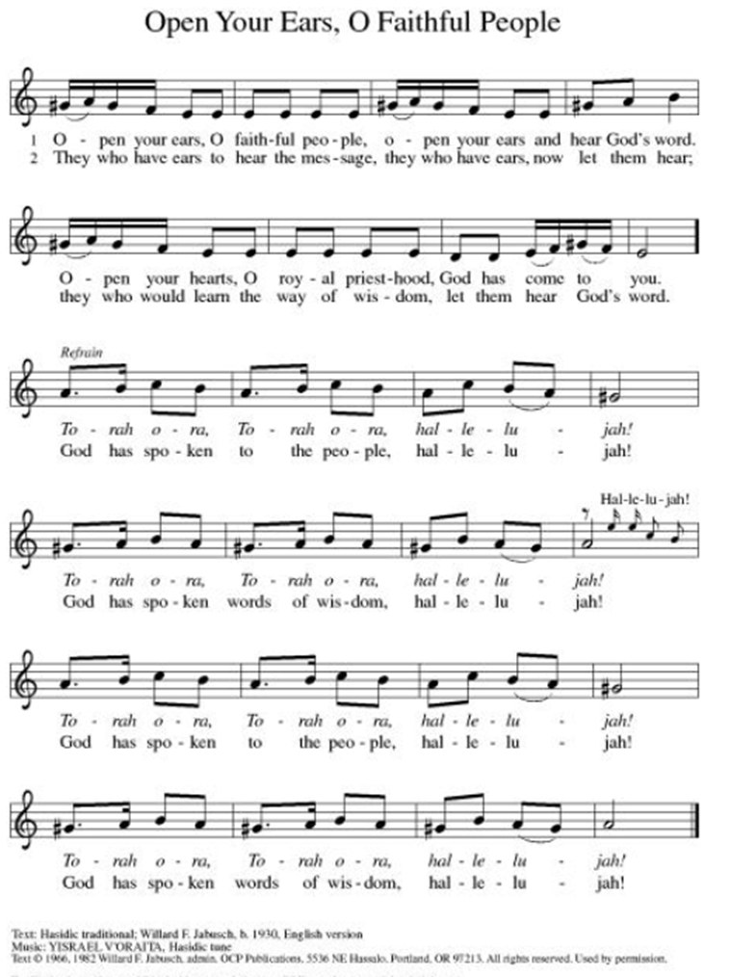
Announcement of the Gospel
Glory to you, O Lord.

Gospel: John 4:1-14

¹When Jesus learned that the Pharisees had heard he was attracting and baptizing more disciples than John – ²though it was really not Jesus baptizing, but his disciples – ³he left Judea and returned to Galilee. ⁴This meant that he had to pass through Samaria.

⁵He stopped at Sychar, a town in Samaria, near the tract of land Jacob had given to his son Jopseph, ⁶and Jacob’s well was there. Jesus, weary from the journey, came and sat by the well. It was around noon.

⁷When a Samaritan woman came to draw water, Jesus said to her, “Give me a drink.” ⁸The disciples had gone off to the town to buy provisions.

⁹The Samaritan woman replied, “You’re a Jew. How can you ask me, a Samaritan, for a drink?” – since Jews had nothing to do with Samaritans.

¹⁰Jesus answered, “If only you recognized God’s gift, and who it is that is asking you for a drink, you would have asked him for a drink instead, and he would have given you living water.”

¹¹“If you please,” she challenged Jesus, “you don’t have a bucket and this well is deep. Where do you expect to get this ‘living water?’ ¹²Surely you don’t pretend to be greater than our ancestors Leah and Rachel and Jacob, who gave us this well and drank from it with their descendants and flocks?”
¹³Jesus replied, “Everyone who drinks this water will be thirsty again. ¹⁴But those who drink the water I give them will never be thirsty; no, the water I give will become fountains within them, springing up to provide eternal life.”

The Gospel of the Lord.
Praise to you, O Christ.

Sermon “Belongings”

Hymn of the Day Soon and Very Soon ELW#439

**Affirmation of Faith – Immigrant’s Creed by Jose Luis Casal

I believe in Almighty God, who guided the people in exile and in exodus, the God of Joseph in Egypt and Daniel in Babylon, the God of foreigners and immigrants.

I believe in Jesus Christ, a displaced Galilean, who was born away from his people and his home, who fled his country with his parents when his life was in danger. When he returned to his own country he suffered under the oppression of Pontius Pilate, the servant of a foreign power. Jesus was persecuted, beaten, tortured, and unjustly condemned to death. But on the third day Jesus rose from the dead, not as a scorned foreigner but to offer us citizenship in God’s kingdom.

I believe in the Holy Spirit, the eternal immigrant from God’s kingdom among us, who speaks all languages, lives in all countries, and reunites all races.

I believe that the Church is the secure home for foreigners and for all believers. I believe that the communion of saints begins when we embrace all God’s people in all their diversity. I believe in forgiveness, which makes us all equal before God, and in reconciliation, which heals our brokenness. I believe that in the Resurrection God will unite us as one people in which all are distinct and all are alike at the same time. I believe in life eternal, in which no one will be foreigner but all will be citizens of the kingdom where God reigns forever and ever. Amen.

**Prayers of Intercession

Holy God, our prayers rise to you like the wings of a dove. We call upon your name, and we ask that you hear us.

God our unity, your church flourishes in different languages, cultures, and movements. Grant us wisdom to discern when our yokes are too heavy, that we may live and serve in the freedom of your rest. God of grace,
hear our prayer.
God our life-giver, we grieve the pains placed upon our common home through war and neglect. What you have lovingly crafted, guide us to lovingly tend. God of grace,
hear our prayer.
God our freedom, you are no tyrant but bring peace. As this nation marks its declaration of independence, teach us our part in announcing peace for future generations. God of grace,
hear our prayer.
God our comfort, liberate all in our community who are captive to fear, who have become isolated or ill, or who are in any need worries especially Monty & Marie, Paul, Helen, Linda, Betty F., Kay, Becky H., Jim & Jan, Melian, Becky W., David, Val, William & family, Judy, Peter & Carrie, Barbara & Donna, Lorey, Brad & Chris, Pastor Sami, families in our community who endure hunger, and our beloved for whom death is near. God of grace,
hear our prayer.
God our guide, we do not always have the strength to do the good we wish to do. Free us from the cycles of violence that bind us, that all know your liberation. God of grace,
hear our prayer.
Pave a way to justice, drown the forces of oppression, bring peace on earth. Give leaders the will to turn from war and violence. Especially we pray for the people of Cuba & Venezuela, Iran, Sudan, Gaza, Israel, and Ukraine. When people must flee their homes, guide them to safety. Comfort those living with deep trauma, anxiety, or fear; all those who serve people in need, and accompany all those who care for people in harm’s way. We also lift up Jim’s grandson Dylan, who is deployed, and Sharon’s great nephew, Taylor, who is deployed in the Middle East. God of grace,
hear our prayer.
We pray for people who rise up against injustice. Bring courage and resilience to those who resist tyranny with their words and their bodies. Strengthen those who fight for justice in your name across the country, and around the world. Protect and sustain immigrants and refugees and all who work with them, that your kingdom, without borders and without walls, may truly come on earth as it is in heaven. We pray for all victims of gun violence or kidnapping, especially those who are targeted out of hate or fear. Embolden us to holy outrage and empower us to speak our truth of love and justice. God of grace,
hear our prayer.
God our home, you model freedom through the love shared across communities of trust and goodwill. As we remember those now gone to eternal rest, we thank you for the gifts of life together. God of grace,
hear our prayer.

Good and loving God, we give everyone we have prayed for into your care. Amen.

** Sharing of the Peace

**Offering is brought forward

** Offertory Response ELW486

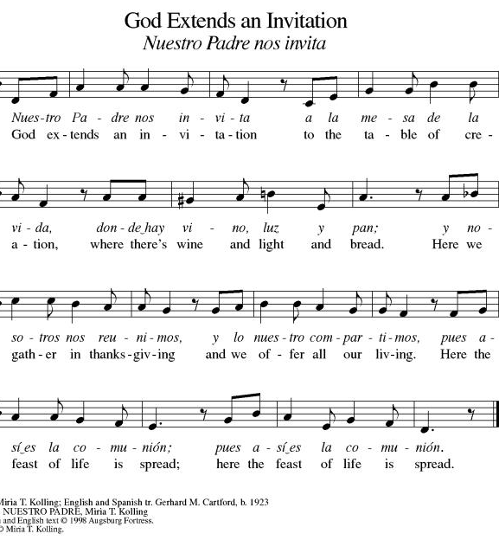
**Offertory Prayer
Jesus, all that we have and all that we are comes from you. Thank you for the gifts you have given us. Receive these gifts – our money, our service, our time – which we give in gratitude for all that we have received from you. Amen.

Blessing of CSL

Dialogue
Christ is with you!
And also with you!

Lift up your hearts in joyful praise!
We lift them up to God in joy!

**Preface: We give thanks and praise to God...this hymn of praise:
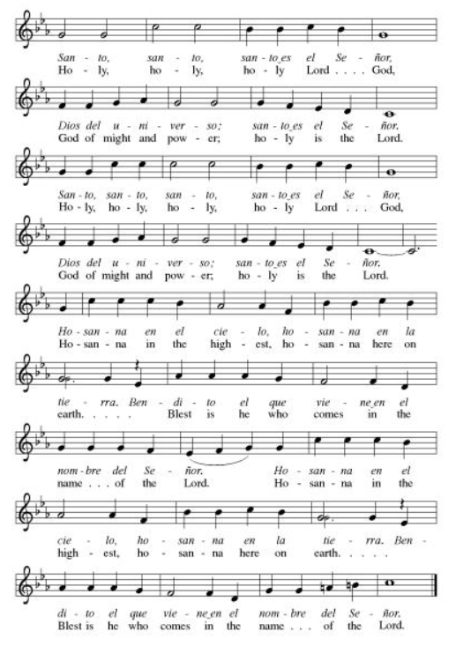
**Words of Institution

**LORD’S PRAYER
You are invited during this Pentecost season to pray whichever version feels most comfortable on your lips and in your soul. A separate sheet is available with alternate versions, should you be interested. Or, you are invited to use one of these:
Our Father in heaven, Our Father, who art in heaven,
hallowed be your name, hallowed be thy name,
your kingdom come, thy kingdom come,
your will be done, thy will be done,
on earth as in heaven. on earth as it is in heaven.
Give us today our daily bread. Give us this day our daily bread;
Forgive us our sins and forgive us our trespasses
as we forgive those as we forgive those
who sin against us. who trespass against us;
Save us from the time of trial and lead us not into temptation,
and deliver us from evil. but deliver us from evil.
For the kingdom, the power, For thine is the kingdom,
and the glory are yours, and the power, and the glory,
now and forever. Amen. forever and ever. Amen.

Invitation to Communion

Communion Hymn Precious Lord Take My Hand ELW#773

**Sending Song ELW 535

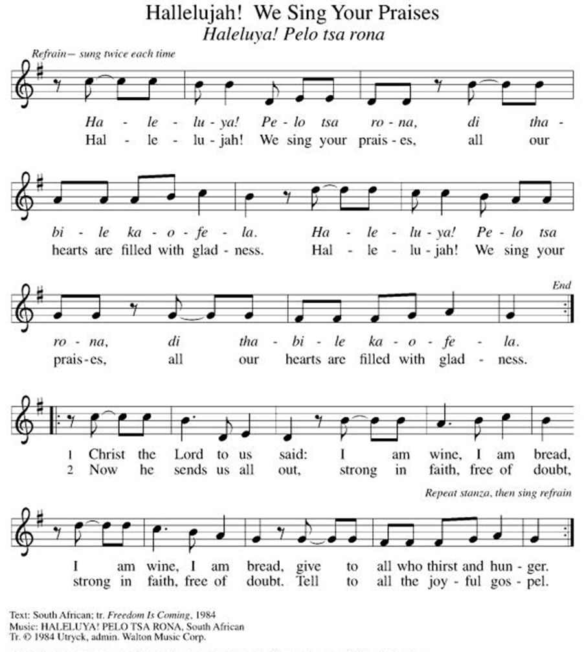

**Prayer After Communion
Holy God, you love us so much that you transformed an act of destruction into an act that gives new life. Thank you for the renewal we receive at your Table, as you send us out from this place into the world. Strengthen us for your service. In Jesus’ name we pray. Amen.

**Blessing

Healing of Nations

**Benediction

**Dismissal

Empowered by the Spirit, may you go in peace to share the gospel!
THANKS BE TO GOD!

+ + + + + +

Setting 07 and hymns from the Evangelical Lutheran Worship are under copyright and used with permission under One License #733618-A. Specific copyright information as listed in bulletin, the Prayers of Intercession are under copyright and are used with permission under Augsburg Fortress Liturgy License #SB155933. All other liturgy written by Sarah Pierce.

Weekly Attendance

Week of June 28:
21
******************************************************************************************

Next Week:
7th Sunday after Pentecost:
Psalm 46
Acts 2:37-42
Luke 9:1-6

John 4:1-14
The color of the day is Green

Calendar of Events

Today
- Blessings of CSL
- Healing Services
This Week
July 07 | Creative Friends
July 08 | Pastor Sarah-MOREZ Training & Strategy Session for Clergy for Social & Economic Justice.  Out of Office 9:00 am-Noon
July 11 | Men’s Breakfast 8:00am

Upcoming Events

July 12 | Baptismal Sunday
July 14 | Creative Friends
July 15 | Council Meeting 6:30 pm
July 20 | Newsletter Deadline
July 21 | Creative Friends
July 25 | Project Comfort
July 26 | Coffee with Council  Celebrate Niel’s Birthday (July 28)
July 28 | Creative Friends  Report Synod Assembly
August 19 | Council Meeting 6:30
September 13 | God’s Work. Our Hands.
September 23 | Council Meeting 6:30 pm
September 27 | Celebration 5th year Anniversary of Pastor’s Ordination

Note: 2026 paint party fundraisers: Aug. 5, Sept. 2, Oct. 7, Nov. 4, Dec. 2
Pastor Sarah Questions:

Questions for Reflection and Discussion

1. As I was thinking about the concept of the new Jerusalem coming down to earth, I was reminded of a scene near the end of “Field of Dreams,” when Ray’s (Kevin Costner) dad asks him, “Is this heaven?” Ray replies, “It’s Iowa.” His dad says, “Iowa? I could have sworn this was heaven.” Ray asks him, “Is there a heaven?” He responds, “Oh, yeah. It’s the place where dreams come true.” Ray looks around and sees his wife and daughter and says, “Maybe this is heaven.” (credit IMDb for the dialogue) It’s a little trite, maybe, but I think it gets the point across. In John’s vision, the new heaven and the new earth will be here, re-created. Not in some cosmic location up in the sky, to which people are raptured, leaving their cars stranded.
2. Revelation 21 and 22 circle back around to Revelation 1 and 4, where the vision is of the entire creation joining in praise to God. Jerusalem is so big that our minds can’t conceive of its size; John intends that. When he describe the richness and beauty of the new Jerusalem, the intention is the same – it is more richly appointed than anything humanity could ever achieve, and it manages to be beautiful, rather than gaudy. (Read the rest of chapter 21 for the size and the description.)
3. In chapter 22, we are redeemed from the curse of Eden, when the tree of life produces fruit that can be eaten and leaves that heal the nations, and John says, “There will no longer be any curse.” And we will not hide from God’s face as Adam and Eve did; instead, we will have an audience with God, enjoying a relationship of absolute trust and openness.
4. But the point is this: we do what we can, maintaining our faith in patient endurance and working to improve conditions in our little corner of this earth, or around the world – wherever and however far our scope of influence reaches. That’s what we are called to do as followers of Jesus. But finally, it is God’s redemptive work that will bring about the new heaven and the new earth, not our actions.

******************************************************************************************
BLUE SPRINGS COMMUNITY SERVICE LEAGUE is very appreciative of your continued support of your neighbor.
July 05
Altar Guild – Mary Ann Gross & Donna Taylor
Lector – Tonya Hamilton
Greeter – Donna Taylor
Usher-Paul Blixrud
Tech – Gary Antes

Prayer Requests
Monty & Marie Health Concerns (March 04)
Paul Health Concerns (May 31)
Mary Health Concerns (May 15)
James & Family Health Concerns (September 11)
Betty F (Sara’s friend) Health Concerns (July 15)
William and Family Health Concerns (September 25)
Becky H Health Concerns (October 28)
David Health Concerns (November 18)
Becky W Health Concerns (November 18)
Judy Health Issues (December 16)
Kay (Sara’s cousin) Health Concerns (July 15)
Sharon Health Concerns (October 22)
Michael Health Concerns (October 22)
Peter and Carrie Health Concerns (November 26)
Melian Health Concerns (November 16)
RJ Health Concerns (November 17)
Barbara Health Concerns (December 30)
Helen Health Concerns (February 25)
Val (Tonya’s sister) Health Concerns (February 18)
Lorey Health Concerns (April 14)
Chris Health Concerns (June 09)
Pastor Sami Health Concerns (June 24)

Merciful God, your justice and mercy are without limits. Bring courage and resilience to those who resist tyranny with their words and their bodies. Strengthen those who fight for justice in your name across the country, and around the world.

Please pray for the people of Venezuela & Iran, Sudan, Gaza, Ukraine, Israel, Cuba, Iran and Palestine.
Please pray for the Homeless.
Please pray for legal & illegal immigrants & those seeking asylum or citizenship

