All Saints Lutheran Church, ELCA
421 SW 19th St. Blue Springs, Missouri 64015 816-229-3633
Pastor Sarah Pierce Spierce.aslcpastor@gmail.com
allsaintslc64015@gmail.com https://aslcbs.org/

Sunday, March 29, 2026

Palm Sunday

You are absolutely invited into this sacred space. We welcome all who are seeking God’s love and grace. All Saints recognizes that we are all unique and beloved children of God. We celebrate and give thanks for the many diverse gifts that God has given us. We affirm the sacredness of people of all sexual orientations, gender identities, and gender expressions. We affirm the sacredness of all those who have experienced exclusion because of race, ability, age, or culture. We are committed to working towards anti-racism in ourselves and our community. We affirm the sacredness of all those who wrestle with addiction, physical or mental health, imprisonment, socio-economic circumstances, or anything that too often divides us. We believe that through our openness we all grow in our faith through Christ’s teaching to love one another as God loves us. We need each other and our sincere hope is by being in community together, we will experience God’s presence in new and real ways.

The offering plate is by the main door to the sanctuary for your convenience.

We practice open communion at All Saints Lutheran Church. What does that mean? It means that if you believe and trust that Christ offers his body and blood For You, you are welcome at the table. At All Saints, we believe that Christ invites all people to the feast. “Come to the banquet for all is now ready.”

**Stand as you are comfortable

Prelude

Announcements

**ACCLAMATION
Blessed is the one who comes in the name of the Lord.
Hosanna in the highest.

Blessed is the one who comes in the name of the Lord.
Hosanna in the highest.

Blessed is the one who comes in the name of the Lord.
Hosanna in the highest.

**Announcement of the Processional Gospel
Glory to you, O Lord.

**Gospel: Processional John 12:12-18

¹²The next day, the great crowd that had come for the Passover feast heard that Jesus was coming to Jerusalem, ¹³so they got palm branches and went out to meet him. They shouted joyfully,
“Hosanna!
Blessed is the One who comes
in the name of our God –
the ruler of Israel!
¹⁴Jesus rode in sitting upon a donkey, in accord with scripture:
¹⁵“Fear not, O people of Zion!
Your ruler comes to you
sitting on a donkey’s colt.”

¹⁶At the time, the disciples didn’t understand all this, but after Jesus was glorified they recalled that the people had done to him precisely what had been written about him.

¹⁷Those who had been present when Jesus called Lazarus from the tomb and raised him from the dead continued to spread the word. ¹⁸A crowd gathered, and they went out to meet Jesus because they had heard he had performed this miraculous sign.
The Gospel of the Lord.
Praise to you, O Christ.

**BLESSING OF PALMS

The Lord be with you.
And also with you.

Let us pray.

We praise you, O God,
for redeeming the world through our Savior Jesus Christ.
Today he entered the holy city in triumph
and was proclaimed messiah and king
by those who spread garments and branches along his way.
Bless these branches and those who carry them.
Grant us grace to follow our Lord in the way of the cross,
so that, joined to his death and resurrection,
we enter into life with you;
through the same Jesus Christ,
who lives and reigns with you and the Holy Spirit,
one God, now and forever.
Amen.

**PROCESSION with Palms
Let us go forth in peace,
in the name of Christ. Amen.

**Entrance Hymn All Glory, Laud, And Honor ELW#344

**Greeting
The grace of our Lord Jesus Christ, the love of God,
and the communion of the Holy Spirit be with you all.
And also with you.

**Prayer of the Day
Jesus, today we cry Hosana! Blessed is the one who comes in the name of our God! Even as we cry these words, make us mindful of all those who are suffering in our community, in our nation, and around the world. Empower us to accompany them in their suffering, as you are with us even to the end. Amen.

Remembrance of Baptism

Reading: Psalm 24

¹The earth and everything on it –
the world and all who live in it –
belong to God.
²God built it on the deep waters,
laying its foundations in the open depths.
³Who has the right to ascend God’s mountain?
Who is allowed to enter God’s holy place?
⁴Those whose hands are clean
and whose hearts are pure,
who do not worship idols, or make false promises.
⁵God will bless them;
God their savior will declare them innocent.
⁶Such are the people who seek God,
who seek your face, God of our ancestors.
⁷Fling wide the gates,
open the ancient doors,
and the Glorious Liberator will come in!
⁸Who is this “Glorious Liberator?”
God, strong and mighty,
God, victorious in battle!
⁹Fling wide the gates,
open the ancient doors,
and the Glorious Liberator will come in!
¹⁰Who is this “Glorious Liberator?”
God Almighty is our Glorious Liberator!

The Word of the Lord
Thanks be to God

**Gospel Acclamation
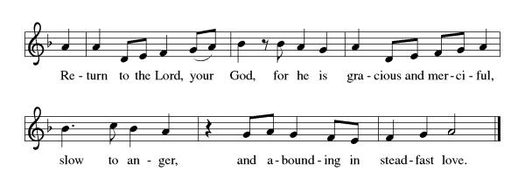
Announcement of the Gospel
Glory to you, O Lord.

Gospel: John 13:1-38, 18:1-19:92

The Gospel of the Lord.
Praise to you, O Christ.

Hymn of the Day At the Name of Jesus ELW#416

**Affirmation of Faith – Immigrant’s Creed by Jose Luis Casal

I believe in Almighty God, who guided the people in exile and in exodus, the God of Joseph in Egypt and Daniel in Babylon, the God of foreigners and immigrants.

I believe in Jesus Christ, a displaced Galilean, who was born away from his people and his home, who fled his country with his parents when his life was in danger. When he returned to his own country he suffered under the oppression of Pontius Pilate, the servant of a foreign power. Jesus was persecuted, beaten, tortured, and unjustly condemned to death. But on the third day Jesus rose from the dead, not as a scorned foreigner but to offer us citizenship in God’s kingdom.

I believe in the Holy Spirit, the eternal immigrant from God’s kingdom among us, who speaks all languages, lives in all countries, and reunites all races.

I believe that the Church is the secure home for foreigners and for all believers. I believe that the communion of saints begins when we embrace all God’s people in all their diversity. I believe in forgiveness, which makes us all equal before God, and in reconciliation, which heals our brokenness. I believe that in the Resurrection God will unite us as one people in which all are distinct and all are alike at the same time. I believe in life eternal, in which no one will be foreigner but all will be citizens of the kingdom where God reigns forever and ever. Amen.

**Prayers of Intercession

God of Love, hear the prayers that we lift before you. Hold close to you all those for whom we pray.

O God, you announce words of grace and truth. Give wisdom to all preachers in your church both globally and locally. Open our hearts to encounter the infinite life you offer in Jesus. Hear us, O God.
Your mercy is great.
You hold the whole universe. Gather sun and moon, clouds and stars, land and sea, and plants and animals around the cross, so that all creation bears witness to your saving love. Hear us, O God.
Your mercy is great.
Your power is sure. Destroy inequity and division in every place, and build your beloved community among all people. Guide judges, attorneys, and juries so that they act with justice and fairness. Hear us, O God.
Your mercy is great.
Your heart breaks open at our pain. Send healing and vindication to all who, like Jesus, know the sting of betrayal, denial, abuse, or false accusations. Be with those experiencing pain or loss this day especially Monty & Marie, Paul, Helen, Linda, Betty F., Kay, Becky H., Jim & Jan, Melian, Becky W., David, Val, William & family, Judy, Kevin, Peter & Carrie, Barbara & Donna, families in our community who endure hunger, and our beloved for whom death is near. Hear us, O God.
Your mercy is great.
Your ways show compassion. Let this same mind be in us as we enter Holy Week. Bless those here who will lead worship and tell the story of Jesus’ death and resurrection. Hear us, O God.
Your mercy is great.
Pave a way to justice, drown the forces of oppression, bring peace on earth. Give leaders the will to turn from war and violence. Especially we pray for the people of Cuba & Venezuela, Iran, Sudan, Gaza, Israel, and Ukraine. When people must flee their homes, guide them to safety. Comfort those living with deep trauma, anxiety, or fear; all those who serve people in need, and accompany all those who care for people in harm’s way. We also lift up Jim’s grandson Dylan, who is deployed, and Sharon’s great nephew, Taylor, who is deployed in the Middle East. Hear us, O God.
Your mercy is great.
We pray for people who rise up against injustice. Bring courage and resilience to those who resist tyranny with their words and their bodies. Strengthen those who fight for justice in your name across the country, and around the world. Protect and sustain immigrants and refugees and all who work with them, that your kingdom, without borders and without walls, may truly come on earth as it is in heaven. We pray for all victims of gun violence or kidnapping, especially those who are targeted out of hate or fear. Embolden us to holy outrage and empower us to speak our truth of love and justice. Hear us, O God.
Your mercy is great.
We lift up all who teach and all who learn. Thank you for teachers who share their knowledge and wisdom. Bless the students in our midst. Especially we remember Evie, in kindergarten; Addison, in high school; and Tyler, Zach, Katie and Katy, in college. Bless Janet, Carla, and Lisa as they teach. Hear us, O God.
Your mercy is great.
O God, your embrace is eternal. Praise and thanks to you for all the faithful departed who rest in your mercy. Deliver us all from death’s power and raise us to life in you. Hear us, O God.
Your mercy is great.

Good and loving God, we give everyone we have prayed for into your care. Amen.

** Sharing of the Peace

**Offering is brought forward

** Offertory Response

Let Us Talents and Tongues Employ (V. 1) ELW#674

**Offertory Prayer

Good and loving God, we give to you these offerings of our time, our talents, and our money, for the work of your people in this place, as we seek to follow your Son. Prepare our hearts and minds to come to your Table, as you feed us with the life-giving body and blood of your son Jesus Christ, through whom we receive the gift of eternal life.

Amen.

Dialogue
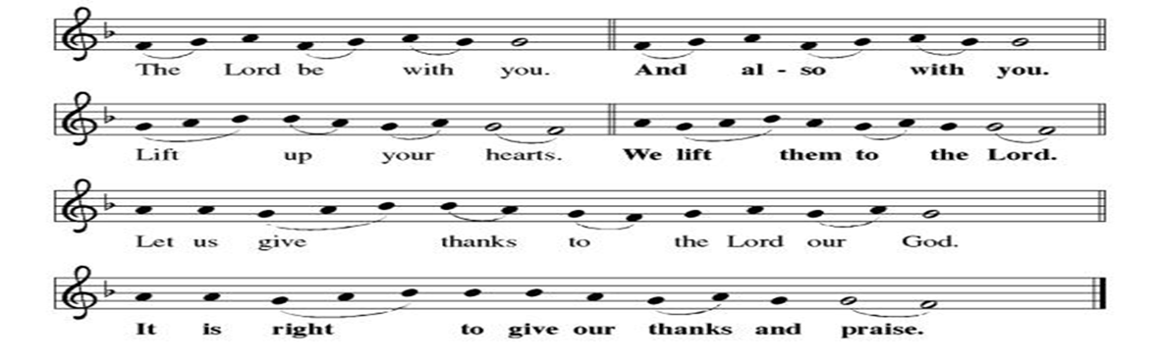

**Preface: We give you thanks, Holy God… this hymn of praise:
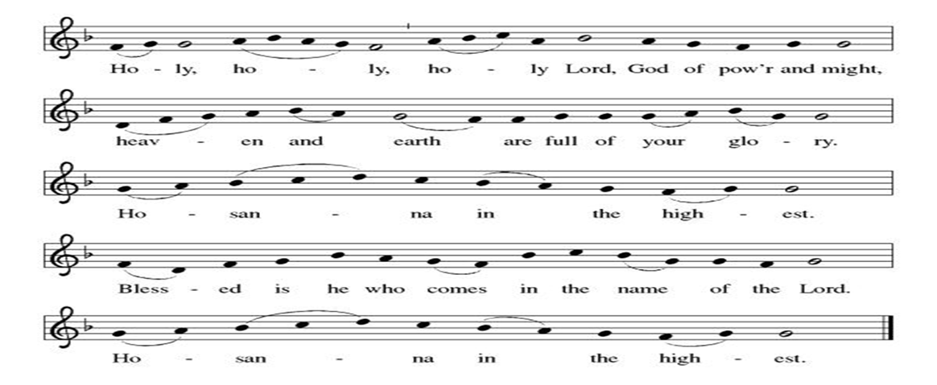
**Words of Institution

**LORD’S PRAYER
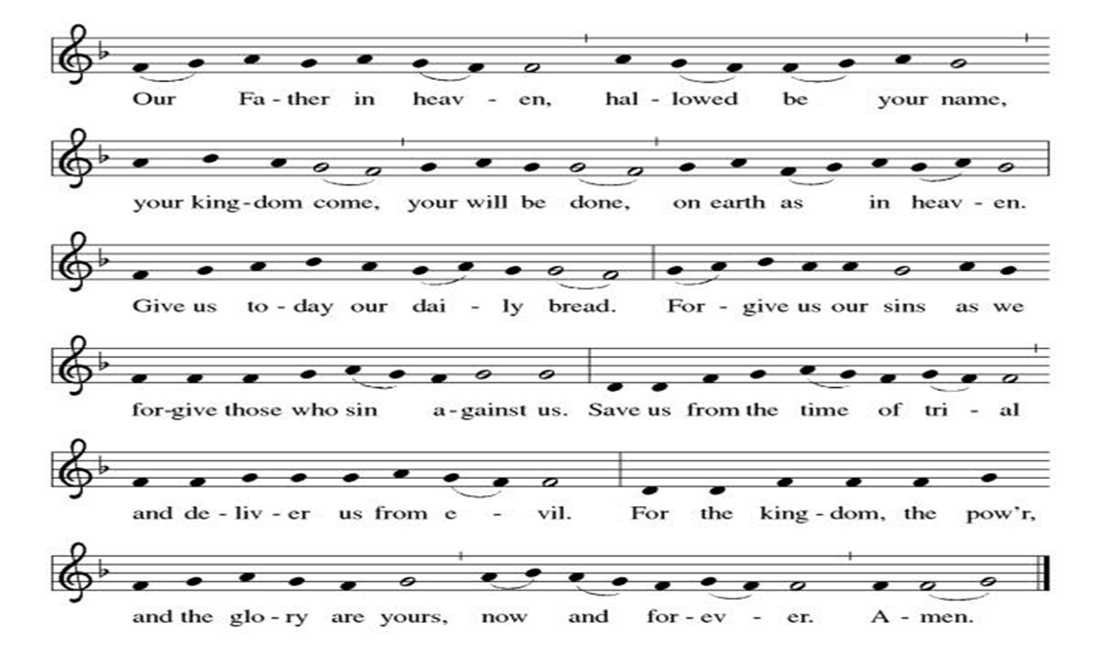

Invitation to Communion

Communion Hymn Ride On, Ride On in Majesty! EL#346

**Sending Song

Now, Lord ELW#201

**Prayer After Communion

Holy and Eternal God, we have been fed at your Table with the goodness of our Savior. Send us out, emboldened to share the good news of your promise of forgiveness and eternal life. Strengthen our resolve to respond to the needs of our neighbors and to care for your world. Amen.

**Blessing

**Closing Hymn Alas! And Did My Savior Bleed ELW#337

**Dismissal

Go in peace. Serve in Love.
THANKS BE TO GOD!

+ + + + + +

Hymns from Setting 05 and the Evangelical Lutheran Worship are under copyright and used with permission under One License #733618-A. Specific copyright information as listed in bulletin, the Prayers of Intercession are under copyright and are used with permission under Augsburg Fortress Liturgy License #SB155933. All other liturgy written by Sarah Pierce.

Weekly Attendance

Week of March 22
26

******************************************************************************************
Calendar of Events
Today
- Palm Sunday/Spring Workday

This Week
March 31 | Bells Prqctice
April 01 | Paint Party Fundraiser
April 02 | Maundy Thursday  Worship 7:00 pm
April 03 | Good Friday Office Closed  Service at 7:00 pm
April 04 | Easter Vigil 7:45 pm

Upcoming Events
April 05 | Easter Sunday  Bells play “My Lord What A Morning” & “We Will Glorify”  Easter Brunch after service
April 07 | Creative Friends
April 08 | Church Council Meeting 6:30 pm
Aoril 11 | Men’s Breakfast
April 12 | View Christian Nationalism Part1
April 14 | Creative Friends
April 15 | Bells practice
April 20 | Newsletter Deadline
April 21 | Creative Friends
April 22 | Bells practice
April 25 | Project Comfort
April 26 | Coffee with Council
April 28 | Creative Friends
April 29 | Bells practice
May 03 | View Christian Nationalism part 2
May 06 | Paint Party Fundraiser
May 10 | Mother’s Day
May 13 | Church Council Meeting 6:30 pm
May 17 | Congregational Meeting after worship
May 24 | Pentecost
May 25 | Memorial Day
June 03 | Paint Party Fundraiser
June 07 | View Christian Nationalism part 3  Ice Cream Social
June 19 | Juneteenth Office Closed
June 28 | Coffee with Council
July 01 | Paint Party Fundraiser
July 04 | Independence Day
July 26 | Coffee with Council  Celebrate Niel’s Birthday (July 28)
September 13 | God’s Work. Our Hands.
Note: 2026 paint party fundraisers: Feb. 4, March 4, April 1, May 6, June 3, July 1, Aug. 5, Sept. 2, Oct. 7, Nov. 4, Dec. 2
Note: Theater group church use: auditions Feb. 6 &7, 6:30-9:30; callbacks Feb. 8, 1-5; rehearsals MWF & Saturday, Feb.16-April 18, MWF 6:30-9:30 and Saturdays 12-4.
*****************************************************************************
Pastor Sarah Questions:

- In traditional Mediterranean thought, the hands and feet were considered to be the “zone of interaction” with the world – anything involving the feet or hands is involved in doing, making, etc. So for Jesus to wash the disciples’ feet is to wash away their past and future actions, forgiving their trespasses (also something you do with your feet). It was also an action that was traditionally done by a servant on first entering the house, because the feet were literally the dirtiest part of the body. So for Jesus to do this is what we would call, in modern parlance, “servant leadership.”
- In the ancient world, trials were not opportunities for innocence or guilt to be established. For social equals, they were opportunities to shame or embarrass your opponent. For social inferiors (as in Jesus’ case when brought to trial by the Sanhedrin), the assumption is that the person on trial is guilty; the purpose of the trial is to determine what the punishment would be.
- Jesus’ question to the soldiers in the garden calls back to John 1, when he’s first calling his disciples and asks them what they’re looking for. This is the only time, however, when he gives a straight answer – when the people looking for him are looking to arrest him.
- Why is it important to us that Peter denies Jesus? Would we deny Jesus? When or how do we deny Jesus?
- Nicodemus makes his return in this story, helping to bury Jesus. What do you think of his story arc, from first appearing at night (revealing his doubt/confusion) to kind of half-heartedly sticking up for Jesus midway through the first half of John’s gospel, to now helping Joseph of Arimathea bury him?

******************************************************************************************
BLUE SPRINGS COMMUNITY SERVICE LEAGUE is very appreciative of your continued support of your neighbor.
*****************************************************************************************
Birthdays
April 03-Suelyn Olson

March 29
Altar Guild – Mary Ann Gross & Donna Taylor
Lector – Kent Deubner
Communion Assistant – Flavia Via
Greeter – Donna Taylor
Tech – Gary Antes

Prayer Requests
Monty & Marie Health Concerns (Maech 04)
Paul Health Concerns (May 31)
Mary Health Concerns (May 15)
James & Family Health Concerns (September 11)
Betty F (Sara’s friend) Health Concerns (July 15)
William and Family Health Concerns (September 25)
Becky H Health Concerns (October 28)
David Health Concerns (November 18)
Becky W Health Concerns (November 18)
Judy Health Issues (December 16)
Kay (Sara’s cousin) Health Concerns (July 15)
Kevin Health Concerns (October 01)
Sharon Health Concerns (October 22)
Michael Health Concerns (October 22)
Peter and Carrie Health Concerns (November 26)
Melian Health Concerns (November 16)
RJ Health Concerns (November 17)
Barbara Health Concerns (December 30)
Helen Health Concerns (February 25)
Val (Tonya’s sister) Health Concerns (February 18)

Merciful God, your justice and mercy are without limits. Bring courage and resilience to those who resist tyranny with their words and their bodies. Strengthen those who fight for justice in your name across the country, and around the world.

Please pray for the people of Venezuela & Iran, Sudan, Gaza, Ukraine, Israel, Cuba, Iran and Palestine.
Please pray for the Homeless.
Please pray for legal & illegal immigrants & those seeking asylum or citizenship

