All Saints Lutheran Church, ELCA
421 SW 19th St. Blue Springs, Missouri 64015 816-229-3633
Pastor Sarah Pierce Spierce.aslcpastor@gmail.com
allsaintslc64015@gmail.com https://aslcbs.org/

Sunday, September 13, 2026

Sixteenth Sunday after Pentecost

You are absolutely invited into this sacred space. We welcome all who are seeking God’s love and grace. All Saints recognizes that we are all unique and beloved children of God. We celebrate and give thanks for the many diverse gifts that God has given us. We affirm the sacredness of people of all sexual orientations, gender identities, and gender expressions. We affirm the sacredness of all those who have experienced exclusion because of race, ability, age, or culture. We are committed to working towards anti-racism in ourselves and our community. We affirm the sacredness of all those who wrestle with addiction, physical or mental health, imprisonment, socio-economic circumstances, or anything that too often divides us. We believe that through our openness we all grow in our faith through Christ’s teaching to love one another as God loves us. We need each other and our sincere hope is by being in community together, we will experience God’s presence in new and real ways.
The offering plate is by the main door to the sanctuary for your convenience.

We practice open communion at All Saints Lutheran Church. What does that mean? It means that if you believe and trust that Christ offers his body and blood For You, you are welcome at the table. At All Saints, we believe that Christ invites all people to the feast. “Come to the banquet for all is now ready.”

**Stand as you are comfortable
Note: Bold Print - Congregational Statements

Prelude
Announcements

Remembrance of Baptism
Marie Benz September 28th

** Confession and Forgiveness
God who created the heavens, the earth, and all that exists, sometimes we feel small when we
stand before you. But we trust that you see and hear us when we come before you.
Let us take a moment to draw near to God.

Holy God,
You always listen to us when we pray.
Forgive us when we forget to center our lives around you.
Forgive us when we turn away, distracted by other things that delight or distress us.
Forgive us when we sin against you, scorning the promises you have made to us.
Help us remember that you are always the solid foundation on which we stand.
Remind us, your children, to turn back to you.

Beloved children of God, the Spirit moves among us, bringing comfort and renewal. Our
Creator, the Source of all that is good and holy, is making all things new. And in Jesus, our
Savior +, we find the promise of forgiveness and mercy.
Amen.

**Entrance Hymn Great is Thy Faithfulness ELW #733

**Greeting
The grace of our Lord Jesus Christ, the love of God,
and the communion of the Holy Spirit be with you all.
And also with you.

**Kyrie
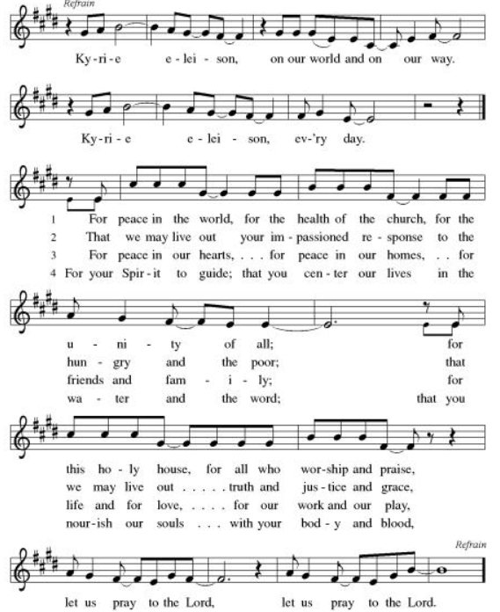

**Hymn of Praise: ELW Canticle of Praise: Glory to God (front of hymnal, pg. 185)
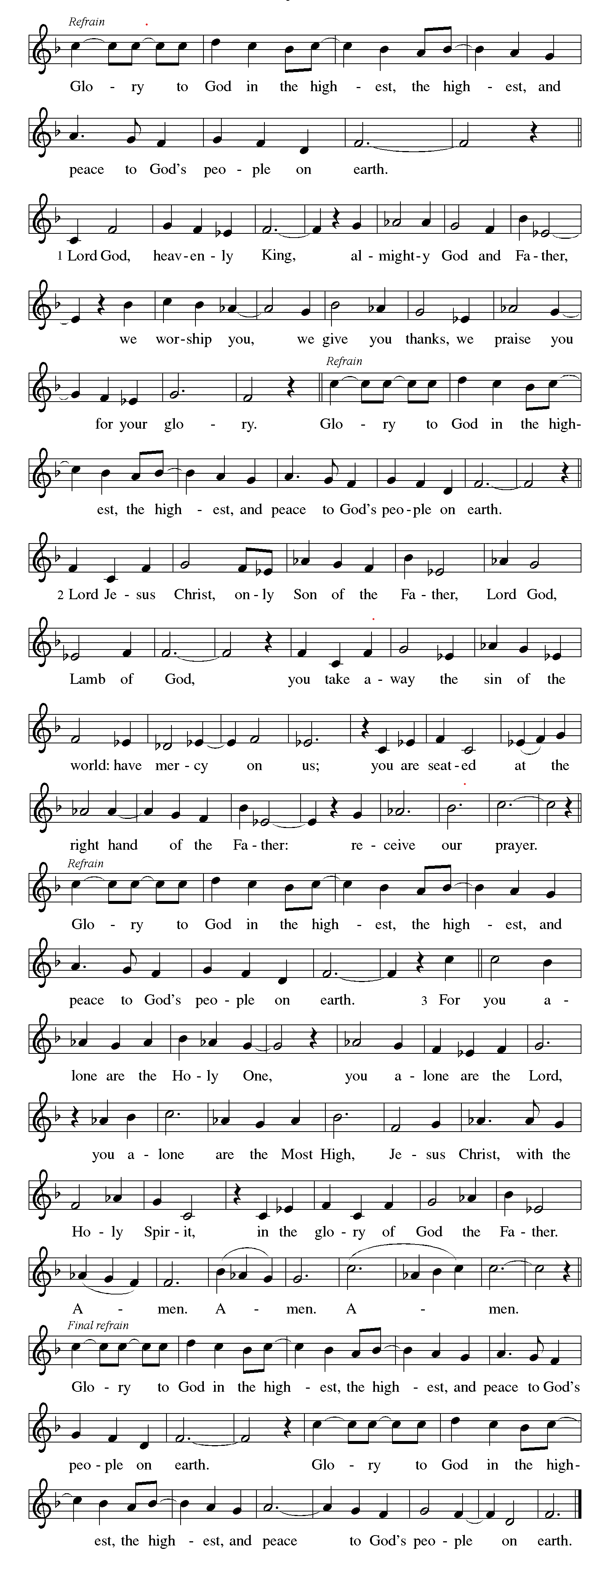
**Prayer of the Day

Holy God, we know that you love us and that you keep your promises to us. Help us to be faithful to you and to care for your neighbor and for creation. We pray this in Jesus' name. Amen.

Reading: Genesis 6:5-22; 8:6-12; 9:8-17

⁵God saw the great wickedness of the people of the earth, that the thoughts in their hearts fashioned nothing but evil.

⁶God was sorry that humankind had been created on earth; it pained God’s heart. ⁷God said, “I will wipe this human race that I have created from the face of the earth – not only the humans, but also the animals, the reptiles, and the birds of the heavens. I am sorry I ever made them.”

⁸But Noah found favor in the eyes of God.

⁹These are the generations of Noah:
Noah was just and blameless among his contemporaries, and walked in accord with God. ¹⁰Noah had three children: Shem, Ham, and Japheth.

¹¹It was clear to God that the world was corrupt and full of violence. ¹²God looked at the earth, and saw that it had gone to ruin; all flesh had defiled its way upon the earth. ¹³So God said to Noah, “The end of all flesh has come before me, for they are the cause of all its violence. I will destroy them, and the earth as well.

¹⁴ “Build an ark for yourself out of cypress. Build rooms in the ark, and coat it with pitch, both inside and out. ¹⁵Its dimensions are to be 450 feet long, 75 feet wide, and 45 feet tall. ¹⁶Put a roof over it, with an overhang of eighteen inches. Put a door on the side, and give it a lower deck, and a second and third deck below that.

¹⁷ “What I have decided to do is to flood the earth and to destroy all flesh under heaven that has the breath of life in it. Everything on earth will die. ¹⁸But I will establish my covenant with you: you and your wife will go into the ark, with your children and their spouses. ¹⁹Bring with you two of every living thing – one male and one female – of all flesh, to preserve them. ²⁰Every kind of bird, every kind of animal, and every kind of thing that creeps on the ground – two of each – are to come to you, to keep you alive. ²¹You must also store up all kinds of food to eat – food for yourselves, and food for all the creatures with you.” ²²Noah did as he was instructed; he did everything that God commanded.

^{8:6}At the end of forty days Noah opened the porthole he had made in the ark ⁷and sent out a raven. It would fly off and return to him as the waters were drying up from the earth. ⁸Then Noah sent out a dove to see if the waters had subsided on the earth. ⁹The dove, finding nowhere to perch, returned to the ark, for there was still water over the whole earth. Putting out his hand for the dove he brought it back into the ark. ¹⁰Noah waited seven more days, and again sent out the dove from the ark. ¹¹In the evening, the dove returned with a freshly plucked olive branch in its beak, and Noah knew that the waters were receding from the earth. ¹²After seven more days, he again sent out the dove, and this time it did not return.

^{9:8}God then said to Noah and his family, ⁹ “I hereby establish my covenant with you and your descendants after you, ¹⁰and with every living creature that is with you – birds, cattle, and the earth’s wildlife – everything that came out of the ark, everything that lives on the earth. ¹¹I hereby establish my covenant with you: All flesh will never again be swept away by the waters of the flood; never again will a flood destroy all the earth.”

¹²God said, “Here is the sign of the covenant between me and you and every living creature fore ageless generations: ¹³I set my bow in the clouds, and it will be a sign of the covenant between me and the earth.¹⁴When I bring clouds over the earth, my bow will appear in the clouds. ¹⁵Then I will remember the covenant that is between me and you and every kind of living creature, and never again will the waters become a flood to destroy all flesh. ¹⁶Whenever my bow appears in the clouds I will see it, and remember the everlasting covenant between God and every living creature on the Earth.” ¹⁷God said to Noah, “This is the sign of the covenant that I have established between me and all living things on the earth.”

Word of God, Word of Life
Thanks be to God

**Gospel Acclamation
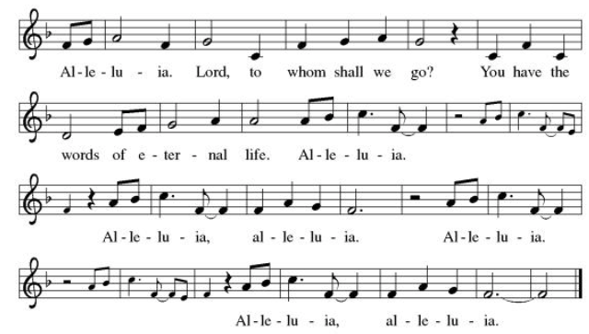

Announcement of the Gospel
Glory to you, O Lord.

Gospel: Matthew 8:24-27

²⁴Without warning, a violent storm broke over the lake, and the boat began to take on water. But Jesus was sleeping, ²⁵so they shook him awake, exclaiming, “Save us! We are lost!”

²⁶Jesus replied, “Why are you afraid? You have so little faith!” Then Jeus stood up and rebuked the winds and the sea, and there was a great calm. ²⁷The others, dumb-founded, said, “Who is this, whom even the winds and the sea obey?”

The Gospel of the Lord.
Praise to you, O Christ.

Sermon “The Flood of Fear and Faith,” D. Kent Deubner

Hymn of the Day Eternal Father, Strong to Save ELW #756

**Affirmation of Faith – Immigrant’s Creed by Jose Luis Casal

I believe in Almighty God, who guided the people in exile and in exodus, the God of Joseph in Egypt and Daniel in Babylon, the God of foreigners and immigrants.

I believe in Jesus Christ, a displaced Galilean, who was born away from his people and his home, who fled his country with his parents when his life was in danger. When he returned to his own country he suffered under the oppression of Pontius Pilate, the servant of a foreign power. Jesus was persecuted, beaten, tortured, and unjustly condemned to death. But on the third day Jesus rose from the dead, not as a scorned foreigner but to offer us citizenship in God’s kingdom.

I believe in the Holy Spirit, the eternal immigrant from God’s kingdom among us, who speaks all languages, lives in all countries, and reunites all races.

I believe that the Church is the secure home for foreigners and for all believers. I believe that the communion of saints begins when we embrace all God’s people in all their diversity. I believe in forgiveness, which makes us all equal before God, and in reconciliation, which heals our brokenness. I believe that in the Resurrection God will unite us as one people in which all are distinct and all are alike at the same time. I believe in life eternal, in which no one will be foreigner but all will be citizens of the kingdom where God reigns forever and ever. Amen.

**Prayers of Intercession

Holy God, our prayers rise to you like the wings of a dove. We call upon your name, and we ask that you hear us.

Move your church throughout the world away from judging and despising others. Lead us to embody the forgiveness you have given us in Jesus. Hear us, O God.
Your mercy is great.
The endless beauty of your creation reminds us of your mercy. Protect those who care for farms and ranches. Guide those who lead us to wonder at your creation. Hear us, O God.
Your mercy is great.
Raise up leaders to hold all in authority accountable for any misuse of the power entrusted to them. Hear us, O God.
Your mercy is great.
Calm the fears of all in need with your promises. Compassionately free the lives of any who feel bound by their failures. Remember your children in need especially Monty & Marie, Paul, Helen, Linda, Kay, Becky H., Jim & Jan, Melian, Becky W., David, William & family, Judy, Peter & Carrie, Barbara & Donna, Brad & Chris, Drake, Bill & Sandy, Betsy and the people of Spokane, Washington, Hawaii, Indonesia, El Salvador, Honduras, Nicaragua, Nepal, and Tibet. Hear us, O God.
Your mercy is great.
Ground this congregation in the welcome you show us in forgiving our sin. Inspire each of us to welcome others for your honor and glory. Hear us, O God.
Your mercy is great.
Pave a way to justice, drown the forces of oppression, bring peace on earth. Give leaders the will to turn from war and violence. Especially we pray for the people of Cuba, Venezuela, Iran, Sudan, Gaza, Israel, and Ukraine. When people must flee their homes, guide them to safety. Comfort those living with deep trauma, anxiety, or fear; all those who serve people in need, and accompany all those who care for people in harm’s way. We also lift up Jim’s grandson, Dylan, who is deployed, and Sharon’s great nephew, Taylor, who is serving in the military. Hear us, O God.
Your mercy is great.
We pray for people who rise up against injustice. Bring courage and resilience to those who resist tyranny with their words and their bodies. Strengthen those who fight for justice in your name across the country, and around the world. Protect and sustain immigrants and refugees and all who work with them, that your kingdom, without borders and without walls, may truly come on earth as it is in heaven. We pray for all victims of gun violence or kidnapping. Embolden us to holy outrage and empower us to speak our truth of love and justice. Hear us, O God.
Your mercy is great.
We lift up all who teach and all who learn. Thank you for teachers who share their knowledge and wisdom. Bless the students in our midst. Especially we remember Evie, in Elementary school; Addison, in high school; and Tyler and Zack, in college. Bless Lisa and Carla as they teach Loving God, all who die in faith have life with you. We give you thanks for the nearness of your salvation for all who have gone before us. Hear us, O God.
Your mercy is great.
With you is found the joy and promise of eternal life. Keep us in that joy as we remember (name/s, and) all those who have gone before us. Hear us, O God.
Your mercy is great.

Good and loving God, we give everyone we have prayed for into your care. Amen.

** Sharing of the Peace

**Offering is brought forward

** Offertory Response Take Oh, Take Me As I Am ELW #814
**Offertory Prayer
Good and loving God, everything that we have and everything that we are comes from you.
We respond in gratitude, offering up to you our gifts of our money, our time, and our
talents. We dedicate these gifts to your service. In Jesus’ name we pray, amen.

**LORD’S PRAYER
Our Father in heaven,
hallowed be your name,
your kingdom come,
your will be done,
on earth as in heaven.
Give us today our daily bread.
Forgive us our sins
as we forgive those
who sin against us.
Save us from the time of trial
and deliver us from evil.
For the kingdom, the power,
and the glory are yours,
now and forever. Amen.

**Sending Song Lord Jesus, You Shall Be My Song (verse 1) ELW #808

**Blessing

**Closing Hymn O Jesus, I Have Promised ELW # 810

**Dismissal

Go In Peace! Serve Your Neighbor!
THANKS BE TO GOD!

+ + + + + +

Setting 08 from the Evangelical Lutheran Worship are under copyright and used with permission under One License #733618-A. Specific copyright information as listed in bulletin, the Prayers of Intercession are under copyright and are used with permission under Augsburg Fortress Liturgy License #SB155933. All other liturgy written by Sarah Pierce.

Weekly Attendance
Week of September 6: 21

******************************************************************************************

Next Week:
17th Sunday after Pentecost:
Genesis 12:1-9
Matthew 28:19-20

John 4:1-14
The color of the day is Green

Calendar of Events

Today
- Remembrance of Baptism

This Week
September 13 | Pastor’s vacation September 09-September 20th  God’s Work. Our Hands.
September 16 | Bell Practice 6:30 pm

Upcoming Events

September 23 | Bell Practice 6:30 pm
September 27 | Celebration 5th year Anniversary of Pastor’s Ordination
September 30 | Bell Practice 6:30 pm
October 03 | Blessing of the Animals
October 04 | Wear Your Work-clothes to Church - Work Day
October 11 | Zoo after services
October 14 | Council Meeting 6:30 pm
October 25 | Reformation Sunday
November 01 | All Saints Sunday  Celebration of Gifts  Service for the Healing of the World
November 11 | Council Meeting 6:30 pm
November 15 | Congregational Meeting
November 25 | Thanksgiving Eve Service 7:00 pm  Pie Night
November 26 - 27 | Thanksgiving - Office Closed
December 6 | Advent Dinner after worship
December 19 | Council Meeting 6:30pm

SYNOD CONFIRMATION

As announced during the recent conference gatherings and synod assembly, the Central States Synod is putting together synod-wide confirmation. Details are in the works, but here are the basics. . .

  - Classes will run from September 3 through April 15. We will meet via Zoom from 6:30 – 7:45 pm on the 1st & 3rd Thursdays.
  - We will be on a two-year cycle. One year will be a Catechism year, and one will be a Bible year. We will be starting this fall with the Catechism year.
  - Anyone of any age can participate. (It's not just for students)
  - Each student will receive a Confirmation Kit containing items that will be used throughout the year.
  - There will be a weekly homework assignment.
  - Participants will be connected via GroupMe. Parents will need to give permission for this.
  - There will be some in-person retreats and/or camps offered along the way to connect in person with the other students.
  

As we prepare, we are hosting orientation meetings for parents, pastoral leaders, and students. We will talk about expectations, logistics, and answer your questions. If you are thinking of participating in the synod confirmation, please join us for one of two sessions, to be held on August 13 and August 20 at 6:30. Ask Pastor Sarah for the link or go to
https://www.css-elca.org/workshops#confirmation to register.

******************************************************************************************
BLUE SPRINGS COMMUNITY SERVICE LEAGUE is very appreciative of your continued support of your neighbor.
Birthdays
September 7 - Evie Soetmelk
September 23 – Phil Gross
September 24 – Gordon Wiltse

September 13
Altar Guild – n/a
Reader – Sara Meyers
Greeter – Donna Taylor
Usher – Paul Blixrud
Tech – Gary Antes

Prayer Requests
Monty & Marie Health Concerns (March 04)
Paul Health Concerns (May 31)
Mary Health Concerns (May 15)
James & Family Health Concerns (September 11)
William and Family Health Concerns (September 25)
Becky H Health Concerns (October 28)
David Health Concerns (November 18)
Becky W Health Concerns (November 18)
Judy Health Issues (December 16)
Kay (Sara’s cousin) Health Concerns (July 15)
Sharon Health Concerns (October 22)
Michael Health Concerns (October 22)
Peter and Carrie Health Concerns (November 26)
Melian Health Concerns (November 16)
RJ Health Concerns (November 17)
Barbara Health Concerns (December 30)
Helen Health Concerns (February 25)
Chris Health Concerns (June 09)
Drake Issues (August 11)
Bill & Sandy Health Issues (August 12)
Betsy Surgery Sept. 17th (September 2)

Merciful God, your justice and mercy are without limits. Bring courage and resilience to those who resist tyranny with their words and their bodies. Strengthen those who fight for justice in your name across the country, and around the world.

Please pray for the people of Venezuela & Iran, Sudan, Gaza, Ukraine, Israel, Cuba, Iran and Palestine.
Please pray for the Homeless.
Please pray for legal & illegal immigrants & those seeking asylum or citizenship

