All Saints Lutheran Church, ELCA
421 SW 19th St. Blue Springs, Missouri 64015 816-229-3633
Pastor Sarah Pierce Spierce.aslcpastor@gmail.com
allsaintslc64015@gmail.com https://aslcbs.org/

Sunday, April 19, 2026

Third Sunday after Easter

You are absolutely invited into this sacred space. We welcome all who are seeking God’s love and grace. All Saints recognizes that we are all unique and beloved children of God. We celebrate and give thanks for the many diverse gifts that God has given us. We affirm the sacredness of people of all sexual orientations, gender identities, and gender expressions. We affirm the sacredness of all those who have experienced exclusion because of race, ability, age, or culture. We are committed to working towards anti-racism in ourselves and our community. We affirm the sacredness of all those who wrestle with addiction, physical or mental health, imprisonment, socio-economic circumstances, or anything that too often divides us. We believe that through our openness we all grow in our faith through Christ’s teaching to love one another as God loves us. We need each other and our sincere hope is by being in community together, we will experience God’s presence in new and real ways.

The offering plate is by the main door to the sanctuary for your convenience.

We practice open communion at All Saints Lutheran Church. What does that mean? It means that if you believe and trust that Christ offers his body and blood For You, you are welcome at the table. At All Saints, we believe that Christ invites all people to the feast. “Come to the banquet for all is now ready.”

**Stand as you are comfortable

Prelude

Announcements

**Thanksgiving for Baptism
Blessed be the Holy Trinity: the God who creates us and all that exists, the Risen One + in whom we are set free from sin, and the Spirit who strengthens and enlightens us with her gifts.
Amen.

Alleluia! Christ is risen!

Christ is risen indeed! Alleluia!

We are joined to Christ in the waters of our baptism, made part of God’s holy family that extends to every time and every place. Through our baptisms, we are given new birth each day, and through the Word and the Meal we receive new life in abundance.

Let us give thanks for the saving gift of our baptism.

Holy God, in our baptism you reached out your saving hand to give to us the gift of new life in you. You are the river of life, the source of all renewal and all joy.

We are blessed by your gift of holy water: oceans and lakes, rivers and streams.
We are blessed by your gift of the holy water which cleans and sustains our bodies.
We are blessed by your gift of holy water: rain and clouds, puddles and pools.
We are blessed by your gift of the holy water which nourishes flowerbeds and fields, and sustains all of creation.

We thank you for the gift of our holy baptism into Christ’s death and resurrection.
Wash away all our sin in your holy water.
Empower and encourage us to share the good news of the empty tomb.
Help us find the courage to speak and act toward justice for all your children.

Refresh us and the world through this holy and living water.
Where there is drought, bring rain and renewal.
Where there is doubt and despair, bring hope.
Where war and chaos thrive, bring the promise of peace.
We ask all these things through Christ, the Risen One,
who reigns with you and the Spirit forever.
Amen.

**Entrance Hymn Here I Am, Lord ELW#574

**Greeting
The grace of our Lord Jesus Christ, the love of God,
and the communion of the Holy Spirit be with you all.
And also with you.

**Kyrie
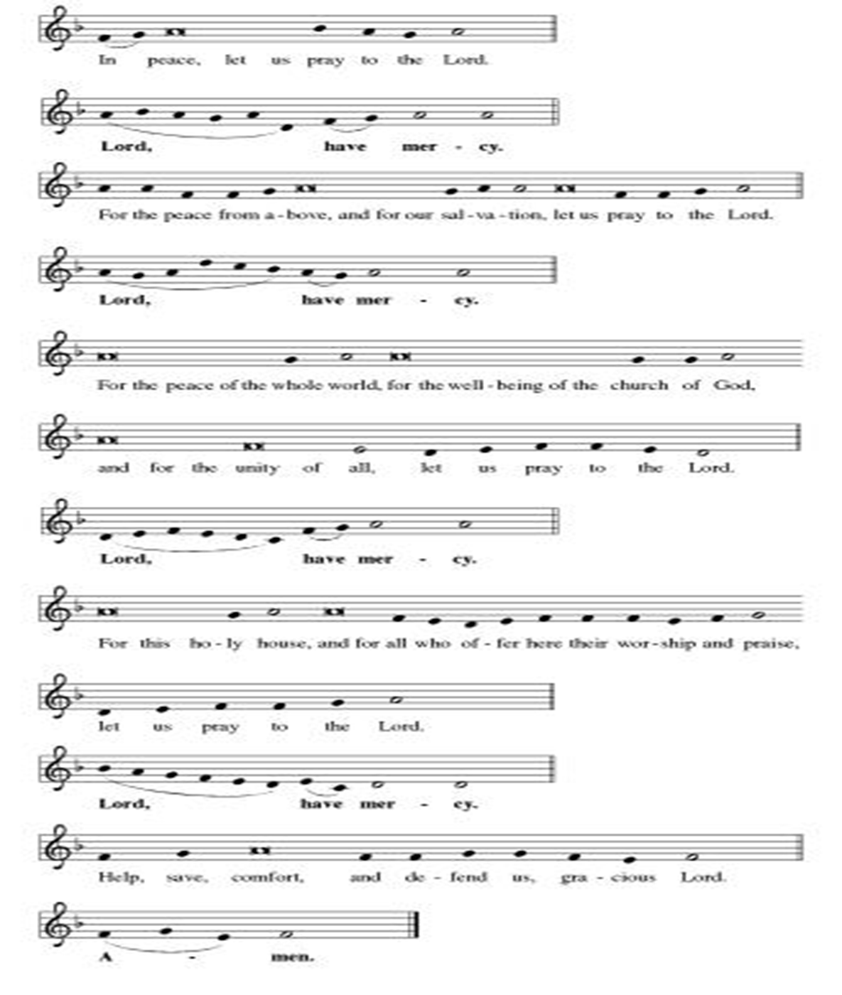
**Hymn of Praise
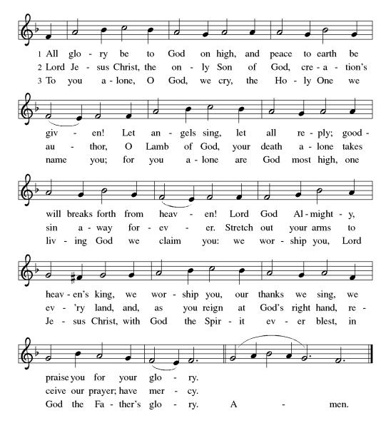
**Prayer of the Day
Sending God, you alone determine what we are capable of doing in your name. Help us to follow your call to extend radical love and acceptance to all your children, especially the ones who need us the most. We pray this in Jesus’ name. Amen.

Reading: Acts 9:1-19a

¹Meanwhile Saul continued to breathe murderous threats against the disciples of Jesus. He had gone up to the high priest ²and asked for letters, addressed to the synagogues in Damascus, that would authorize him to arrest and take to Jerusalem any followers of the Way that he could find, both women and men.

³As he traveled along and was approaching Damascus, a light from the sky suddenly flashed about him. ⁴He fell to the ground and heard a voice saying, “Saul, Saul, why are you persecuting me?”

⁵“Who are you?” Saul asked.
The voice answered, “I am Jesus, and you are persecuting me. ⁶Get up now and go into the city, where you will be told what to do.” ⁷Those traveling with him were speechless. They heard the voice, but could see no one.
⁸Saul got up from the ground unable to see, even though his eyes were open. They had to take him by the hand and lead him into Damascus. ⁹For three days he continued to be blind, during which time he ate and drank nothing.

¹⁰There was a disciple in Damascus named Ananias. Christ appeared to him in a vision, saying, “Ananias.”

Ananias said, “Here I am.”

¹¹Then Christ said to him, “Go at once to Straight Street, and at the house of Judah ask for a certain Saul of Tarsus. He is there praying. ¹²Saul had a vision that a man named Ananias will come and lay hands on him so that he would recover his sight.”

¹³But Ananias protested, “I have heard from many sources about Saul and all the harm he has done to your holy people in Jerusalem. ¹⁴He is here now with authorization from the chief priests to arrest everybody who calls on your name.”

¹⁵Christ said to Ananias, “Go anyway. Saul is the instrument I have chosen to bring my Name to Gentiles, to rulers, and to the people of Israel. ¹⁶I myself will show him how much he will have to suffer for my name.”

¹⁷With that Ananias left. When he entered the house, he laid his hands on Saul, saying, “Saul, my brother, I have been sent by Jesus Christ, who appeared to you on the way here, to help you recover your sight and be filled with the Holy Spirit.”

¹⁸Immediately, something like scales fell from Saul’s eyes, and he regained his sight. He got up and was baptized, ¹⁹and his strength returned after he had eaten some food.

Word of God, Word of Life
Thanks be to God

**Gospel Acclamation
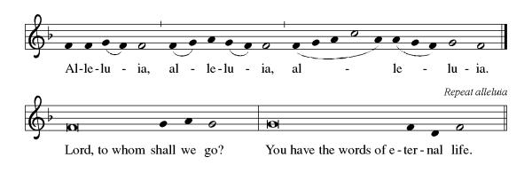
Announcement of the Gospel
Glory to you, O Lord.

Gospel: Matthew 6:24

²⁴[Jesus said,] “No one can serve two superiors. You will either hate one and love the other, or be attentive to one and despise the other. You cannot give yourself to God and Money.”
The Gospel of the Lord.
Praise to you, O Christ.

Sermon "Meanwhile..."
Hymn of the Day Chief of Sinners Though I Be ELW#609

**Affirmation of Faith – Immigrant’s Creed by Jose Luis Casal

I believe in Almighty God, who guided the people in exile and in exodus, the God of Joseph in Egypt and Daniel in Babylon, the God of foreigners and immigrants.

I believe in Jesus Christ, a displaced Galilean, who was born away from his people and his home, who fled his country with his parents when his life was in danger. When he returned to his own country he suffered under the oppression of Pontius Pilate, the servant of a foreign power. Jesus was persecuted, beaten, tortured, and unjustly condemned to death. But on the third day Jesus rose from the dead, not as a scorned foreigner but to offer us citizenship in God’s kingdom.

I believe in the Holy Spirit, the eternal immigrant from God’s kingdom among us, who speaks all languages, lives in all countries, and reunites all races.

I believe that the Church is the secure home for foreigners and for all believers. I believe that the communion of saints begins when we embrace all God’s people in all their diversity. I believe in forgiveness, which makes us all equal before God, and in reconciliation, which heals our brokenness. I believe that in the Resurrection God will unite us as one people in which all are distinct and all are alike at the same time. I believe in life eternal, in which no one will be foreigner but all will be citizens of the kingdom where God reigns forever and ever. Amen.

**Prayers of Intercession

God of Love, hear the prayers that we lift before you. Hold close to you all those for whom we pray.

Living Savior, just as you encountered Paul on the road to Damascus, accompany us on our journey of faith. Welcome us at your table, as you instructed Ananios to welcome Paul, so that we are strengthened for your service. Merciful God,
receive our prayer.
Almighty God, you provide for the needs of all creation. Bless the fields that are being prepared for planting, and send favorable weather so that the soil may yield an abundant harvest. Merciful God,
receive our prayer.
God of justice, where leaders abuse power, confront them and call them to repentance. Where there is corruption, bring integrity; where there is violence, sow peace. Merciful God,
receive our prayer.
Healing Savior, your resurrection brings hope to a hurting world. Heal those who are sick especially Monty & Marie, Paul, Helen, Linda, Betty F., Kay, Becky H., Jim & Jan, Melian, Becky W., David, Val, William & family, Judy, Kevin, Peter & Carrie, Barbara & Donna, Lorey, Barb & family of Ed, families in our community who endure hunger, and our beloved for whom death is near. Strengthen the weary, give courage to the despairing, and comfort the dying. Merciful God,
receive our prayer.
Gracious One, you have made us your own through the gift of baptism. Unite us in genuine love for one another and uphold this community in your name. Merciful God,
receive our prayer.
Pave a way to justice, drown the forces of oppression, bring peace on earth. Give leaders the will to turn from war and violence. Especially we pray for the people of Cuba & Venezuela, Iran, Sudan, Gaza, Israel, and Ukraine. When people must flee their homes, guide them to safety. Comfort those living with deep trauma, anxiety, or fear; all those who serve people in need, and accompany all those who care for people in harm’s way. We also lift up Jim’s grandson Dylan, who is deployed, and Sharon’s great nephew, Taylor, who is deployed in the Middle East. Merciful God,
receive our prayer.
We pray for people who rise up against injustice. Bring courage and resilience to those who resist tyranny with their words and their bodies. Strengthen those who fight for justice in your name across the country, and around the world. Protect and sustain immigrants and refugees and all who work with them, that your kingdom, without borders and without walls, may truly come on earth as it is in heaven. We pray for all victims of gun violence or kidnapping, especially those who are targeted out of hate or fear. Embolden us to holy outrage and empower us to speak our truth of love and justice. Merciful God,
receive our prayer.
We lift up all who teach and all who learn. Thank you for teachers who share their knowledge and wisdom. Bless the students in our midst. Especially we remember Evie, in kindergarten; Addison, in high school; and Tyler, Zach, Katie and Katy, in college. Bless Janet, Carla, and Lisa as they teach. Merciful God,
receive our prayer.
Eternal Light, we give thanks for all who have nurtured your church’s life in ages past. Bring us at last with them to the brightness of your glorious presence. Merciful God,
receive our prayer.

Good and loving God, we give everyone we have prayed for into your care. Amen.

** Sharing of the Peace

**Offering is brought forward

** Offertory Response

Let Us Talents and Tongues Employ (Refrain Only) ELW#674

**Offertory Prayer

Good and loving God, all you have created is good. Help us to be generous with that which you have first given us, so that we can respond to those who hunger in any way. As we gather now at your Table, prepare us to go out and proclaim Christ’s resurrection through what we say and do. Amen.

Dialogue
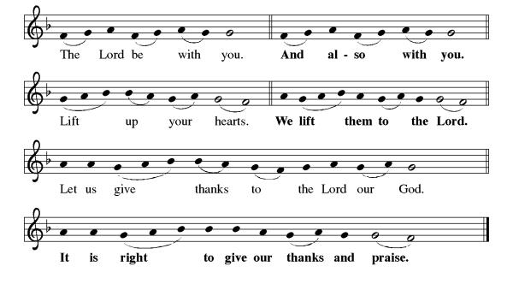
**Preface: As we celebrate Christ’s resurrection from the dead… this hymn of praise:
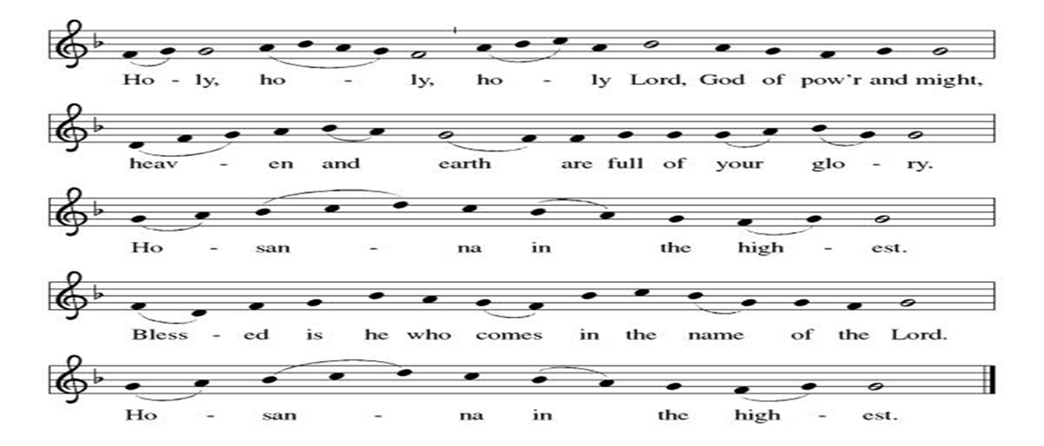
**Words of Institution

**LORD’S PRAYER
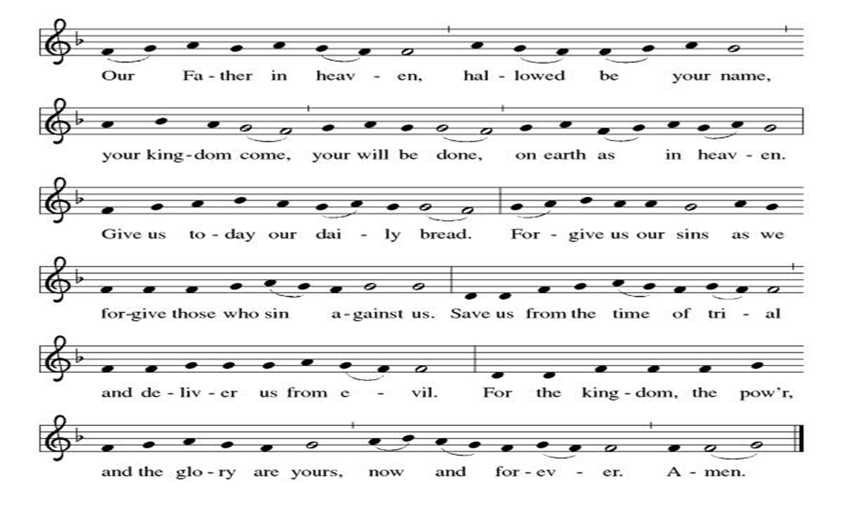

Invitation to Communion

Communion Hymn This Little Light of Mine EL#677

**Sending Song

Now Lord ELW#201

**Prayer After Communion
Alleluia! We give you thanks, risen Lord, for your life-giving presence among us. You have fed and refreshed us with the healing gift of life. Now send us out to share the good news of the empty tomb, through all that we say and do. Amen! Alleluia!

**Blessing

**Closing Hymn Amazing Grace ELW#779

**Dismissal

Go in peace to serve our Risen Christ. Alleluia!
THANKS BE TO GOD!

+ + + + + +

Hymns from Setting 05 and the Evangelical Lutheran Worship are under copyright and used with permission under One License #733618-A. Specific copyright information as listed in bulletin, the Prayers of Intercession are under copyright and are used with permission under Augsburg Fortress Liturgy License #SB155933. All other liturgy written by Sarah Pierce.

Weekly Attendance

Week of April 12
16

******************************************************************************************

Calendar of Events
Today
- Adult Bible Study

This Week
April 20 | Newsletter Deadline
April 21 | Creative Friends
April 22 | Bells practice
April 25 | Project Comfort

Upcoming Events

April 26 | Coffee with Council
April 28 | Creative Friends
April 29 | Bells practice
May 03 | View Christian Nationalism part 2
May 06 | Paint Party Fundraiser
May 10 | Mother’s Day
May 13 | Church Council Meeting 6:30 pm
May 17 | Congregational Meeting after worship
May 24 | Pentecost
May 25 | Memorial Day
June 03 | Paint Party Fundraiser
June 07 | View Christian Nationalism part 3  Ice Cream Social
June 19 | Juneteenth Office Closed
June 28 | Coffee with Council
July 01 | Paint Party Fundraiser
July 04 | Independence Day
July 26 | Coffee with Council  Celebrate Niel’s Birthday (July 28)
September 13 | God’s Work. Our Hands.

Note: 2026 paint party fundraisers: May 6, June 3, July 1, Aug. 5, Sept. 2, Oct. 7, Nov. 4, Dec. 2
Note: Theater group church use: auditions Feb. 6 &7, 6:30-9:30; callbacks Feb. 8, 1-5; rehearsals MWF & Saturday, Feb.16-April 18, MWF 6:30-9:30 and Saturdays 12-4.
*****************************************************************************
Pastor Sarah Questions:

- The Saul/Paul that we meet in Acts is not precisely the same one that we meet in the Epistles. The Paul that we meet in the Epistles is the Historical Paul; the writer of Luke/Acts changes the story to suit his theological needs. So while the overall outline of the person is the same (started as a Pharisee, persecuted Christians, underwent this metamorphosis on the road to Damascus, became a follower of Christ and traveled around the Mediterranean teaching and writing letters), the details differ. This is one of those “don’t sweat the small stuff” things.
- But what isn’t “small stuff” is the authentic encounter that Saul has with Jesus. It changes his life. While we don’t have theophanies (from the Greek theos (God) + phanein (to appear)), we do sometimes have authentic encounters with Jesus. How do we know? They don’t just change our actions and our faithfulness; they alter the way we perceive reality.
- There are a couple of important things here that I didn’t touch on in my sermon that I want to lift up. First: in Saul’s theophany, the voice of Jesus and the voice of God cannot be separated. For followers of Christ, they are one and the same. Second, when Christ tells Ananias that Saul has been commissioned and is being sent out, and Ananias goes to Saul to tell him and baptize him, and fill him with the Holy Spirit, God’s commission cannot take place apart from the empowerment of the Holy Spirit. Those things cannot be separated. (This is a very trinitarian story!)
- In Acts, no one who experiences deliverance and receives the Holy Spirit does it alone. There are always implications for the wider community. In Saul’s case, the “wider community” is the world, as Saul is sent to the Gentiles and the rulers, as well as the people of Israel. Outside the Samaritans, who are first-cousins to the Judeans, this is the first time in Acts that there is direct mention of sending an apostle to the Gentiles. And Ananias is the representative of the community of followers of Christ.
- How are we called to be disciples? How are we called to welcome people who have undergone a metamorphosis and been radicalized by the gospel to accept and love people? How are we called to BE radicalized by the gospel?

******************************************************************************************
BLUE SPRINGS COMMUNITY SERVICE LEAGUE is very appreciative of your continued support of your neighbor.
Birthdays
April 20-Tonya Hamilton
April 23-Teresa Dustin

April 19
Altar Guild – Mary Ann & Donna Taylor
Lector – Kent Deubner
Greeter – Donna Taylor
Usher-Paul Blixrud
Tech – Gary Antes

Prayer Requests
Monty & Marie Health Concerns (Maech 04)
Paul Health Concerns (May 31)
Mary Health Concerns (May 15)
James & Family Health Concerns (September 11)
Betty F (Sara’s friend) Health Concerns (July 15)
William and Family Health Concerns (September 25)
Becky H Health Concerns (October 28)
David Health Concerns (November 18)
Becky W Health Concerns (November 18)
Judy Health Issues (December 16)
Kay (Sara’s cousin) Health Concerns (July 15)
Kevin Health Concerns (October 01)
Sharon Health Concerns (October 22)
Michael Health Concerns (October 22)
Peter and Carrie Health Concerns (November 26)
Melian Health Concerns (November 16)
RJ Health Concerns (November 17)
Barbara Health Concerns (December 30)
Helen Health Concerns (February 25)
Val (Tonya’s sister) Health Concerns (February 18)
Lorey Health Concerns (April 14)

Barb & family of Ed

Merciful God, your justice and mercy are without limits. Bring courage and resilience to those who resist tyranny with their words and their bodies. Strengthen those who fight for justice in your name across the country, and around the world.

Please pray for the people of Venezuela & Iran, Sudan, Gaza, Ukraine, Israel, Cuba, Iran and Palestine.
Please pray for the Homeless.
Please pray for legal & illegal immigrants & those seeking asylum or citizenship

