Kansas Lion’s Theme Basket Auction to be held at the 2019 State Convention in Lawrence

“Celebrating 100 Years of Lions in Kansas!”

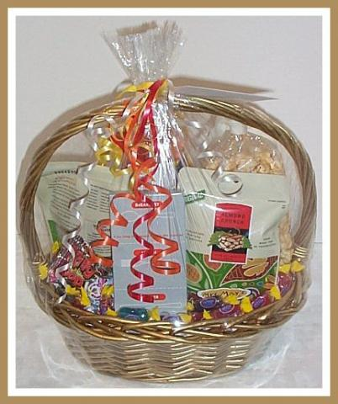

Choose a theme to reflect the history, heritage or highlights of living in your community!
Fill the basket with lots of goodies!
Bring to the State Convention in Lawrence by Friday Evening’s meal.
Bid on purchasing your favorite basket before 3PM on Saturday.
Pick up the basket(s) you purchased after the Banquet on Saturday evening.

Sponsored by the Multiple District PDG Club with proceeds to go toward State PDG Scholarships.
To register or if you have ?’s, contact PDG Carleen Rajala 913-481-7328 lioncarleen@gmail.com

