CITY OF SPRAGUE 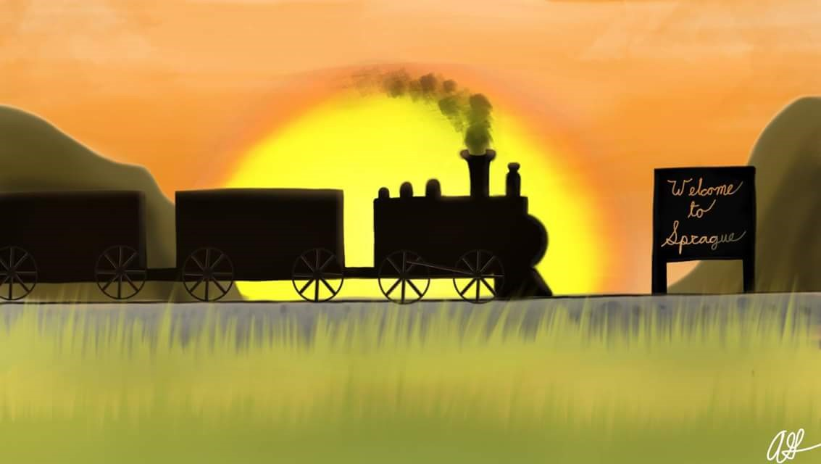

RV OVERNIGHT PARKING

City Ordinance # 691, Section 1.06.020,
(b) No person shall park or occupy any mobile home, trailer, or recreational vehicle on any premises which are situated outside an approved mobile home park except as provided in Section 1.06.030.

Section 1.06.030,
Special permits may only be issued for the following:
(a) Emergency repairs requiring more than eight hours.
(b) Guests visiting a resident of the city.

Date __________ Name ______________________

Choose one option: A____Emergency or B_____Guest

Vehicle Model and Year ______________________________

License No._____________________ State ______________

License Expiration Date ______________________________

Overnight Parking Limited To __________________________
(Address)
Resident Signature __________________________________

Permit Issued By ____________________________________

Permit Expires ______________________________________
(7 days)

CLERK: _____________________ DATE: _________________

