Bay Area
Drama
Art
Music

Ages
3 to 18
Creative Kids
Presents
1st and 2nd Grade
Reader’s Theater
Have fun and strengthen reading skills through Reader’s Theater! Learn voice, movement, acting, and stagecraft while performing stories from around the world.
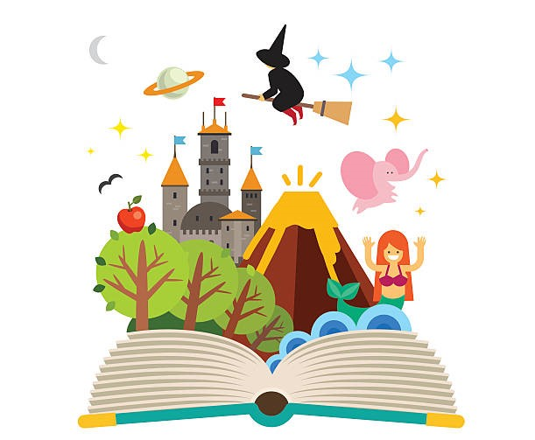
*Partial scholarships available- application online.

This is not a program of the Benicia Unified School District (BUSD) and BUSD accepts no liability or responsibility for this program.

Bay Area Creative Kids’ Programs are a great way to introduce the long-term benefits of dramatic arts participation including developing motor skills and speaking skills, building confidence, and enhancing early social skills and creative learning.

Please enroll my child in the following classes: Session 1 Session 2 Session 3 TTL: _________
Child name: _________________________ School: _________ Grade: _____ Teacher: ________________ CDU: Y / N
Parent Name: ________________________ Phone: ______________ Email: ___________________________
Reserve and pay online, or return form with check or money order (payable to: Jennifer Sundberg) to the school office, or mail to Bay Area Creative Kids, 467 Brentwood Dr., Benicia, CA 94510. Please Note: Confirmation of enrollment with Registration and Liability form will be emailed to you and must be returned prior to the first day of class to participate.
.

For more information, visit:
www.bayareacreativekids.com
or contact Jennifer Sundberg at
707-980-5279; bayareacreativekids@gmail.com
When: Wednesdays from 2:45 pm – 4:30 pm
Where: Mary Farmar Elementary (MPR)
Fall Session: 11/5, 11/13, 12/4, 12/11, 12/18
Spring Session: TBD
Tuition: $110/session (5 weeks)
Class Size: 6-13
Program is open to all Benicia students.
Kindergarten Drama Time and 3rd-5th Improv Club also available at MFE this Fall.
See our website for more details on these and other programs for Preschool – 5th grade!

