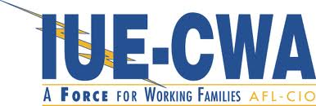
LOCAL 717
SALUTE TO 2018 GRADUATES!
Submit your graduate’s information and photo for publication in the IUE-CWA Local 717 Union News’ “Salute to 2018 Graduates”. Please complete the form below and return with photo to the President’s Office not later than May 25, 2018.
SALUTE TO 2018 GRADUATES!
Name of Graduate:___________________________________________________
Child of Member(s):__________________________________________________
Department & Shift/Crew: _____________________________________________
Phone Number (at least one): Home: __________________________
Cell: ____________________________
Department: ______________________

School Member Graduated From: _______________________________________

Graduate’s Plans (optional):

College/To Attend: _________________________________________________

Study Area: ____________________________________

Enlist In Military: _________________________________________________
(Branch)

Other/Comments: __________________________________________________

Please return completed form with photo of graduate to President’s Office by May 25, 2018

