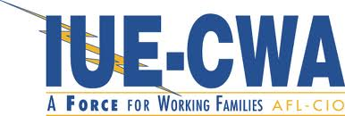
LOCAL 717
SALUTE TO 2019 GRADUATES!
Submit your graduate’s information and photo for publication in the IUE-CWA Local 717 Union News’ “Salute to 2019 Graduates”. Please complete the form below and return with photo to the President’s Office not later than June 27, 2019.
SALUTE TO 2019 GRADUATES!
Name of Graduate:
Child of Member(s):
Department & Shift/Crew: Dept.
School Member Graduated From:

Graduate’s Plans (optional):

College/To Attend:

Study Area: ____________________________________

Enlisted In Military: _________________________________________________
(Branch)

Other/Comments:

Please return completed form with photo of graduate to President’s Office by June 27, 2019

