Edie & Jim Altier, Sr. Memorial Scholarship Program
The Edie and Jim Altier, Sr. Memorial Scholarship is a one-time $500 award to be given to a high school senior who is a child or grandchild of an active member of IUE-CWA Local 717*. The application process will begin on January 1, 2021 and packets will be accepted until April 1, 2021.
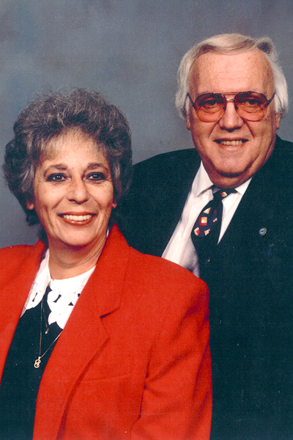

About the Program
This scholarship has been established memory of Edie and Jim Altier, Sr by their children – Sheryl Reitz, Jim Altier Jr, and Joe Altier Sr. Both Edie and Jim Sr. were long time members and supporters of Local 717. Edie began her employment with Packard Electric in 1955, retiring in 1988 from the Printed Circuit department. Jim Sr later joined Packard in 1959. During the early 1960s, he served on the local’s district committee and building committee and as a full-time assistant to the chairman of its shop committee. He became the local’s first full-time benefits representative in 1967 and joined the IUE staff in 1990 as pension and benefits specialist and unemployment benefits representative for the Delphi/GM Conference Board, which bargains jointly with other AFL-CIO unions and represents several locals comprising about 20,000 IUE-CWA members.

Scholarship Application Process
This scholarship is open to any high school senior who is a child or grandchild of an active member of IUE-CWA Local 717* who is planning on continuing their education post-graduation. To be considered, the student must complete the attached demographic form and must also submit a typed essay. In your essay, please tell us about yourself (including activities, interests, etc), your future goals, and how receiving this scholarship would help you in achieving those goals. This essay should not be more than 500 words and should be submitted as a PDF with the demographic form to: altierscholarship@gmail.com. The application deadline is 11:59pm EST on April 1, 2021.

*Recipient will be chosen upon meeting all criteria and upon verification of current membership to Local 717*

Edie & Jim Altier, Sr. Memorial Scholarship Program
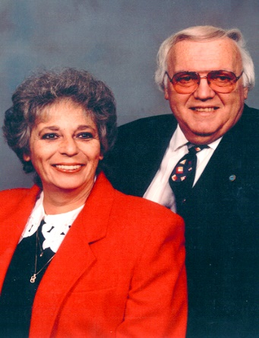

Demographic Information
Name:
Address:
Phone: Email:

IUE-CWA Local 717 Information
Relative Name:
Relationship: Department Number:

Student Information
High School:
School/Program Entering Post-Graduation:

The following must be completed and signed by a representative of applicant’s high school:
Student’s GPA:
Class Rank: out of
Attendance: Days Absent:
Days Tardy:
School Representative: Date:

