Biographical Information
Tim Campbell, Ph.D.
Global Fellow, Woodrow Wilson Institute
Speaker and Author

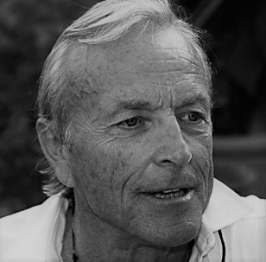
Contact Points
51 Domingo Avenue
Berkeley, CA 94705 USA
Cell +1 301 661 0205
Email: TimCampbellphd@gmail.com
www.TimCampbellphd.name

Tim Campbell has experience of 40 years in urban development working in scores of countries and hundreds of cities in Latin America, South and East Asia, Eastern Europe, and Africa. His areas of expertise include the role of cities in global affairs; smart cities, city learning, exchange and innovation; strategic urban planning; city development strategies; decentralization; urban policy; and social and poverty impact of urban development.
He holds a B.A. in Political Science from U. C. Berkeley (1966), a Masters in City and Regional Planning from U.C. Berkeley (1970), and a Ph.D. in Urban Studies and Planning from M.I.T. (1980).
Tim Campbell was recently named a Global Fellow at the Woodrow Wilson International Center for Scholars. He was formerly a visiting scholar at the University of California, Berkeley. He was awarded a Senior Fellowship, Comparative Domestic Policy Program, The German Marshall Fund of the United States for in-depth studies in Barcelona, Charlotte, Portland (OR) and Turin. His book Beyond Smart Cities: How Cities Network, Learn and Innovate (London: Routledge) was published January of 2012 (translated into Chinese, Spanish and Italian).
He retired from the World Bank in December of 2005 after more than 17 years working in various capacities in the urban sector. His most recent positions were as head of the World Bank Institute urban team (from 2001), and head of the Urban Partnership, which was responsible for identifying changing demand and developing new Bank products and services for cities (from 1998). He pioneered the Bank’s city development strategies (CDS) and was the Bank-wide coordinator for CDS, a new analytical tool focusing on cities as the unit of analysis in national development. From 1995 to 1997, he served as a member of the Advisory Group in Latin America and the Caribbean Region and was the Region’s Chief of the Urban and Water Unit (1993-1995).
Before joining the Bank, he worked for more than 13 years as a private consultant and university professor. His consulting clients included private sector firms, governments, and international organizations. He taught at Stanford University and the University of California at Berkeley. He lived in rural and small town Costa Rica as a Peace Corps Volunteer.
In addition to many papers and articles on decentralization, urban policy, and institutional development, Mr. Campbell has authored several earlier books. The Quiet Revolution, explores the rise of political participation in cities with the onset of decentralization in Latin America from 1983-1995 (University of Pittsburgh Press, 2003) published in Spanish by Alfaomega, Bogota. A second book, Leadership and Innovation (World Bank, 2004), is a collection of case studies about the innovation process observed in leading local governments in Latin America.

June 2020

