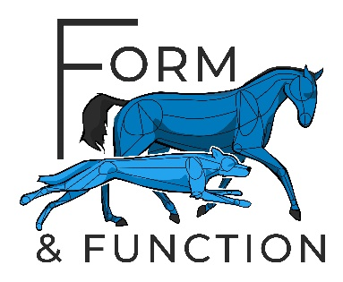

VETERINARY CONSENT FORM
Kathryn Stickney BSc (Hons), MIRVAP (VP)

The client named below has requested a veterinary physiotherapy appointment for their animal registered with yourselves.
Client Name: _______________________________________________________

Address: __________________________________________________________

__________________________________________________________________

Animal/s: __________________________________________________________

Client Authorisation: ______________________________ Date: _____________
Any appointments are provisionally booked pending your consent.
Please contact me should you have any queries.
Does the animal/s have any relevant medical history which I need to be aware of? YES/NO (If yes please email notes or advise a good time to contact you)
Would you like me to contact you directly to discuss consent or previous history? YES/NO
I give consent for Kathryn Stickney BSc (Hons), MIRVAP (VP) to assess and treat the above named client;
Signature: ________________________ Date: _____________
Print: ____________________________ Report Required: YES/NO
Please return by email to: kathryn@formandfunction.fit

Tel: 07929 237921 Email: kathryn@formandfunction.fit
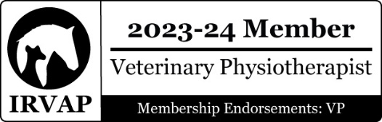
www.formandfunction.fit

