|  |  |
| --- | --- |
| Information about hemp & CBD Facts About Hemp Hemp is one of the earliest know domesticated plants, cultivated by civilization for approximately 12,000 years.  comes  Logo placeholder | Facts About Hemp────Benefits of Hemp────What is CBD?────Terminology────Endocannabinoid SystemCBD-Msk 8043 W Candlewood Way Florence, AZ 85132  218-310-3599  www.cbdmsk.com |

Comes from the Cannabis Sativa L. plant. This type of hemp grows differently than THC-containing cannabis and looks similar to bamboo. It contains over 120 cannabinoids.

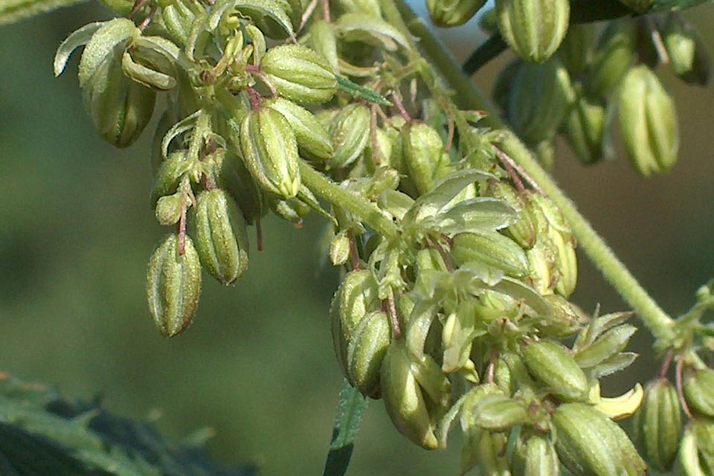

Hemp has little potential to produce high-content THC when pollinated. Cannabidiol, or CBD, is the second most prominent compound found in the hemp plant.

Agricultural hemp keeps you healthy, is non-intoxicating and doesn’t get you “high”.

Not only is hemp renewable and fast-growing, nearly every part of the plant is useable for food, fiber, building materials, fuel and much more consisting of 25,000 uses! (See next page).

Hemp contains excellent nutritional value, providing essential nutritional components called Essential Fatty acids that the human body does not produce naturally, and must be consumed by the diet. Further, emerging scientific research supports the consumption of CBD from hemp oil for general well-being.

It is also good for the earth, as hemp sequesters CO2 and leaves the soil in better condition than before it was planted.

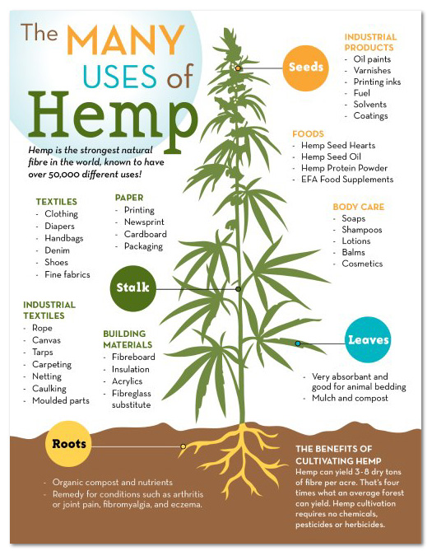

**Terminology**

Cannabis Sativa L – a plant also known as Indian hemp and thought to have originated in the mountainous districts of India, north of the Himalayan mountains. Also, the source of medical cannabis and agricultural hemp. It contains over 120 cannabinoids, CBD being among them.

Medical Cannabis – is cannabis for medical purposes, which contains high amounts of THC, and is also known as marijuana. This cannabis has been used for recreational uses also.

Agricultural or Industrial Hemp – is hemp plant which contains less than 0.3 % THC by dry weight and there are many uses of the whole plant.

**Endocannabinoid System (ECS)**

Since its discovery in 1992, researchers have been investigation the existence of a central regulatory system called the Endocannabinoid System (ECS). The ECS is made of cannabinoid receptors, endogenous (self-made) cannabis-like compounds and enzymes that create and inactivate them. The ECS is one of the most important physiologic systems involved in establishing and maintaining human health.

Phyto cannabinoids like CBD, of which well over 100 have been found to exist, are plant derivatives that “talk” to just about every major organ system in the body via the ECS, helping restore normal balance and physiologic homeostasis.

Endocannabinoids and their receptors are found throughout the body. In each tissue, cannabinoids perform different tasks, but the goal is always the same: Homeostasis, maintaining a stable internal environment despite fluctuations in the external environment.

CBD is important because it modulates endocannabinoid tone and helps keep healthy people healthy.

The ECS is like a master control system which keeps us balanced and the endocannabinoids are the messenger that communicate via cannabinoid receptors.

They are involved in direct regulation of:

* Appetite
* Metabolic Health
* Pain
* Inflammation
* Thermoregulation
* Intraocular Pressure
* Sensation
* Muscle Control
* Motivation/Reward
* Mood
* Memory
* Learning

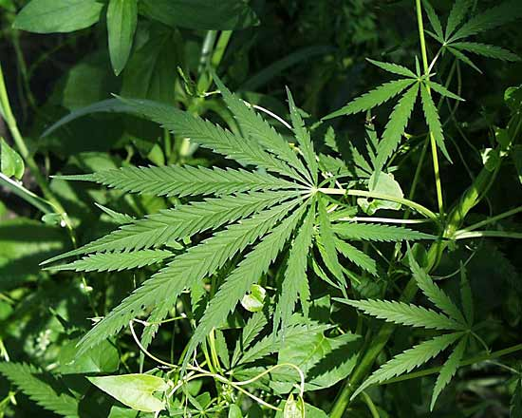

**What is CBD?**

Simply cannabidiol, or CBD, is a promising Phyto cannabinoid found in agricultural hemp. It has been recognized for its benefits on HUMAN and ANIMAL health and is capable of affecting nearly every biological process.

CBD is non-intoxicating (i.e. it does not result in feeling of euphoria) and has a remarkable safety profile.