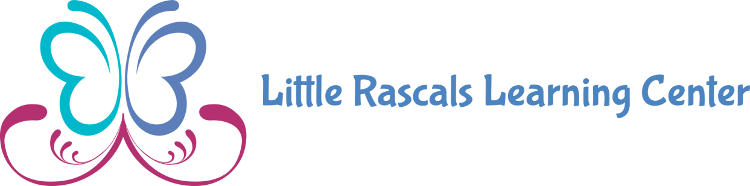

**PHOTO PERMISSION FORM**

**Permission To Photograph Child**

**I give my permission for_________________ to be photographed and/or videotaped by teachers and staff of the Little Rascals Learning Center for purpose of advertising, public relations, and family enrichment. I understand the pictures and or videos which may include my child may be published in the center, on social media and or other public sources for advertising.**

**Parents Name____________________ Date_________**

**Parent’s Signature______________________________**