**PATIENT INSTRUCTIONS AFTER TREATMENT**

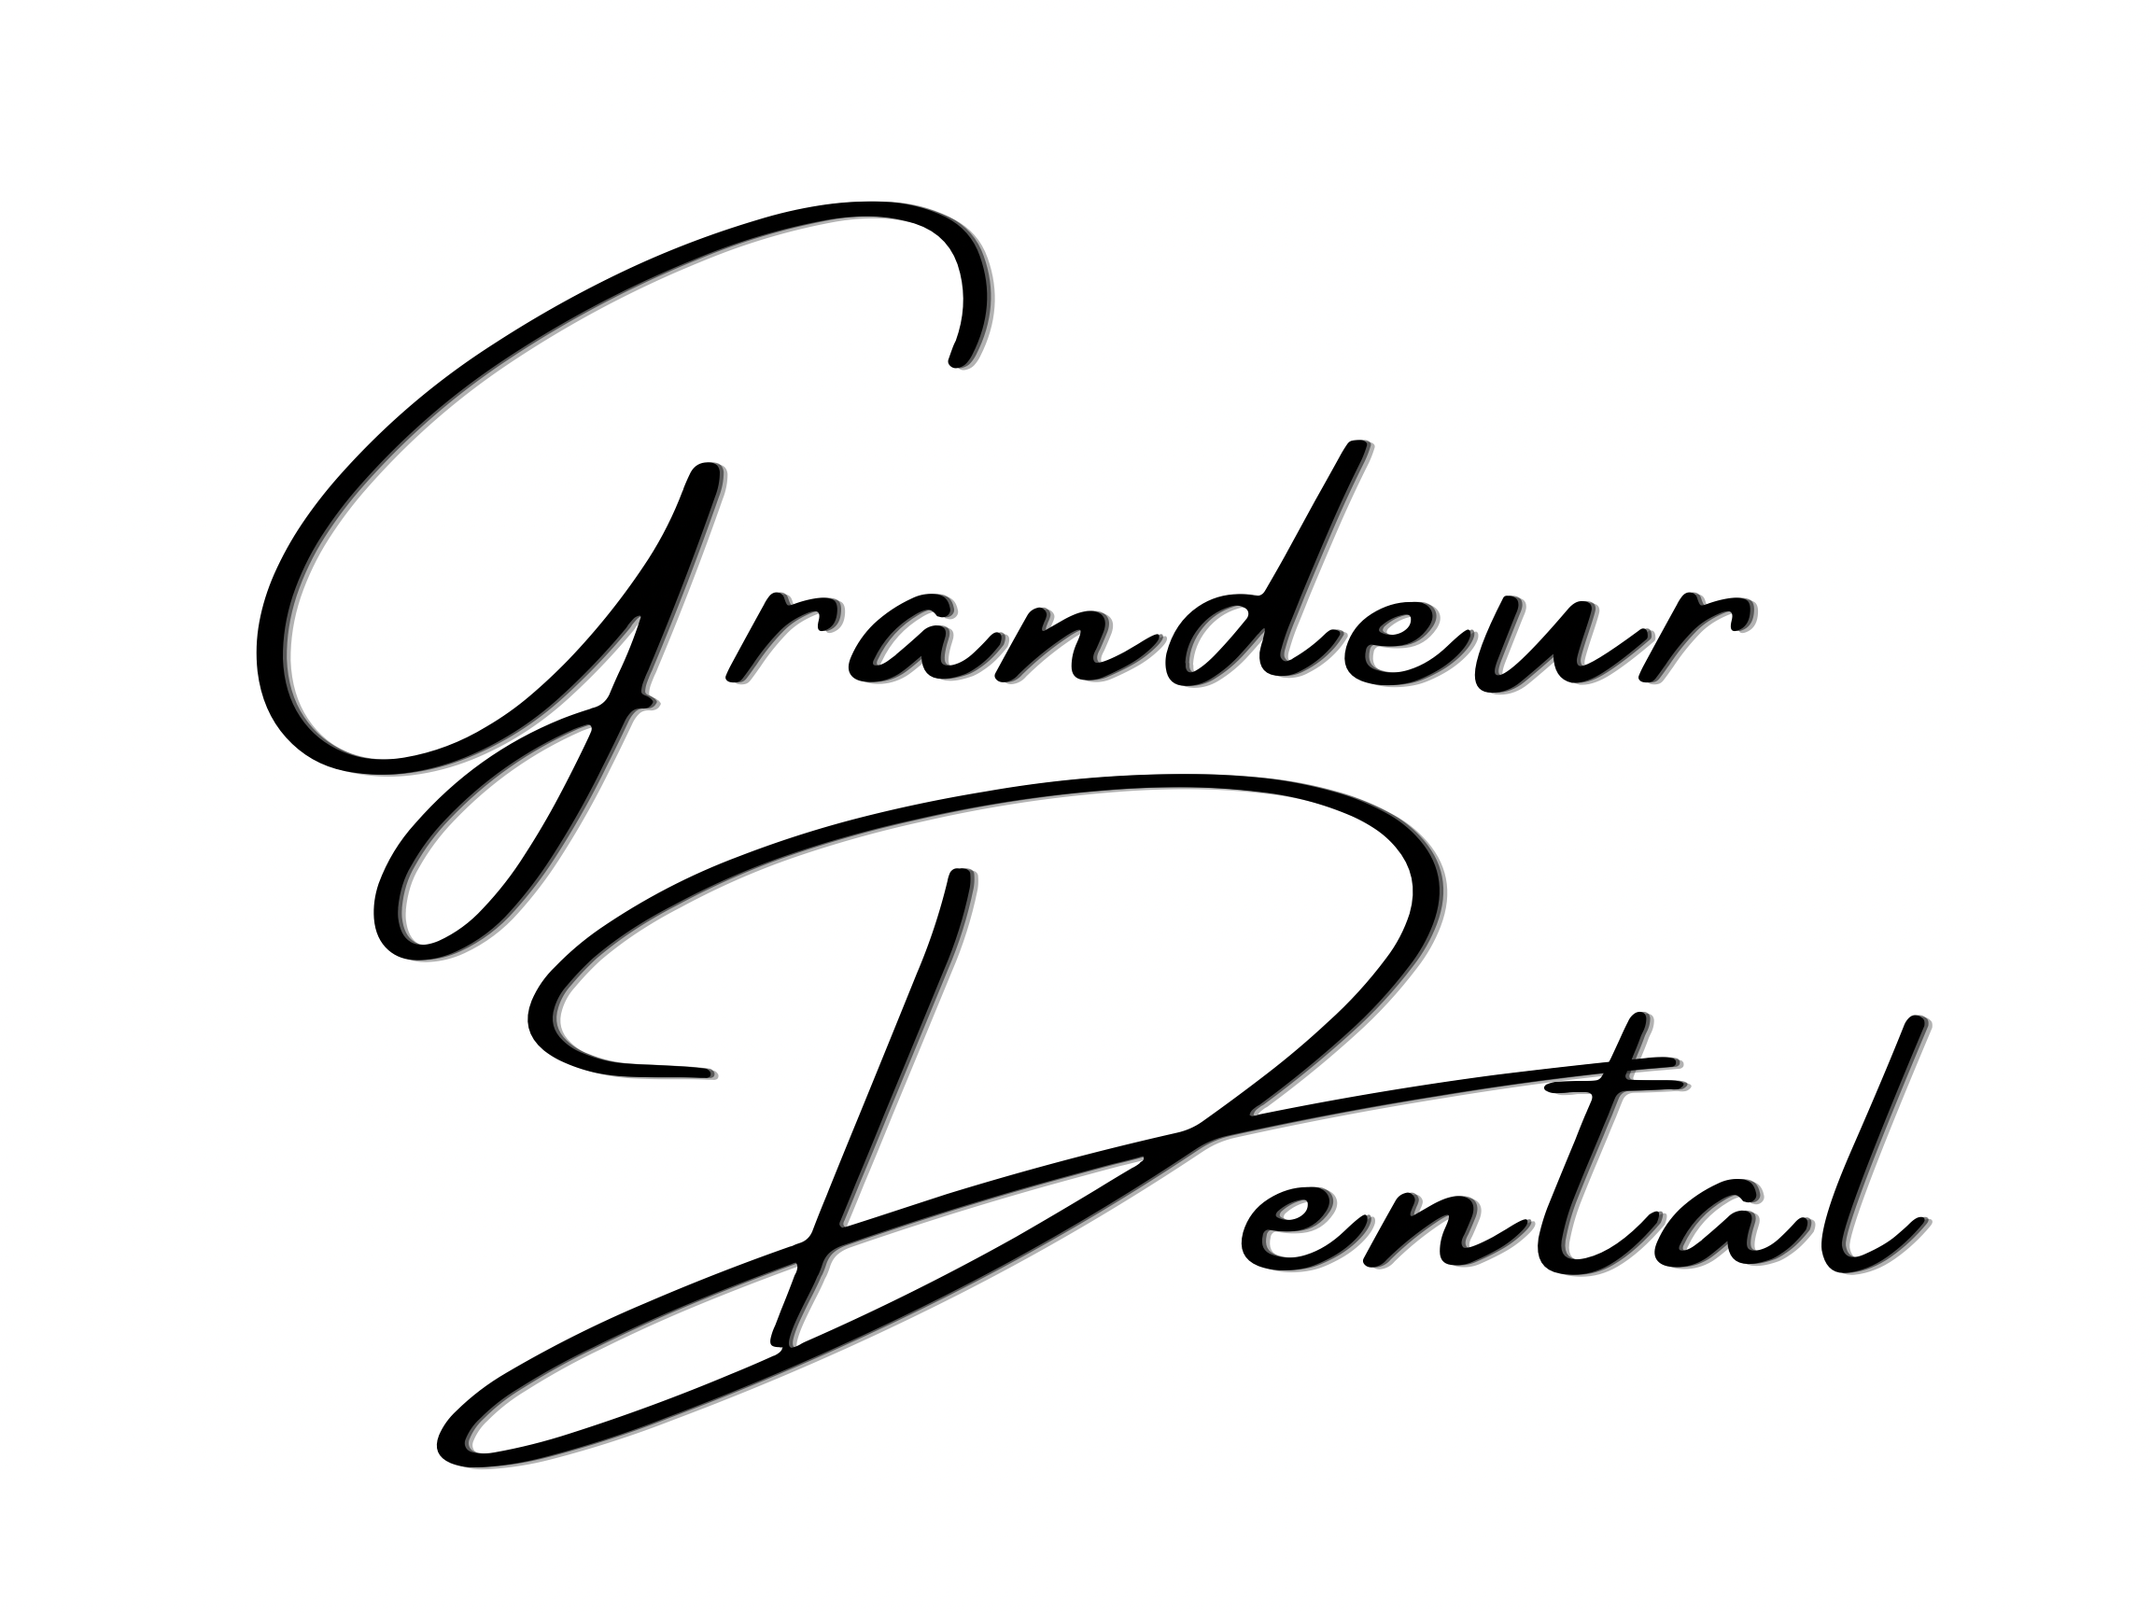

16917 Devonshire St. Granada Hills, CA 91344

GrandeurDental.com | Phone: (818) 488-9533 or (818) 516-8881

**__________________________________________________________________________________________**

Dentist: Place a check mark on the service(s) performed. **DATE: ­­­_________________**

Patient: Follow the instructions in the section(s) checked off by your dentist.

* **EXTRACTIONS**
* Place cold towels or an ice bag to your face for the first 6-8 hours. Apply for 15 minutes, then remove for 15 mins.
* Do not rinse mouth until the following day.
* On the morning following surgery rinse mouth with warm salt water (1/2 teaspoon salt to a glass of warm water). Repeat this several times daily.
* Keep fingers and tongue away from socket.
* Following dental surgery, it is normal to experience some discomfort. If medication has been prescribed, take as instructed.
* BLEEDING – It is normal for saliva to be slightly streaked with blood for 1-2 days. If abnormal bleeding occurs, place moist gauze over extraction site and bite down for 30-45 minutes.
* SWELLING and STIFFNESS – It is normal and should not cause alarm. Apply cold towels or ice bag for 15 minutes of each hour as needed.
* DIET – A liquid or soft diet is advisable during the first 24 hours. Drink lots of water.
* Return to the office if undue symptoms develop.
* **PERIODONTAL TREATMENT**
* For pain or discomfort you may take over-the-counter pain medication.
* It is advisable to eat only oft food for the first 24 hours, and avoid any hard or spicy foods which could cause irritation.
* Drink plenty of water during the first 24 hours – at least 8 glasses are recommended.
* Place cold towels or an ice bag to the outside of your face in the treated area. Apply for 15 minutes, then remove for 15 minutes during the first 4-6 hours.
* On the morning after the treatment, rinse mouth with warm salt water (1.2 teaspoon salt to a glass of warm water). Repeat this several times daily.
* Brush teeth gently to help remove plaque that has started to form. We suggest using fluoridated, tartar control toothpaste.
* Don’t use floss or other home tooth care products, such as toothpicks or electric toothbrushes, until the day after your treatment. Begin very gently at first.
* Because it is very common for periodontal diseases to recur, patients should have regular checkups to monitor progress and prevent recurrence.

**See reverse.**

* **CROWN OR BRIDGE TREATMENT**
* After your first appointment or crown and bridge treatment, a temporary crown is usually place on the tooth or teeth involved. The temporary crown protects while the custom crown is being produced. Temporary cement is used so that the crown can be easily removed at your next appointment.
* If your temporary crown comes off before your next appointment, pace the temporary crown back on your tooth and call our office.
* With your temporary crown and with your permanent crown you may experience some discomfort due to irritation of the area during the treatment procedures. You may also notice sensitivity to cold or pressure.
* Your new permanent crown will be shaped and shaded especially to your teeth in color and fit. The temporary crown is made to serve you temporarily, so its color and fit are not custom-matched to your teeth.
* After your new permanent crown is in place, you may need a few days to adjust to it. If you feel the bite is not correctly balanced, please call for an appointment and we can adjust it.
* Care for your new crown with proper brushing and flossing. It is especially important to keep the edge of the crown clean at the gum line.

Please follow these home care instructions carefully and

call this office if you have any questions or concerns.