Applicant Guidelines

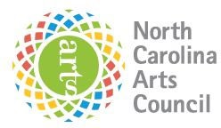 | 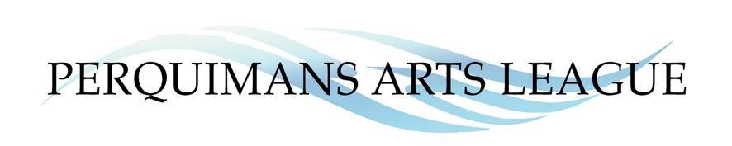
North Carolina Arts Council Artist Support Grant
Applications due by Friday, October 17, 2025

Guidelines and Information
The Artist Support Grant is a regional grant program to support individual artists in all phases of their career. The grant funds professional and artistic development for emerging and established artists to enhance their skills and abilities to create work or to improve their business operations and capacity to bring their work to new audiences.
Artists representing visual, craft, performing, traditional, and interdisciplinary art forms are encouraged to apply. Applicants should demonstrate a commitment to spending a significant portion of their time on their work as artists. The Artist Support Grant will support projects from [grant funding period]. Awards may range from $500 to $1,000. Applicants may receive full or partial funding.

Eligibility
Individuals and Artist Collectives — Both individual artists and small, unincorporated groups of collaborating artists are eligible to apply.
Residency — Artists should have lived continuously in the region where they are applying for at least one year before the consortium’s application deadline. An applicant must be at least 18 years old and either a U.S. citizen or a permanent resident alien. The consortium may require proof of residence and status. Artists who live in more than one region should apply only where they spend most of the year. All members of a collaborating team must be North Carolina residents, live in the region in which they are applying, and meet the other eligibility requirements. Résumés documenting residence for all team members should be included with the application.
Multiple Awards — Artists who are sole proprietors of organizations that have already received funding for FY 2025-2026 from the N.C. Arts Council are ineligible to apply. Awardees must also wait at least two years after the award year before becoming eligible to reapply.
Conflict of Interest — Current board and staff members of the consortium partner organizations and their family members are not eligible to apply for the award.
Student Status — The Artist Support Grant is intended for adult, nonstudent artists. Artists enrolled full-time in undergraduate or associate degree-granting programs may not apply for the grant. Artists in certificate programs are generally eligible. Artists pursuing graduate degrees in subjects other than their art form may be eligible if they meet the other eligibility criteria. Other questions and special circumstances should be discussed with N.C. Arts Council staff.

Eligible Projects and Costs
Up to 50 percent of the grant amount may be used for artist fees.
Completion/Presentation of a New Work — Cost of resources necessary to complete or present a significant new work (e.g., purchasing art supplies or equipment or space rental)
Career Promotion — Projects aimed at advertising artists’ work and/or demonstrating their skill level (e.g., websites, portfolios, audio-visual documentation, and online presentation)
Training — Costs to attend a class or workshop (in-person or virtual) aimed at either enhancing the artist’s skill level or professional development (e.g., a master class or workshop taught by acknowledged authorities in the applicant artist’s medium)
Travel — Costs of transportation, lodging, and food for training, professional conferences, or research.

Ineligible Projects and Costs
- Scholarships for undergraduate- or graduate-level education
- Projects that support or oppose a particular candidate for public office
- Projects that are exclusive to members of a particular religious faith group
- Projects that do not have a direct effect on the applicant’s growth as an artist (e.g., the promotion of other artists’ work)

Deadline
Applications must be completed and emailed (ansell2000@gmail.com), mailed or hand delivered to PAL 133 N Church St, Hertford, NC 27944 by October 17, 2025.

Evaluation Criteria
- Overall excellence of the applicant’s artwork as demonstrated by work samples
- Feasibility of the proposed project
- Contribution of the proposed project to the advancement of the applicant’s professional artistic development and practice

Review Process
All completed Artist Support Grant applications will be judged by a multi-county panel of established artists, arts professionals, arts educators, and administrators who will review and evaluate the applications and allocate funds for selected projects.

Information and Assistance
For more information, please contact Dorothy Ansell, ansell2000@gmail.com
An applicant workshop will be held via Zoom on September 15 at 5:30pm. Contact ansell2000@gmail.com for the Zoom link.

Local Arts Council Contact Information
• Bertie County Arts Council: Laura Goguet, Board President • Lgoguet@hotmail.com
General Email: bertiearts@gmail.com
• Chowan County Arts Council: Kim Asack, Managing Director: cacedenton@gmail.com
• Arts of the Albemarle: Lauren Luther, executive director executivedirector@artsaoa.com
• Camden County Library: Rachel Bryant • rbryant@earlibrary.org
• Gallery Theatre, Ahoskie: Latrice Carter • gallerytheatreahoskie@gmail.com
• Currituck County Arts Council: ccacginfo@gmail.com'
• Perquimans Arts League: Dorothy Ansell, ansell2000@gmail.com

