Watercolor Workshop
The How’s and Why’s of Granulating Colors
Tuesday July 14 & Thursday July 16
10a-1p Hertford Rec Center
Skill Level: All levels are welcome

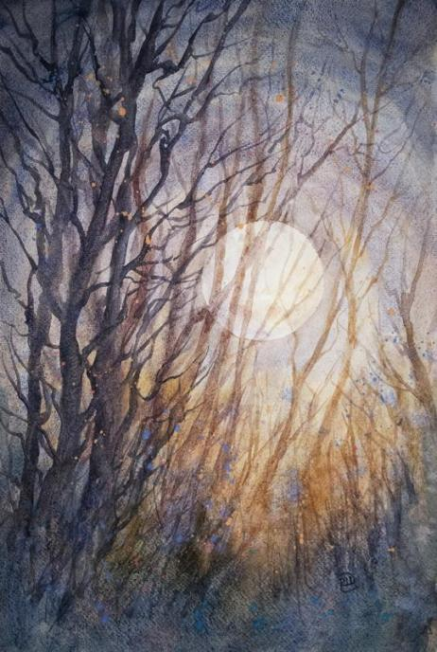

We already have granulating colors on our palette; Ultramarine Blues, Cobalt Blue/Green, Cerulean Blue, Burnt Sienna, Raw Sienna and many more.
What are they? Why do they do this? What do we do with these colors? How to use them effectively and what to use when we don’t want that effect.
We’ll discuss everything you need to know about granulation in this fun, exploratory two-day workshop.

Supplies:
Watercolor paints - bring what you have. If you are unsure, Winsor & Newton Cottman watercolors are a good choice and can be found at Hobby Lobby.
* Optional and only if you already have, Lunar Black or any of the Daniel Smith Lunar colors or PrimaTek on them, bring them.
Watercolor paper - Preferable 100% cotton papers like Arches or Fabriano
Watercolor Brushes
Water Bucket
White Gouache *optional
Spray bottle
Paper Towels/Cotton towel
2b pencil + kneaded eraser
Table covering
Other (will be notified in advanced)

