**Feathers and Fur**

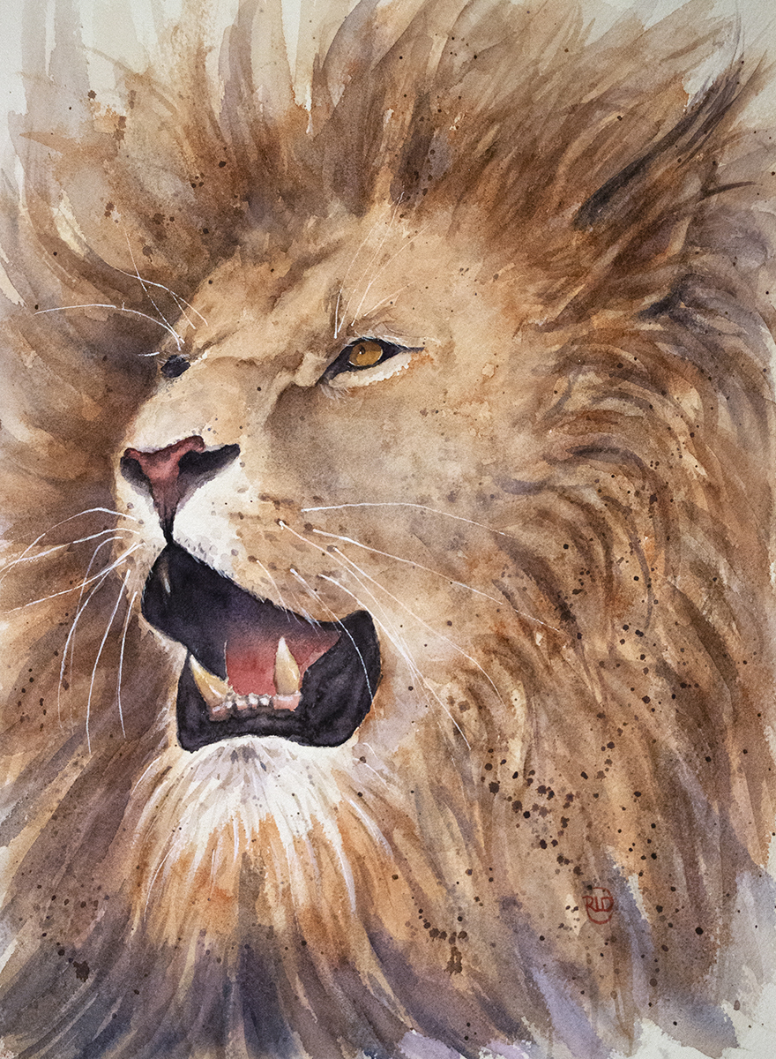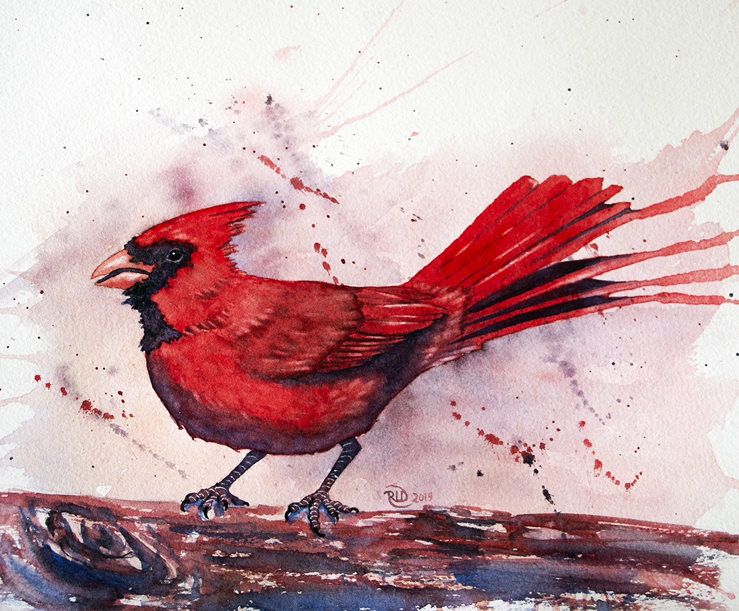

**Six week class**

Techniques on creating fur and feathers.

Whether you’re looking for whimsy or realistic, we’ll talk about techniques for creating interesting textures for each.

We’ll also go over background effects to help enhance our subject matter. Whether it be a simple wash or more in depth with painting wet in wet (to get a fuzzy, out of focus background). How to create the bokeh effect (blurry circles of light or shallow depth of field like in some photography).

**Supplies**

Watercolor Paints

Watercolor Brushes - Bring what you have but a range of at least round sizes 6, 8, 12, Flat sizes 1/2 or 1” and a stiff bristled brush for lifting.

Watercolor Paper - minimum 9x12 size. It is important to have at least 140lb 100% cotton paper like Arches or Fabriano. Strathmore or Canson XL papers will not work with the techniques we will be using!

White gouache or White Gelle Pen or White Posca Marker

Water Bucket(s)

Spray Bottle

Paper Towels

2B Pencil and Eraser

Table Covering

Water and Snack if you wish.

Optional Supplies:

Plastic wrap

Table Salt

Straw

White Crayon

Masking Fluid