The Flow of Water

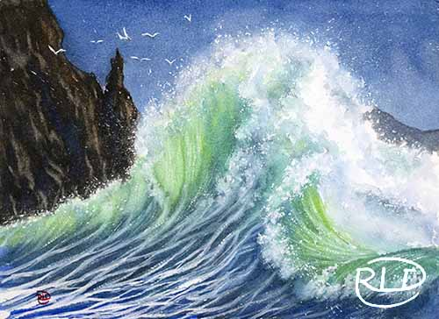
Where: Hertford Rec Center (310 Granby St.)
When: Thursday, Sept 24 - Oct 29, 10a-1p
Visit: perquimansarts.org

A six-week class on painting water in watercolor. This is inspired by all the forms of water found in our local area. From grassy marsh-like wetlands to cypress tree reflections on the river and sparkling sunlit waters to frothy ocean waves. We’ll cover all the techniques you’ll need to know to paint water in whatever situation you’ll come across… and more!

Supplies:
Watercolor paints - bring your basic supplies. If you are unsure, Hobby Lobby has Winsor & Newton Cottman watercolor paint set.
Watercolor Brushes - bring what you have. If you are unsure, round brushes (a small, medium and large) and a larger flat brush works well.
Watercolor Paper - Preferably 100% Cotton paper like Arches or Fabriano, 9”x12” size. Can be block or pad.
Water Bucket
Tape - painter’s tape or similar
Water Spray Bottle
White Gouache
Paper Towels/cotton towel
Table Covering
2b pencil and eraser
Masking Fluid - Optional
Other - will be notified in advance

