Cultural Resources Survey of the Proposed
Water Improvements in the
Village of Centertown, Missouri

Prepared for:
𐓁𐓣 𐓂𐓤𐓘𐓯𐓤𐓘 (The Osage Nation),
Bartlett & West, Inc,
Village of Centertown, Missouri,
and
Missouri Department of Natural Resources
State Historic Preservation Office

Prepared By:
ARCHAEOLOGCIAL RESEARCH CENTER OF ST. LOUIS INC.
2812 Woodson Road
St. Louis, Missouri 63114
Phone: 314-426-2577 Fax: 314-426-2599
Email: arc@arcstl.com Website: arcstl.com

Principal Investigator:
Kimberly Byrnes

Author:
Kimberly Byrnes, Abigail Dairaghi, and Gwyneth Vollman

Cartographer:
Gwyneth Vollman

Research Report #945 May 2020

SECTION 106 SURVEY MEMO REVIEWER Missouri Dept. of Natural Resources
Historic Preservation Program Date SHPO Log # P.O. Box 176
Jefferson City, Missouri 65102-0176 Accepted Rejected
(573) 751-7858 SHPO USE ONLY

- SHPO Project #12-CO-20

Location Information and Survey Conditions:

- County(s): Cole County

- Quadrangle: Russellville 1969 (1971 ed.) and Centertown NW 1969 (1971 ed.) 7.5’ USGS Quadrangle (Figure 1)

- Project Type/Title: Phase I, Cultural Resources Survey of the Proposed Water Improvements in the Village of Centertown, MO, Archaeological Research Center of St. Louis Report #945

- Funding/Permitting Federal Agency(s): Department of Natural Resources, State Revolving Fund and Department of Economic Development – Community Development Block Grant

- Section: 26 7) Township: 45N 8) Range: 14W

Section: 25 7) Township: 45N 8) Range: 14W

- U.T.M.: 15S Section 1, North End: Northing: 4274732 Easting: 550808 Section 1, South End: Northing: 4274561 Easting: 550784

Section 2, North End: Northing: 4274831 Easting: 550973
Section 2, South End: Northing: 4274783 Easting: 550929

Section 3, North End: Northing: 4274686 Easting: 551051
Section 3, South End: Northing: 4274574 Easting: 550995

Section 4, North End: Northing: 4274778 Easting: 551466
Section 4, South End: Northing: 4274699 Easting: 551456

- Project Description: A Phase I cultural resource survey was conducted for the proposed water improvements in the Village of Centertown, Cole County, Missouri. These improvements are proposed at four locations (Figure 1).

- Topography: The proposed project area is located primarily within the rolling prairie uplands. Elevations range from 810 feet MSL to 840 feet MSL. Located at the northern edge of the Ozark Highlands and south of the Missouri River, the area originally supported oak hickory forest. Surficial geology consisted of the upper formations of the Canadian Series that dated to the Ordovician System. This formation is composed of various layers of dolomite and sandstone. Of economic value to the Precontact people was the Jefferson City formation, which had chert that could be worked into a variety of extremely sharp tools. Also just north of this location near the river was Burlington formations that also contained chert that could be easily knapped into a variety of tool.

- Soils: The soil survey of Cole County identified two soil series within the project area (Davis 2005). This includes the Cotton soil series, and Wrengart soil series (Figure 2).

The Cotton soil series consists of very deep, moderately well drained and permeable soils that are found on uplands. It is formed in loess and the underlying residuum from cherty limestone. Slopes range from 1 to 14 percent. The typical pedon usually consist of:

Ap 0-20cm brown (10YR 4/3) silt loam
E 20-36cm pale brown (10YR 6/3) silt loam
Bt 36-48cm yellowish brown (10YR 5/4) silt loam
Btg1 48-71cm dark grayish brown (10YR 4/2), dark yellowish brown (10YR 4/4), and yellowish red (5YR 5/8) silty clay
Btg2 71-84cm dark grayish brown (10YR 4/2), dark yellowish brown (10YR 4/6) and yellowish brown (10YR 5/8) silty clay
2Btx1 84-107cm dark yellowish brown (10YR 4/4) silt loam

The Wrengart soil series consists of very deep, moderately well drained soils found on uplands. It is formed in loess and residuum from cherty limestone. Permeability is moderately slow. Slopes range from 2 to 35 percent. The typical pedon usually consists of:

Ap 0-15cm brown (10YR 4/3) silt loam
Bt1 15-23cm dark yellowish brown (10YR 4/4) silty clay loam
Bt2 23-41cm dark yellowish brown (10YR 4/4) silty clay loam
Bt3 41-66cm dark yellowish brown (10YR 4/6) silty clay loam
2Btx1 66-86cm dark yellowish brown (10YR 4/4) silt loam
2Btx2 86-114cm dark yellowish brown (10YR 4/4) silt loam

- Drainage: Missouri 2 Watershed of the Central Missouri Drainage Basin

- Land Use/Ground Cover (Including % Visibility): The project area is divided into four sections. Section 1 contained farmland used for growing hay and a manicured lawn (Photos 1 and 2). Visibility was poor at 0% (Photo 2). Section 2 contained a road, gravel lot, maintenance building, and a water tower (Photos 4 and 5). Section 3 was located in a manicured lawn and provided surface visibility of 0-10% (Photo 8). Section 4 contained part of the railroad, the railroad berm, and the paved road. Surface visibility on the railroad berm was 0% (Photo 12).

- Survey Limitations: Gravel lot and utilities cover Section 2.

Historical Background Information:

X 16) HPP - Cultural Resource Inventory

17) Archaeological Survey of Missouri

X 18) GIS Database

19) Historic Plats/Atlases/Sources: Geo. Ogle & Co. 1914 (Figures 3 & 4), W. W. Hixson & Co. 1930 (Figure 5), R. C. Booth Enterprises 1963 (Figure 6), 7.5’ USGS Topographic Map 1969 (Figure 1), 7.5’ USGS Topographic Map 1949 (Figure 9)

People altered their society over time in order to take advantage of new economic or social opportunities, resulting in the emergence of different cultural profiles that can be divided into distinct temporal periods. The cultural sequence used herein is based on overviews of this region prepared by Chapman (1975, 1980), O’Brien and Wood (1998), and Ahler et al. (2010), which has been supplemented by new data obtained from recent cultural resource management studies.

Pre-Clovis Period (? - 9500 B.C.E.)
The earliest defined cultural period in North America is termed the Pre-Clovis Period. These first people are thought to have reached the North American continent from Siberia via the Bering Strait land bridge. During the Pleistocene, sea levels dropped nearly 300 feet, exposing this land bridge which was crossed by people who followed herd animals. When people first reached North America and spread across the continent is still not known, but they appear to have reached the lower Missouri River valley at least by 13,000 to 12,000 years ago. Sites dating to this time are extremely rare and usually controversial. At the present, no sites positively associated with these first people in Missouri have been identified in this area. No clear cultural markers are known for these first inhabitants, so the identification of their remains is difficult.

It is assumed that the first residents lived in small nomadic groups and that they pursued megafaunal species such as mastodon, elk, and bison. However, like most hunting and gathering groups, the subsistence base of these populations was probably diversified. Habitations would be represented by only small ephemeral camps. Due to their limited use, few remains would be left behind other than fire hearths, possibly some shallow storage pits, lithic debris discarded during tool manufacture and maintenance, and trash during the processing and consumption of food.

If these early populations did reach this area, it is likely they used a settlement scheme similar to that used by later Paleoindian groups. Most habitation sites were probably placed near major drainages. In this way, people could watch for migrating herds as they came to these waters and monitor other resources in the region.

Paleoindian Period (9500 - 8600 B.C.E.)
This period represents the first groups positively identified within Missouri, although few of these sites have been investigated. It is thought that Paleoindian people lived in small nomadic groups and hunted megafaunal species with the aid of finely made, collaterally flaked, and fluted projectile points such as Clovis and Folsom varieties thrown with the aid of atlatls (Chapman 1975:79-93). Fluted points were found in association with mastodon remains at Mastodon State Park in northeastern Jefferson County providing positive evidence of people having hunted these megafaunal species (Graham 1980; Graham et al. 1981:1115-1117). Other researchers suggest that subsistence strategies were considerably more diversified than originally thought (Meltzer and Smith 1985). Information is limited, but at the few sites where flotation samples have been obtained, the subsistence base appears to be varied, including several small and large faunal species as well as a variety of floral species, especially fruits and nuts.

Paleoindian kill sites were generally located near waterways or marshy locations because these animals required large quantities of water to survive. It was once thought that the animals were driven into these waters so that they could become mired down in the mud, making them an easier target. It is more likely that Paleoindian hunters camped or set up hunting blinds near favorite watering spots, waiting to attack vulnerable animals. Ethnographic analogy drawn from similar hunting/gathering groups suggest that while Paleoindian hunters would have known the location of trails used by these herds, they would not know when these animals would come to these watering places. As a result, they established hunting camps where some members of the party watched for game while the rest of the hunting party, a short distance away, sharpened and repaired tools, prepared meals, or spent their time in leisure activities (Binford 1983).

People established residential camps occupied for short durations on bluff tops, ridges, or high terraces. These locations were more conducive to habitation than places within the bottoms. They were drier and afforded a vantage point from which people could monitor the resources in the surrounding region.

Dalton Period (8600 - 7900 B.C.E.)
The Dalton Period represents a time of transition from more nomadic subsistence strategies covering large areas, to strategies based on intensive hunting and foraging within more restricted territories. This shift may have been precipitated by a climatic change after the Pleistocene epoch. Changes in circulation patterns resulted in an increasingly warmer and dryer climate. This climatic shift, in concert with possible over-killing by Paleoindian hunters, may have contributed to the extinction of most megafaunal species.

Dalton groups changed their settlement pattern using a seasonal round, moving from camp to camp within their territory and then returning to the original camp the following year to begin the round again. Most of their camps were placed on ridge tops or within the uplands as the bottoms were still very wet and marshy due to the melting of the glaciers. However, some Dalton sites have been found on higher terraces. These camps typically were small and generally contained only a few features such as fire hearths, shallow basins, or concentrations of lithics where tools were worked. Tools used to gather local resources were often stored at these locations with the intent of being used the following years. Fluted points were replaced by partially fluted varieties, Dalton Serrated points, and lanceolate shaped tools (Chapman 1975:105-107). Larger animals (e.g. deer) were hunted, but smaller animals continued to be important. Plant resources were important as indicated by tools such as diggers, adzes, spokeshaves, drills, and milling and nutting stones. Gaertner’s (1994) microscopic analysis of wear patterns on the edges of Dalton adzes revealed that some were used for working charred wood, suggesting they were used to produce watercraft.

Early Archaic Period (7900 - 6500 B.C.E.)
Based on the few sites that have been identified in Missouri that date to the Early Archaic Period, it appears that groups continued to use a seasonal round. The most common artifacts associated with this period are projectile points including finely flaked, stemmed varieties such as St. Charles notched, Thebes, Hardin barbed, Graham Cave notched, and Rice lobed points, along with some earlier lanceolate style tools (Chapman 1975:127-129). Fluted types were no longer manufactured. Sites dating to this period are generally small and contained similar remains as found at Dalton sites. These were usually placed within the uplands near major drainages.

Middle Archaic Period (6500 - 3000 B.C.E.)
This period represents a drier and warmer climate known as the Hypsithermal Climatic Episode. The maximum expansion of the grasslands occurred at the start of the Middle Archaic Period. Asch et al. (1972) have argued that the lower Illinois River valley, and by analogy valleys along larger waterways, would have been favored at this time. The dropping water table exposed terraces, and most sites were placed on terraces within the valleys or on the nearby ridge margins. These locations were near the marginal zones between the forest and riverine environments, providing a variety of resources within easy access of the inhabitants of these seasonal camps.

Like the other earlier periods, few sites dating to this time have been investigated, so little is known about this culture. An increase in site density has been identified, suggesting a population increase. From the small number of sites that have been excavated in Missouri, it appears that groups continued to rely on a diversity of resources. However, the dropping water table exposed new lands allowing plants such as starchy seeded chenopodium and knotweed and oily seeded sump weed to grow and be harvested. The dropping water table also was more conducive to increasing populations of mussels and fish that could be more easily gathered. As a result, Middle Archaic people were more specialized on the resources that they gathered than during the earlier periods. This resource selectivity is indicated by the greater quantities of food remains at some sites, such as hickory nuts or mussel shells. Specialized tools were developed to procure and process preferred foods more effectively. Evidence also suggests that the first cultigen, gourds (Cucurbita pepo), were grown during this period (Asch and Asch 1982). This plant was probably more important for use as a container or a net float than as a food source.

Habitation sites have a greater number of features than were present during the earlier periods, including deeper storage pits and nut processing pits used in processing hickories and acorns. These camps, however, were still occupied on only a seasonal basis.

Late Archaic Period (3000 - 600 B.C.E.)
The Late Archaic Period is characterized by a greater diversity and number of sites than during the previous cultural periods, possibly due to a relatively rapid increase in human population. It was assumed in the past that this population increase forced people to use a smaller territory that resulted in an increased regional differentiation, which eventually caused them to live in permanent settlements and to grow their own foods in order to survive. Recent work suggests that instead of economy declining during this time, it was expanding. Late Archaic groups were more efficient at gathering and processing selective foods, which allowed them to have larger populations and to aggregate into larger settlements.

At the start of the Late Archaic Period, people continued to use a seasonal round, but these scattered groups coalesced into larger communities within protected areas along the river or large creek bottoms to spend the fall and winter together. During the fall, the greatest quantity of food was available for exploitation, requiring larger groups to collect and process these resources. Nuts appear to have been a particularly important source of food, as well as fish. Fish were acquired using lines or traps, but large quantities were obtained through the use of long nets that required numerous people to hold and then force the fish towards shore where they were caught and placed over a smoking fire to preserve them for future use. Several important social and ceremonial activities seem to have taken place at these large base camps as suggested by the presence of ceremonial objects, such as gorgets.

By the middle of the Late Archaic Period, people exchanged items over long distances, with Burlington and Jefferson City cherts comprising an important trade item. Some of these goods consisted of rhyolite projectile points from the central Ozarks, galena and hematite from the upper Meramec River valley, and steatite bannerstones and copper ornaments from the Great Lakes region. Little is presently known about how this developing trade network operated. This expanding trade network and improved efficiency in processing foods appears to have spurred groups to occupy some communities on a permanent basis. This may have been due to a change in attitudes concerning land rights, with settlements established near particularly good sources of highly desired resources in an attempt to control these resources.

During the latter portion of the Late Archaic Period, large settlements were established and occupied on a permanent basis as suggested by the presence of large storage facilities, a wider array of tools, evidence of permanent houses, and planned communities. One such planned community with semi-subterranean homes was identified on a terrace at the base of the Missouri River bluffs just east of Jefferson City (Harl et al. 2001). Some of these permanent communities have separate burial grounds, whose graves were marked by stones to prevent their inadvertent desecration. Mounds also were occasionally constructed, further suggesting the permanence of the villages, the growing influence of community leaders, and reflecting a groups control over the local resources. However, during this latter part of the Late Archaic Period, occupants of permanent communities seem to have used local resources and sent out work parties to gather more distant ones. The large-scale trade networks, common during the middle of the Late Archaic Period, was discontinued. The causes for these economic changes are still not known.

Early Woodland Period (600-150 B.C.E.)
In Missouri, the Early Woodland Period is characterized by a continuation of the lifestyles used at the end of the Late Archaic Period. The artifact assemblage remained relatively unchanged except for the addition of contracting stemmed projectile points, such as Burkett, Adena, and Gary Stemmed, or long-stemmed forms, such as Kramer. Pottery (i.e., Marion Thick style) was introduced by this time, although it has been found at only a few sites and does not appear to have been widely accepted.

Population density may have stabilized or even declined during this period as suggested by the identification of fewer sites. The general lack of Early Woodland sites in Missouri could be due to a population decline, but it also may be due to these groups continuing to use a Late Archaic type of lifestyle, making these sites difficult to distinguish from earlier ones. Early Woodland sites also may be under recorded because most researchers identify them based solely on the presence of Early Woodland pottery and not by projectile points. The sites that have been found tend to be small temporary encampments that are situated within the bottoms near rivers or major tributaries with occasional forays into the uplands (Martin 1997).

Middle Woodland Period (150 B.C.E. - C.E. 300)
The Middle Woodland Period is distinguished by the widespread acceptance of pottery manufacturing. Also, during this period, an interregional exchange and communications network was established. Groups along the major rivers participated in this exchange system on an opportunistic basis with some groups more involved in this network than others. Village entrepreneurs, “Big Men,” seem to have utilized the growing trade system and the expanding economy to increase their own prestige and influence. Exchanged items typically consisted of exotic goods such as copper ornaments, whelk shells, mica materials, obsidian tools, and decorated pottery. Shared ideas are implied by the widespread construction of burial and effigy mounds, which may have served to integrate populations on a broad local scale (Chapman 1980). People were drawn to the more successful leaders in search of greater economic opportunities, which further increased the prestige of these elite.

Kay (1979, 1980) suggests a stratified production model operated during the Middle Woodland Period. Some villages served as nodal communities, where raw materials or manufactured goods obtained from smaller settlements in the surrounding area were exchanged for commodities in the larger trade network. These redistribution centers generally were placed at key locations along the trade routes, such as near highly desired resources or major intersections (e.g., at the confluence of waterways). Positions near the mouth of local waterways afforded easy access to the smaller interior sites via streams and were close to the major trade routes along the river. Smaller communities typically would have been placed near waterways.

Late Woodland Period (C.E. 300-1000)
At the beginning of the Late Woodland Period, the exchange of exotic goods diminished. Concurrently, pottery was less elaborately decorated with only cordmarked exterior surfaces. The lips of these vessels sometimes had cordwrapped or plain dowel impressions on their exterior and later interior surfaces. Braun (1977) suggested that the similarity of pottery styles throughout the Midwest was due to widespread trade and communication between regions. However, Wolf (1982:32) suggested long distance traders, “... tended to favor luxury goods, that is, goods that yielded a high profit per unit sold”. The undecorated vessels could have been produced anywhere. The low demand for these pieces would not offset the cost of transportation and risks of entering new territories.

Jars produced during the first half of the Late Woodland Period were rounded or “coconut” shaped jars (Chapman 1980:112, 117), with a conical shaped jar popular during the latter half of this period. Also produced, was a small percentage of bowls (Hoard 2000; Chapman 1980:112-118).

Projectile points used during the first half of the Late Woodland Period were similar to those produced during the Middle Woodland Period consisting of Rice Side Notched, Kings Corner Notched, Steuben, and Snyders. After C.E.. 700, smaller Scallorn points were popular reflecting the introduction of the bow and arrow into this area (Hoard 2000:226-227; Chapman 1980:115).

During the Late Woodland Period, subsistence strategies changed from hunting and gathering to farming. Although maize was known, having been introduced into this region from Mexico during the Middle Woodland Period as an exotic food, it was not widely favored as a food source. Instead, most groups raised starchy seed plants native to the region. These seeds had been altered to make them more economical as a food source, including lambsquarter, knotweed, maygrass, and little barley; and oily seeds of sumpweed and sunflowers. These crops were supplemented by various naturally available species. Deer was an important focus of hunting, but fish and waterfowl also were common (Hoard 2000:227-228).

The settlement pattern consisted of long-term habitation sites generally placed within the bottoms associated with permanent waterways, although a small number of short-term camps and longer habitation sites were placed on ridge tops and within the uplands similar to the project area. During the early part of this phase, the habitation sites were small, with larger ones occupied after C.E.700. These communities were surrounded by smaller short-term extraction camps, which were placed in a variety of topographic locations. Rock shelters and caves were utilized for short durations (Ahler et al. 2010), but these are not present within the current project area. Major communities were associated with mounds usually placed on the ridges overlooking the village, however, burial goods associated with them suggest that most of these mounds actually date to the Mississippian Period (Hoard 2000; 212, 221-223).

Changes that took place after the Middle Woodland Period have been compared to the “Dark Ages,” which took place in Europe at the same time. More likely these changes reflected new social attitudes. The entrepreneurial exploits of the community elite during the Middle Woodland became less popular by the start of the Late Woodland Period, when it appears that people placed more emphasis on community homogeneity, equality, and benevolence than by their conspicuous consumption. People preferred to live in smaller, self-sufficient communities utilizing local resources.

Mississippian Period (C.E. 1000-1400)
The influence of the Mississippian culture throughout Missouri is debated at this time. Some suggest that local Late Woodland groups remained unchanged until the French settlers in the 1700s, based primarily on the presence of cordmarked pottery (Chapman 1980; Hoard 2000; Reeder 2007; Ahler et al. 2010). Harl et al. (2012), however, suggests that certain changes in pottery vessels utilized at this time (e.g. the cordmarking on the the upper portion of pottery jars being smoothed over, and presence of loop handles and lugs), projectile point styles (small notched and triangular points), evidence of exotic goods in mounds (whelk shells and marine shell beads), and social changes (mounds associated with caves or springs, and images used in petroglyphs), represent influences of Mississippian culture on indigenous groups. These local groups appear to have accepted certain aspects of this culture and rejected others. The Mississippian Period is characterized by the development of a hierarchy of settlements from small isolated farmsteads to large civic/ceremonial centers that contained numerous burial and platform mounds (Fowler 1978). Smaller villages tended to be less organized than larger ones and contained households spaced over extensive areas (Milner et al. 1984:186; Fortier et al. 2006; Harl 1991:213-214). Long range trade networks served to integrate the various settlements into a whole.

During this period, most farmsteads and villages were located near fertile soils, capable of producing rich agricultural yields within the bottoms of local waterways. However, the grasslands around the project area were probably sporadically utilized during this period for hunting. Deer were hunted with small triangular shaped points, but small stemmed Scallorn points continued to be utilized.

Protohistoric Period (C.E. 1400 - 1700s)
For a variety of reasons, the Mississippian culture declined around C.E. 1300-1400 and the trade networks decreased in scale or ceased altogether. The major influence of the Mississippian culture appears to have shifted to the south. Groups in Missouri may have reverted to a lifestyle similar to that practiced during the Late Woodland or Archaic periods, with people living in smaller, more isolated communities. Some groups may have raised only a few crops and reverted to a reliance on hunting and gathering for most of their needs. Moffat (1985) and Woods (1986) found in western Illinois that near the end of the Mississippian Period, groups moved away from the urban centers and major rivers, establishing smaller farmsteads in more secluded locations. This could suggest that this period was unstable. Where previously the rivers proved to be the main avenues of travel and commerce, during this time they may have provided raiders with easy access to farming communities, which could be raided for their stored goods and crop surpluses. The Osage did establish villages within this region starting around C.E. 1400 .

Cole County History
The rich resources of the region of Cole County attracted European hunters and trappers, mostly of French heritage. Furs were highly desired in Europe and fortunes were made in the acquisition and exportation of pelts. In 1803, the Louisiana Purchase made Missouri, and subsequently the project area, part of the United States. Lewis and Clark sailed up the Missouri River in June of 1804 during their exploration of the newly acquired territory; however, the project area most likely was not visited by the explorers during this trip or the return visit (Brandt 2002:28-29). European American settlement was slow during the first decade of the 19th century because of Native American unrest, partially due to encouragement by the British. After the War of 1812 and the pacification of Native American tribes, an avalanche of settlers, mostly from the Upper South, came into Missouri (Goodspeed Publishing Co. 1889:212). As part of the Missouri Territory, this region was initially considered part of St. Louis County. With the influx of European American settlers, however, the territory was divided into more counties. In 1815, this portion of the Missouri River valley was part of Howard County, then Cooper County in 1818, and by 1820 it was incorporated into Boone, Callaway, and finally Cole County. It had a population of 1,028 people, with Missouri’s overall population being 70,647, with 11,254 being slaves. The county was named for Stephen Cole who established Cole’s Fort near Booneville as a place of refuge for residents during the War of 1812 (Historical Records Survey et. al. 1938:3). The first Cole County judges appointed were John Vivion, James Stark, and Jason Harrison, with Paul Whitley as the first sheriff. Jefferson City was founded in 1825 and became the state capital on October 1, 1826, consisting of 31 families with a general store, tavern, distillery, grist mill, and Rising Sun Hotel. In 1840, Jefferson City had a population of 1,174 with 262 being slaves, and Cole County had a population of 9,286 with 1,179 being slaves. A large influx of German immigration took place from 1840-1890s in Cole County with 90,000 of the 160,000 total Missouri foreign-born citizens being German. Coal was exploited, with multiple beds worked in the western part of the county. Lead was found in great abundance in the south and southwestern parts of the county, kaolin found in the bluffs of the Osage, copper in the south-central part of the county, and iron near the Osage river.

Centertown History
The first person to live in what would become Centertown was Judge Freshour in 1852 who lived north of the Missouri Pacific Railway, which now divides the town. Centertown was officially laid out in 1867 and a mill was erected around the same time. The town was expanded upon twice in 1872, and most of the town centered upon the railroad and depot. Coal and iron were mined near Centertown by residents in the early decades of its existence. In 1888, the train depot along with several residences and a store were burned in a fire (Johnston, J. W. 1900). Centertown is now a small village of 257 people (Village of Centertown 2020).

Landowner History
The original landowners of the project area were Richard Miller, James Moad, and John Moore (BLM 2020). Richard Miller bought 80 acres of the east ½ of the southwest ¼ of section 25 on November 10, 1830, James Moad bought the southwest ¼ of the southwest ¼ of section 25 on November 2, 1837 and the east ½ of the southeast ¼ of section 26 on November 10, 1841, and John Moore bought the northwest ¼ of the southwest ¼ of section 15 on November 10, 1841. Richard Miller was born about 1822 in Kentucky. He married Mary Jane McClelland on April 5, 1840 in Callaway, Missouri and together had eight children; William (born about 1841), Jonathan (born about 1843), Orris (born about 1845), Charles (born about 1847), Richard (born about 1853), Bettie (born about 1856), George (born about 1858), and William (born about 1861). In 1850, Richard was living in Callaway, Missouri along with his wife and children (U.S. Census 1850). It can be inferred that Richard and his family did not live in the project area, but still owned that land. Richard worked as a merchant. In 1860, Richard lived in Boone, Missouri, with his wife and children, and worked as a farmer (U.S. Census 1860). He had a real estate value of $6,800 and a personal estate value of $7,000. In 1870, Richard continued living in Boone County, Missouri with his wife and children and worked as a produce dealer (U.S. Census 1870). He had a real estate value of $10,000 and a personal estate value of $1,000. Richard died on February 27, 1884 in Cole County, Missouri.

James Moad was born about 1798 in North Carolina. He married Rebecca Pauly on November 19, 1820 in Ray, Missouri and together had five children; Granville (born about 1828), James (born about 1830), Joseph (born about 1832), Rebecca (born about 1835), and Benjamin (born about 1840). In 1850, James lived in Cole County, Missouri and worked as a farmer (U.S. Census 1850). He shared his home with his wife, children, and mother Barbara Moad (born about 1777). James had a real estate value of $1,500. James died in October of 1856 in Cole County, Missouri. It is unclear if he lived near the project area or not.

John Moore was born about 1782 in Maryland. He married Elizabeth Jane Lemmons in 1809 in North Carolina and together had six children; Pinckney (born about 1810), John (born about 1819), William (born about 1823), Milton (born about 1828), Henry (born about 1830), and Emily (born about 1834). In 1840, John lived in Cole County with 23 other people: 14 free white persons and 9 total slaves (U.S. Census 1840). In 1850, John lived in Cole County, Missouri and worked as a farmer (U.S. Census 1850). He lived with his wife, children, inferred farm labor boarder Presley E. Miller (born about 1824), and Elizabeth Miller (born about 1827), and 16 enslaved individuals. John had a real estate value of $1,000. In 1860, John continued living in Cole County, Missouri with his wife and has no employment listed (U.S. Census 1860). He had a real estate value of $4,000 and a personal estate value of $14,660. John died in May of 1866 in Cole County, Missouri.

The property owners in 1914 were J.R. Pummell, A. A. Stiggal, E. Thompson, R. Kieselback, and Myra J. Hathorne (Geo. A. Ogle & Co. 1914). Joseph R. Pummell was born about 1871 in Ohio with his parents both from Ohio. He married Ora Coffman in December of 1896 in Saline, Missouri and they had one daughter, Josie (born about 1908). In 1910, Joseph lived in Moniteau, Missouri and worked as a merchant in a grocery store (U.S. Census 1910). It can be inferred that Joseph and his family did not live in the project area, but still owned that land. He lived with his wife and daughter and rented his home. In 1920, Joseph lived in Moniteau, Missouri and worked as a merchant in a grocery store (U.S. Census 1920).

Eugene Thompson was born about 1859 in Missouri with his father from Massachusetts and mother from Virginia. He married Vinettie Rawson in Cole County, Missouri in December of 1880 and together had eight children; Lula (born about 1882), Minnie (born about 1883), Arthur (born about 1885), Bessie (born about 1886), Roy (born about 1891), John (born about 1894), and two others who died at young ages. In 1900, Eugene lived in Cole, Missouri and worked as a farmer (U.S. Census 1900). He lived with his wife and children and owned his home. In 1920, Eugene lived in Cole County, Missouri with his wife and worked as a farmer (U.S. Census 1920). He owned his home and was able to read and write. In 1930, Eugene was widowed and lived with boarder Robert Arnold (born about 1880) in Cole County, Missouri (U.S. Census 1930). Eugene does not have employment listed but owned his home with a home value of $10,000. He owned a radio set. By 1940, Eugene lived in the home of his daughter and son in law James W. Brown (born about 1883) (U.S. Census 1940). Eugene died in December of 1946.

Myra (Sunday) Hathorne owned property to the south of J. R. Pummell, and was born about 1850 in Missouri with her father from Iowa and mother from Missouri. She married David Hathorne in April of 1871 and together had eleven children; John (born about 1875), David (born about 1878), George (born about 1880), Clarence (born about 1883), Zella (born about 1885), Ray (born about 1888), Willis (born about 1891), Ruth (born about 1895), Francis (born about 1897), Harley (born about 1899), and Margarette (born about 1901). In 1880, Myra lived in Cole, Missouri with her husband and children (U.S. Census 1880), but not on this property. She kept the house while her husband worked as a clerk. In 1910, Myra lived in Cole County, Missouri with her husband and children (U.S. Census 1910). She kept the house while her husband worked as a farmer. They owned their home and was able to read and write. By 1920, Myra was widowed and shared her home with her daughter, Margaret, in Cole County, Missouri (U.S. Census 1920). She is not listed as having employment, but she owned her home. Myra died in August of 1928 in Jackson County, Missouri.

No information could be found on R. Kieselbach or A. A. Stiggal.

The property owners in 1930 were Alice Smith and Lee Alexander (W. W. Hixon & Co. 1930). However, it should be noted that this map is not accurately drawn and does not show homes. Alice (Hudson) Smith was born about 1879 in Missouri, with her parents both from Missouri. She married Joe N. Hudson in March of 1895 in Moniteau, Missouri and together had four children; Roger (born about 1897), Eugene (born about 1900), Joe (born about 1906), and one other who died at a young age. In 1920, Alice lived in Cole County, Missouri with her husband, children, father Owen Hudson (born about 1850), and mother in law Helen Smith (born about 1850) (U.S. Census 1920). Alice is not listed as having employment, but her husband worked as a cashier at a bank. They owned their home and were able to read and write. By 1940, Alice was widowed and living in Cole County, Missouri (U.S. Census 1940). She shared her home with her son, Roger, and worked as a seamstress. She rented her home at a monthly rental of $36. Her income was $624. Alice died in February of 1958.

Lee Alexander was born about 1872 in Missouri with his father from Ohio and mother from Missouri. He married Nettie Hart in 1899 and together had one daughter, Abbie (born about 1899). In 1900, Lee lived in Cole County, Missouri and worked as a farmer (U.S. Census 1900). He shared his home with his wife, daughter, and father Henry Alexander (born about 1835). Lee owned his home and was able to read and write. By 1910, Lee was widowed and lived with his daughter in Cole County, Missouri (U.S. Census 1910). He worked as a farmer and owned his home. In 1920, Lee lived in Cole County, Missouri and worked as a farmer (U.S. census 1920). He shared his home with his daughter and cook Anna Reeves (born about 1902). The census also shows three more people listed as Lee’s children living with him in 1920; Hazel (born about 1913), Lavern (born about 1915), and Norman (born about 1917). It can be inferred that Lee did remarry, but his second wife died before the 1920 census , as he is still listed as widowed. Lee owned his home at this time. In 1930, Lee lived in Cole County, Missouri and worked as a farmer (U.S. Census 1930). He shared his home with his son Norman, servants Anna Reeves and Ida Reeves (born about 1906), and Olive Chambers (born about 1885). Lee owned his home and had a radio set. In 1940, Lee was a boarder in Cole County, Missouri on Tony Walter’s property (U.S. Census 1940). He is not listed as having employment at this time. Lee died in 1949 in Callaway, Missouri.

The property owner in 1963 was A.D. Hunter (R.C. Booth Enterprises 1963), however, no information could be found on this individual.

20) Previously Reported Sites: On May 4, 2020, an archival review was conducted of the files maintained by the Missouri Department of Natural Resources, State Historic Preservation Office (SHPO), in Jefferson City. The search revealed that no archaeological sites existed within the project area, but three sites were identified within one mile (Figure 6). These are summarized in Table 1.

Table 1: Archaeological Sites Within One Mile of the Project Area
Site # | Affiliation | Type | Date Recorded | Author
CO226 | Prehistoric | Campsite | 06/1977 | Michael S. Weichman
CO536 | Prehistoric | Lithic Scatter | 07/2006 | Brianne Olson
CO537 | Prehistoric | Lithic Scatter | N/A | Larissa A. Thomas

21) Previous Surveys: Missouri SHPO archival review indicated that one previous cultural resource survey has taken place in the project area, and four additional surveys have taken place within a mile of the current project area (Figure 6). Survey CO-60 was conducted on June of 1996 by the Center for Archaeological Research. This survey for proposed improvements to Highway 50 from Sedalia to St. Martins, Missouri Within the. This survey revisited 116 previously identified archaeological sites and identified 55 new archaeological sites and 42 isolated finds, and only one site is within a mile of the project area (Lopinot, McRaven and Mead 1996). The remaining previous surveys are summarized in Table 2.

Table 2: Archaeological Surveys Within One Mile of the Project Area
Survey # | Title | Author | Conducted by | Date
CO-126 | Addendum to “Cultural Resource Studies for the Proposed Highway 50 Corridor, Sedalia to St. Martins, Missouri.” Reassessment of 23CO536, 23CO537, 23CO538, and 23CO539. #J5P0632A Addendum to “Route 50 West-Central Corridor Location Study #J5P0691 | Brianne Olson | MODOT/MHTD | 08/2006
CO-81 | Section 106 and NEPA Project Information Request, Centertown- 5281. Centertown, Missouri. | Edwin P. Grimmer | SCI Engineering Inc. | 09/2001
CO-140 | Cultural Historic Preservation Act (NHPA) Section 106, Archaeological/Architectural Viewshed Investigations, GSS, Inc. Tower Project, US Cellular Centertown (Schepers) Tower Site No. 793336, Cole County, Missouri | Mark W. Kelly | K & K Environmental LLC | 01/2008
JA-196 | Kansas City, MO to Saint Louis, MO Segment: Level (3) Communications, Corps of Engineers Section 404 Permits | HDR Engineering, Inc. | HDR Engineering, Inc. | 1999

The Missouri archival SHPO review indicated that no buildings were listed on the National Register of Historic Places within one mile of the project of the project area.

22) Regional Sources Utilized: Missouri Department of Natural Resources, State Historic Preservation Office Archives in Jefferson City.
23) Master Plan Recommendation: N/A
24) Investigation Techniques: The project area was divided into four sections. Section 1 is located to the west of town and contains a manicured lawn and a wheat field which provided 0-10% surface visibility (Photos 1 & 2). The construction in this area will include a new elevated water storage tank and a gravel road to provide access to this tank. A total of 20 shovel tests were placed in a 15 by 15-meter grid throughout Section 1 (Figure 8). No cultural resources were identified. The shovel tests showed soils consisting of a 10YR 4/3 (brown) silty clay from 0-15 cm on top of a 10YR 4/4 (dark yellowish brown) clay which was excavated down to 30 cm. This soil is consistent with the Wrengart soil series (Photo 3).

Section 2, located in town, includes the current water tower, the Village Hall building, a paved road, and a gravel lot (Photos 4 & 5; Figure 8). Construction in this area will include revisions to yard piping, installation of a security fence, and the demolition of the existing water tower. No shovel tests could be placed in this section due to the gravel continuing into the grass near the water tower and the presence of buried utilities in this area (Photos 6 & 7). The construction of the water tower, building, and utility lines have disturbed all of Section 2 of the project area. The surface at the edges of this area was surveyed, and no cultural resources were identified in Section 2.

Section 3, south of Section 2, is primarily located in a manicured lawn. The western most part of this section contains a natural drainage, and the southern portion is comprised of Lookout Trail and the built-up berm supporting the road (Photo 8; Figure 8). Construction in Section 3 will include the installation of approximately 350 feet of 6-inch diameter water line for the Lookout Trail Crossing. This area was covered with a manicured lawn and allowed for 0-10% surface visibility. A total of twelve shovel tests were placed in a 15 by 15-meter grid across the project area which was not in a drainage, built up area, or road (Figure 7). No cultural resources were identified in shovel tests at this location. The soils consisted of a top layer of 10YR 3/2 (very dark grayish brown) silty clay which extended down to 30 cm followed by a layer of 10YR 4/3 (brown) clay which extended down to 40 cm. Shovel tests also contained gravel and filled with water at 40 cm (Photo 9). This is consistent with the Wrengart soil series located in the project area. In the western portion of Section 3 is a covered concrete cistern (Photo 10). The 1914 Historic Atlas shows the land where Section 3 is not situated was owned by Myra J. Hathorne. No buildings are shown on the map, suggesting that there would have been no need for a cistern in this location at that time. Unfortunately, historic maps for Centertown are limited, and the first map which shows a residence near Section 3 is the 1949 topo (Figure 8). It is likely that the cistern is related to the house currently situated on the lot, to the east of the project area. Further investigation is not recommended. Also located in the middle of Section 3 is a brush pile which contains modern trash and is used by the current property owners (Photo 11).

Section 4 is the eastern most section of the project area and spans Main Street, Oak Street, and East Railroad Road and the Missouri Pacific Railroad. Construction in this section will include the installation of approximately 220 feet of 6-inch diameter water line for the Oak Street railroad Crossing to replace the current water line and expand upon it. Only three shovel tests were able to be placed in Section 4, due to most of the area being covered by roads and the railroad. These tests were placed 15 meters apart in a heavily weedy area which allowed for 0% surface visibility (Photo 12). This sole grassy patch in Section 4 was on a slope, so shovel tests were placed near the apex of this incline. Each of the three shovel tests revealed a different soil series with one being full of gravel and the other two being dug to 30 cm without a soil change (Photo 13). This reveals that Section 4 has been previously disturbed. It is unlikely that any intact cultural sites exist in this area due to this disturbance.

25) Time Expended: 32 Person Hours

- Sites Located: None

- Cultural Resources: Cistern
- Curated At: N/A

- Collection Techniques: N/A

- Area Surveyed (Acres and Square Meters): 5.5 Acres / 21778 Square Meters

- Results of Investigation and Recommendations:

X a) No Cultural Resources Located.

b) No National Register Eligible Cultural Resources Located.

  - National Register Eligible Cultural Resources Located.

  - Resources May Meet Requirements For National Register Eligibility; Phase II Testing Is Recommended.

  - Comments: The archival review revealed that no cultural resources have been identified within the proposed project area. The cultural resource survey resulted in the identification of no artifacts and one concrete covered cistern which can be avoided and will not be impacted by the proposed improvements. For these reasons, project clearance is recommended. However, if alterations are made to the project plans, then the Missouri State Historic Preservation Office will need to be notified to determine if further evaluation of the area is necessary.

Cultural Resource Management Contractor Information:
Archaeological Contractor: Archaeological Research Center of St. Louis, Inc.

- Address/Phone: 2812 Woodson Road St. Louis, MO 63114

- Phone: 314-426-2577 Email: arc@arcst.com

- Surveyor(s): Kimberly Byrnes, Justin Bensley, Gwyneth Vollman, and Abigail Dairaghi

- Survey Date(s): May 18, 2020

- Report Compiled By: Kimberly Byrnes

- Date: 6/1/2020
Submitted By (Signature and Title): Principal Investigator

- Attachment Checklist: (Required)

X 1) Relevant Portion of USGS 7.5' Topographic Quadrangle Map(s) Showing
Project Location and Any Recorded Sites;

X 2) Project Map(s) Depicting Survey Limits and, when applicable, Approximate Site
Limits, and Concentrations of Cultural Materials;

3) Site Form(s): One Copy of Each Form;

- All Relevant Project Correspondence;

X 5) Additional Information Sheets As Necessary.

- Address of Owner/Agent/Agency to Whom SHPO Comment Should Be Mailed:

Bartlett & West

1719 Southridge Drive, Suite 100

Jefferson City, MO 65109

- Contact Person: Gary W. Davis

- Phone Number: 573-659-6731 Email: gary.davis@BARTWEST.COM

REFERENCES CITED
Ahler, Steven R., Paul P. Kreisa, and Richard Edging
2010 Marginality and Continuity: The Archaeology of the Northern Ozarks. Missouri Archaeological Society, Special Publication No.9, Springfield, Missouri.

Asch, David L. and Nancy B. Asch
1982 A Chronology for the Development of Prehistoric Horticulture in Westcentral Illinois. Paper Presented at the 47th Annual Meeting of the Society of American Archaeology, Center for American Archeology, Archeobotanical Laboratory Report #46, Kampsville, Illinois.

Asch, Nancy B., Richard I. Ford, and David L. Asch
1972 Paleoethnobotany of the Koster Site: The Archaic Horizons. Illinois State Museum Reports of Investigations 24, pp. 191-247, Springfield, Illinois.

Bureau of Land Management (BLM)
2020 General Land Office Records, U.S. Department of the Interior. Electronic Document, https://glorecords.blm.gov/search/default.aspx?searchTabIndex=0&searchByTypeIndex=0, Accessed May 6, 2020.

Binford, Lewis R.
1983 Researching Formation Processes: My Style. In Working at Archaeology. 213-378, Academic Press, New York.

Brandt, Anthony
2002 The Journals of Lewis and Clark. National Geographic Adventure Classics, Washington, D.C.

Braun, David P.
1977 Middle Woodland-(early) Late Woodland Social Change in the Prehistoric Central Midwestern United States. Unpublished Ph.D. Dissertation, Department of Anthropology, University of Michigan, Ann Arbor.

Chapman, Carl H.
1975 Archaeology of Missouri I. University of Missouri, Columbia, Missouri.

1980 Archaeology of Missouri II. University of Missouri, Columbia, Missouri.

Cole County Missouri
2020 Cole County. Electronic Document, https://www.colecounty.org/353/County-History, accessed May 6, 2020.
2020 Cole County Bicentennial. Electronic Document, https://www.colecounty.org/747/Cole-County-Bicentennial, accessed May 6, 2020.

Davis, Keith O.
2005 Soil Survey of Cole County, Missouri. U.S. Department of Agriculture, Natural Resources Conservation Service, Washington D.C.

Find A Grave
2014 Richard L. Miller. Electronic document, https://www.findagrave.com/memorial/134906557, accessed May 6, 2020.

2006 Granville “James” Moad. Electronic document, https://www.findagrave.com/memorial/14619982, accessed May 6, 2020.

2011 John W. Moore, Jr. Electronic document, https://www.findagrave.com/memorial/74827059, accessed May 6, 2020.

2010 Jospeh R. Pummell. Electronic document, https://www.findagrave.com/memorial/55916366, accessed May 6, 2020.

2009 Eugene Thompson. Electronic document, https://www.findagrave.com/memorial/55916366, accessed May 6, 2020.

2012 Myra Jane Sunday Hathorne. Electronic document, https://www.findagrave.com/memorial/84591747, accessed May 6, 2020.

Fortier, Andrew C., Thomas E. Emerson, and Dale L. McElrath
2006 Calibrating and Reassessing American Bottom Culture History. Southeastern Archaeology 25(2):170-211.

Fowler, Melvin L.
1978 Cahokia and the American Bottom: Settlement Archaeology. In, Mississippian Settlement Patterns, Bruce Smith, Editor, Academic Press, New York.

Gaertner, Linda M.
1994 Determining the Function of Dalton Adzes from Northeastern Arkansas. Lithic Technology 19:97-109.

Goodspeed Publishing Co.
1889 History of Cole, Moniteau, Morgan, Maries and Osage Counties, Missouri. Goodspeed Publishing Co., Chicago, Illinois

Graham, Russell W.
1980 Final Report on Paleontological and Archaeological Excavations and Surface Surveys at Mastodon State Park. Illinois State Museum, Springfield.

Graham, Russell W., C. Vance Haynes, Donald L. Johnson, and Marvin Kay
1981 Kimmswick: A Clovis-Mastodon Association in Eastern Missouri. Science 213:115-117.

Harl, Joe
1991 An Alternative Explanation for the Shift from a Late Woodland to a Mississippian Lifestyle Based on Evidence from the Bridgeton Site (23SL442) and Other Sites Along the Lower Missouri River Valley. Unpublished Master’s Thesis. Department of Anthropology, Washington University, Missouri.

Harl, Joe, Mary Jo Cramer, Cynthia L. Balek, Marjorie B. Schroeder, and Elizabeth M. Scott
2001 Data Recovery Investigations at the Callaway Farms Site (23CY227): A Terminal Late Archaic Village Within Callaway County, Missouri. Report on file at the Missouri Department of Natural Resources, State Historic Preservation Office, Jefferson City, Missouri.

Harl, Joe, Meredith Hawkins Trautt, Kathryn Parker, and Lucretia Kelly
2012 Data Recovery Investigations at the Lilly Site (23FR1553): A Maramec Spring Phase, Late Woodland Site in the City of Washington, Franklin County, Missouri. Research Report #634, Archaeological Research Center of St. Louis.

Historical Records Survey, Division of Women’s and Professional Projects and the WPA
1938 Inventory of the County Archives of Missouri, No. 26. Historical records Survey, St. Louis.

Hoard, Robert J.
2000 Late Woodland in Central Missouri: The Boone Phase. In Tradition and Transformation Across the Midcontinent, Edited by T.E. Emerson, D.L. McElrath, and A.C. Fortier, pp. 211-239, University of Nebraska Press, Lincoln, Nebraska.

Johnston, J. W.
1900 The Illustrated Sketch Book and Directory of Jefferson City and Cole County. Missouri Illustrated Sketch Book Co.. Press of Tribune Printing Co, Jefferson City, MO.

Kay, Marvin
1979 On the Periphery: Hopewell Settlement in Central Missouri. In Hopewell Archaeology:
The Chillicothe Conference. Kent State University, Kent, Ohio.

1980 The Central Missouri Hopewell Settlement-Subsistence System. Missouri Archaeological Society, Research Series #15, Columbia.

Lopinot, Neal H., John S. McRaven, and Tory A. Mead
1996 Cultural Resource Studies for the Proposed Highway 50 Corridor, Sedalia to St. Martins, Missouri, Vol. I: Archaeological Background. On File Missouri Department of Natural Resources, State Historic Preservation Office, Jefferson City, Missouri

Martin, Terrell L.
1997 The Early Woodland Period in Missouri. The Missouri Archaeologist, Volume 58, Columbia, Missouri.

Meltzer, David J. and Bruce D. Smith
1985 Paleoindian and Early Archaic Subsistence Strategies in Eastern North America. In Foraging, Collection, and Harvesting: Archaic Period Subsistence and Settlement in the Eastern Woodland, Sarah J. Neusius, Editor, pp. 3-32, Center of Archaeological Investigations, Occasional Paper #6, Southern Illinois University, Carbondale.

Milner, George R., Thomas Emerson, Mark Mehrer, Joyce Williams, and Duane Esarey
1984 Mississippian Period. In American Bottom Archaeology: A Summary of the FAI-270
Project Contribution to the Cultural History of the Mississippi River Valley. Charles J. Bareis and James W. Porter, Editors, pp. 157-186, University of Illinois Press, Urbana.

Missouri Digital Heritage
2020 Standard Certificate of Death, Alice Hudson Smith. Electronic Document, https://www.sos.mo.gov/images/archives/deathcerts/1958/1958_00000667.PDF, accessed May 7, 2020.

Moffat, Charles R.
1985 The Mississippian Occupation of the Upper Kaskaskia Valley: Problems in Culture History and Economic Organization. Ph.D. Dissertation, Department of Anthropology, University of Illinois, Champaign-Urbana.

O’Brien, Michael J. and W. Raymond Wood
1998 The Prehistory of Missouri. University of Missouri Press, Columbia, Missouri.

Reeder, Robert
2007 Late Prehistoric Occupation of the Gasconade River Drainage. The Missouri Archaeologist 68:29-93.

U.S. Census
1840-1940 Population Schedule. Ancestry.com

Village of Centertown
2020 Village of Centertown. Electronic Document, https://centertownmo.org/, Accessed May 22, 2020.

Wolf, Eric R.
1982 Europe and the People Without History. University of California Press, Berkeley.

Woods, William I.
1986 Prehistoric Settlement and Subsistence in the Upland Cahokia Creek Drainage. Ph.D. Dissertation, University of Wisconsin, Milwaukee.

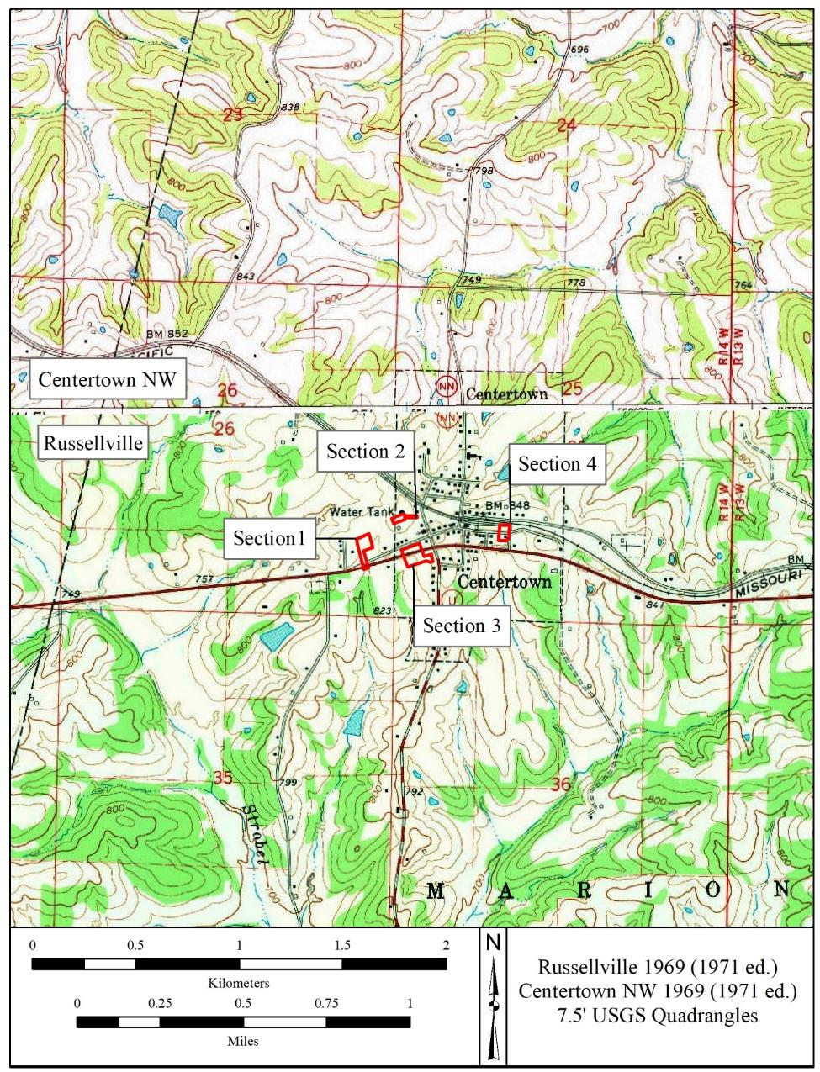
Figure 1: Location of Project Area Section 1

Figure 2: Soils Map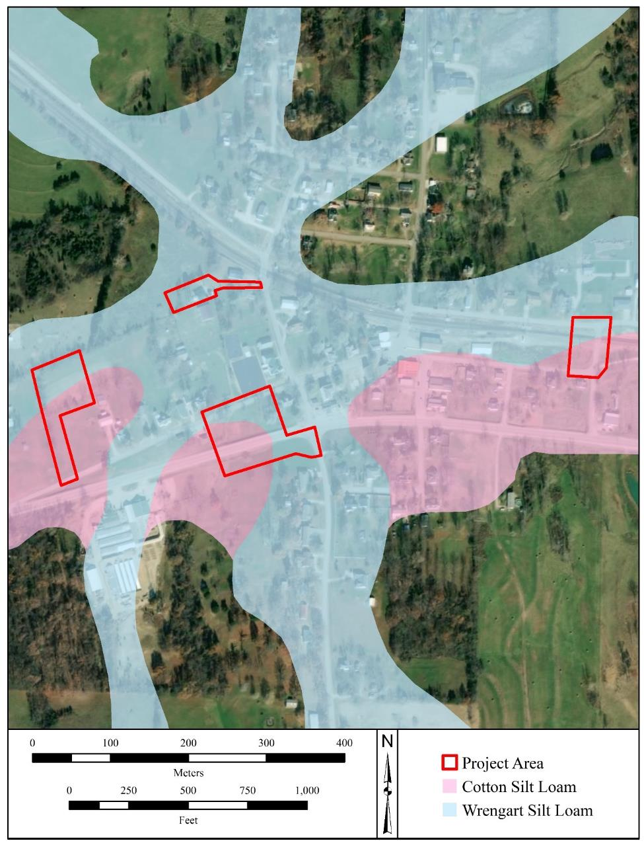

Figure 3: 1914 Historic Map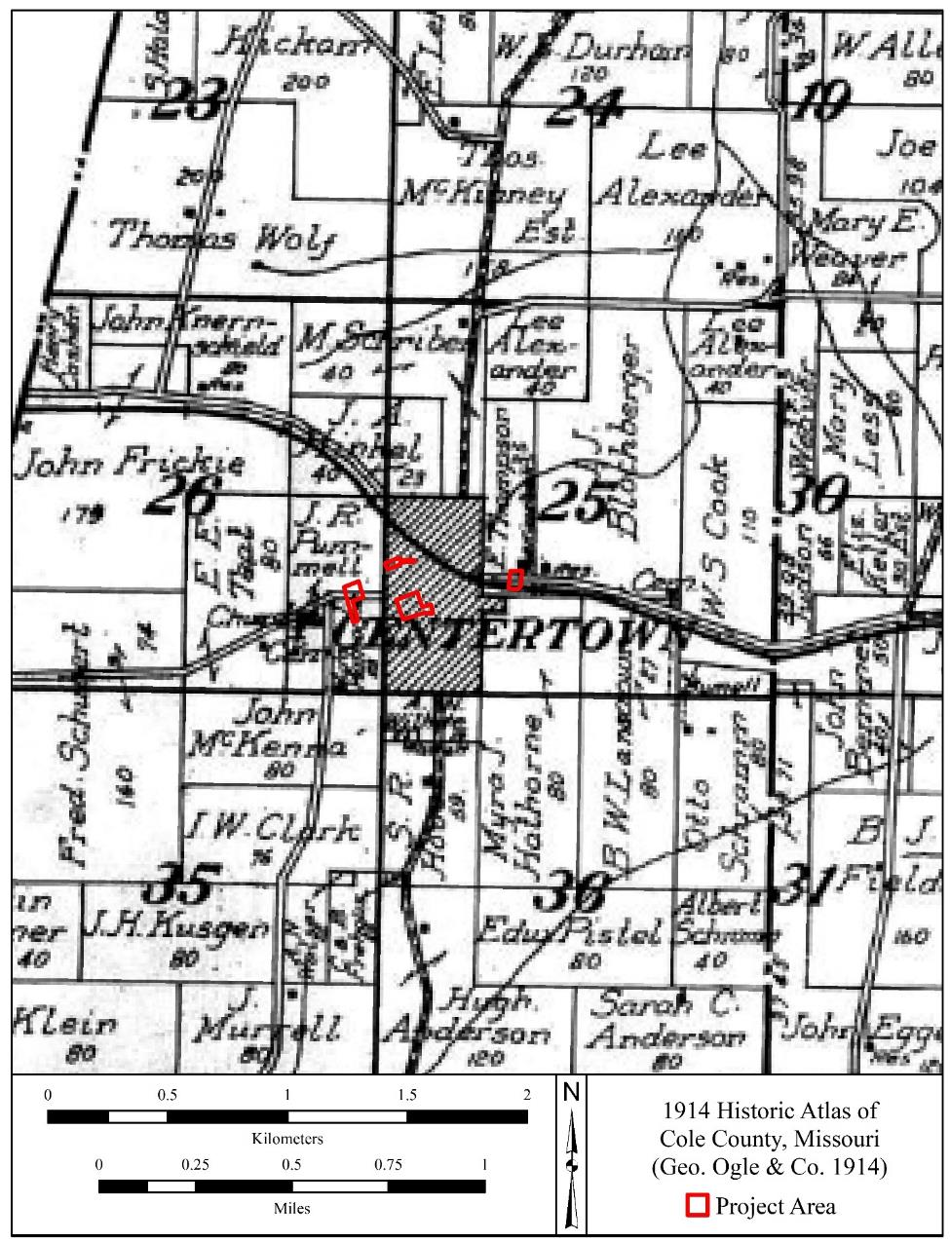

Figure 4: 1914 Atlas Centertown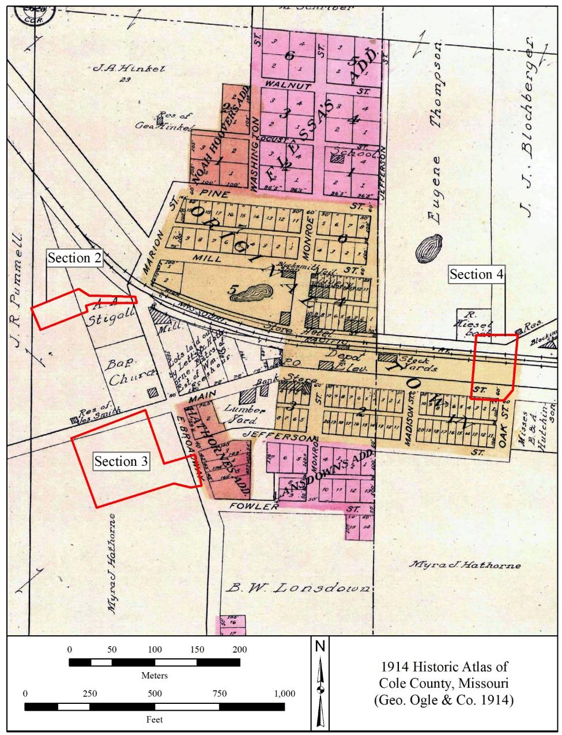

Figure 5: 1930 Historic Map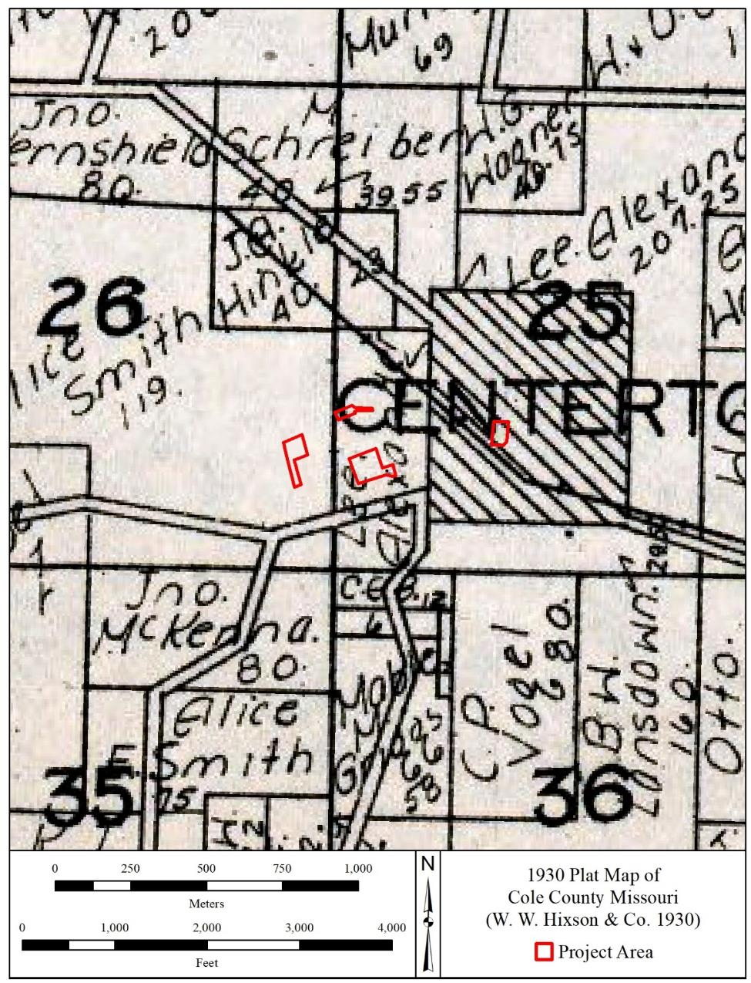

Figure 6: 1963 Historic Map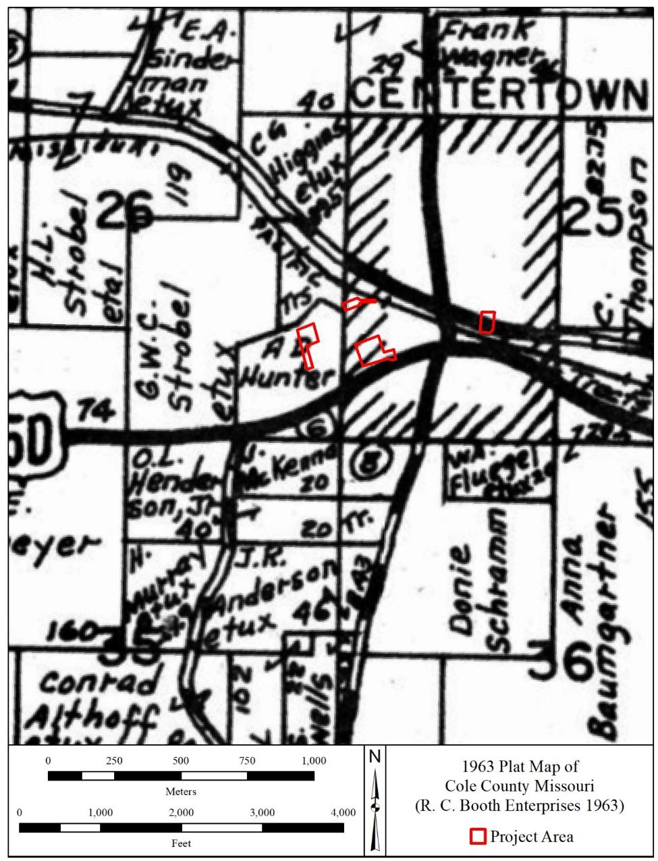

Figure 7: Previous Investigations Map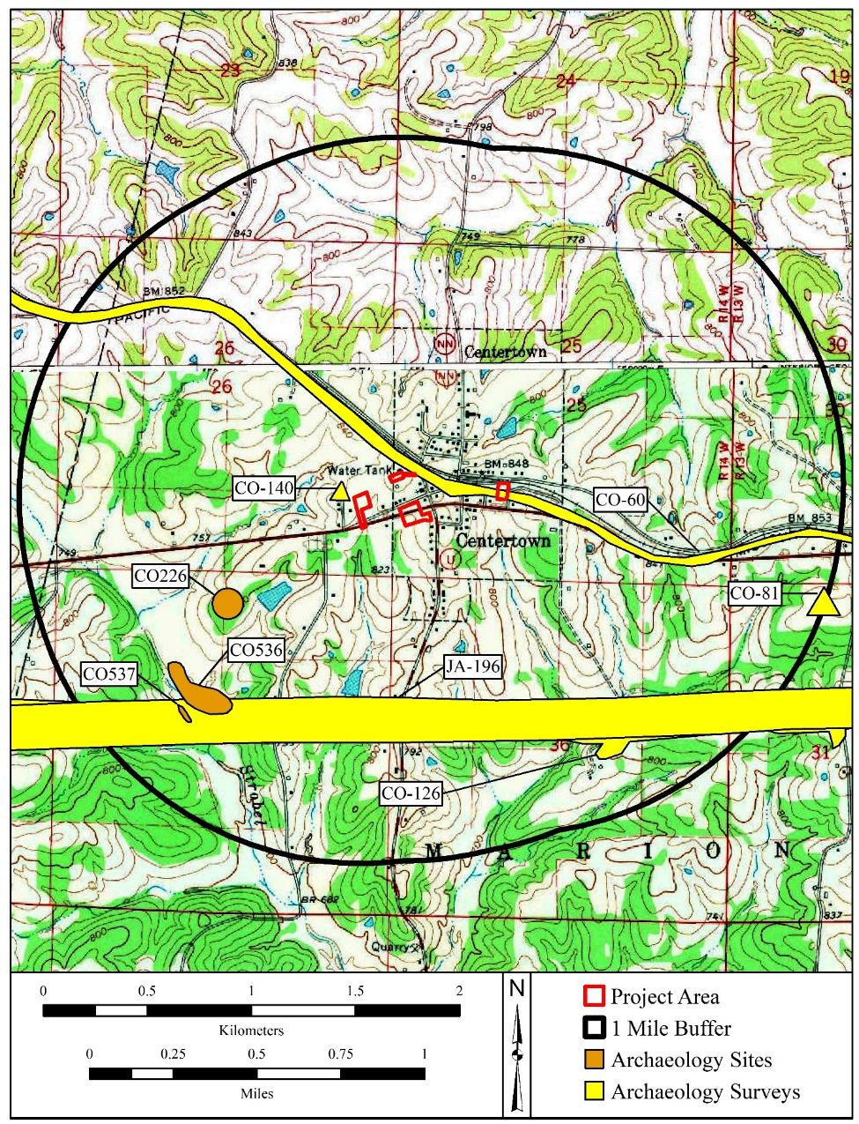

Figure 8: Shovel Tests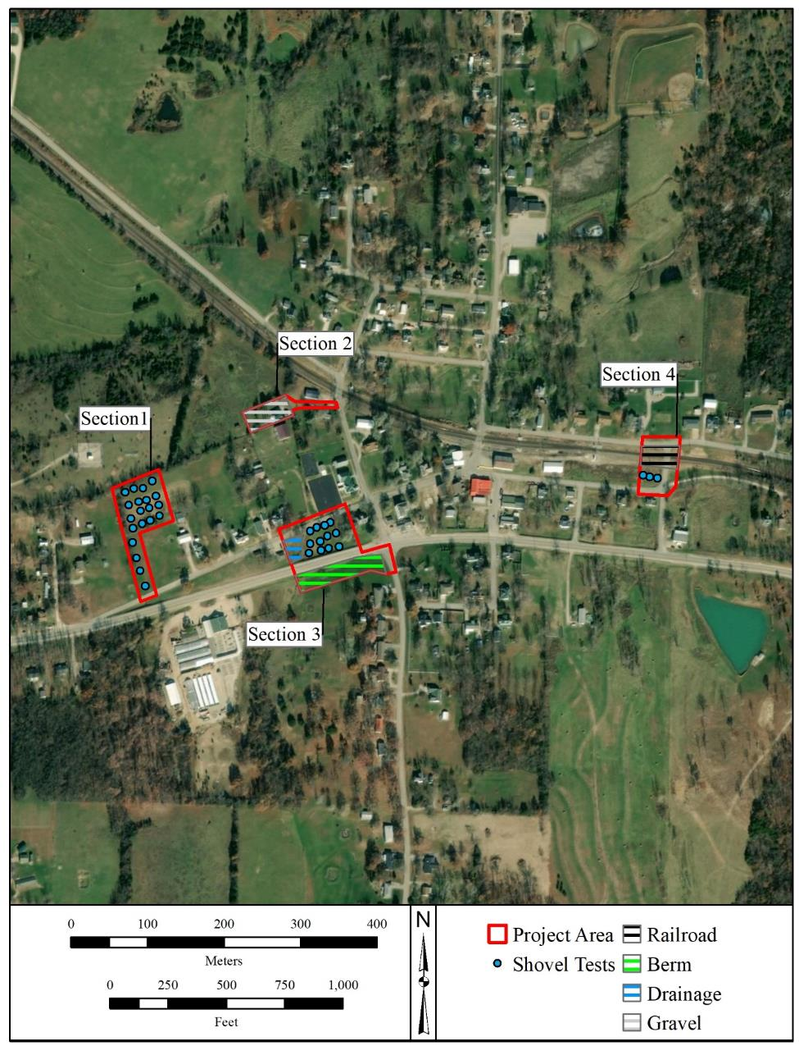

Figure 9: 1949 Topographic Map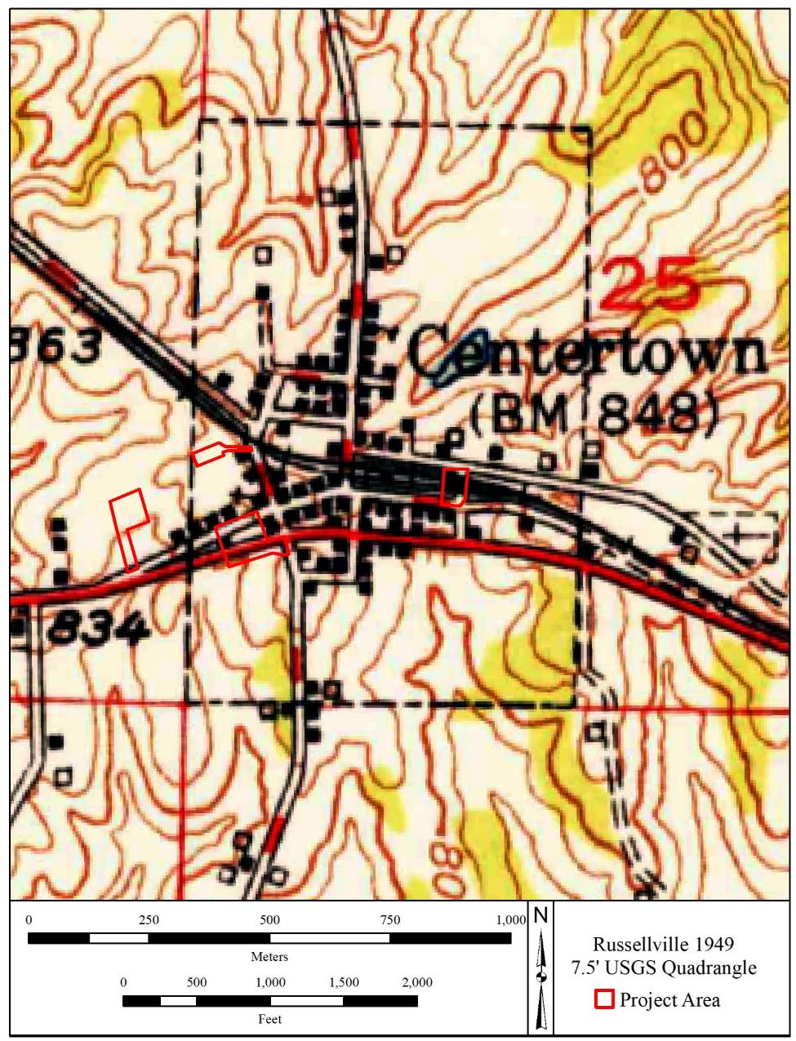

Photo 1: Section 1 Overall Grass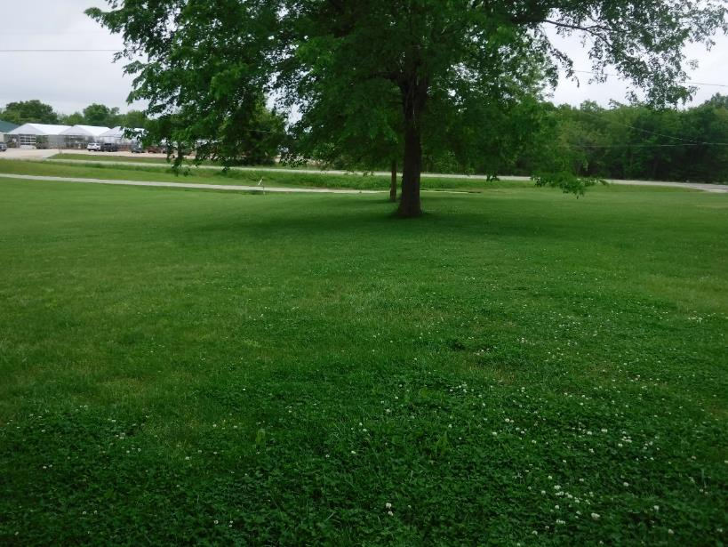

Photo 2: Section 1 Overall Field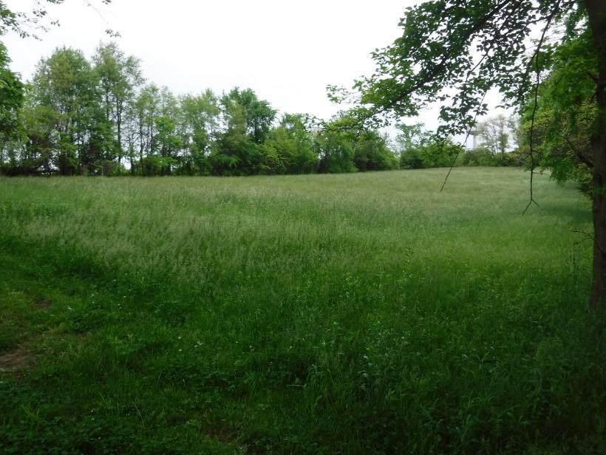

Photo 3: Section 1 Shovel Test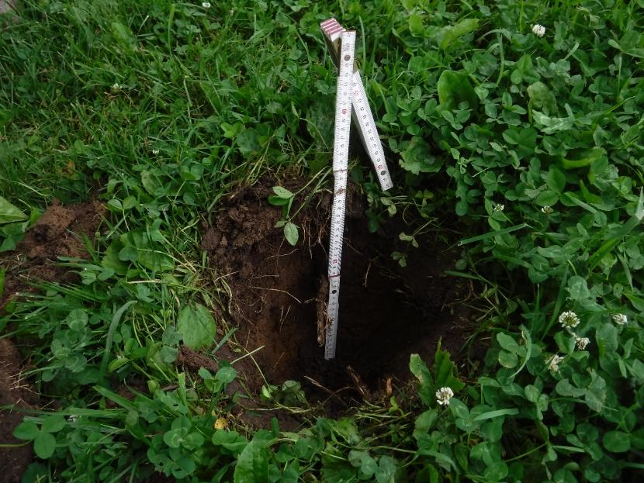

Photo 4: Section 2 Road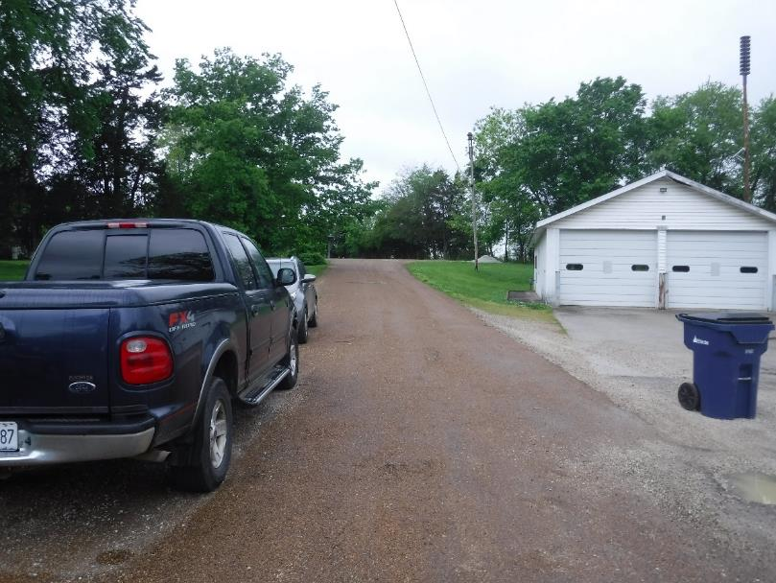

Photo 5: Section 2 Overall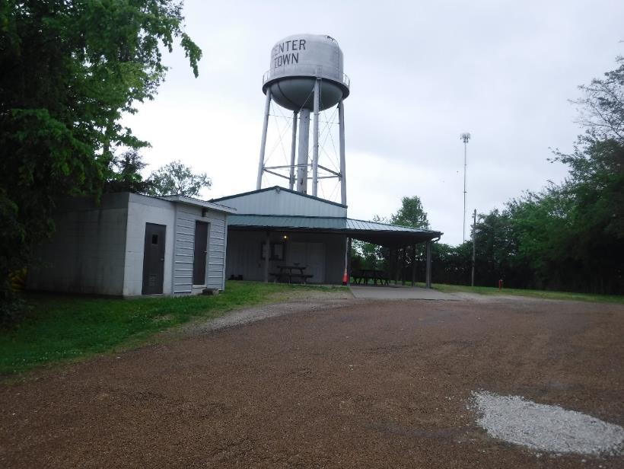

Photo 6: Section 2 Gravel in Grass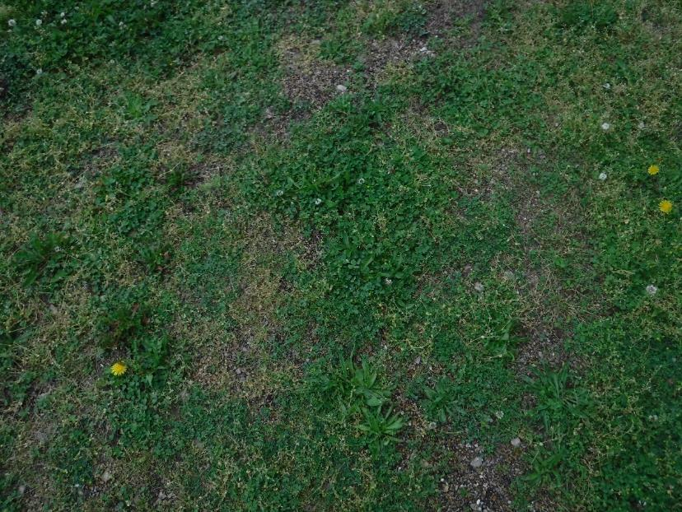
Photo 7: Section 2 Utilities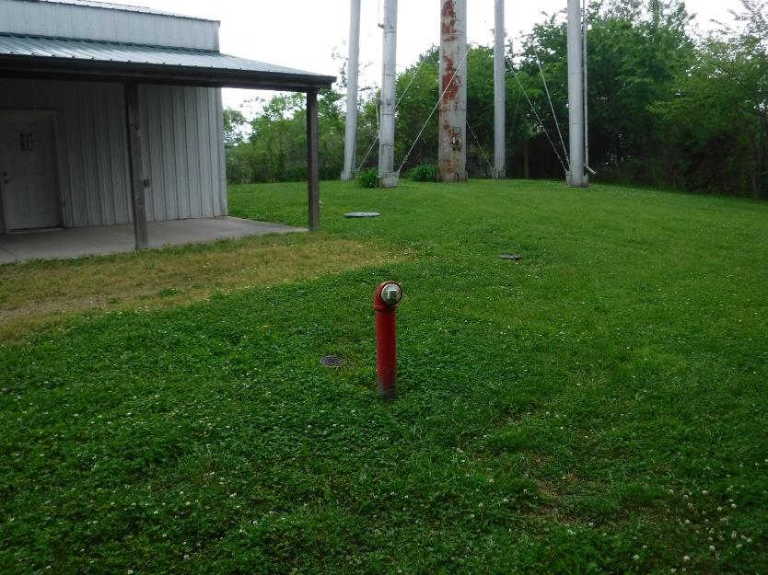

Photo 8: Section 3 Overall and Road Berm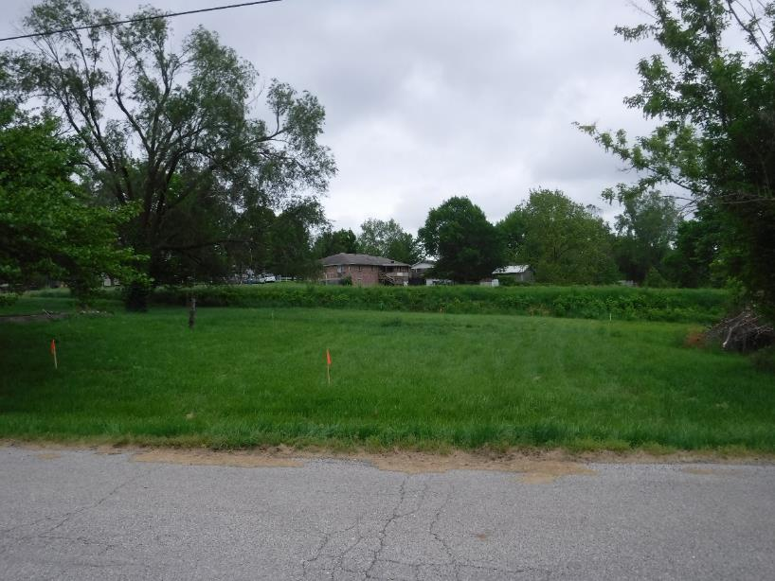
Photo 9: Section 3 Shovel Test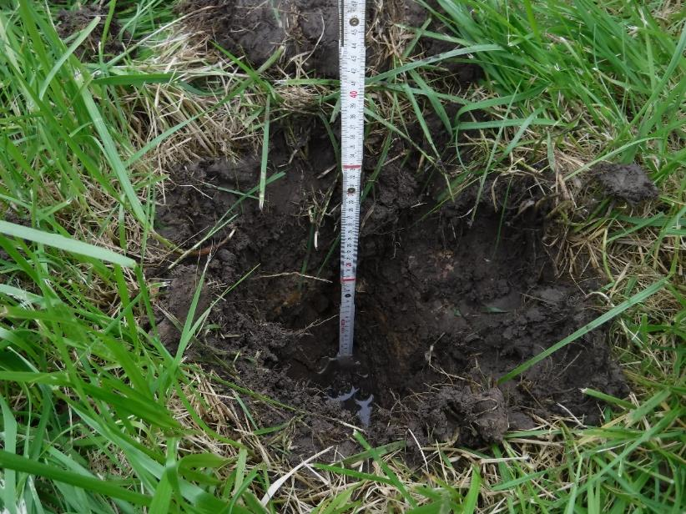

Photo 10: Section 3 Cistern and Drainage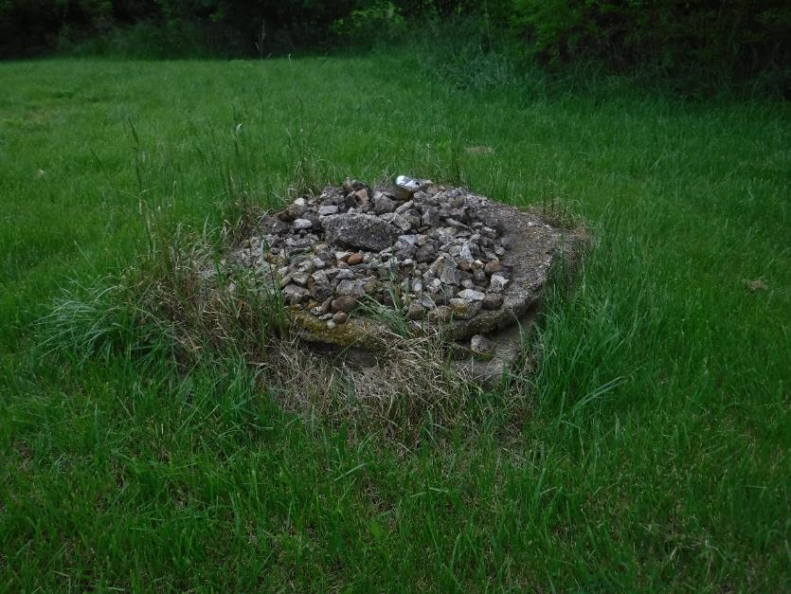
Photo 11: Section 3 Brush Pile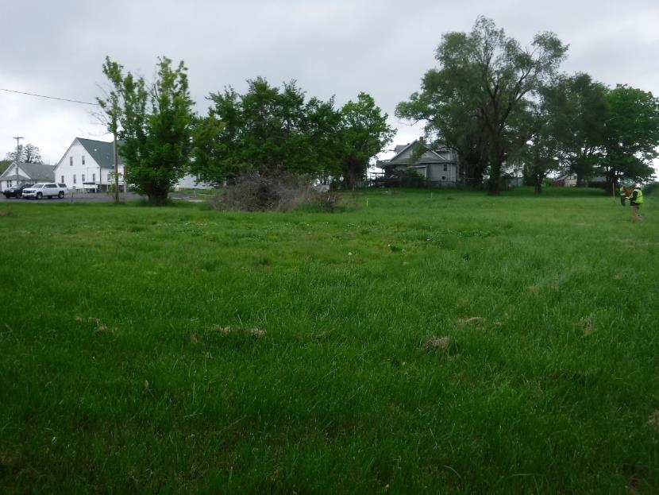

Photo 12: Section 4 Overall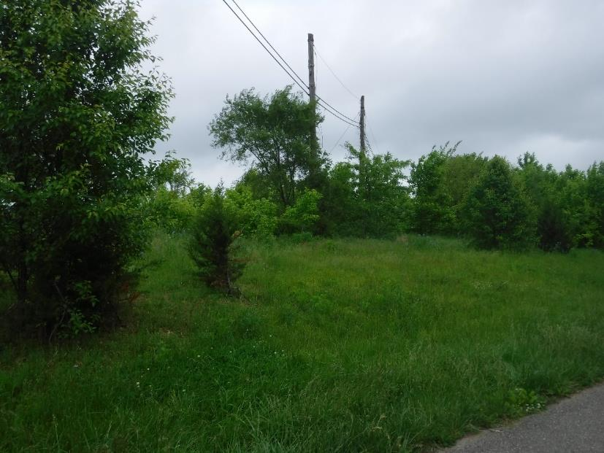

Photo 13: Section 4 Shovel Test