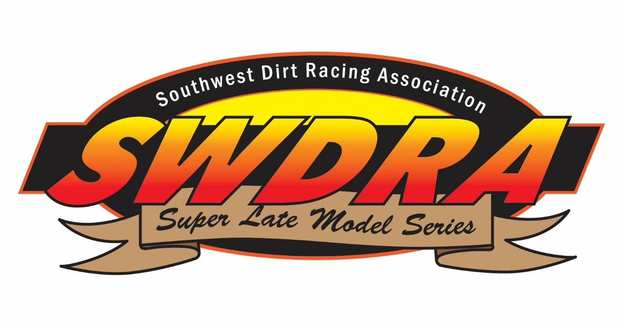

2021 SWDRA Series Rules
***These Rules are subject for revision and change at the discrepancy of SWDRA Officials, ALL
OFFICIAL DECISIONS ARE FINAL***
**Drivers - it is YOUR responsibility to be aware of your crew at the track as well on social
media**
Any Rules not listed will refer back to the current Lucas Oil Rule Book, https://lucasdirt.com/
GENERAL INFORMATION
1. Membership
a. Membership cost $100
b. Must be a member to receive point fund, contingency prizes, and be eligible for rookie of the
year. All drivers with a paid membership will be eligible for full point fund prize money.
c. Decals - There are certain decals that must be carried on the car, in order to earn both points
towards the Season Ending Championship Payout and Prize Money. These Decals must be on
both sides of the car at every Series race in which the car competes.
d. Contingencies - Certain other Product Manufacturers will be awarding Contingency, these
Awards are dependent upon the Manufacturer’s Decal being carried on the race car. If you wish
to be eligible to receive an Award from the Manufacturers concerned, it is your responsibility to
ensure that the correct decal is affixed to your race car. (The series will provide decals) All cars
will be checked by Series Personnel for the appropriate decals.

2. Event Procedures
a. Sign in at SWDRA trailer- Members $20 entry fee per night/Non-members $30 entry fee per
night
b. Heat race winners and Top 4 from the main must go directly to tech or will be disqualified
(tech area will be announced at the track)
c. Heat Races will be lined up by pill draw, unless other noted in the drivers meeting, the winner
of Heat race #1 will draw for an invert. 0, 4, 6, or 8 cars if 2 heat races, and 0, 3, 6, or 9 if 3 heat races. Feature will then be lined up by finish in heat race and then inverted based on the inversion draw. If there is a night specific invert rule, it will be discussed in the drivers meeting.
d. Starts/Restarts at the cone (will be announced in drivers meeting where it will be located)
e. Spin Rule - Any driver that is involved in two (2) single car incidents resulting in a caution
will be black flagged from that event and sent to the pits.
f. RaceCeivers are required – frequency set by the track
3. Starts / Restarts
a. All original starts will be double file and start at the start cone (Location will be announced at
drivers meeting). Front Row should approach the start cone at a moderate pace, keeping nose
pieces as even as possible. Once the front row reaches the start cone the pole sitter may
accelerate and the race will be underway. Any driver jumping the original start will be warned
for the first offense, second offense - the driver will be moved back a row.
b. Brake checking on a start or restart will not be tolerated. If you change your pace coming to
the green flag on a start or restart and cause damage to another car, you will be subject to
being disqualified from that race with no warning.
4. Yellow Flags
a. Cautions On First Lap - Once the green flag drops, the race is officially underway. On the
original start and before one (1) complete lap is scored, if only one car is involved in a caution
and stops on the track, that car will restart from the tail. If more than one (1) car is involved in a
caution before one (1) lap is scored, all cars involved in the caution that came to a stop will
receive their original starting positions, provided there are no penalties to be assessed.
b. Caution Procedures After First Lap - In the event of a Caution, the car, or cars, involved in the
incident that comes to a stop on the race track, will be sent to the rear. All cars that are
indirectly involved in the accident (spinning or stopping to avoid the wreck) will be given their
position back.
c. Restarts - Delaware Double-File Restarts - All restarts must be nose to tail and start at the
start cone placed between turn four and the starter’s stand. Leader may accelerate exiting turn
four at a moderate pace approaching the start cone. If leader accelerates early, defined as
accelerating anywhere other than the exit of turn four, the leader will be warned for first
offense – second offense they will be moved back a row. Drivers, other than the leader, may
not pass until they have passed the start cone. LEADER alone on first row, 2nd Chooses inside
or outside and everyone else fills in from there. 5 or less to go in feature will be single file
5. Championship Points
a. Feature Points breakdown
Positon

1) 100pts
2) 97pts
3) 94pts
4) 91pts
5) 88pts
6) 85pts
7) 82pts
8) 79pts
9) 76pts
10) 73pts
11) 70pts
12) 67pts
13) 64pts
14) 61pts
15) 58pts
16) 55pts
17) 52pts
18) 49pts
19) 46pts
20) 43pts
21) 40pts
22) 37pts
23) 34pts
24) 31pts
b. Heat Race Bonus Points
1) 3 pts
2) 2 pts
3) 1 pts
c. Points will be based on all feature and heat race points minus one feature finish. (a 0pts/no show can be used as your dropped race, otherwise it will be a driver’s lowest feature finish.)
d. Rookie of the Year Championship Points
10 SWDRA races or less in last 3 years to be eligible to run for ROY.
SWDRA LATE MODEL TECH RULES
**TECH AND/OR SERIES OFFICIALS HAVE FINAL SAY**
Any Rules not listed will refer back to the current Lucas Oil Rule Book, https://lucasdirt.com/
1. Tires
HTW plated Tire Mandatory: all cars must run the Hoosier D55 WRS-2 “HTW” plated tire on all 4
wheels for the feature.
b. Cars that do not run the HTW plated tire on all 4 wheels are ineligible for point fund money
and may be disqualified from the event at the discretion of the race director.
c. Out-of-state drivers are granted a 3 race grace period throughout the calendar year to run
non-HTW plated D55 tires. A driver that has competed in 4 or more SWDRA events in a
calendar year is required to race the HTW plated tire by the 4th event.
d. All tires are subject to durometer testing and will read 55 or greater, it a tire registers low on
the durometer it will be at the discretion of the series officials to take a tire sample and hold
the drivers payout for the night. If the tire proves legal, the driver will be awarded their payout,
if a tire is deemed illegal, the driver will receive a $500 fine in addition to not receiving their
payout and a suspension is possible per series official decision
e. All wheels must fit template with 14” maximum width.
f. Any tire can be confiscated by officials on any night at any track to be evaluated and returned
within a reasonable period of time.
g. There will be no defacing or altering of manufacturer’s identification markings on any tire. It
is prohibited to remove any letters, words, or numbers that would identify the tire. Any
alteration of tires may result in disqualification at the discretion of a series official.
h. No tire softener or tire treatment of any kind.
2. Engines, Weight Limit, and Spoiler
a. Open Aluminum-block engine: Minimum weight after race with driver 2400 lbs, 8” spoiler height maximum, 72” spoiler width maximum. Must run a 1.25 restrictor plate.
b. Open Steel-block engine: Minimum weight after race with driver 2300 lbs, 10” spoiler height maximum, 72” spoiler width maximum. Must run a 1.25 restrictor plate.
c. Sealed 525 crate engine: Minimum weight after race with driver 2300 lbs, 10" spoiler height maximum, 72” spoiler width maximum. No restrictor plate.
d. Sealed 602 or 604 crate engine: Minimum weight after race with driver 2250 lbs, 12” spoiler height maximum, 72” spoiler width maximum. No restrictor plate. 7000 chip.
e. All engines limited to 1 spark plug and 2 valves per cylinder. No dual magnetos.
f. One 4 barrel carburetor; no fuel injection; no electric fuel pumps.
g. Weight to be measured on scales selected and determined by officials for each racing event.
1 pound light is illegal.
h. All added weights must be securely mounted to car with minimum of 2 ½” bolts through each
50 lbs of added weight. No weights on rear bumper or outside body of car. All added weight to
be mounted below windows and interior sheet metal.
i. All added weights must be white or silver, with driver’s number painted on them
3. Exhaust System – Muffler
a. All cars will be required to have mufflers. Mufflers must be securely attached to headers. Pop
riveting of mufflers will not be permitted. It is recommended that mufflers be welded to the
headers. The mufflers must remain inside the doors. Muffler rules are determined by each
track.
** Some tracks may require a Schoenfeld muffler PN 14272735 **
4. Ignition
a. Only one MSD box permitted.
5. Bodies
a. Standard Dirt Late Model bodies. Refer to latest version of Lucas Oil Dirt Late Model series
body rules for details. LR Deck height limit is 39”, with front wheels pointed straight ahead, with
driver in car.
b. Side spoiler supports must not exceed Lucas Oil Late Model Rules.
6. Safety Equipment
a. Fire resistant uniforms and gloves are mandatory.
b. Full face racing helmet with minimum Snell rating of SA2005 is mandatory.
c. Window net on driver’s side is recommended, but not required.
d. Halon fire extinguisher system is recommended, but not required.
e. A commercially manufactured racing seat belt with shoulder harness is required and must be
securely fastened to the car frame.
f. HANS device or other neck restraint recommended.
g. Full containment seat recommended
7. Fuel Cells and Fuel
a. All cars must have fuels cells – 32 gallon maximum in completely enclosed 18 gauge steel
container. All fuel cells must be completely visible.
b. Minimum 1 ½” tubing braced loop behind cell, in place any time car is on track.
c. Fuel cells cannot be lower than the bottom of quick change.
d. All fuel cells must have check valve in breather for prevention of fire in a rollover.
e. No use of nitrous oxide, nitrous methane, propylene oxide, or any oxygen enhancing
additive. All fuel is subject to be sampled at any time during an event.
8. Drive Shafts
a. Drive shaft must be a minimum of 2” in diameter.
b. A 1 ½” 18 gauge steel drive shaft loop mandatory.
c. All drive shafts must either be (painted) silver or white.
d. Only one drive shaft is permitted.
9. Roll Cage
a. Cars must have a suitable steel roll cage in driver’s compartment.
b. Roll cage must be welded to the frame.
c. Roll cage must be above drivers head.
d. All round tube chassis are recommended to be a minimum of 1 ¾” OD tubing with minimum
wall thickness of .083.
10. General Car Specs
a. No cockpit adjustable shocks, hydraulic or pneumatic weight jacks, trackers, MSD boxes or
similar adjustable components of any kind inside cockpit of car.
b. No electronic or computerized wheel spin traction control devices permitted. No controlled
timing device attached to or controlling accelerator or rotation of wheel allowed.
c. Transmission must be bolted to engine. Must have forward and reverse gears. Must be able
to shift to forward or reverse with engine running.
d. No mirrors.
e. No 2-way radios allowed in race car, or on anyone connected with car.
11. Results Posting, Official Finish and Protests
a. Transponders are required at all tracks.
b. When the Official Finish is posted, drivers have thirty (30) minutes after the finish is posted
to file a formal complaint if they disagree on the track scoring.
c. All drivers who wish to file a protest must do so within this time frame in order for SWDRA
officials and track personnel to determine the merit of each protest.
d. After the Official Finish is posted and the time limit has passed, the posted finish will be
considered closed and no protests will be accepted. Each driver is responsible for checking the
finish and deciding if they have a protest. Points and Payout will be awarded from the Official
Finish.
12. Conduct – Drivers, Team Members, Team Owners
a. Remember that we are here because of race fans, track owners/promoters, sponsors and
others. In order for Super Late Models to be successful, this needs to be a win-win for
everyone involved.
b. Rough driving or retaliation: Any driver taking part in rough driving as deemed by officials will
be black flagged for that event. Retaliation consisting of any driver using a car to retaliate
against another driver will be subject to either being black flagged for that event and being
scored last, and/or being suspended from participating in future events. This policy includes
actions on the track, leaving the race track or in the pit area.
c. There will be no derogatory or distasteful statements on any race car or hauler. Officials will
have the final decision on all lettering on the race cars and haulers with suspensions and fines
left to the discretion of the promoter or series official.
d. Any driver, team member (including family), team owner who approaches another drivers pit
in a physical confrontation will be considered as the aggressor and may be suspended from the
next event and fined up to a $500 fine and suspensions. All drivers are responsible for their
crew or team members; this includes family members who may be in the pit area as well.
e. If both drivers are not in their respective pit areas when a physical confrontation occurs, then
both drivers will be considered as the aggressors and will be held equally responsible.
f. Fines collected will be added to the series season fund.
g. No driver, team member, team owner shall subject any official to any threatening
statements, abuse or improper language at any time. Any driver, team member or team owner
who assaults or threatens any official may be fined up to $1000 and suspended from all events
until the fine is paid and reinstatement is approved by the track or series promoter.

