Barkleying Up the Wrong Tree
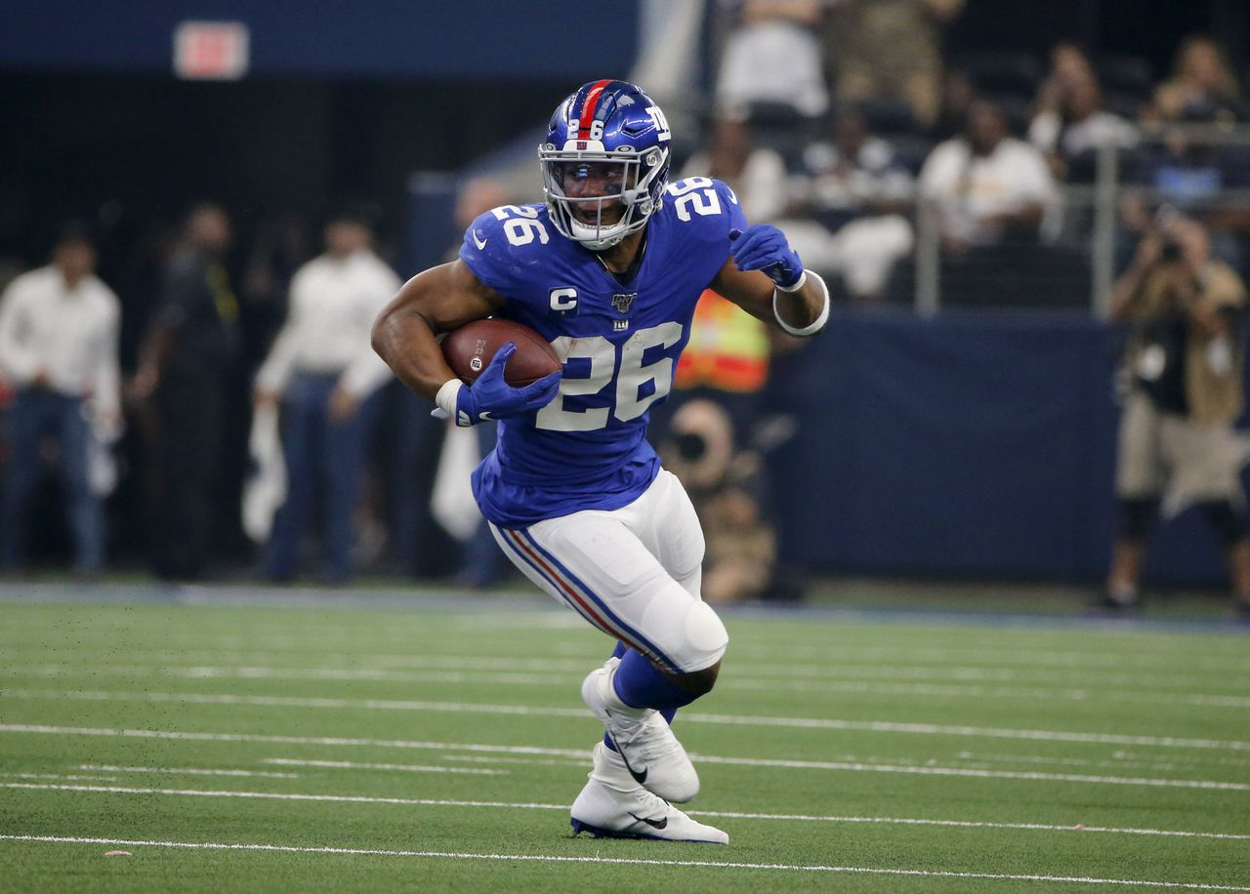
In Fantasy Football the running back position is king. Chances are the player who won your fantasy football league had the duo of powerhouse running backs. Which explains why the top tier running backs are drafted high in the first round. It’s undeniable the workhorse running backs are true difference makers. The Christian McCaffrey, Ezekiel Elliot, Todd Gurley, LeVeon Bell work horse running backs are becoming more and more scarce as NFL teams begin to switch to a running back by committee approach. There are still a few true three down running backs left in the NFL, one of which is the focus of this article. That running back is Saquon Barkley.
We all probably know who Saquon Barkley is but for those who don’t, I’ll give a little background on him. In the 2018 NFL draft, the New York Giants selected Barkley with the second overall pick. Coming out of the University of Penn State, Barkley was a highly coveted NFL prospect. In his three seasons at Penn State, Barkley was a machine racking up 3,843 rushing yards, 48 rushing touchdowns, 1,195 receiving yards, and 8 rushing touchdowns in his three years. He averaged 5.7 yards per carry and in his junior season caught 54 passes leading to 632 receiving yards. On paper, Barkley’s numbers are phenomenal.
Furthermore, Barkley is an athletic specimen. Weighing in at 230 pounds, runs a 4.4 forty-yard dash and has a 41-inch vertical jump, Saquon is arguably the most athletically gifted running back in the NFL history. Barkley’s athleticism has been compared to Barry Sanders, Walter Peyton and Emmitt Smith. That is pretty good company if you ask me. It’s safe to say Barkley is a generalization talent based off his athleticism.
In Barkley’s rookie season, he showed everyone why he was drafted number two overall. In 2019, Barkley ran for 1,307 yards, 11 touchdowns and averaged a healthy five yards per carry. Additionally, Barkley was a phenomenal weapon through the air. Eli Manning targeted Barkley 121 times which turned into 91 receptions for 721 receiving yards and 4 receiving touchdowns. Barkley had an outstanding rookie season finishing second in rushing yards and put the NFL on notice.
Fantasy football players respected Barkley as he was the consensus second overall pick in fantasy drafts in 2018. Barkley returned that draft value finishing as the second best running back in fantasy football in a half ppr scoring format. Since his rookie season Barkley has had a average draft position (ADP) of 1.01 in 2019 and 1.02 in 2020. However in those past two seasons, Barkley has faced injuries causing him to miss most the season. But Saquon is back and ready to go for the 2021 season. Or is he?
Now before I begin, I want to clarify, I’m not knocking Barkley the player. I think when healthy and, on the field, he is the best running back in the NFL. But health has been the crux for Barkley these past two seasons. Okay, now that I have built Barkley up, I’m ready to tear him down.
Right now, Barkley has an ADP of 1.06 on fantasy pros. However, on ESPN platforms he is often picked in the top five in the first round. I have a huge problem with this. Specifically, I have three problems- Barkley’s health, targets and quarterback.
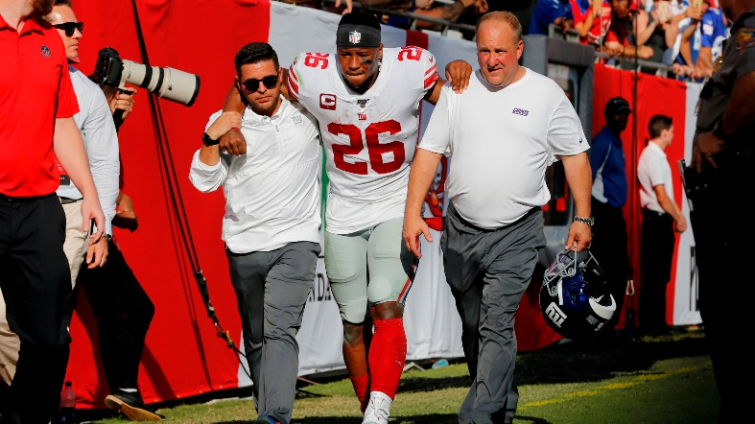
Barkley suffered an ACL injury in week two ending his 2020 season. Due to the severity of the injury Barkley didn’t get surgery until late October. The standard recovery timeline for a torn ACL is twelve months. There were reports coming out of the Giants training camp that Barkley isn’t where he should be in the recovery process. Thus, the Giants decided to place him on the physically unable to perform list (PUP list) to begin training camp. This doesn’t surprise me because there are two options if a player gets hurt during training camp. The team must either cut the player or put him on injury reserve to start the season. Obviously, the Giants wouldn’t cut Barkley so they would place him on the injury reserve list, which they also don’t want to do. Instead, the Giants took a cautious approach by putting Barkley on the PUP list and let him get right.
Recently, Barkley has been activated from the PUP list and cleared to return to practice. This is a promising sign because the Giants wouldn’t allow him to practice if he wasn’t feeling good. That being said, I’m still very concerned about his health. As I mentioned earlier, the normal timeline of recovering from a torn ACL is twelve months. That means Barkley is two months away from being fully recovered. If Barkley plans to play in week one against the Denver Broncos, there is a chance of reinjuring himself which would lead to additional time missed. The other scenario is Barkley is on a touch restriction and gets off to a slow start for fantasy players.
My second argument against Saquon Barkley is the targets. In Barkley’s rookie season he received 121 targets which he turned into 91 receptions, 721 yards and 4 touchdowns. Those are exceptional numbers. However, in his second season Barkley saw a dip in involvement in the passing game. Only appearing in 13 games but extrapolating the numbers Barkley would have seen 90 targets, 64 receptions, 537 yards, and 2 touchdowns. Clearly, Barkley benefited from having a immobile Eli Manning dumping the ball off to Saquon his rookie year. Now going into Barkley’s fourth season, Barkley faces a lot of competition. The Giants just gave Kenny Golladay a big bag of money to come and be the wide receiver one for the team. Tight end Evan Engram has seen 100+ targets in two out of four seasons and was on track for a third 100+ target season before going down to injury in 2019. The Giants also drafted first round pick Kadarius Toney; and let’s not forget Darius Slayton who is no slouch himself. As we can see, there is a lot of mouths to feed in this Giant’s offense and worst-case scenario, Barkley could be the fourth or fifth target in the offense.
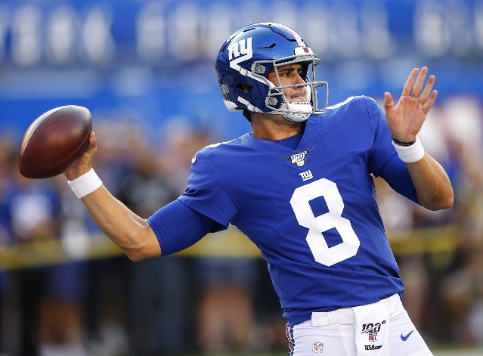
My last point against Barkley is his quarterback, Daniel Jones. In his first two years, Jones had shown moments of brilliance but overall has been disappointing. In his rookie season, Jones threw for 3,027 passing yards, 24 touchdowns and completed 61.9% of his passes. On top of that Jones threw 12 interceptions and fumbled the ball 18 times. Not numbers you want to see from your quarterback. There was hope coming into his second season Jones could take the next step and become a better quarterback. However, those hopes didn’t come true. Jones ended 2020 with 2,943 passing yards, 11 touchdowns and completed 62.5% of his passes. Jones did greatly reduce his turnovers, throwing 10 interceptions and fumbling the ball only 11 times. If you couldn’t tell, I was being sarcastic. Jones this far has proven to be a lack luster quarterback, which affects the fantasy potential of Barkley in 2021.
To conclude, my worries on Barkley this season have to do with his health, unknown targets and quarterback play. Barkley is a phenomenal talent and fantasy asset. However, I think fantasy players are drafting Barkley based on his rookie season and hoping he can replicate those numbers. Even healthy, I don’t think Barkley can be as productive as his rookie year. I would say best case scenario Barkley finishes as the RB3, but more than likely Barkley is the RB5 to RB10. Which would be fine but currently on ESPN Barkley has a ADP of 1.04. Players are drafting Barkley near his ceiling, which leaves a lot of room for him to be a fantasy bust for your fantasy team.
The last thing I want to leave you with is this, since 2010 of the first 10 running backs drafted, three have busted, meaning they finished significantly lower than where they were drafted. Last season Christian McCaffery, Ezekiel Elliot and Barkley himself were all drafted in the top 10 and finished much lower than their ADP’s. I fear this season Barkley will be one of the three running backs to bust. Now there is a point where I will draft Barkley, which is at the back of the first round, but Barkley will never be there so in that sense Barkley is off my board. But these are just my thoughts. You must decide if Saquon is worth the risk and a player you want to invest in 2021.

