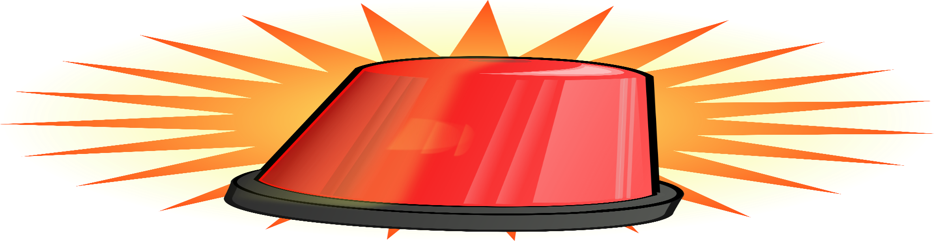
The Panic Room

November 9, 2021

Welcome to the panic room! The panic room is where I breakdown player’s and if we should be panicking about them or not. Today’s panic room highlights three players: Patrick Mahomes, Antonio Gibson and Kyle Pitts. These three were chosen because they were player’s fantasy managers invested a lot of draft capital or traded a lot for and have been underperforming recently. I’m going to breakdown why they’ve been struggling; will they bounce back and what to do with them.
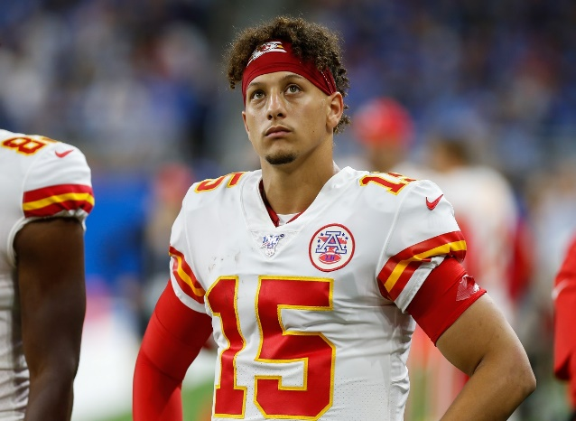
First up is the former MVP, Superbowl winner, master of the miraculous, Ketchup boy himself, Patrick Mahomes. Renowned as the best player in the world, Mahomes was playing anything but that. From weeks five to nine, Mahomes was the QB12 averaging 16.03 fantasy points in a four point per touchdown scoring format. To put that into perspective, Ryan Tannehill, Teddy Bridgewater and Carson Wentz were all better fantasy options. During his 5-game cold streak, Mahomes completion percentage was 60.1%, averaging 263.2 passing yards, he threw six touchdowns and six interceptions. This is exactly why I never draft quarterbacks early. Because of all the players, Mahomes seemed like the safest. But early quarterbacks. Aren’t. Safe.
The next question is why Mahomes was struggling. I went back and watched the tape, it’s the way teams were playing the Chiefs. They are playing cover two and cover three against Mahomes, eliminating the deep ball and forcing him to dink and dunk his way down the field. Now Mahomes can do this. But what happens then is an increase in plays per drive, which increases the probability of a turnover. Which was happening. Mahomes would get impatient and try to force a deep ball when he shouldn’t, leading to a turnover. Now I want to specify, not all the turnovers were Mahomes fault. There were several times the ball hit Tyreek Hill in the hands, or worse, hit Mecole hardman in the face, popping the ball up and the defense got the interception.
The second reason the Chiefs were struggling is more narrative, so take it for what you will. But they just had no confidence. I saw Mahomes complete a big twenty plus yard strike to Kelce and in the past Kelce would have gotten hype after the play. But this time, Kelce got up and was shaking his head. I couldn’t hear Kelce, but the look on his face said “finally, it’s about ($@*!) time”. The Chiefs were playing with no confidence and not having fun. This once explosive and electrifying offensive was a shell of itself. Until Mahomes lit up the Raiders throwing for 400+ yards and 5 touchdowns. All the worries about the Chiefs and Mahomes were put to rest after their latest showing. Or have they?
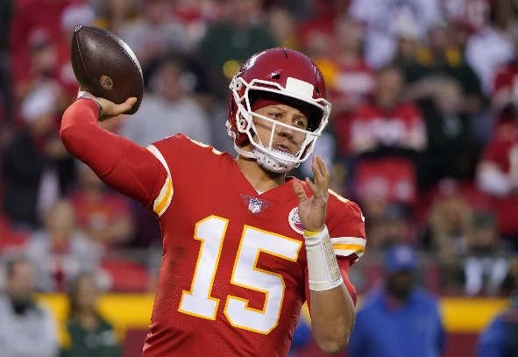
The big question fantasy players want to know is, what to do with Patrick Mahomes coming off the huge performance? Do we trade him? Do we trade for him? Do we hold him? My answer is simple. He’s Patrick. Fricking. Mahomes. In his first four games, Mahomes was the number one quarterback averaging 28.8 points per game. He was everything fantasy players drafted him to be. But people were quick to forget that and his past two seasons of work. He’s got elite pass catching weapons in Tyreek Hill and Travis Kelce. Andy Reid is one of the best offensive player callers in the NFL. And Patrick Mahomes is the best quarterback in the NFL. I was confident the Chiefs would break out of this rut. And I was right. I was really upset I didn’t get this out before last Sunday, but life happens. Mahomes you’re safe from the panic room.
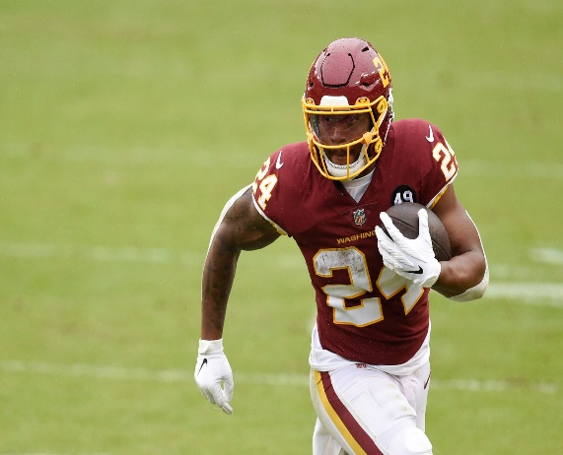
The next player being brought into the panic room is Antonio Gibson. Coming into 2021, there was a lot of hype surrounding Gibson. After an outstanding rookie campaign, Gibson came into 2021 with high expectations. This led to Gibson being the RB12 off the board and ADP of 16th overall. Thus far he’s been extremely disappointing. In a half ppr format, Gibson is the RB19 on averaging 11.9 ppg with 506 rushing yards, five rushing touchdowns, 19 receptions, 158 receiving yards and 1 receiving touchdown. Gibson is also sporting an underwhelming 3.7 yards per carry. That’s a whole yard less than what Gibson averaged as a rookie. I can’t remember where I saw the stat, but this season Gibson ranks dead last among players with expected yards per plays called. Meaning Gibson is being extremely inefficient with his opportunities. The bottom line is Gibson hasn’t looked good or been good on the field.
One reason that could explain Gibson’s struggles this season could be that he’s been banged up. Gibson has been playing with a hairline fracture in his shin. Coming into the season Gibson was nursing this shin injury and he claimed it wasn’t going to affect him. That was a big fat lie. Not only has Gibson been hurt but Ryan Fitzpatrick went out in the first game of the season with a hip injury. Terry McLaurin has been battling a shoulder injury. Curtis Samuel and Logan Thomas have been sidelined most of the season themselves. It’s clear this Washington Football Team has been plagued with injuries and it’s affected their offense.
But things seem to be looking up. Nicki Jhabvala of the Washington post, a reporter for the Washington Football team, got to speak with Gibson on Friday. Gibson said “playing against Tampa was the best I’ve felt since the start of the season”. Gibson had 24 carries for 64 yards and found pay dirt twice on the ground. Gibson’s teammates McLaurin, Thomas and Samuel also seem to be progressing from their injuries. The big question is, was the Tampa Bay game the start of Gibson’s bounce back? No, I don’t think it was.
The reason I don’t think Gibson’s performance is the start of a bounce back is because of this offense. It’s not good. Washington is 18th in yards per game, 20th in ppg, and 16th in rushing yards per game at 115.4. Not great numbers you want from your offensive. Additionally, Washington’s defense has surrendered the 5th most ppg 27.3 to opponents, leading to many negative game scripts for themselves. This greatly affects Gibson because he’s not the pass catching back. That role belongs to JD McKissic, because when you have the chance to give McKissic the ball over Gibson, you’ve got to take it right? That one still baffles me. But regardless, Gibson’s ceiling and floor is immensely lowered due to the lack of involvement in the passing game and his defense being horrific.
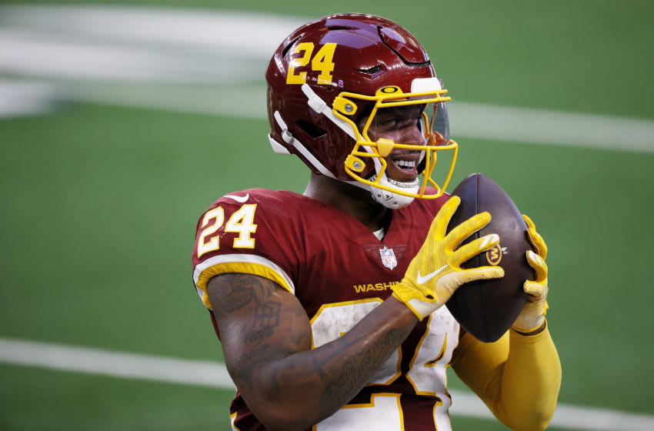
The next question fantasy managers want answered is what do with Gibson? Do you hold him after the big game? Sell him? My answer isn’t so simple. I think you must ask yourself what you believe about Gibson. If you think he’s going to turn it around then keep him, because there is a non-zero percent chance he does bounce back. However, I’m in the camp where I’m cashing in off of his big performance against Champa Bay.
My number one trade target would be Darrell Henderson. Henderson has been bad the past 3 of 4 games and has his bye. But he’s the RB12 averaging 14.4 ppg in half ppr. Plus, he has the 7th best playoff schedule with Seattle, Minnesota and Baltimore. The Henderson owner would probably be willing to trade Henderson for Gibson straight up and I would do that in a heartbeat. Other running backs I would go after would be Melvin Gordon, James Robinson, and James Conner. If you strong at running back and need wide receiver help, I’d recommend DeAndre Hopkins, Antonio Brown and even kicking the tires on A.J. Brown. Sorry Gibson but you’re in the panic room.
The final player I’m going to be discussing is Kyle Pitts. Coming into the season there was never a player I was higher and lower on at the same time. I believe in Pitts the football player. Pitts put up elite numbers at his combine and has been compared to Calvin Johnson. Pitt’s size, speed and strength makes him a generation talent. Regardless, Pitts is a rookie tight end, and they haven’t been fantasy relevant.
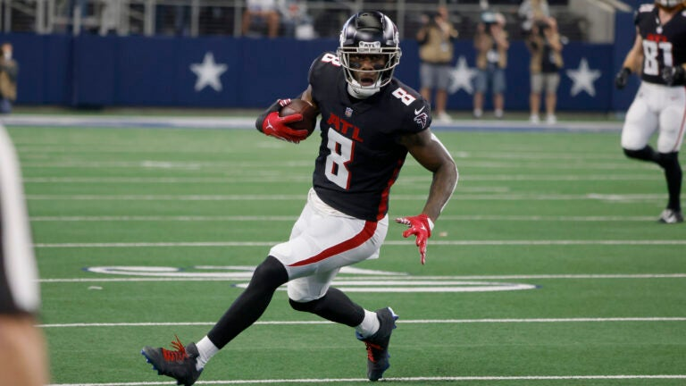
Thus far, Pitts has 43 receptions on 69 targets, 635 receiving yards and one touchdown. That puts Pitts on pace for 73 receptions, 117 targets, 1079 receiving yards and two touchdowns. Pitts would just beat out Mike Ditka for the most receiving yards for a rookie tight end, who currently holds the record with 1076 receiving yards. Not too shabby if you ask me.
But let’s not forget, this is about fantasy football. This season Pitts is the TE4 averaging 9.25 fantasy points in a half ppr scoring format. Pitts was the TE 4 off the board and a late fourth round draft pick. Despite having returned value, Pitts feels like a disappoint. There was a lot of hope for Pitts would be the next breakout tight end like George Kittle or Mark Andrews. But the simple fact is Pitts is a rookie tight end. Not to mention the Falcons lost Calvin Ridley, who some would argue helps Pitts because that means more targets for him. In my eyes that hurt Pitts so much because now teams can focus on Pitts and not Ridley. Which is exactly what has been happening.
The big question fantasy players are clamoring to know is will Pitts finish the season strong? My answer is no. Going forward Pitts has the second hardest strength of schedule. Pitts expected fantasy points per game for the rest of this season is 9.2. What’s expected fantasy points? It’s simply the remaining teams Pitts plays this year and how many points they will surrender to him per game. Those averages are based off of how teams have done weeks 1-9 and in a half-ppr scoring format. It also just happens to be how many points Pitts is averaging now.
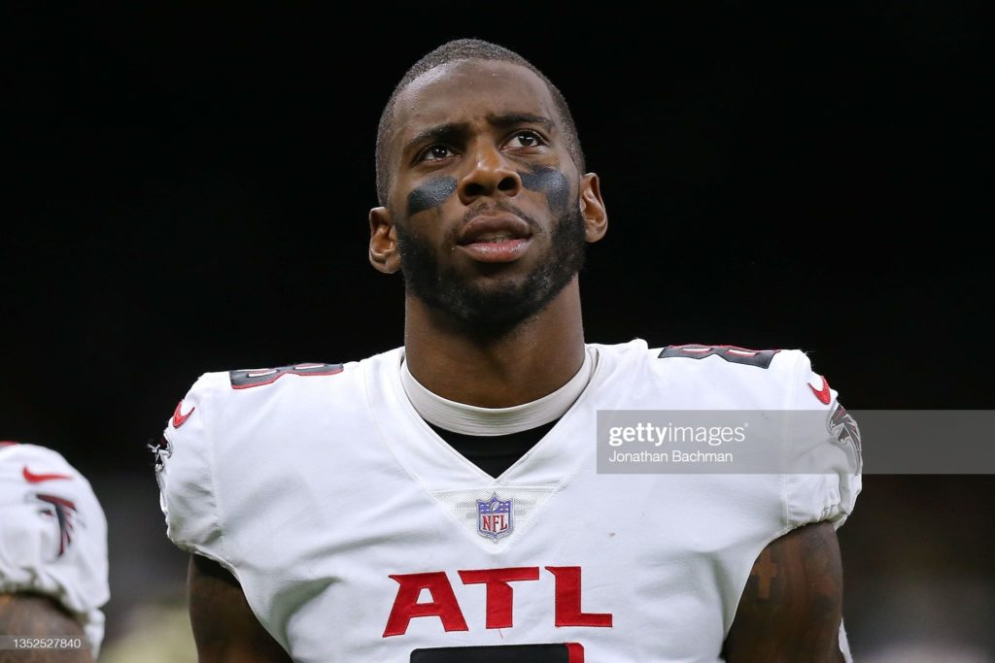
The second reason I think things don’t get better for Pitts is the lack of talent around him. With Ridley gone and a lack of a rushing attack, opposing defenses can hone in on Pitts and put their number one corners on him. Plus, with Matt Ryan looking worse than 10lb’s of trash in a 5lb bag, you get a horrific concoction of fantasy disappoint. My advice with Pitts, is including him in a package deal. Pair him with another receiver and go target a Gronk, Pat Freirmuth, or Mike Gesicki. I’d even kick the tires on the Darren Waller. The Waller owner maybe so fed up with Waller’s performances, they’d be willing to trade him for Pitts plus a wide receiver. If you need help at running back or wide receiver again, go target Hopkins, AJ Brown, AB, Henderson, Gordon, and Conner. Additional target’s could be Amari Cooper and Devonta Smith who I love the rest of the season. Pitts you’re in the panic room!

