Zekeing a Bounce Back
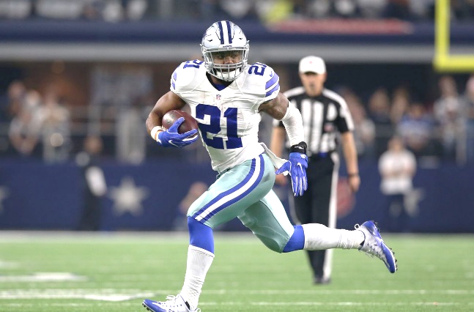
Fantasy football is where dreams are made and where they are crushed. These dreams are decided by fantasy players ability to manage their teams by drafting players, making the best waiver decisions and executing on trades. But at the end of the day, it really comes down to the football players to execute. Every year there are players predicted to breakout and become fantasy studs. Additionally, every year elite players hit a wall and have a fall from fantasy grace. One of the players who had fantasy falling out in 2020 was Ezekiel Elliot. Elliot will be the focus of this article and what my prediction is for his fantasy outlook in 2021.
Ezekiel Elliot running back for Dallas Cowboys
In the 2016 NFL draft with the fourth overall pick the Dallas Cowboys selected Elliot. As a rookie, Elliot carried the ball 322 times while racking up 1631 yards and 15 touchdowns. Elliot also was involved in the passing game seeing 39 targets which he caught 32 of them earning 363 receiving yards and a touchdown. Since entering the league Elliot has hit the ground running, literally. Elliot’s rookie season was one of the best ever for a rookie, making him the RB2 in a half ppr scoring format in 2016.
The following season Elliot was suspended for the first six games to start the season. This hurt fantasy managers but Elliot more than made up for it when he returned averaging 98 yards a game, 24 carries while scoring seven times in the ten games. I took Elliot’s averages over that ten game span and extrapolated it over sixteen game span and found Elliot would have finished with 1573 yards, 11 touchdowns, 42 receptions for 422 receiving yards and three receiving touchdowns. Despite missing the six games, Elliot still finished as the RB10.
Now I don’t want to bore you with numbers and fantasy finishes of Elliot’s entire NFL career so I will summarize his production with Elliot’s fantasy finishes. In 2018 Elliot was the RB5 and in 2019 the RB4. It wasn’t until last did Elliot finish outside of the top 10 at his position. But in 2020 Elliot had a falling from fantasy grace finishing as the RB11. So, what happened? I’ll tell you what happened. Elliot sucked. Being an Elliot fantasy owner, I can truthfully tell you he looked definitely bad on the field and was extremely disappointing. Last year was Elliot’s lowest yard per carry of his career down at 4 yards, lowest in yards per reception at 6.5 and he tied his career low in rushing touchdowns at 6. Even though Elliot still finished as an RB1 Elliot was a fantasy bust being he was the consensus third running back drafted last year.
Now the big question to be answered is Elliot washed? Or will he bounce back? I believe he will bounce back in a big way and I have three reasons, Dak is back, the Cowboys offensive line is healthy and Elliot is himself healthy.
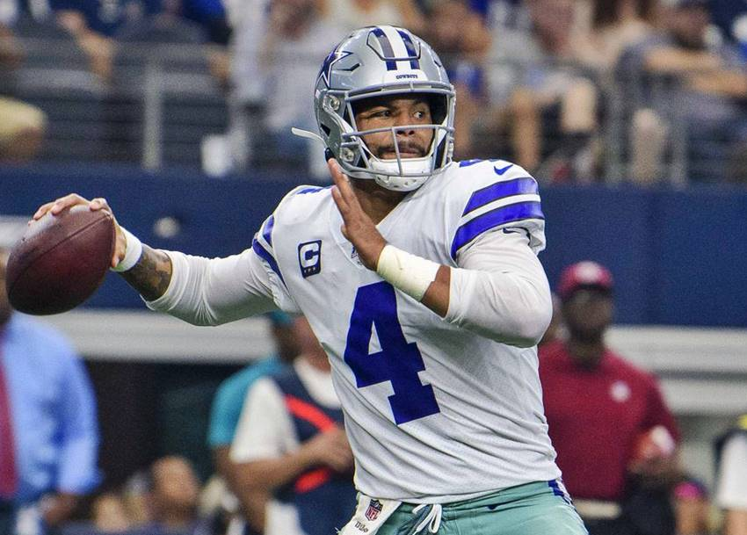
My first reasons Elliot will have a bounce back season is because his starting quarterback Dak Prescott is back. For those who don’t know Prescott suffered a season ending injury in week 5 against the Giants. From week’s one through five, Elliot was the RB3 averaging 19.9 ppg in a half ppr scoring format. Then looking at weeks six through seventeen, Elliot was the RB25 averaging 9.8 ppg. Clearly loosing Prescott affected Elliot’s fantasy production as opponents didn’t have to respect the pass. Which to be fair, I wouldn’t either if Ben DiNucci or Andy Dalton are playing quarterback. But now with Prescott back and healthy, this offense looks to be easily one of the best in the entire NFL.
Quarterback Dak Prescott preparing to throw the ball
The second reason Elliot will bounce back is the offensive line is back to full strength. Last season the Cowboys offensive line was decimated by injuries. Starting tackle La’el Collins missed most of the season after getting hip surgery. All pro and top 100 player Tyron Smith only played two games, Zack Martin, offensive guard, only played in eight games. Don’t forget Travis Frederick retired leaving a hole at the center position. Clearly the once elite Cowboys offensive line was a shell of itself leaving Elliot with not much to work with in 2020. But now Collins, Smith and Martin are all back and ready to go in 2021.
My final reason Elliot will bounce back is he himself is healthy. I think people forget how Elliot looked in 2020. After watching Elliot’s 2020 tape he didn’t have that burst or explosiveness like in previous years. But coming into the 2021 season Elliot is in shape. Currently he is listed as 216 pounds, 10 pounds lighter than last year. Head Coach Mike McCarthy in a interview with the Athletic commented “He’s (Elliot) is in much better shape this year than last year”. Elliot himself said “Cleaned up the diet a little bit, little bit different training — definitely made an emphasis to get lighter coming into the season”. I myself have gotten to see Elliot on the television series “Hardknocks” and I like what I see. Elliot looks cut, illusive and expolsive once again. Elliot is motivated and committed this offseason to get himself in prime shape for the 2021 campaign.

To recap, my three reasons Elliot will bounce back in 2021 is the return of Dak, the O-line is at full strength and Elliot is prime condition. Everything is indicating that Elliot is going to explode for fantasy managers in 2021. Now fantasy players might argue Tony Pollard was in the game a good amount and out targeted Elliot. My response is Pollard showed flashes in the game and last season. But he is still the second best running back on the team. That being said, Pollard will take touches away from Elliot, but that shouldn’t scare fantasy mangers away. In the end, Elliot has been a superstar on the field and on fantasy football teams’ year in and year out. Personally, I was comfortable taking Elliot third overall in half or full ppr drafts. Only Christian McCaffrey and Alvin Kamara I would definitively have picked over Elliot. But other players like Dalvin Cook, Derrick Henry, Davante Adams and even Travis Kelce were worthy picks, but I think Elliot provides a higher floor and higher ceiling for fantasy players.
Ezekiel Elliot haters after week one “WhAt AbOuT ToNy PoLlArD?”
With week one in the review mirror fantasy managers might be dreading their Elliot pick. Which is understandable because Elliot was pretty much irrelevant in the show down against the Buccaneers. Elliot ended the game with 11 carries for 33 yards and two receptions for 6 yards, earning four fantasy points. In totality Elliot did have bad week and fantasy managers should be disappointed. But I still fully believe and Elliot.
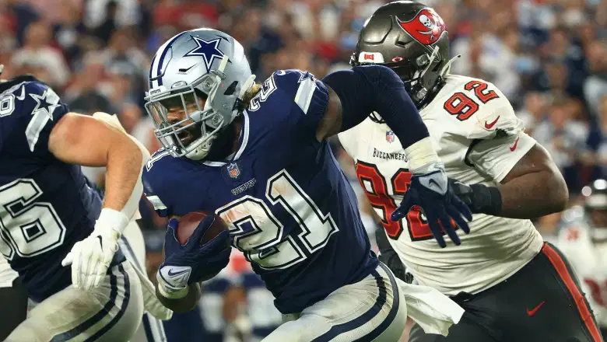
For anyone who is doubting Elliot I recommend going back and watching the tape. From the get-go the Cowboys found themselves in a passing game script in order to keep up with the Buccaneers high powered offensive. Not to mention the Buccaneers were the fourth best defense against running backs in 2020 allowing only 17.4 fantasy ppg in a half ppr scoring format. Despite the disappointing stat line there are positives to take away from Elliot’s performance against the Buc’s. The first is Elliot lead the team in carries with eleven, the next closes was Pollard with four. Second, Elliot was out there on 84.3% of the snaps, which is a lot! To compare Pollard was out on 24.3% of the snaps. So too all the people saying Pollard took work away from Elliot can sit down now. To conclude despite Elliot’s lack luster opening performance I still have the upmost confidence in him and would buy low Elliot while I can. But these are just my opinions. It’s up to you and what you believe about Elliot.
Elliot running away from a defender in Dal vs. TB

