**Air Dryer Suppliers, Inc.** Filter Housings

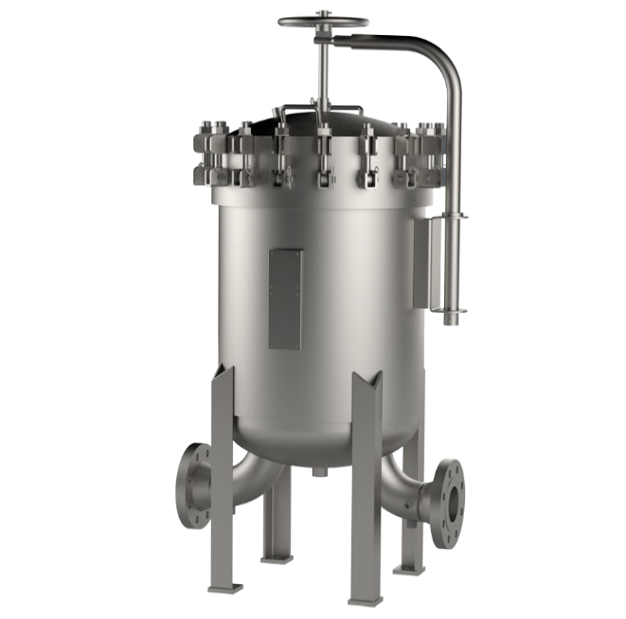**GB SERIES**

**ADS GB Series ASME (U or UM) Multi-round Bag Vessels Accommodate High Flow Rates & High Particulate Retention**

# APPLICATIONS

## Water

Food & Beverage Oil

Cutting Oils Lubricants Chemicals Solvents Electronics

Inks/Paints/Coatings Pulp & Paper



Designed to handle flow rates of up to 4,200 gpm (15,900 lpm), the ADS GB Series bag and strainer filter vessels provide excellent filtration in a wide range of industrial and chemical applications. All aspects of design, materials, construction and workmanship of the GB Vessel Series conform to ASME code. (Also available in non-ASME code design and construction.)

# BENEFITS

* Accepts standard #2 size bag filters or mesh-lined baskets
* Built in accordance with ASME (U or UM stamp) Boiler and Pressure vessel code
* 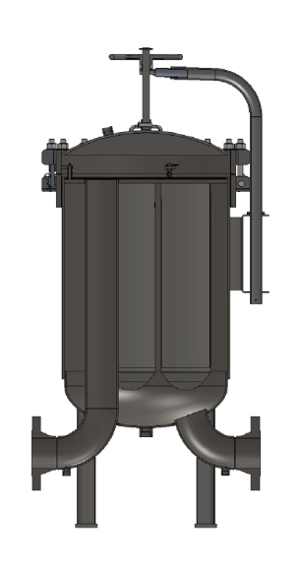Non-code design and construction (parallel code standards)
* Standard design pressure is 150 psi (10.3 bar) or 300 psi (20.7 bar)
* Available in carbon steel, 304 or 316L stainless steel
* Single O-ring seal closure design assures quick, positive cover seal
* Swing bolts with hex nuts for easy closure
* Buna-N standard O-ring with optional Viton**®**, Neoprene, EPDM and fluoropolymer elastomers available
* O-ring sealed baskets to prevent bypass
* Floating spring loaded bag compression plate seal to prevent bypass
* Bags located near vessel opening for ease of accessibility
* Cover locating pin for quick and accurate cover alignment
* In-line inlet and outlet for uniform piping elevation
* Bottom inlet for even flow distribution
* Stainless steel perforated basket
* Other materials available
* Customizable designs available (per specifications)

**GB**

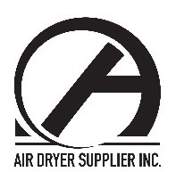

-

**3**

**4**

**6**

**7**

**8**

**10**

**12**

**16**

**17**

**23**

**30**

1626 Wind Chase Drive Talbott,TN37877

P: 865-415-7478 P: 865-415-7317

[www.airdryersuppliers.com](http://www.airdryersuppliers.com/)

**F**

**2**

**GB**

|  |  |
| --- | --- |
| MAX DESIGN TEMPS | |
| CARBON STEEL | 500°F (260°C) |
| 304 SST | 300°F (150°C) |
| 316 SST | 400°F (204°C) |
| GASKET | 250°F (121°C) |

|  |  |
| --- | --- |
| CLOSURE O-RING GUIDE | |
| MATERIAL | MAX TEMP |
| NITRILE (BUNA-N)** | 250°F (121°C) |
| EPDM (EPR) | 300°F (149°C) |
| FKM (VITON®) | 400°F (204°C) |

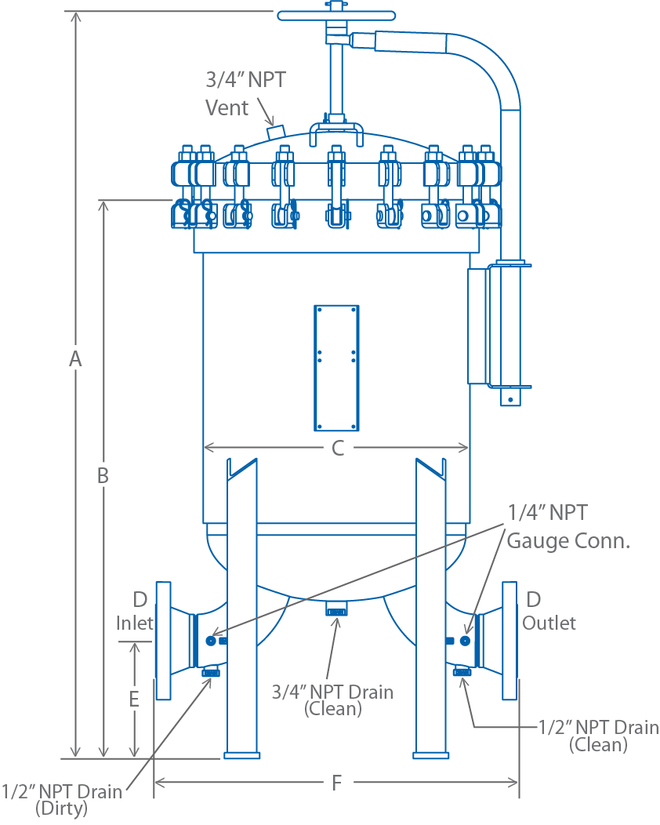**NITRILE O-ring is standard

Note: ADS also offers non- code cartridge filter vessels. For more information, please refer to the 4NBF datasheet.

**GB**

|  |  |  |  |  |  |  |  |  |  |
| --- | --- | --- | --- | --- | --- | --- | --- | --- | --- |
| MODEL | NO. OF BAGS | MAXIMUM FLOW*  (gpm) | DIMENSIONS (in.) | | | | | | SHIPPING WEIGHT  (lbs) |
| A | B | C | D (IN/OUT) | E | F |
| GB22-4GBGB1 | 2 | 400 | 57.75 | 40.50 | 16.50 | 4 | 8 | 27.31 | 450 |
| GB32-4GBGB1 | 3 | 400 | 60.56 | 43.38 | 18.50 | 4 | 8 | 27.50 | 475 |
| GB42-6GBGB1 | 4 | 800 | 64.94 | 47.00 | 22.50 | 6 | 10 | 35 | 570 |
| GB62-6GBGB1 | 6 | 900 | 65.19 | 47.50 | 24.50 | 6 | 10 | 40 | 600 |
| GB72-8GBGB1 | 7 | 1400 | 70.88 | 52.50 | 28.50 | 8 | 12 | 46 | 760 |
| GB82-8GBGB1 | 8 | 1600 | 71.94 | 52.63 | 30.75 | 8 | 12 | 46 | 850 |
| GB102-8GBGB1 | 10 | 1600 | 72.63 | 53.00 | 32.75 | 8 | 12 | 48 | 1000 |
| GB122-10GBGB1 | 12 | 2400 | 79.25 | 58.50 | 36.75 | 10 | 14 | 56 | 1200 |
| GB162-10GBGB1 | 16 | 2450 | 79.63 | 58.50 | 40.88 | 10 | 14 | 60 | 1650 |
| GB172-12GBGB1 | 17 | 3400 | 85.38 | 63.63 | 42.88 | 12 | 16 | 67 | 2200 |
| GB232-12GBGB1 | 23 | 3500 | 86.44 | 63.75 | 49.00 | 12 | 16 | 75 | 2600 |
| GB302-14GBGB1 | 30 | 4300 | 95.38 | 70.13 | 55.00 | 14 | 18 | 85 | 3400 |

*Actual flow rate is dependent on fluid viscosity, micron rating, contaminant and media type. Consult flow charts for each application. GB10 and larger have closure bolts with hex nuts in lieu of eye nuts.

# ORDERING INFORMATION

|  |  |
| --- | --- |
| MATERIAL | |
| **OMIT** | CARBON STEEL |
| **4** | 304 SST |
| **6** | 316 SST |

|  |  |
| --- | --- |
| DESIGN SERIES | |
| **OMIT** | ASME / 150 psig |
| **H** | ASME / 300 psig |
| **N** | Non-ASME |

|  |  |
| --- | --- |
| BAG FILTER SERIES | |
| **GB** | MULTIPLE BAGS (7.06 in. O.D.) |

|  |  |  |  |
| --- | --- | --- | --- |
| # OF COLUGBS |  | BAG LENGTH | |
| **2 2** | | | 32 in. |

|  |  |
| --- | --- |
| INLET / OUTLET | |
| **4** | 4 in. |
| **6** | 6 in. |
| **8** | 8 in. |
| **10** | 10 in. |
| **12** | 12 in. |
| **14** | 14 in. |

|  |  |
| --- | --- |
| CONNECTION TYPE | |
| **F** | ANSI SORF |

|  |  |
| --- | --- |
| INLET/OUTLET CONFIGURATION | |
| **BB** | BOTTOM IN/BOTTOM OUT |
| **BS** | BOTTOM IN/SIDE OUT |
| **SB** | SIDE IN/BOTTOM OUT |
| **SS** | SIDE IN/SIDE OUT |

|  |  |
| --- | --- |
| COVER LIFT | |
| **K1** | MECHANICAL |
| **K2** | HYDRAULIC |