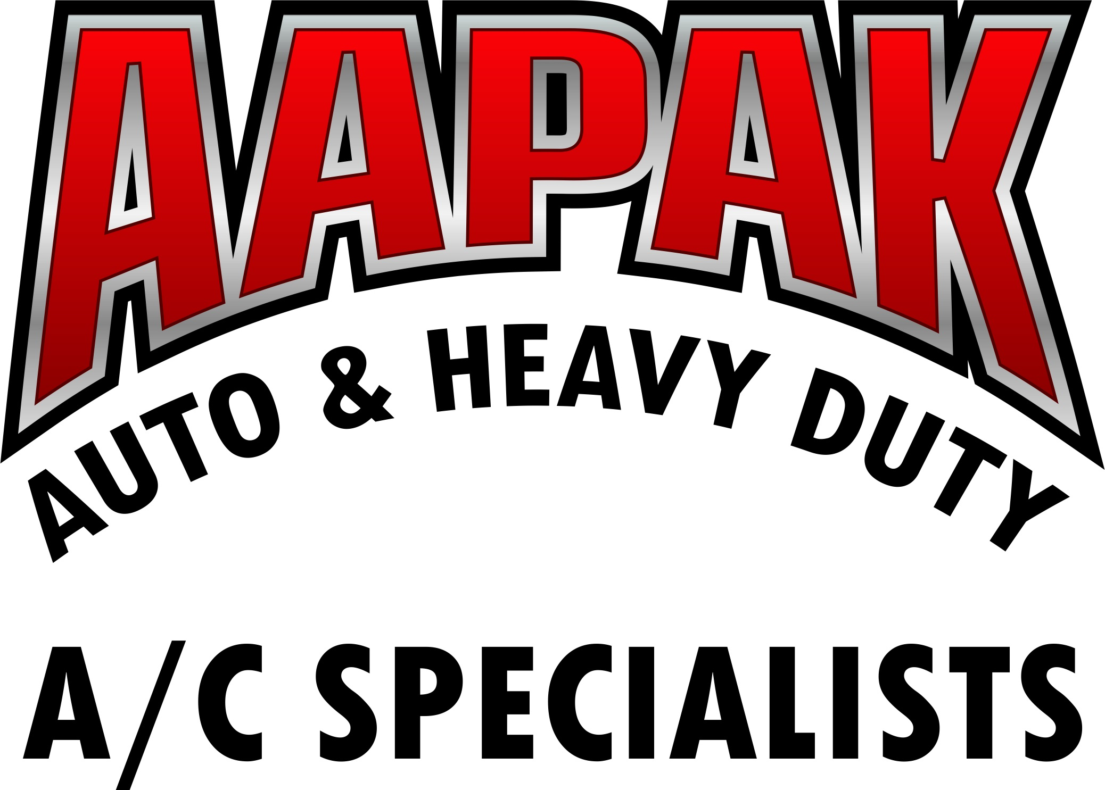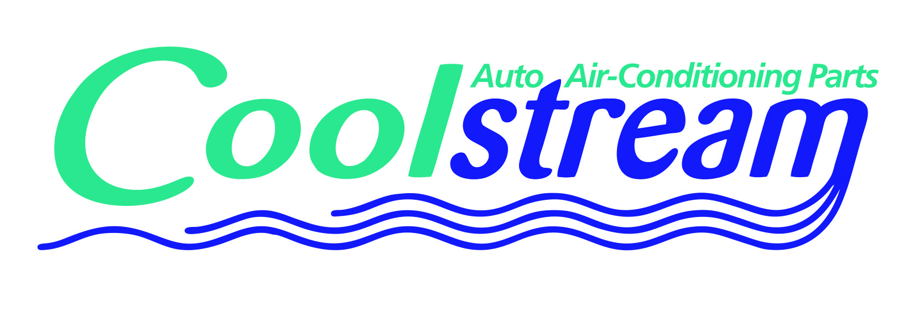 | 1028 E Broadway Blvd  Tucson Arizona 85719  520-918-3604  info@aapak.com  www.coolstreamac.com | 1845 NW Grand Avenue  Phoenix, Arizona 85007  602-254-1116 - Local  1-800-832-5544 – Toll Free  602-252-5065 – Fax  info@aapak.com  www.aapak.com

MANUFACTURER’S DEFECT
WARRANTY POLICY

WARRANTY COVERAGE

Warranty coverage includes any part which, when installed on a vehicle or system, is found to be DEFECTIVE within the period covered by limited warranty and service policy, and are subject to terms of the warranty policy.

Warranty coverage also includes any part, which is found to be DEFECTIVE when unpacked from the original container in which it was shipped. THIS DOES NOT INCLUDE FREIGHT DAMAGE. The customer must handle freight damage claims with the appropriate freight carrier to receive credit for freight-damaged goods. Insurance costs from all freight shipments are the responsibility of the customer receiving the goods in transit.

AAPAK Coolstream honors the manufacturers defect warranty policy on all products sold by AAPAK Coolstream to the original purchaser as follows:

- A/C components sold individually – one year from date of purchase for individual component only (does not cover A/C compressor sold separately without proof of purchase of required kit parts)
- Compressor Kit without required Condenser – one year from date of purchase
- Compressor Kit with required Condenser – two years from date of purchase
- Radiators – one year warranty against defect
- Condensers – one year warranty against defect

Ultimate responsibility of product warranty and length or term of warranty lies with each manufacturer, and therefore all manufacturers’ warranties will prevail against distributor returns. All returned products are subject to inspection and verification of warranty conditions and policies before credit will be issued. Electrical products are warranted for 90 days from the date of installation unless otherwise specified by the manufacturer.

It is the responsibility of every Installer to correctly install any AAPAK Coolstream part in accordance with the Original Equipment Manufacturers instructions and policies. It is also their responsibility to have technicians/installers properly trained so they can handle service complaints and warranty problems, as well as identify parts, order parts, and to properly handle any return parts under warranty.

DEFECTIVE PARTS RETURNED TO AAPAK COOLSTREAM

AAPAK Coolstream reserves the right to conduct a review and inspection of each warranty claim and to accept or deny any claims not meeting AAPAK Coolstream's or the manufacturer's requirements for warranty. AAPAK Coolstream will not warranty parts which it did not sell, have been abused, mishandled, altered or used inappropriately. AAPAK Coolstream does not warranty freight damage of any kind.
All incidental or inconvenience costs will not be paid by AAPAK Coolstream for any reason. NO labor or refrigerant allowance whatsoever will be paid on any individual AAPAK Coolstream part sales.

Warranty CheckList

When replacing a failed compressor, always follow OE-recommended service procedures. This will assure optimum performance from the A/C system and help protect the compressor warranty.

Follow these five steps to do it right:

To restore an A/C system after compressor failure, and to maintain the warranty on the compressor you are installing, check to make sure each of the following steps have been taken:

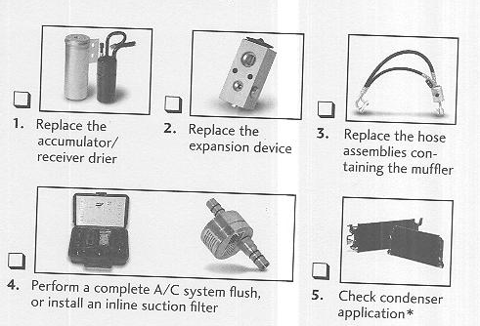

In the event warranty reimbursement is called for, you will need to have complete documentation that the work above was performed. A work order or a receipt for a flush kit is advisable for Step 4. A complete list of required documentation is provided on page 3.

Remember:
- The most common failure of replacement compressors is foreign material from a previously failed compressor.
- The system must be flushed and parts that can’t be flushed must be replaced.
- If debris remains, the system will clog and starve the replacement compressor of refrigerant and oil, causing it to also fail.
- Always match or replace the new compressor oil with the OEM-recommended type and viscosity. Use only R12346f, R-134a or R-12 refrigerant
- *On applications built after 1994, the condenser can not be thoroughly flushed of debris and contaminants, and should be replaced.

REQUIRED COMPRESSOR WARRANTY DOCUMENTATION

The following steps are required to return a compressor for manufacturer warranty consideration. This is a manufacturer requirement therefore failure to provide this documentation will void all compressor warranty claims.

Returned compressors and clutches must have the following documentation and information:
- Original AAPAK Coolstream invoice
- A repair order must accompany the compressor, stating that before the compressor was taken out of service, the following service procedures were performed:
  - Replaced the accumulator or receiver-drier
  - Replaced the expansion device (orifice tube, expansion valve or liquid line containing the orifice tube)
  - Replaced the hose assemblies containing mufflers (these cannot be flushed)
  - Performed closed loop flushing of all components not being replaced
  - Catastrophic compressor failure requires the replacement of any parallel flow or serpentine style condenser
  - Installed an in-line suction or liquid line filter
  - Used only approved R1234yf, R134A compressor oil including the use of proper viscosity. Used only mineral oil / Ester oil for R12 systems
  - Used only R1234yf, R134A or R12 refrigerants. Blend or hydrocarbon refrigerants of any kind are unacceptable and will void all warranties
  - High side and low side gauge readings where possible

