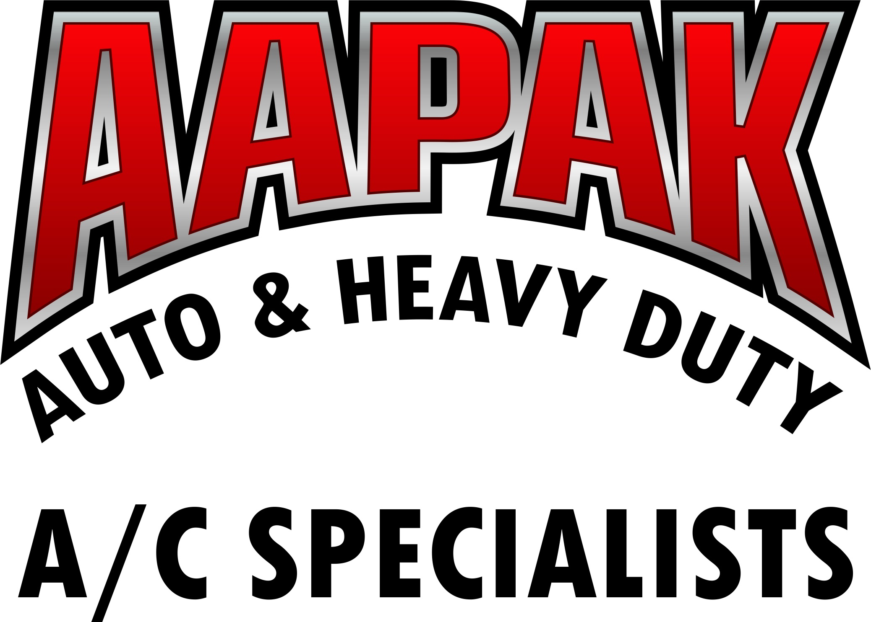 | 1028 E Broadway Blvd  Tucson Arizona 85719  520-918-3604  info@aapak.com  www.coolstreamac.com | 1845 NW Grand Avenue  Phoenix, Arizona 85007  602-254-1116 - Local  1-800-832-5544 – Toll Free  602-252-5065 – Fax  info@aapak.com  www.aapak.com

AAPAK COOLSTREAM RETURN POLICY

All returns require original AAPAK Coolstream invoice clearly identifying part number, date, and item cost. Product must have been purchased within the past (3) months from date of return to be eligible for return consideration.

Any product returned opened or damaged will be ineligible for return credit. Product must be in undamaged original carton, be in a resalable condition, and carry an identifiable AAPAK Coolstream part number before return credit will be considered.

Returns will only be accepted on regularly stocked items. No special priced, special order, or merchandise not purchased from AAPAK Coolstream may be returned for credit. Freight charges for returned product(s) are the responsibility of the purchaser and will not be considered for refund.

All returned product will be refunded in the same manner of original payment (VISA, check, cash). Customers will only receive credit based on the original invoiced prices for items approved for return, less applicable discounts or fees (restocking or reboxing fee).

If returning by mail, products/merchandise must be returned “Freight Prepaid”. Any product being returned by any means other than freight prepaid will be refused by our Receiving Department and returned at the customer’s expense. Shipping product “Freight Collect” will only be allowed under special circumstances at AAPAK Coolstream’s discretion and must be approved in advance.

All returns should be shipped to 1028 E Broadway Blvd, Tucson Arizona 85718

Customers will be contacted by AAPAK Coolstream if any product is ineligible for credit or if any discrepancies arise. The customer is responsible for the decision to return the ineligible product, “Freight Collect” or scrapped without receiving credit.

RETURN WILL BE REJECTED IF:

- Part is returned without AAPAK Coolstream invoice
- Upon inspection, the part is found to be damaged or not in a re-saleable condition
- The claim is over 3 mos old from the date of invoice
- Part was a special order, on sale item, or special priced item
- The part was not furnished by AAPAK Coolstream

