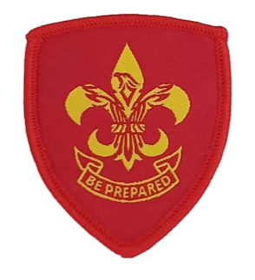
Phoenix Independent Scouts Association
Annual application for Renewal of Membership

The Association is a CIO registered in England and Wales with the Charity Commission – registered number 1195203.
Objects of the Association are:
To develop good citizenship and character among young people who are both self-reliant and useful to others. This is delivered through progressive training based on the principles and values of Scouting laid down by Lord Baden-Powell and the Law and Promise given by him in Scouting for Boys.
Membership criteria
Phoenix Independent Scouts Association is an Association of Independent Scout Groups, each of which must have either its own charity registration or be a recognised charitable social enterprise. Member Groups may not be members of any other Scout Association.
Member Groups must take total responsibility for governance, policies, finance, insurance, safety, management of risk, safeguarding, youth and leader training, uniform, badges, suitable meeting facilities and all other matters pertaining to the operation of their Group, and an authorised representative of each Group will be required to declare understanding of this on an annual basis.
The Phoenix Independent Scouts Association materials or financial or governance interest in any member Group, although may from time to time offer materials, or facilitate the sharing of best practices to support its membership.
Census of members (1st January 2024)
Section name | Age range | Youth members | Uniformed adult leaders | Non uniformed adult leaders | Total
Beavers
Wolf Cubs
Scouts
Senior Scouts
Rover Scouts
Other adults not otherwise counted
Totals

NB – adults named in Appendix 1, will be the only ones eligible to vote at Association General meetings.

Fees
Payment of £2 per person declared in the above census will be made, and only upon receipt of that payment will Phoenix Independent Scouts Association renew membership and benefits.
Statement to be signed by nominated authorised representative of the Group
On behalf of (add Scout Group name) I am authorised to sign and accept the following:
(add Scout Group name) is totally responsible for the governance, policies, finance, insurance, safety, management of risk, safeguarding, youth and leader training, uniform, badges, suitable meeting facilities and all other matters pertaining to the operation of the Group. I acknowledge that the Phoenix Independent Scouts Association acts only to facilitate support and sharing of best practices amongst its members.
Signed
Position
Date

Annex 1 – Names, position and email contact details of all adult members of the Group, who will be entitled to vote at Phoenix Scouts Association General Meetings (following approval of full Group membership).

