A STEP-BY-STEP GUIDE TO WRITING YOUR RESEARCH

## PHASE 1

1. Google Scholar

Go to <https://scholar.google.com/>

1. Search for your keywords*
2. 2020 only! (on the left side bar, click on SINCE 2020)

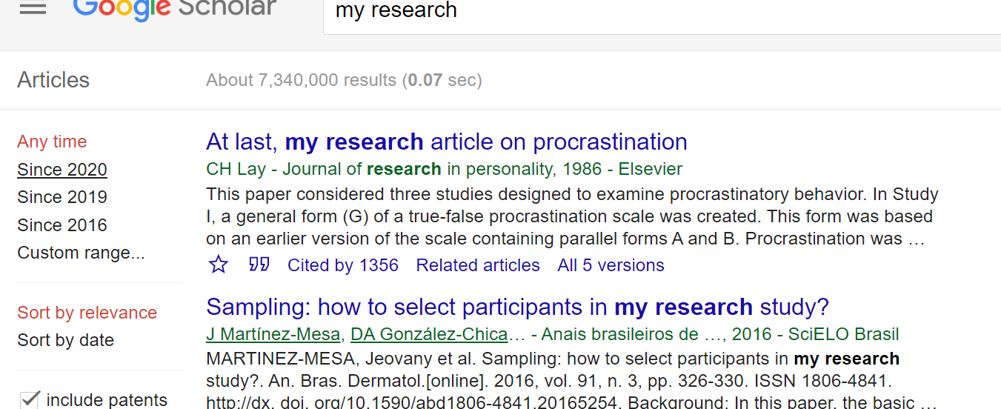

1. From the results, choose one to three articles and open them.
2. Read the abstract and if it is what you are interested, then copy the abstract in a word file for yourself.
3. Copy the citation (reference) – click on (**”**)

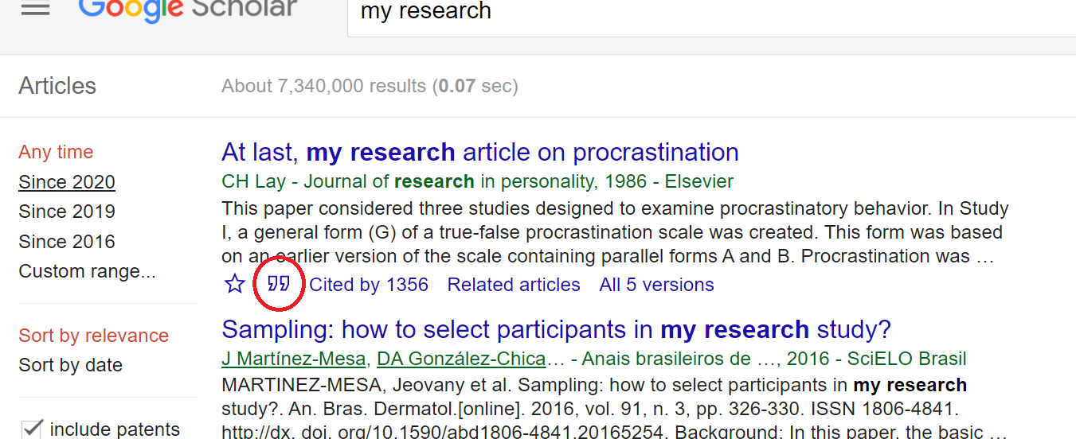

1. Use APA format

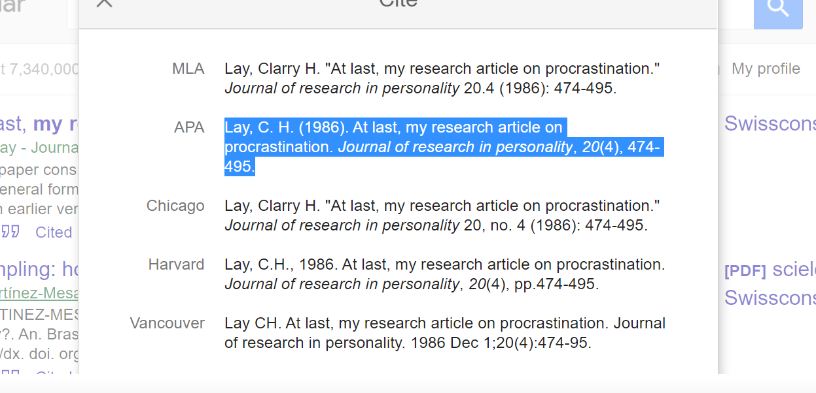

1. Keep everything in one file

## PHASE 2

Paraphrase the abstract that you have found using your words and understanding of the topic.

At this point, you should have a clear understanding of what your project is.

In your abstract you should include the following:

1. Introduction to your topic (paraphrasing from what you found)
2. Purpose/Aim/Objective of your research in clear written format that explains WHY you are doing this
3. Design/Methodology/Approach – *you can leave this part until the next phase*
4. Expected Results of your research
5. Implications of your research in real life.   
   **Example:** if your research is how increasing salary will have positive effect on job satisfaction, then your implication is that managers of companies should consider increasing salaries of their staff to make them more satisfied with their jobs.   
   **Example 2**: if your research is regarding how teachers can enhance students learning English through Netflix, then your implication would be for teachers using Netflix in their curriculum and school authorities to provide facilities where such services can be applied.

## PHASE 3

Upon completion of previous phases, you will now define the following:

* Research Method
* Keywords
* A brief literature review
  + finding similar studies to your topic
  + Only 2020 and 2019 studies
  + Ensure that you find relevant **theories**
  + You will use the theory/ies you found to link it to your research  
    Remember that only mentioning a theory is not using it. You need to use your critical thinking and explain why and how a certain theory will support your research in terms of conduct and results.
* Provide your references using the same system in Phase 1. (APA)
  + Ensure that your references are correctly written – Wrong reference will lead to reduction of your mark

**\*Recommended Topics:**   
**International Marketing:**

Covid-19 and consumer behavior (ch. 6 slide 10) or any topic related to international marketing

**Psychology:**

Critical thinking and perception (or any topic related to psychology)

**Leadership:**

Event-driven leadership, toxic leadership, toxin handlers (or any topic related to leadership and organizational culture)

**Risk Management:**

Risk management and Covid-19, enterprise risk management (or any topic of your interest related to the course subject)