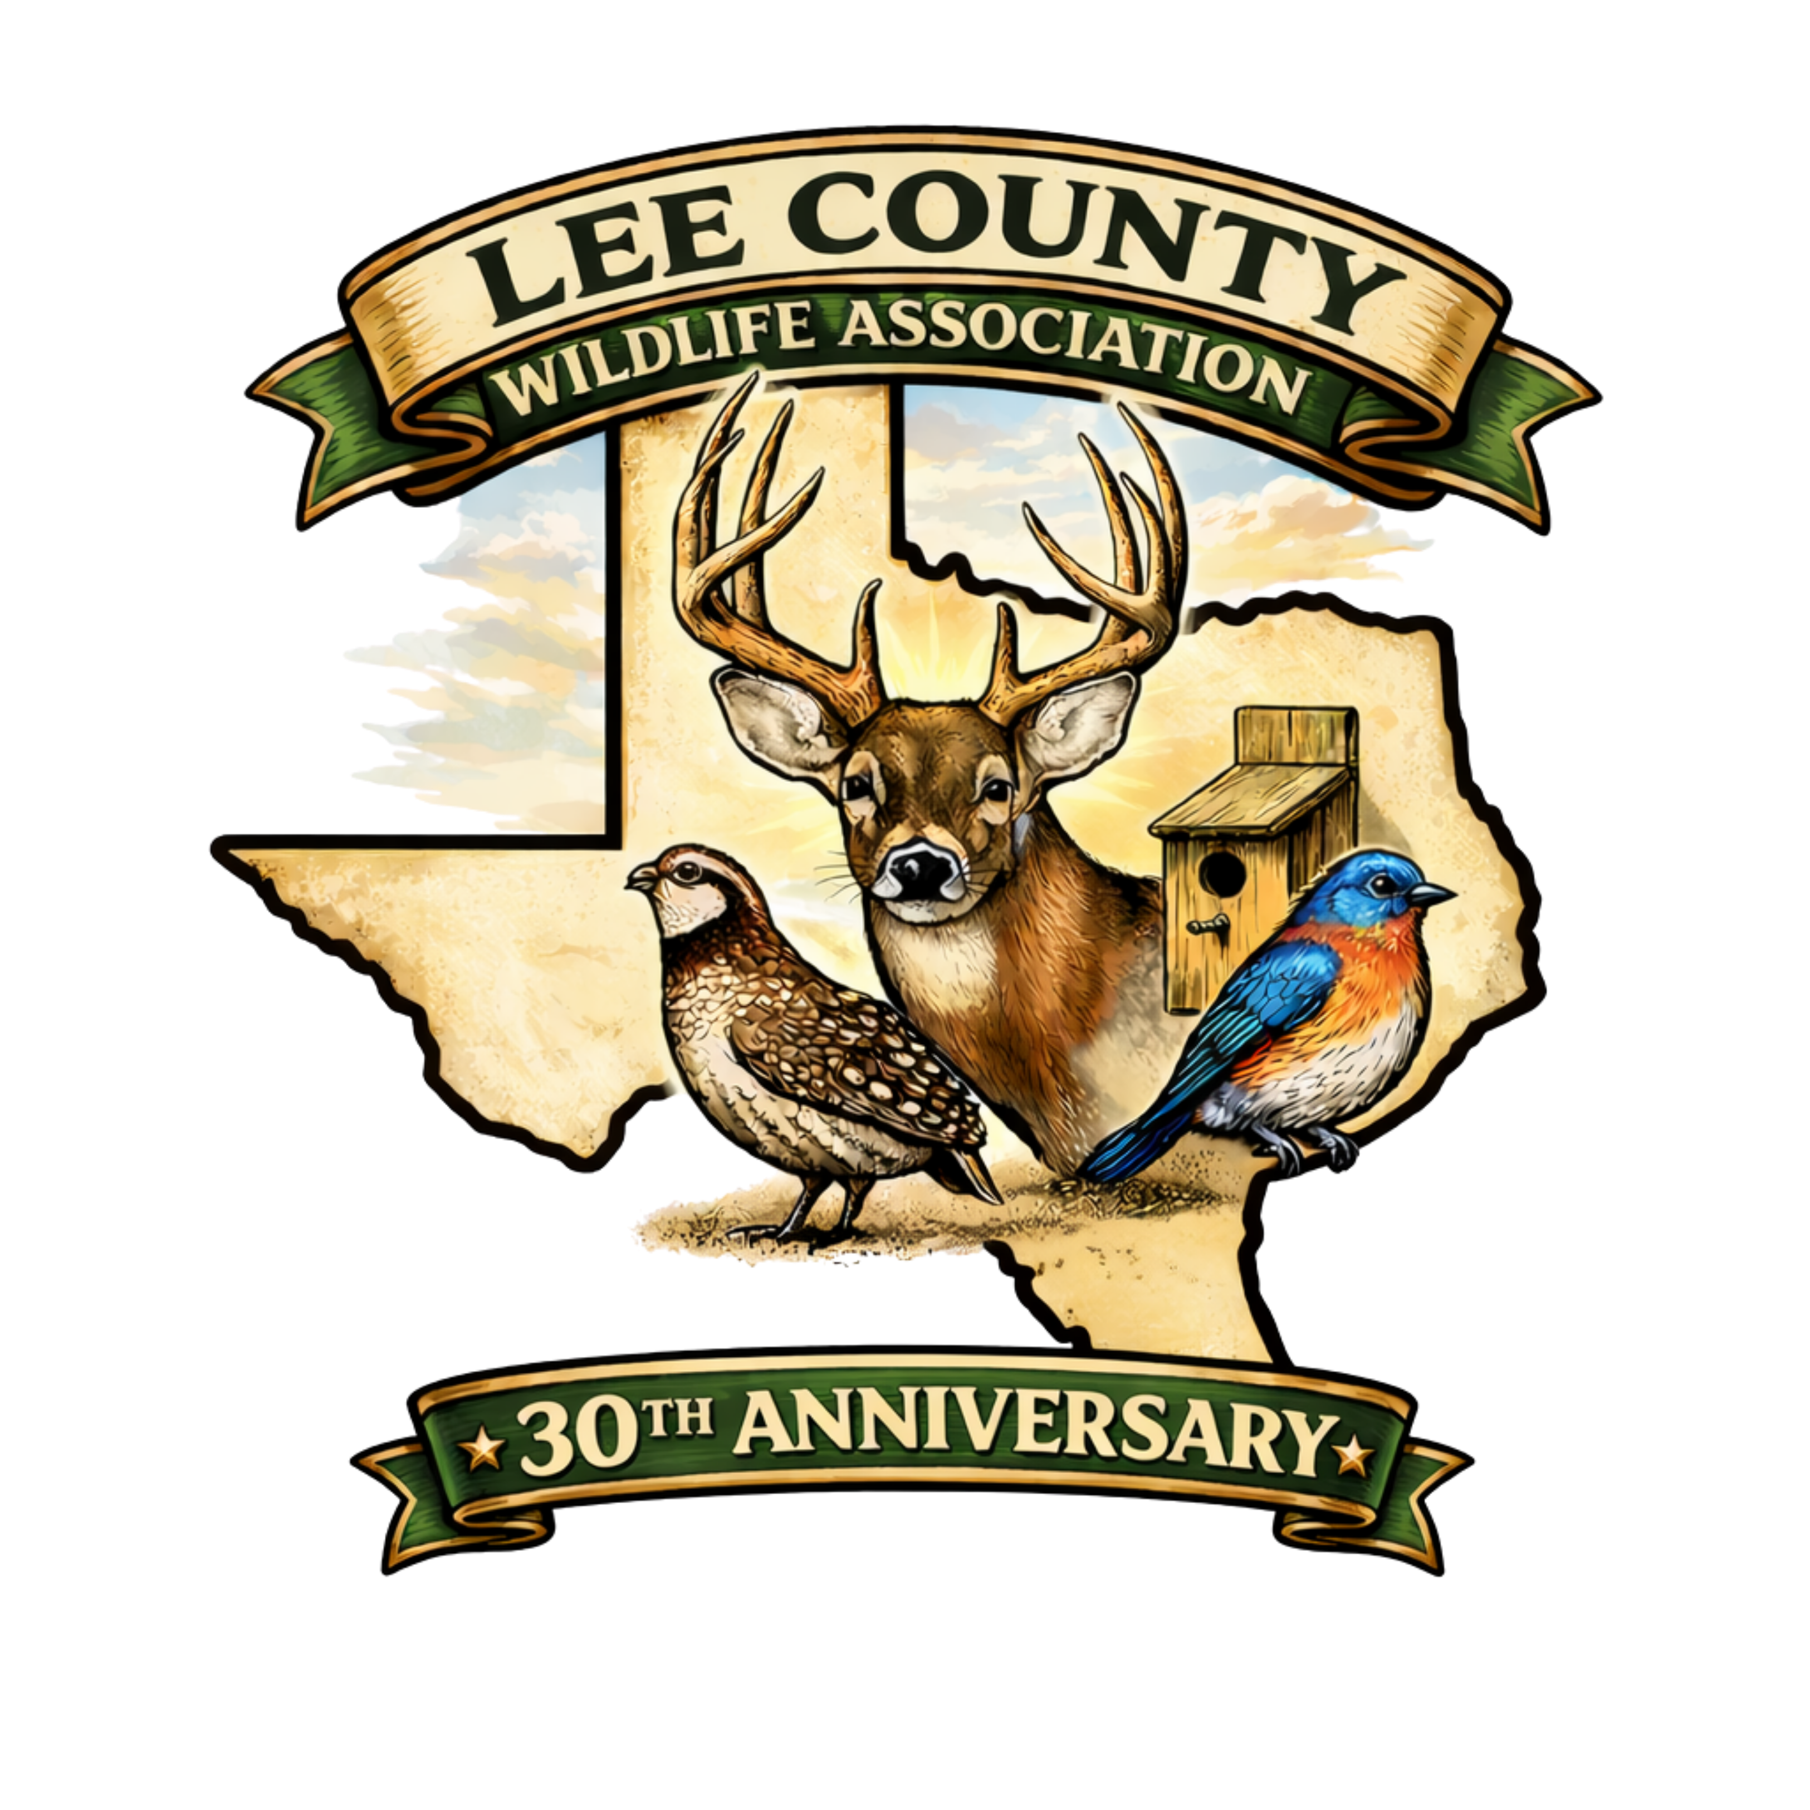 | LEE COUNTY WILDLIFE ASSOCIATION  Scholarship Application  2026-2027
Up to $16,500 in scholarships | Up to 10 qualifying scholars
APPLICATION DEADLINE | 4:00 PM - Tuesday, January 5, 2027
INTERVIEWS | Thursday, January 14, 2027
AWARDS PRESENTED | Friday, February 5, 2027 - LCWA Annual Meeting
LOCATION | The Silos on 77 Event Center
Scholarship Overview
The Lee County Wildlife Association (LCWA) is awarding up to $16,500 in scholarship funding for up to 10 qualifying scholars for the 2026-2027 school year. Scholarship recipients will be recognized at the LCWA Annual Meeting on Friday, February 5, 2027, at The Silos on 77 Event Center. Applicants will be notified by phone and/or email before the meeting. Attendance at the Annual Meeting is required if selected for a scholarship.
Scholarship winners will receive information and deadlines for receiving scholarship funds by email. A downloadable application is available at: leecountywildlife.org/scholarships
Eligibility Requirements
- Applicant's parent/legal guardian or grandparent must have paid and show an active membership in the Lee County Wildlife Association (LCWA) as of March 1, 2026.
- Applicant must be in their senior year and graduating during the 2026-2027 school year.
- Applicant must have a parent/legal guardian who resides in, owns, or leases land in Lee County.
- Applicant must intend to enroll in a college, university, or trade school within six months of graduation.
- If awarded, applicant must provide LCWA proof of enrollment in a college, university, or trade school by September 1, 2027.

Application Requirements & Important Information
- A completed application must be submitted by 4:00 PM on Tuesday, January 5, 2027 to a Lee County school counselor or the Lee County Extension Office at 310 S. Grimes, Giddings, TX 78942. Late applications will NOT be accepted.
- Qualified applicants must complete an interview with the Scholarship Committee on Thursday, January 21, 2027 at the Lee County Extension Office. An LCWA representative will contact applicants to arrange an interview time. Please provide accurate contact information.
- Applicant must submit either a digital or printed professional headshot, graduation photo, or similar image for use on the LCWA website and in future LCWA newsletters if selected.
- All pages of this application must be TYPEWRITTEN, except signatures. All pages must be completed.
- Applicant must provide an official copy of their high school transcript.
- Applicant must provide two letters of recommendation.
- Applicant must complete BOTH essay prompts included in this application on an additional page.
Application Checklist
☐ Completed and typewritten application
☐ Official high school transcript
☐ Two letters of recommendation
☐ Professional headshot / graduation photo
☐ Essay responses on an additional page
☐ Applicant and parent/legal guardian signatures

Applicant Information
Name of active LCWA member: __________________________________________________________________
Relationship to applicant (Parent / Grandparent): ________________________________________________
Number of years as an LCWA member: ___________________________________________________________
Applicant's full name: ___________________________________________________________________________
Applicant’s mailing address:
_________________________________________________________________________________________________
_________________________________________________________________________________________________
City: ____________________________________________
ZIP Code: _____________________________________________
Applicant contact number: _____________________________________________
Parent/Guardian contact number: _____________________________________________
Applicant email address: _____________________________________________
Parent/Guardian email address: _____________________________________________
High school: _____________________________________________
Graduation date: _____________________________________________
GPA: _____________________________________________
Class standing: #__________ of __________

Academic & Career Preparation
Honors/AP Classes Taken: ☐ Yes ☐ No
List Honors/AP classes:
__________________________________________________________________________________________________________
__________________________________________________________________________________________________________
__________________________________________________________________________________________________________
Career and Technology Courses Completed: ☐ Yes ☐ No
List career and technology courses:
__________________________________________________________________________________________________________
__________________________________________________________________________________________________________
__________________________________________________________________________________________________________

College / Technical Education Plans
College/Technical Classes Completed: ☐ Yes ☐ No
Course Title | Grade

College, university, or trade school of intent:
__________________________________________________________________________________________________________
__________________________________________________________________________________________________________
Date enrollment begins: _____________________________________________
Major / course of study:
__________________________________________________________________________________________________________
__________________________________________________________________________________________________________
Academic Accomplishments and Awards
__________________________________________________________________________________________________________
__________________________________________________________________________________________________________
__________________________________________________________________________________________________________
__________________________________________________________________________________________________________
__________________________________________________________________________________________________________

Activities, Service & Leadership
Extra-Curricular Activities, Accomplishments and Awards (including community service):
__________________________________________________________________________________________________________
__________________________________________________________________________________________________________
__________________________________________________________________________________________________________
__________________________________________________________________________________________________________
__________________________________________________________________________________________________________
__________________________________________________________________________________________________________
Leadership Accomplishments:
__________________________________________________________________________________________________________
__________________________________________________________________________________________________________
__________________________________________________________________________________________________________
__________________________________________________________________________________________________________
__________________________________________________________________________________________________________

Outdoor Activities & Brief Biography
Outdoor activities in which you participate (examples: bird watching, fishing, camping, hunting, habitat improvement, wildlife management, etc.):
__________________________________________________________________________________________________________
__________________________________________________________________________________________________________
__________________________________________________________________________________________________________
__________________________________________________________________________________________________________
__________________________________________________________________________________________________________
Please provide a brief biography of yourself. If selected for a scholarship, this may be used on the LCWA website under scholarship winners and in future newsletters.
__________________________________________________________________________________________________________
__________________________________________________________________________________________________________
__________________________________________________________________________________________________________
__________________________________________________________________________________________________________
__________________________________________________________________________________________________________
__________________________________________________________________________________________________________

Essay Question
Answer BOTH of the following essay questions on an additional page:
1. How can agriculture, ranching, and wildlife conservation work together to protect the natural resources and wildlife of Lee County, Texas?
2. How does the loss and fragmentation of wildlife habitat affect native species in Lee County, and what can our community do to address it?
Certification
I certify that all information provided in this application is correct and complete.
Signature of Applicant: _____________________________________________
Date: _____________________________________________
Signature of Applicant's Parent/Legal Guardian: _____________________________________________
Date: _____________________________________________
Submission
Submit the completed application and all required attachments by 4:00 PM on Tuesday, January 5, 2027 to a Lee County school counselor or:
Lee County Extension Office
310 S. Grimes
Giddings, TX 78942
LATE APPLICATIONS WILL NOT BE ACCEPTED.

