Dart War Birthday Package
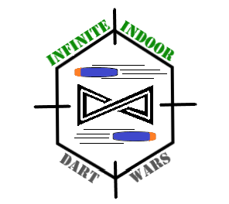
Blasters & Ammo Included
Birthday Shirt
Drinks Provided
Private Battlefield Use
$250.00 Birthday Package Includes:
- 2 Hour Facility Rental (this includes the party room and field use)
You may arrive 30 minutes early for setup. Setup and tear down must be completed within the 2 ½ hours
- Pitchers of soft drinks/Hi-C provided (up to 40 glasses full)
- Birthday boy/girl receives a T-shirt
- Private access to battlefield and all rental blasters
- Waiver of liability forms must be signed by each attendee’s guardian
- Participants are encouraged to bring in their own blasters.

Child’s First Name:
Last Name:

State:
City:
Zip:
Address:
__________________________________________________________________________________________________
Guardian’s Name:
Gender:
Age:
Date of Birth:

Contact #:
Date of party:
Estimated # of attendees:
Email Address:
Time of party:

Birthday Child’s Shirt Size: (Please Circle) YXS YS YM YL AS AM AL AXL AXXL

By signing, I/we agree to release, acquit, forever discharge, indemnify, and hold harmless Infinite Indoor Sports Center, which includes its officers, officials, coaches, employees, representatives of all league and tournament sponsors and their respective officers, directors, and agents from any and all claims, demands, actions or causes of action, liability or injury or damage arising out of or in a way related to participation in any activities at Infinite Indoor Sports Center. I/we also indemnify Infinite Indoor Sports Center from any and all actions arising out of negligence. I/we also agree that my/our child has my/our permission to participate in any and all activities at Infinite Indoor Sports Center. In the event of injury or illness to my/our child, I/we hereby grant authority to a qualified medical professional to render such medical treatment as said professional deems reasonable and necessary, and I/we also accept responsibility for any expense involved with such illness, injury, and treatment. By signing this agreement, I/we also acknowledge that Infinite Indoor Sports Center may compile address labels and lists and may utilize any photographs arising out of any activity associated with Infinite Indoor Sports Center. I/we also agree to waive all rights to compensation arising out of the use of these photographs for the promotion and/or operation of Infinite Indoor Sports Center. I/we also agree to abide by all rules, regulations, and philosophies of Infinite Indoor Sports Center.
Date: ________ Guardian’s Name (print): ____________________ Signature _______________________

Infinite Indoor Sports Center 105 E Park Rd. Washington, Indiana 47501 (812) 674-2626 www.InfiniteIndoorSportsCenter.com Like us on Facebook to stay updated

