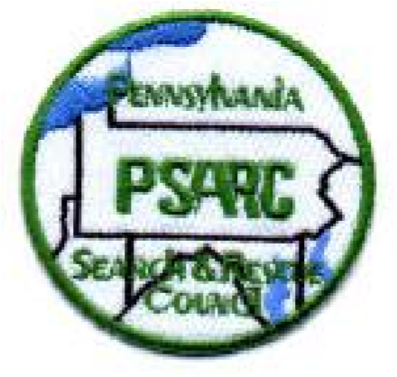
.
PA Search and Rescue Council
Member Team Contact Information Sheet

Failure to complete and return this form by February 15, 2026
WILL result in your team not receiving emergency callouts.
Email to pompjandl@aol.com or mail to PSARC, 117 McMunn Ave., Pgh. PA 15205
EMERGENCY RESPONSE AREA:
Region(s) ______________________________ * ___________________________
______________________________ * ___________________________
Counties ______________________________ * ___________________________
______________________________ * ___________________________
______________________________ * ___________________________
______________________________ * ___________________________
______________________________ * ___________________________
______________________________ * ___________________________
EMERGENCY CALL-OUT INFORMATION:
Contact Name:______________________________________ Number: ___________________________

1st Back up: _________________________________________ Number: ___________________________

2nd Back up: _________________________________________ Number: ___________________________

Members shall be deemed to be in a region based upon their official address. If they reside outside of the Commonwealth, their region is determined by extending the regional Pennsylvania boundaries into the location of their official address.

- Northeastern – North of Interstate 80 and east of Route 15
- Northwestern – North of Interstate 80 and west of Route 15
- Eastern - South of Interstate 80 and East of the Susquehanna River
- Central - South of Interstate 80 from the Susquehanna River to the Laurel Ridge
- Western - South of Interstate 80 and West of Laurel Ridge
TEAM INFORMATION:

Team Name: ________________________________________________________________________

Mailing Address: _____________________________________________________________________

Business Phone: ___________________________________ Region: __________________________

