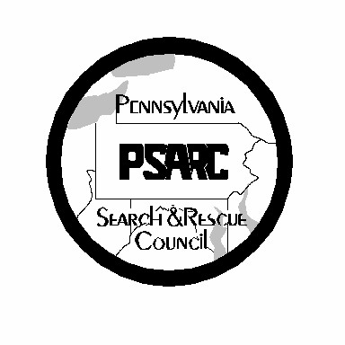
Pennsylvania Search and Rescue Council
2026 Code of Ethics

As a Pennsylvania Search and Rescue Council Organization, we agree to abide and honor the following values:
- As a volunteer search and rescue provider we agree to furnish search and rescue services and care, to the best of our abilities and training, to any individual who is missing or injured and in need of these services. We will do so regardless of race, sex, religion, cultural background, sexual preference and economic or social condition.
- We ensure that, in the performance of our duties, we will conduct ourselves with honesty and integrity and shall not misrepresent ourselves, or any member of our team, beyond our abilities or training. This will include honest representation on submitted resource documentation.
- We will not seek publicity or financial renumeration for our team, or ourselves as individuals, in response to any search.
- Our first and foremost thoughts, at a search, will be to provide the most immediate response, and best of care to the missing or injured individual or persons, while ensuring the safety of all searchers involved.
- We agree to work in unity with all responding search personnel, called upon by the organizers of the search.
- We support the rights of the victim to the utmost of discretion, on our part, in the matter of confidentiality of privileged information.
- We believe that we not only have an obligation to advance our knowledge and skills in relation to the search and rescue field; but also agree to assist, to the best of our abilities, with the development and training of any individual or team truly interested in this endeavor.
As an Officer of the following organization, I realize that my signature upon this document instills, upon my team, certain responsibilities and conduct by which this team is willing to enforce and abide.

Organization/Team Date

Name Title
Email to Melissa Parker melissaparker@liamsar.org

