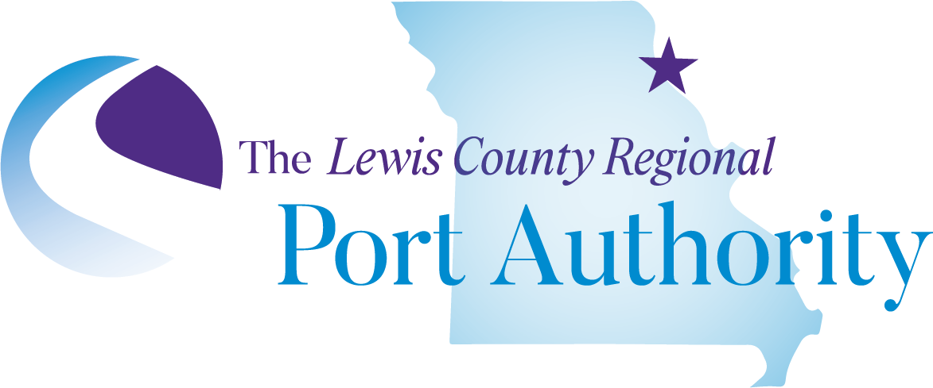

STATEMENT OF POLICY

TITLE VI

Civil Rights Act of 1964

As amended – And its Related Statutes
Lewis County Regional Port Authority gives public notice of its policy to uphold and assure full compliance with the non-discrimination requirements of Title VI of the Civil Rights Act of 1964 and related nondiscrimination authorities. Title VI and related nondiscrimination authorities stipulate that no person in the United States of America shall on the grounds of race, color, national origin, sex, age, disability, income level or Limited English Proficiency be excluded from the participation in, be denied the benefits of, or be otherwise subjected to discrimination under any program or activity receiving Federal financial assistance.

Any person who desires more information regarding Lewis County Regional Port Authority’s Title VI and ADA Program can contact Ralph Martin, Director at the address noted below.

Any person who believes they have, individually or as a member of any specific class of persons, been subjected to discrimination based on race, color, national origin, sex, age, disability, income level or Limited English Proficiency has the right to file a formal complaint. Any such complaint must be submitted in writing within 180 days of the date of the alleged occurrence to:

Lewis County Regional Port Authority
Ralph Martin, Director
108 N Jackson St/PO Box 85
Monticello, MO 63457
573-767-5393
portauthority056@gmail.com

A complainant may also file a complaint directly with the Maritime Administration by emailing civilrights.marad@dot.gov or mailing a written complaint to:
United States Maritime Administration Office of Civil Rights
West Building, 2nd Floor MAR-130 1200 New Jersey Avenue,
SE Washington, DC 20590

