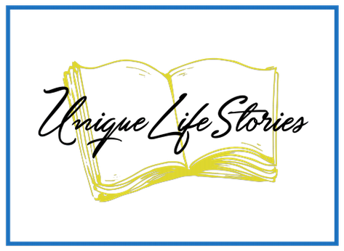
Helpful Resources for Getting Your Story Underway
We all have family around us, sharing life and holidays and vacations, and just, in general, enjoying being together, making memories, and sharing life experiences. Suddenly, you realize time is running out because these family relationships are dynamic. They are constantly changing, children grow up, people move away, couples break up, grandparents die, and a myriad of other circumstances are continually changing.
One day you are struck that time is running out to get your own story down for your family and friends. Relax! There are plenty of options available to you—from low to high cost, from hands-on where you do most or all of the work yourself to hands-off where you hire professions to do the heavy lifting for you. And there are dozens of options in between these extremes.
So, with so much available, here to start becomes of paramount importance. There are dozens of books to help you write your story or get your family member's story. They have different perspectives, for example, from grandparent to grandchild, where the grandparent answers questions that the grandchild might like to know. You can write your story from prompts that give you an idea, and you write or record an anecdote in response.
You probably have many resources right at your fingertips that you might overlook, but that can help you start your story. Here are just a few examples:
- People often keep diaries at particular times in their lives
- A family member's Holy Bible may include essential dates related to births, deaths, marriages, religious confirmations, or events.
- Sometimes, people wrote letters with information that can help construct stories, think of letters exchanged in times of war or engagement or travel
- Baby books that recorded children's milestones
- Photo albums also can tell of special times, friends, houses, schooling, graduations, moves, and much more.
- Select objects in and around your house might help you remember events and people from your past.
- Music albums also offer an interesting window into a person's life—or any other collection you might have or have inherited.
- You can glean much from your family plot where dates and relationships are recorded on the headstones.
- Genealogical records that you or that you can access through the internet are also good ways to tell your story.

When you have exhausted all that you can easily find, you can move on to more formal writing that you might need to do, like books and websites. This field is continuously changing, and new resources are always becoming available. Some methods will be more helpful than others, depending on your preference. And, some questions and directions will work for you better than others. What you want to do is get started. Whatever method helps you get started the fastest and works for you to keep at this long process, that is the best way for you to go.

Here are some resources out of my personal library that might be helpful in you getting your or a relative's life story down in a useable form. These are books I have used in helping people get started on their life stories. And I have used these resources with others as well as personally.
The Book of Myself: A do-it-Yourself Autobiography in 201 Questions by Carl and David Marshal
ObitKit: A Guide to Celebrating Your Life: How to personalize the obituary process and create your written legacy by Susan Soper
This is My Story: Creating a Scrapbook Legacy of Faith by Lisa Whelchel
My Life/My Legacy: A Timeless Portrait of Who You Are for Those You Love produced by Howard Books

There are several websites to help you get your story done. They change all the time. Be sure that the one you choose has some kind of track record that they will not disappear with all your valuable information, not that they will sell or use your information in their advertising or some other unauthorized way.

If you want to enlist some professional help, these questions might help you.
- What is the form of this life story that will be best used in your family?
  - Video
  - Online website
  - Printed book—either professionally or locally offset printing
  - Printed book with pictures
  - Picture book
  - A creative form, like a framed picture or collage
- Do I have the skills to bring this project to an acceptable conclusion in the final shape I want?
- If I cannot see this project to the end, how do I want to get some help?
- What local resources are available to help me to get started?
  - Could be a memoir writing group at your local library
  - Could be a professional company or person who helps people with their life stories, search your local area
  - Could be a professional memoirist who will help me with this story
  - Locally available—look online for your writers or editors
- Online with a larger company
- Perhaps I just want to write my story and have my family members do what they want with them later.

I hope these ideas have helped get started with your life story or your family member's story. I heard that we get the idea for our story early, but we get started too late always. When our family member or even our member fails, the stories become more difficult. We will need more help to get those precious memories recorded in some form.

Remember, the most crucial time to start is now. And you are the best person to tell your story or to collect your relative's story.

Remember…when you are ready to get started, …we are ready to help!
Write me at carol@uniquelifestories.com if you any questions.

